**Able to Develop complex calculated measures using DAX, and create and share more impactful reports and dashboards from your data.**

**KO1:** Able to understand Columnar Database Able to add Business Logic with Calculated Columns and Measures.

**Calculated columns** is the one which looks at the other values in same row to produce calculated value.

**Measure** is Expression which summarize all the data. It iterates all the data into single value and that value is computed dynamically (Run Time)

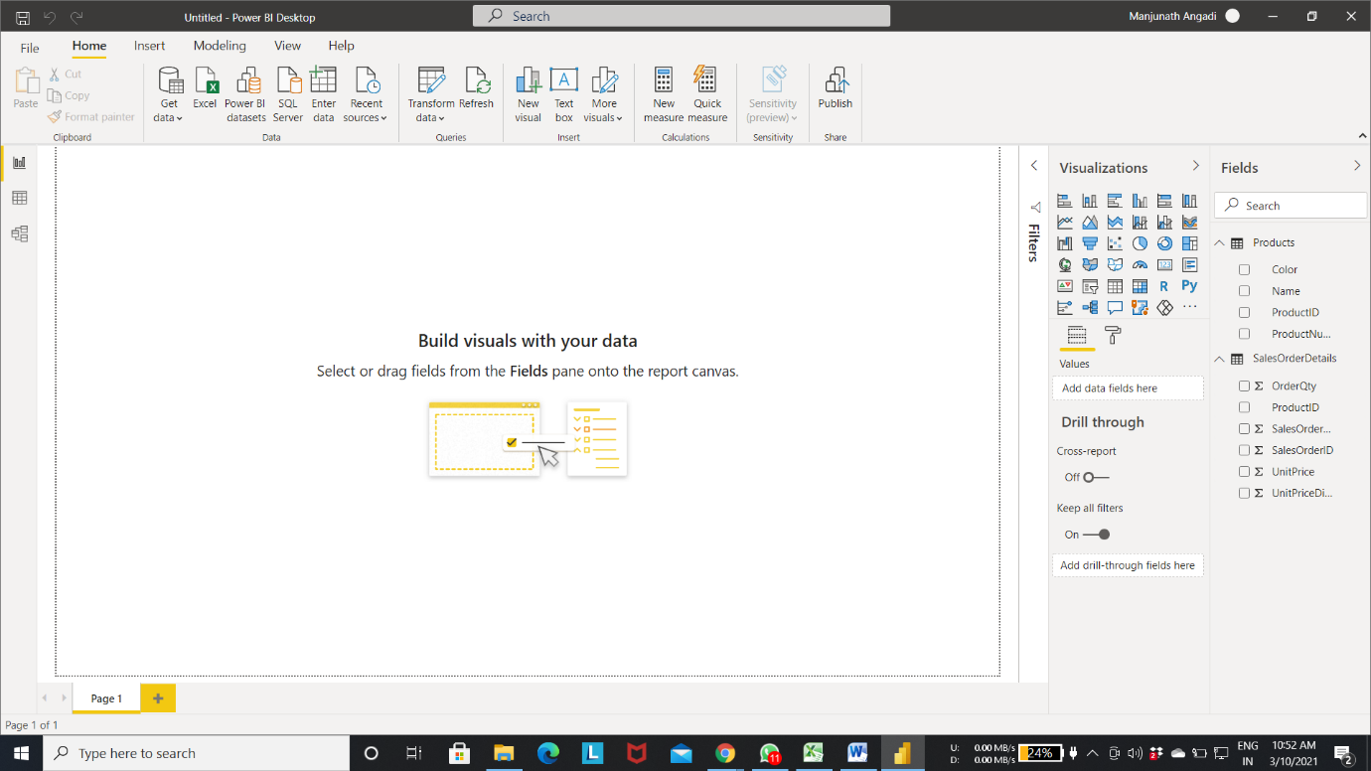

To add New column to the existing Table

Step 1: Right click on **Table** -> Select “**New Column**” (or) On the menu bar over at right, you can also select “**New column**”

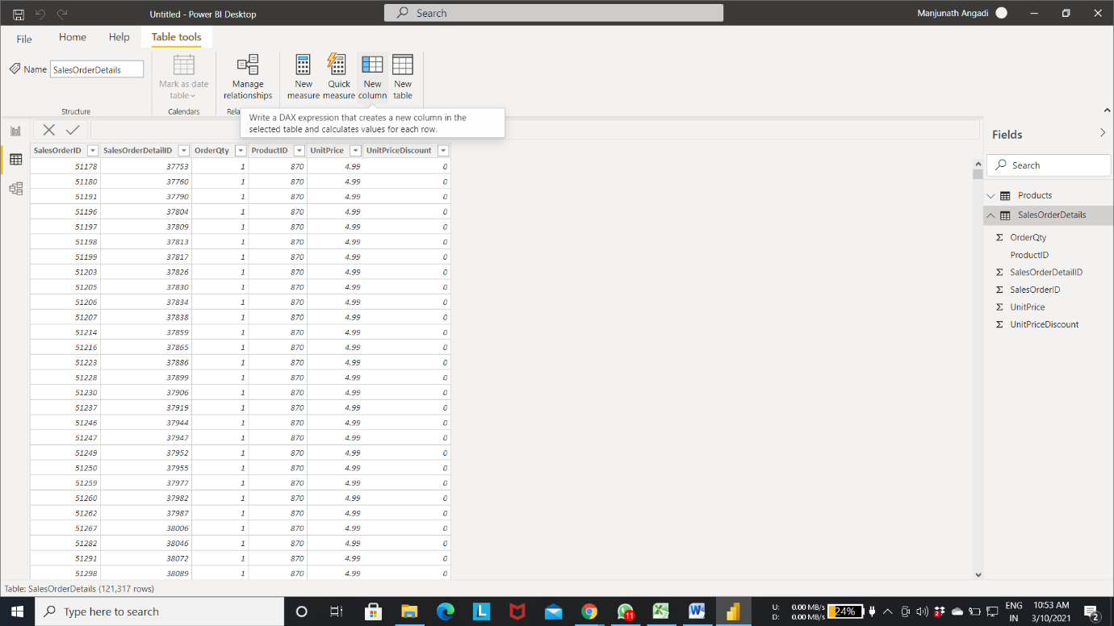

You can see the “**New column**” added to the Table

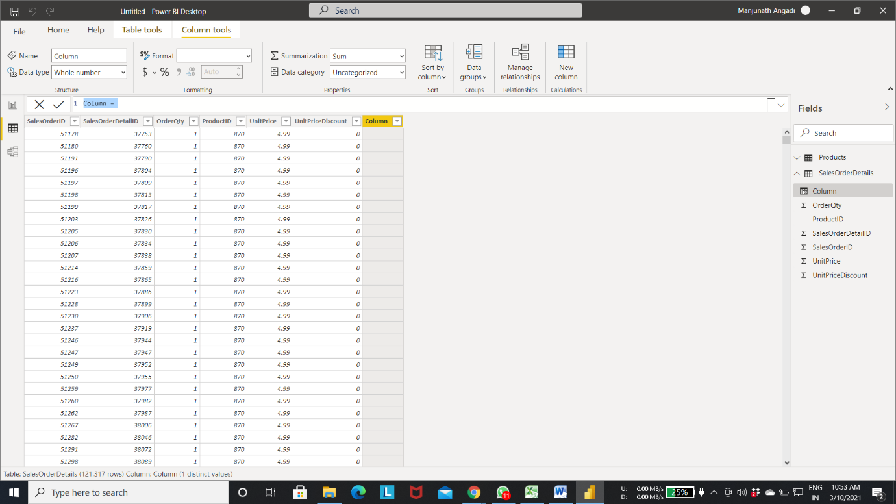

Step 2: Name the column, in my case it is “**Line Total**” and write the query

“Line Total = SalesOrderDetails[OrderQty]*SalesOrderDetails[UnitPrice]*( SalesOrderDetails[UnitPriceDiscount])”

Step 3: Hit **Enter**

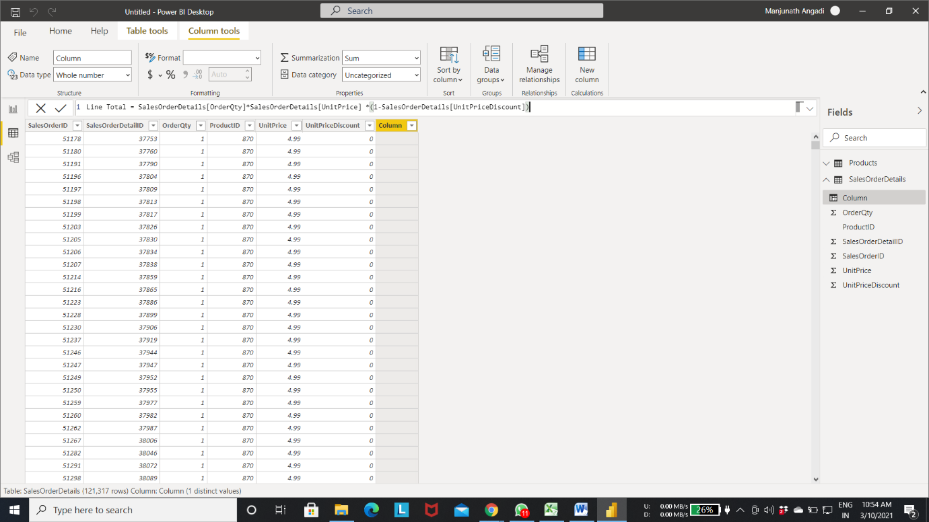

You can see the column “**Line Total**”

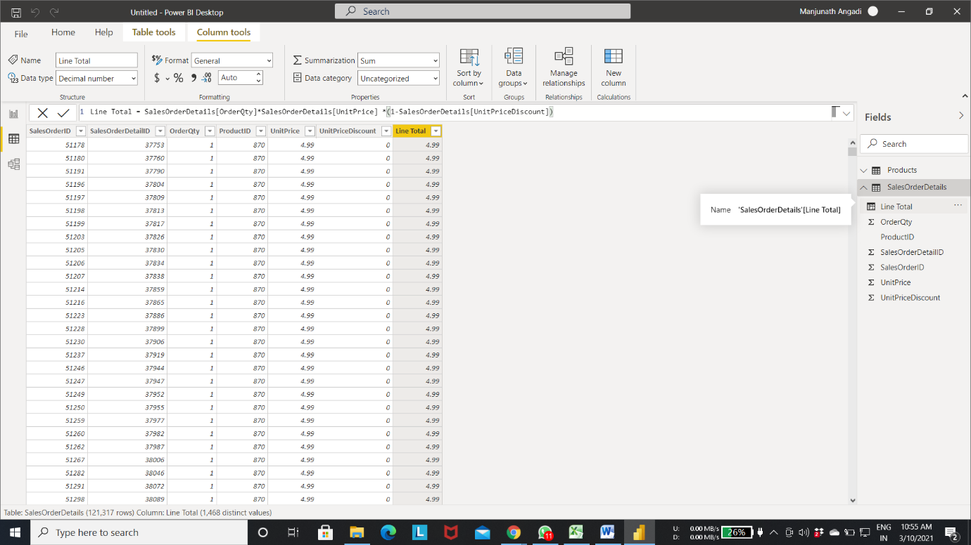

Now, you can see each and every row calculated accordingly

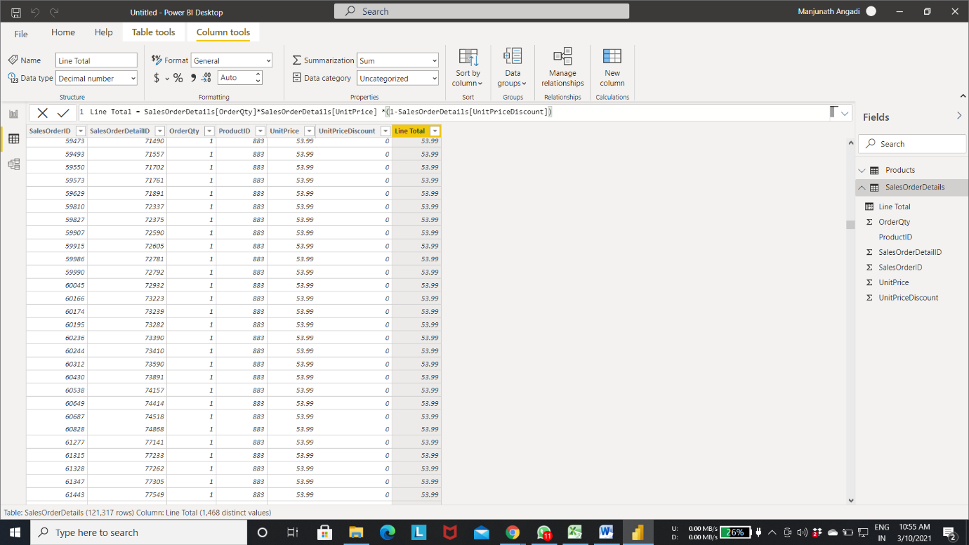

Click on **Model** to check out the schema

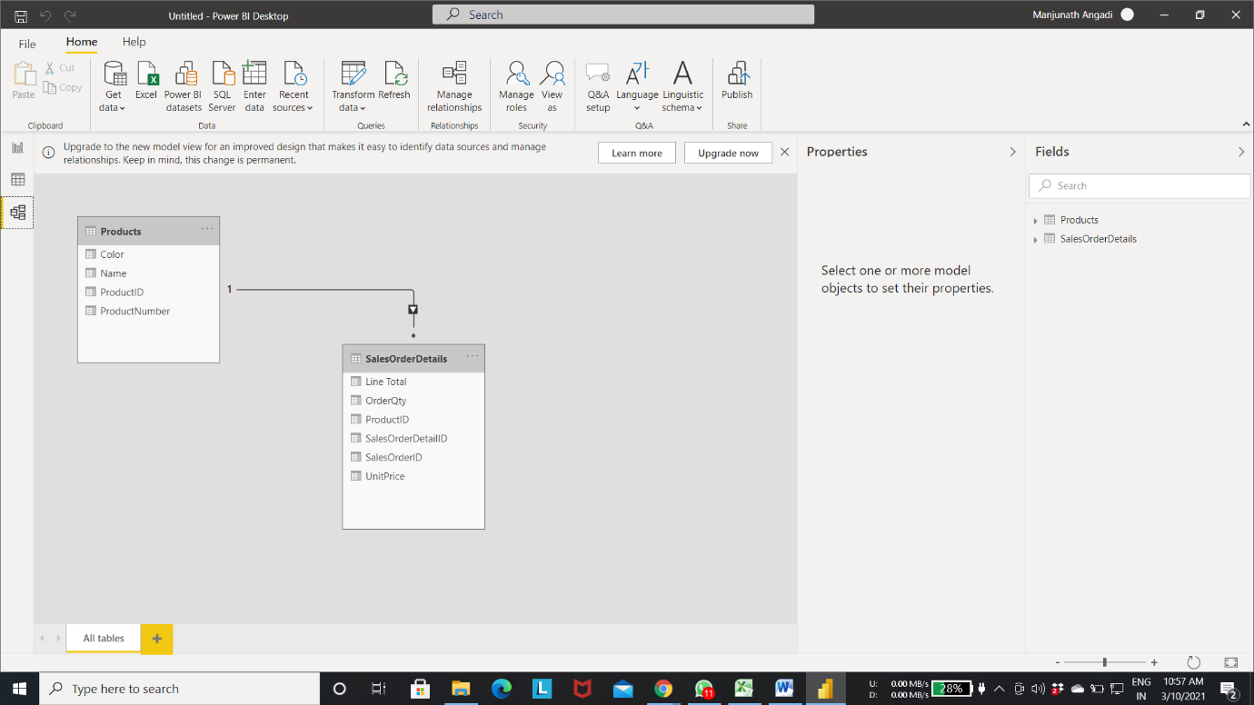

Step 4: Right click on **Table** -> Select “**New Column**” (or) On the menu bar over at right, you can also select “**New column**”

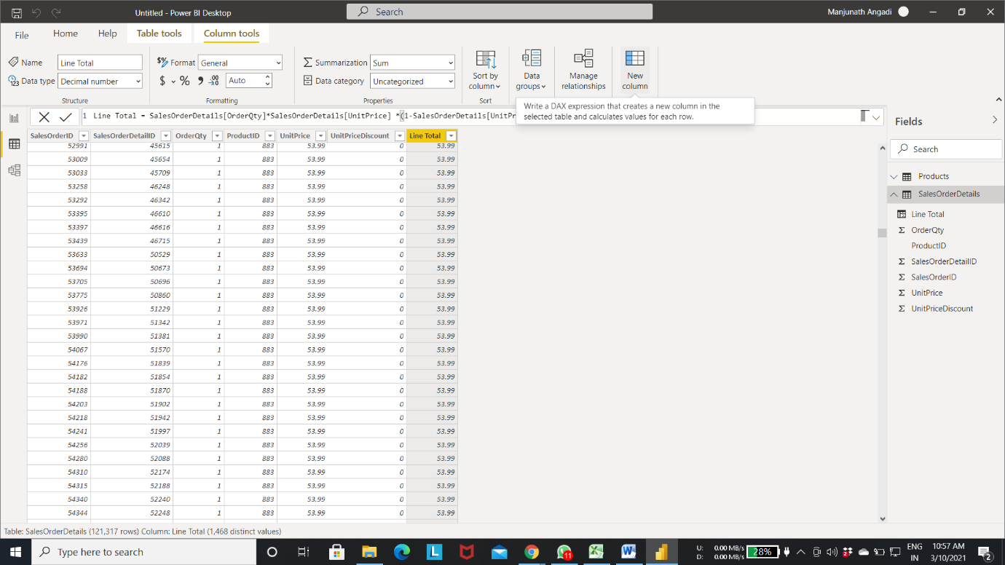

Column “**Colour**” is from “**Product”** Table, to get that column from different Table use “**RELATED**” Function

Step 5: Name the column, in my case it is “**color**” and write the query

“color=RELATED(Products[color])”

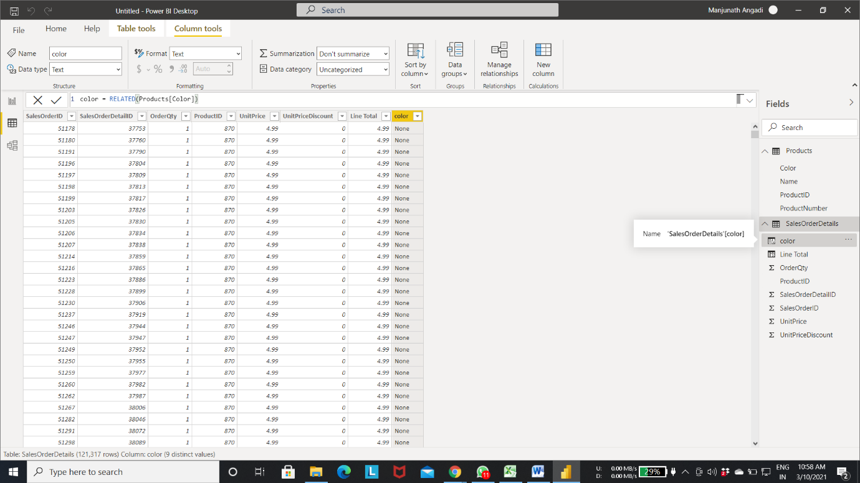

To add column in “**Products**” Table

Step 6: Right click on **Table** -> Select “**New Column**” (or) On the menu bar over at right, you can also select “**New column**”

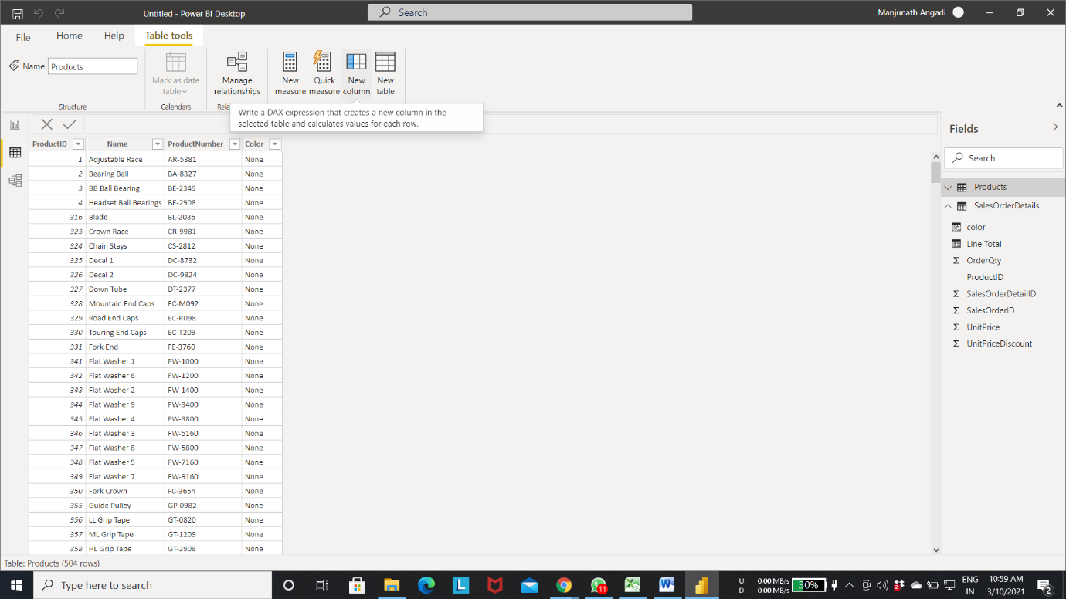

Step 7: Name the column “**Total Sales**” and write the query

“SUMX(RELATEDTABLE(SalesOrderDetails), SalesOrderDetails[Line Total])”

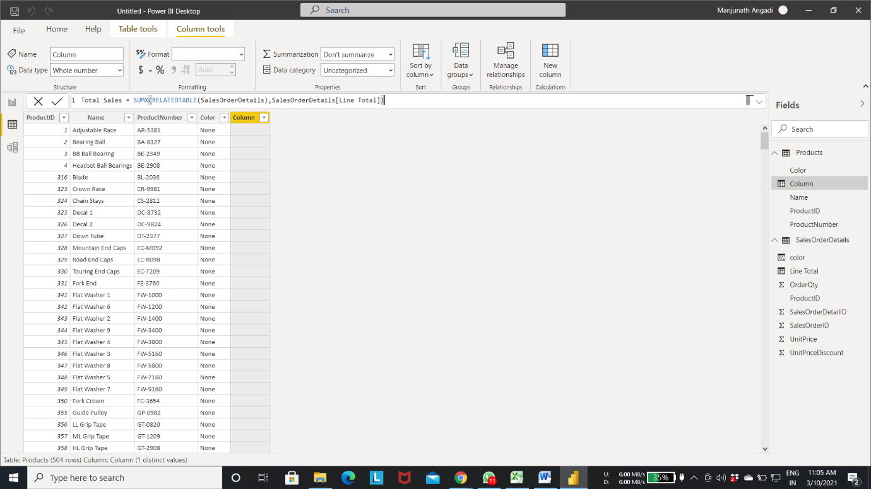

Now, you can see each and every row calculated accordingly

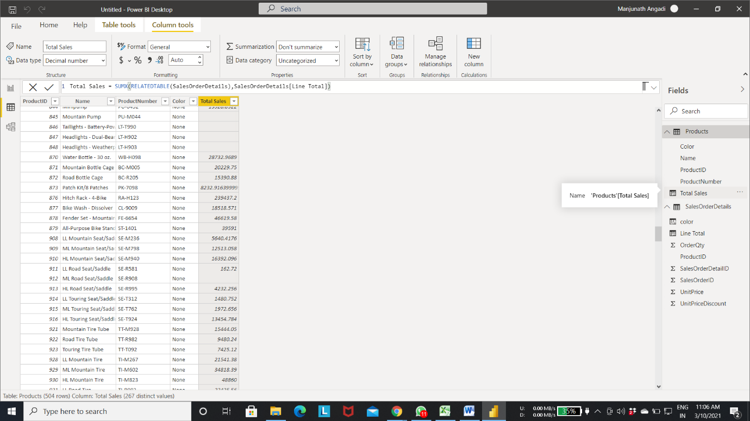

Step 8: Click on “**Reports**”

Step 9: Select **Matrix** in Visualization.

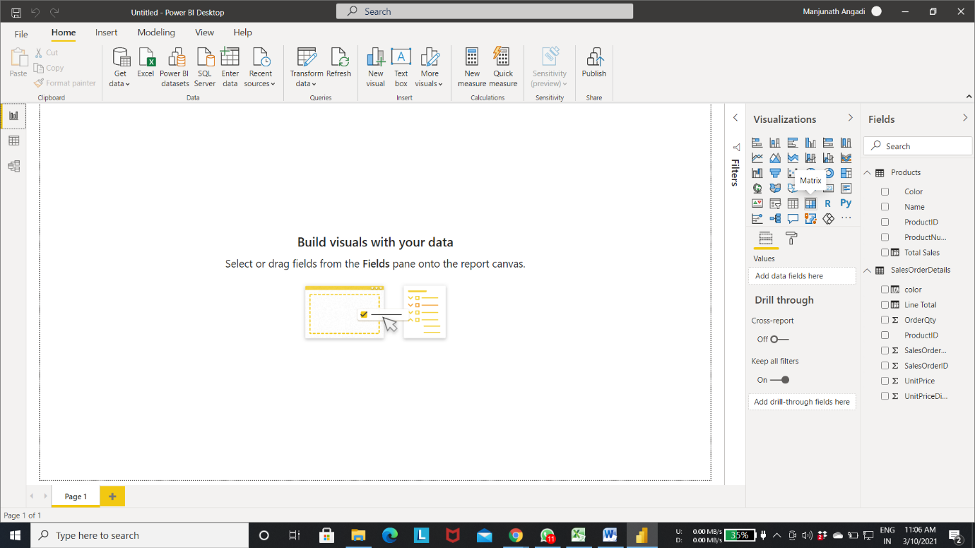

Step 10: Select “**Color**” and “**Line Total**” columns in **SalesOrederDetails.**

You can see the matrix view in below image,

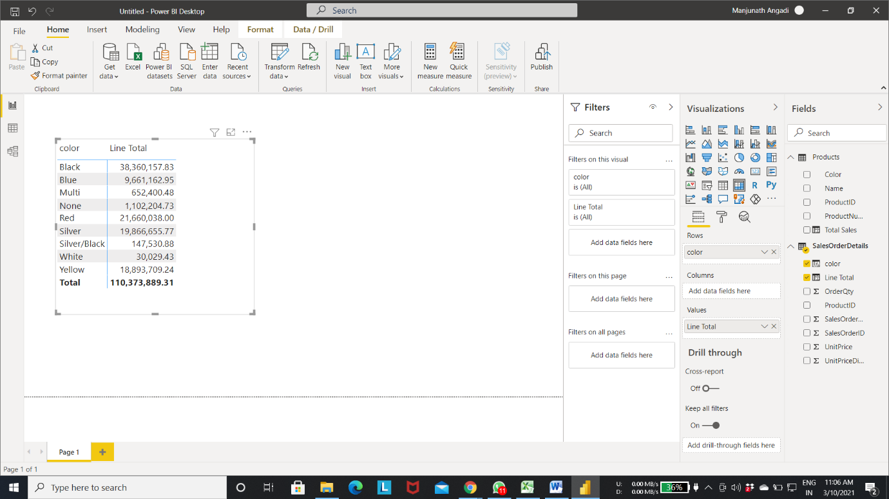

To add Measure to the Table

Step 11: Right click on “**SalesOrderDetails**” **->** Select “**New Measure**”

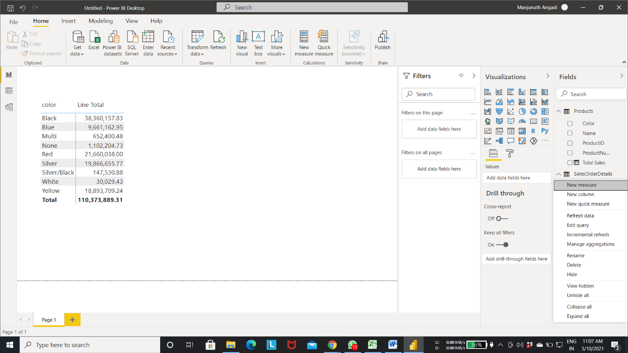

Step 12: Name the Measure as “**MIN PRICE**” as shown below

“MIN PRICE = MIN(SalesOrderDetails[UnitPrice])”

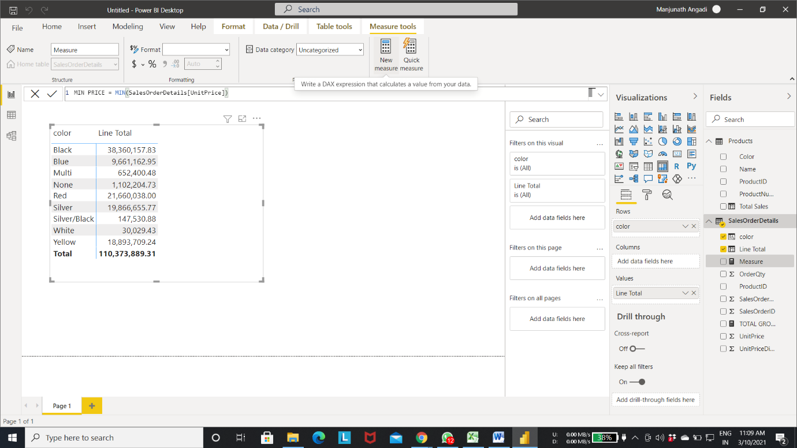

Step 13: Drag and drop **MIN PRICE** to the values block

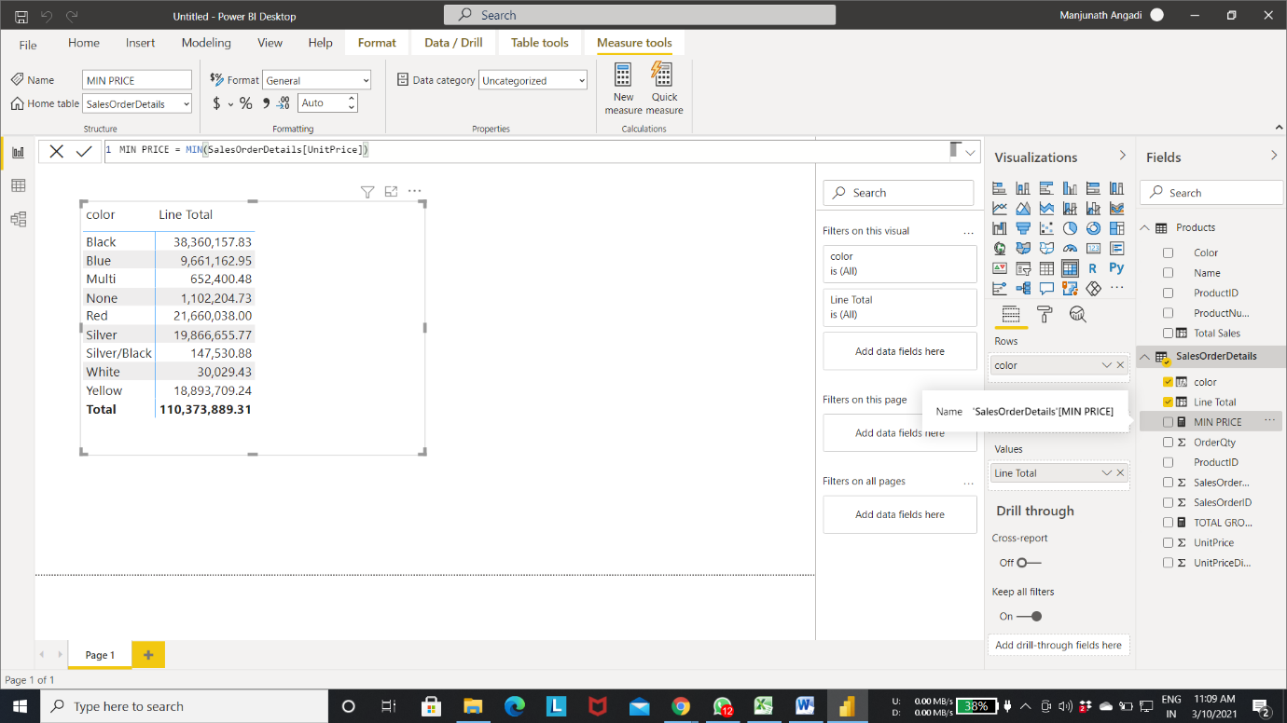

And you can see the changes in matrix as shown in image

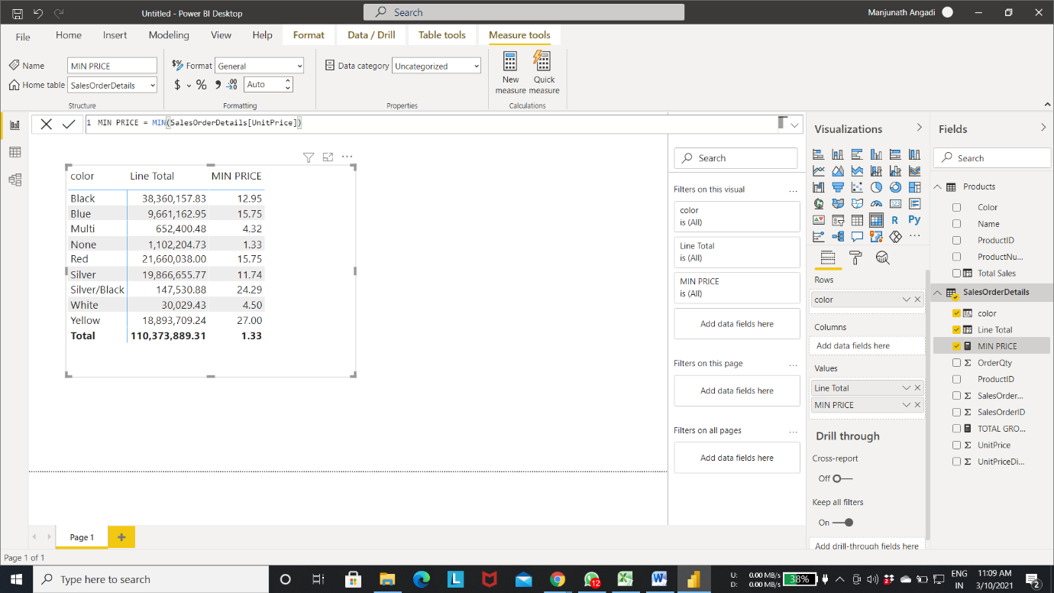

**SLICER**: Slicer is the one used to filter out the records.

Step 14: Select a “**Slicer**” in visualization.

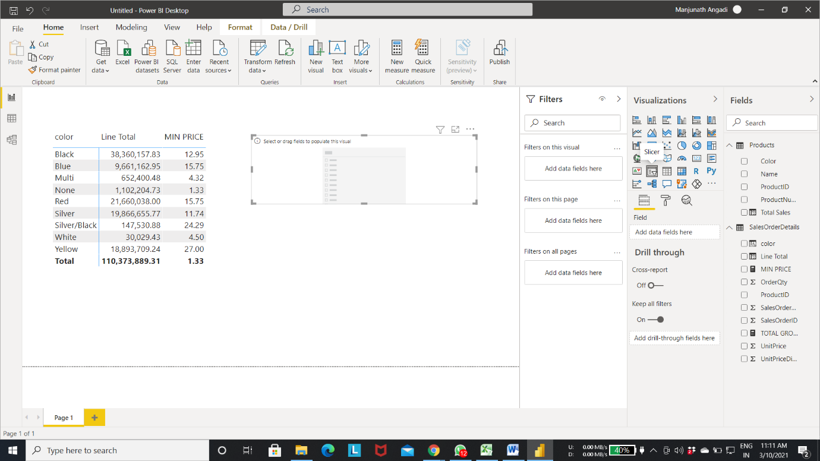

Step 15: select the colour “**Red**” to get the results of only that colour

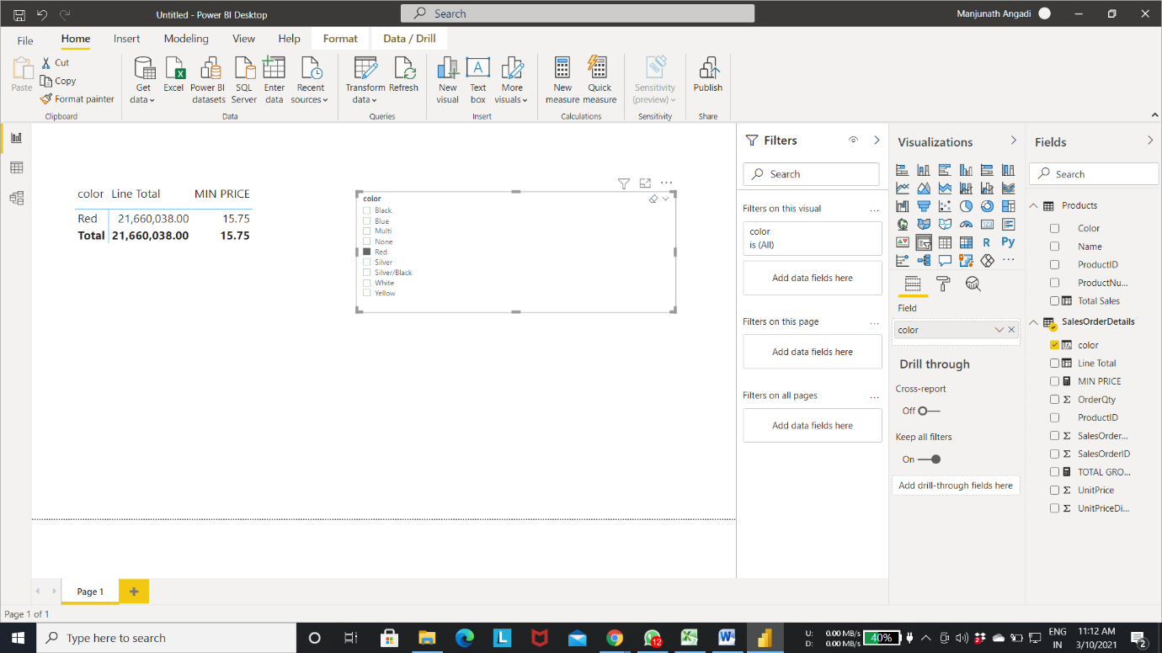

**Ko2: Able to Filter Data Using CALCULATE, Loop Over Data with Iterators.**

**Filtering Data Using Calculate**

Uses of filter

* Comparison by dimensions
* Drill down
* Period based comparison
* Slice-of-pie comparison

1.Implicit Explicit Filter

Implicit Filter: Implicit filtering is the filtering applied by user or layout of report.

Explicit Filter: Explicit filtering is the filtering applied by measures.

Let us see how we can override that by using CALCULATE functions to explicitly filter and override the implicitly filter

Step 1: Initially add **Table** from visualization.

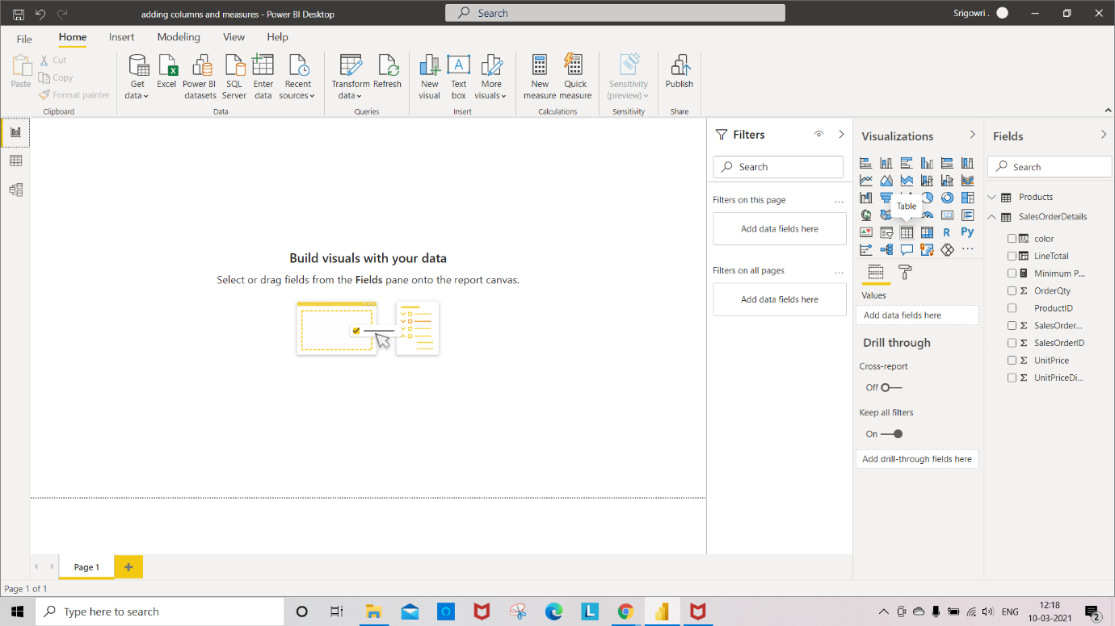

Step 2: Group that by **color** and **UnitPrice**

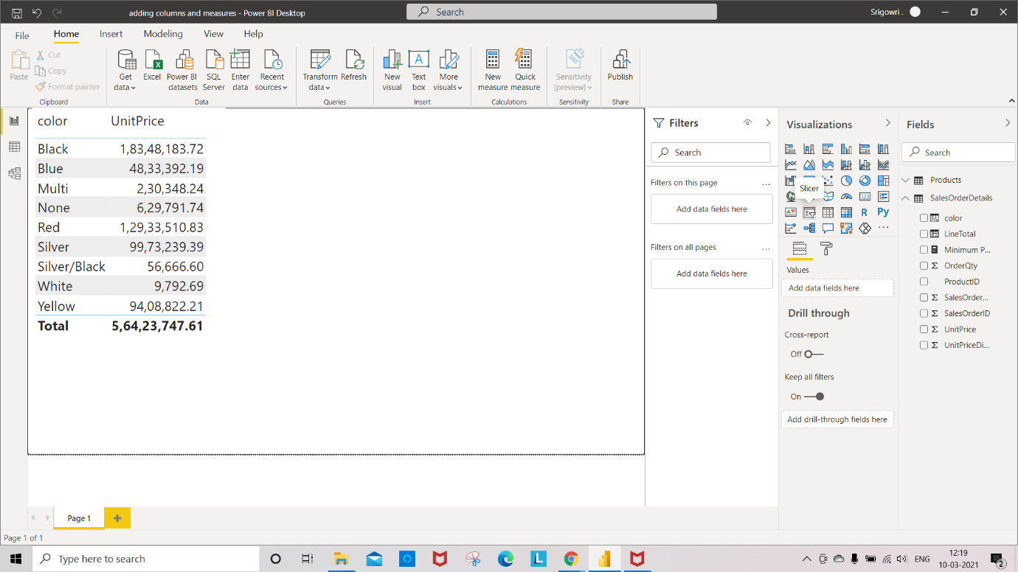

Step 3: add **Slicer** to filter the records.

Over left each of these line items is applying an implicit filter and

Over Right apply filter through user interaction.

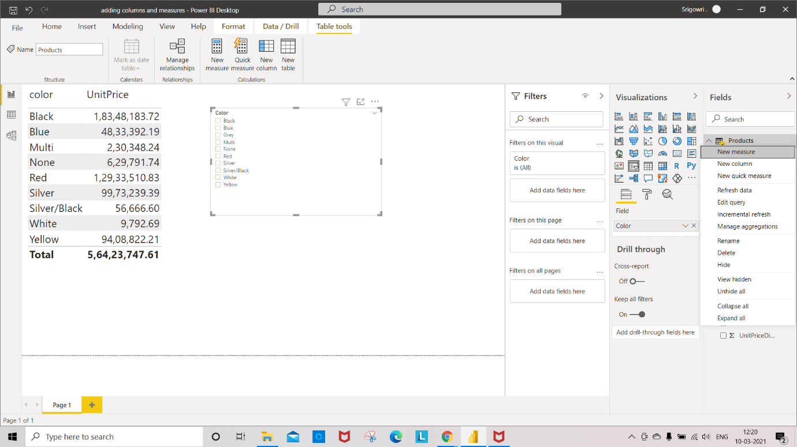

Step 4: Change the function **Don’t summarize** to **Average** for UnitPrice column

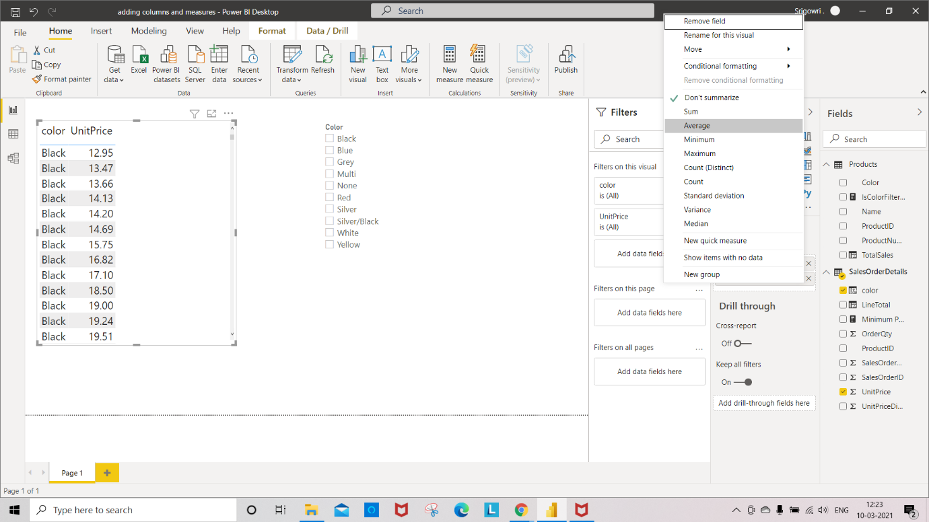

Step 5: Create a New measure ‘**IsColorFilter’**

“IsColorFilter = ISFILTERED(Products[Color])”

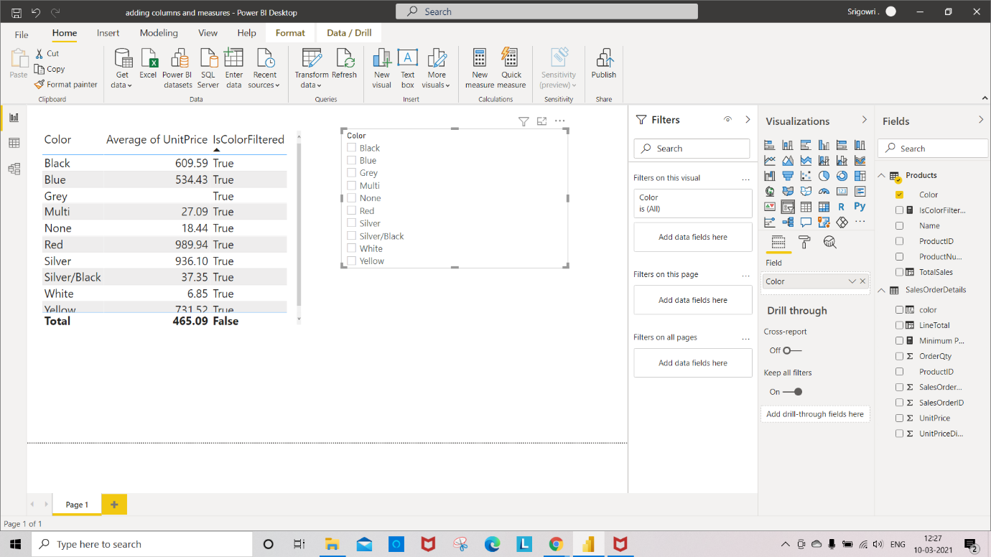

Step 6: Select “IsColorFilter”

Now, you can see the column added to table

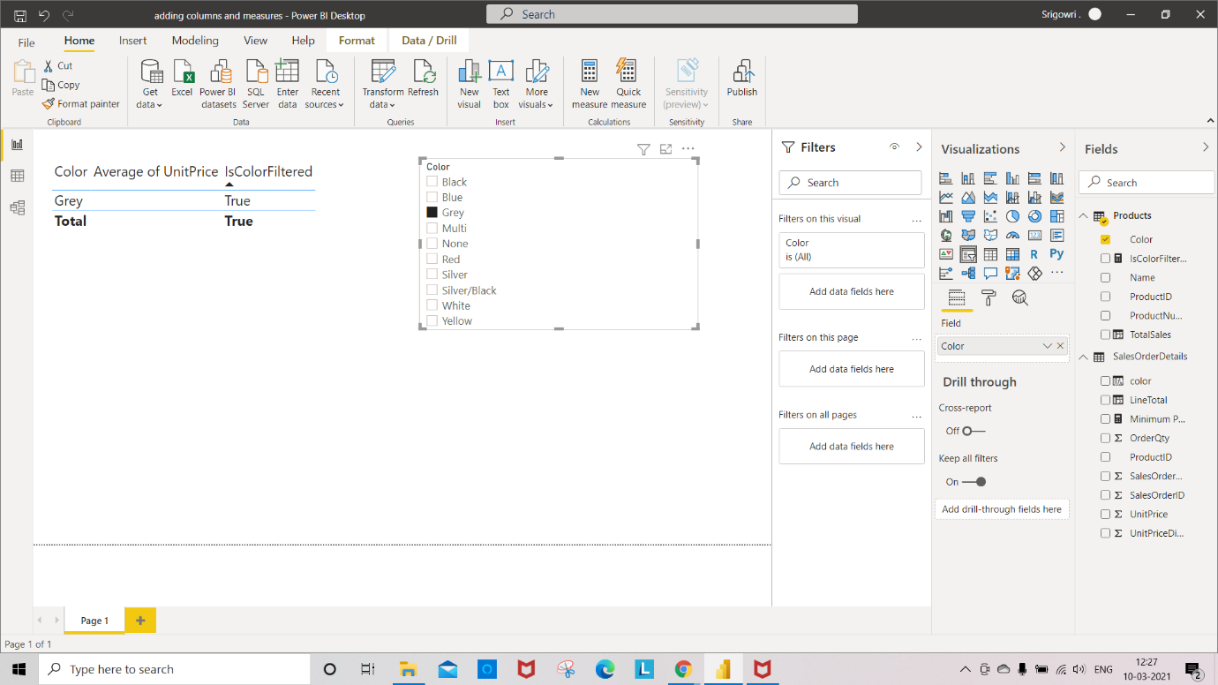

Step 7: select “Blue” color in slicer to see the changes in table.

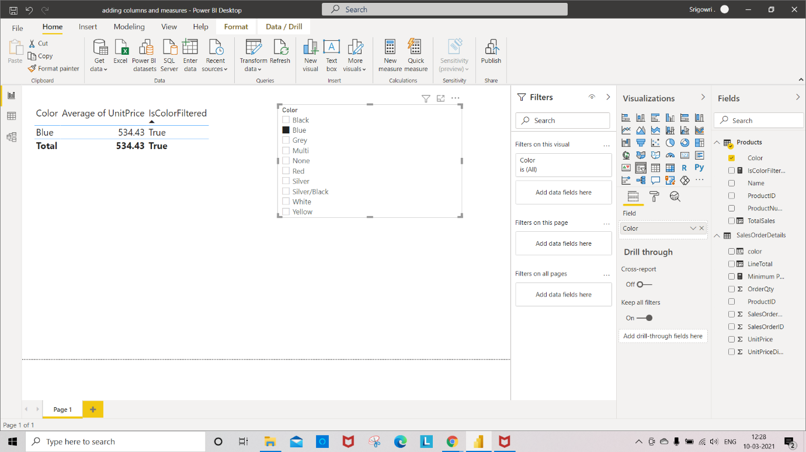

Step 8: Select new measure “**BlackAvaragePrice**”

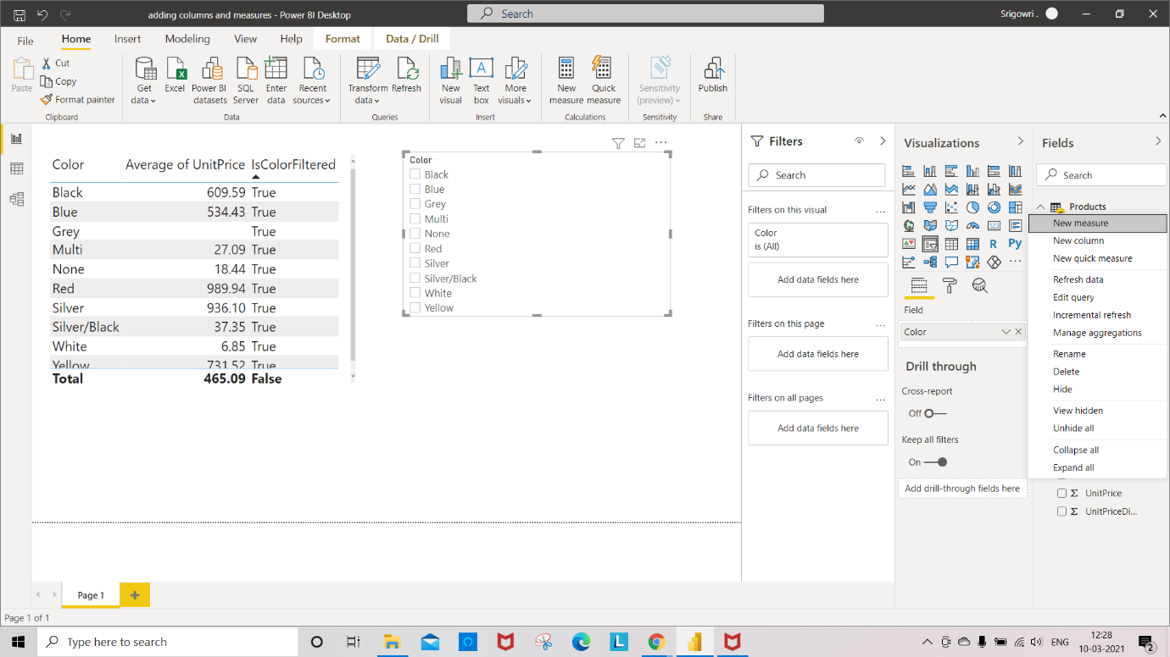

**“BlackAvaragePrice =** CALCULAT(AVERAGE(SalesOrderDetail[unitPrice]),Product[Color] =

“black””

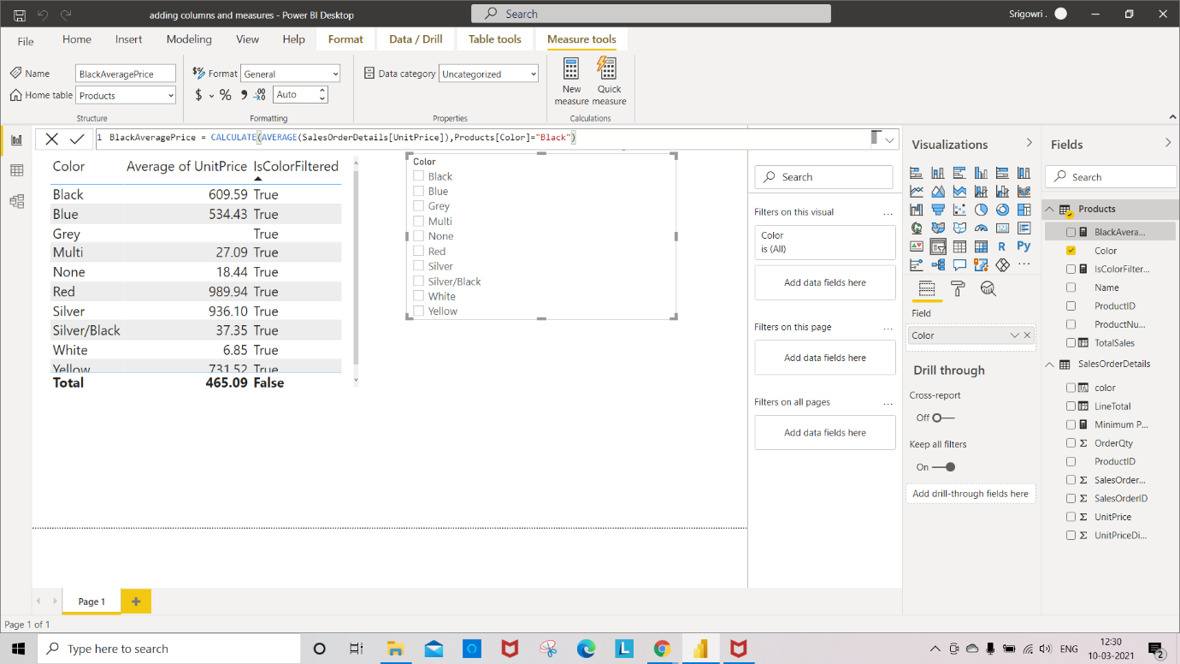

Step 9: Select the column “**BlackAvaragePrice”**

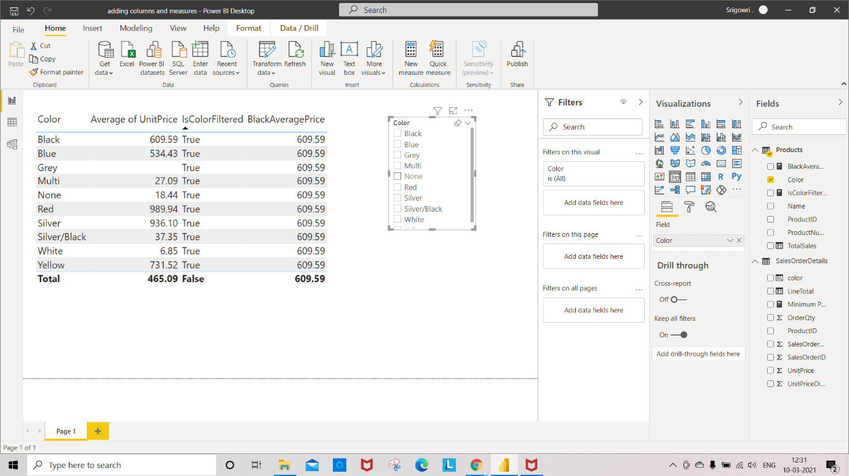

Step 10: select “Grey” color in slicer to see the changes in table.

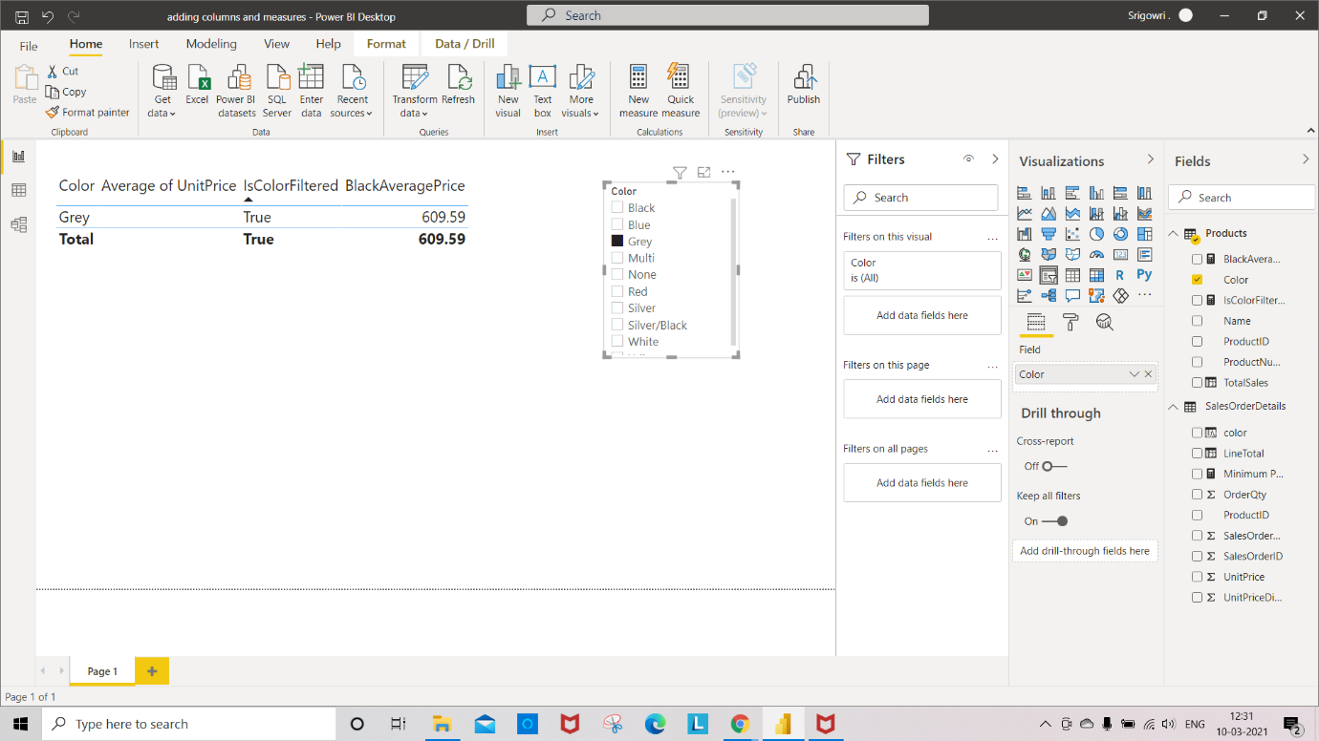

2.UsingFilter

Uses of Filter:

* Evaluate on multiple columns
* Comparing to an aggregate function or measure
* Needing to return a table

Step 1: Select **table** in visualization

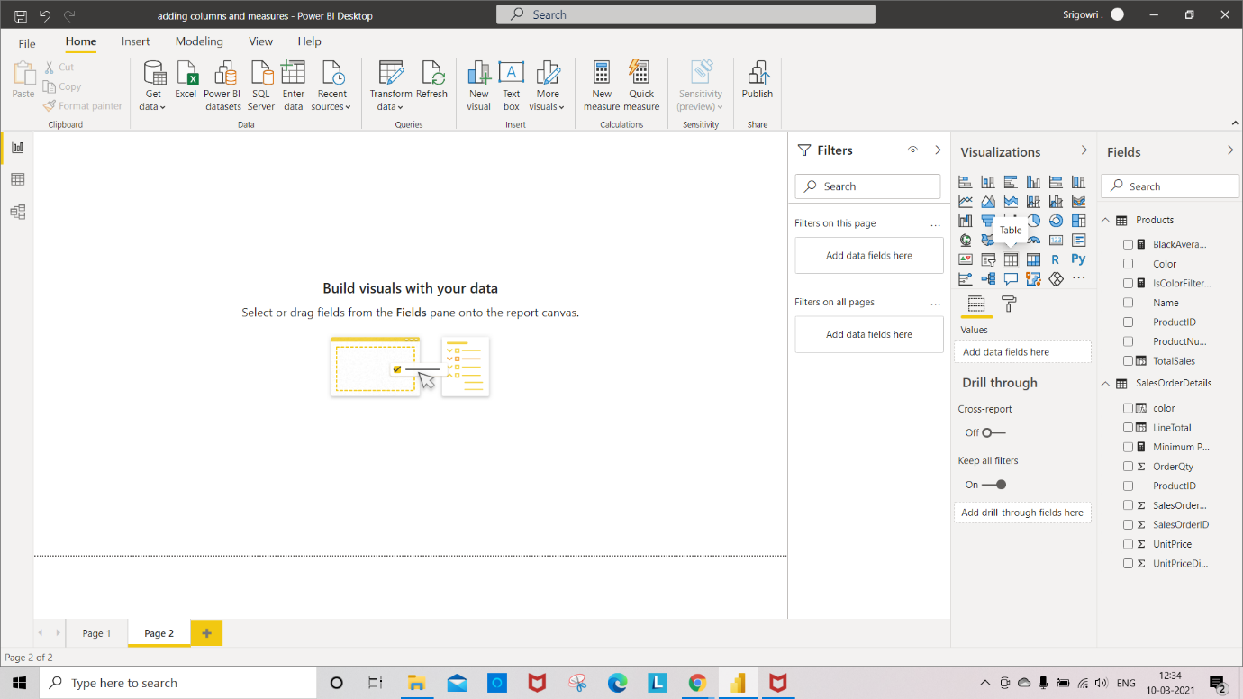

Step 2: add **color** and **AvarageOfUnitPriceDiscount** column to table.

Let’s look at the instance, where the discount of the person received was atleast $10 and see what the AvaragePriceDiscount is.

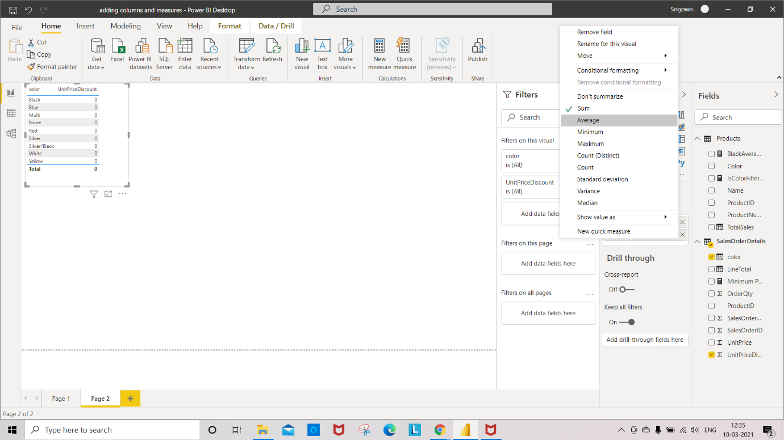

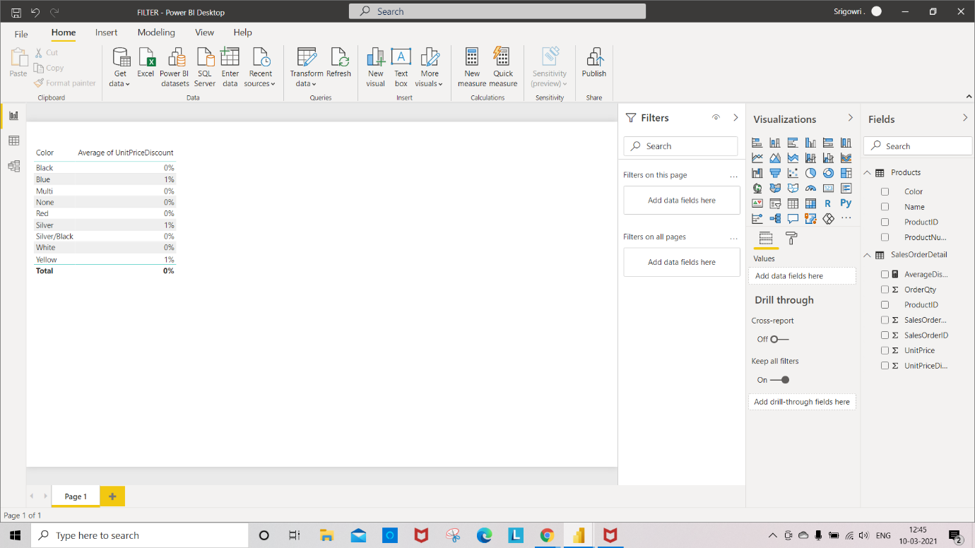

Step 3: add “New measure” to the table **AvarageDiscountGreaterThanTen** as shown in the image.

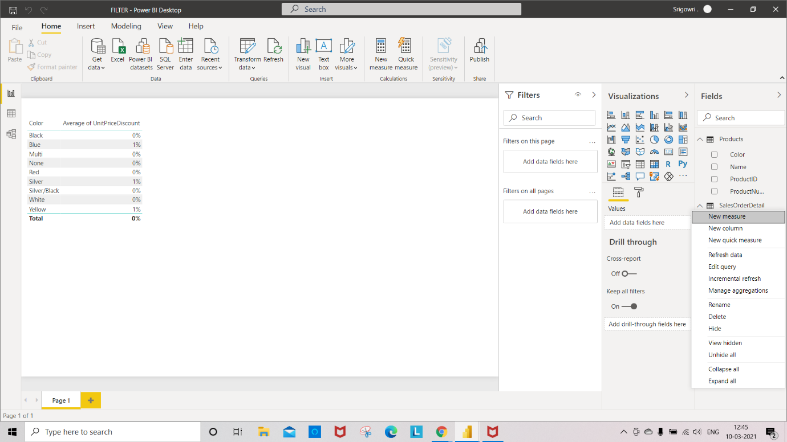

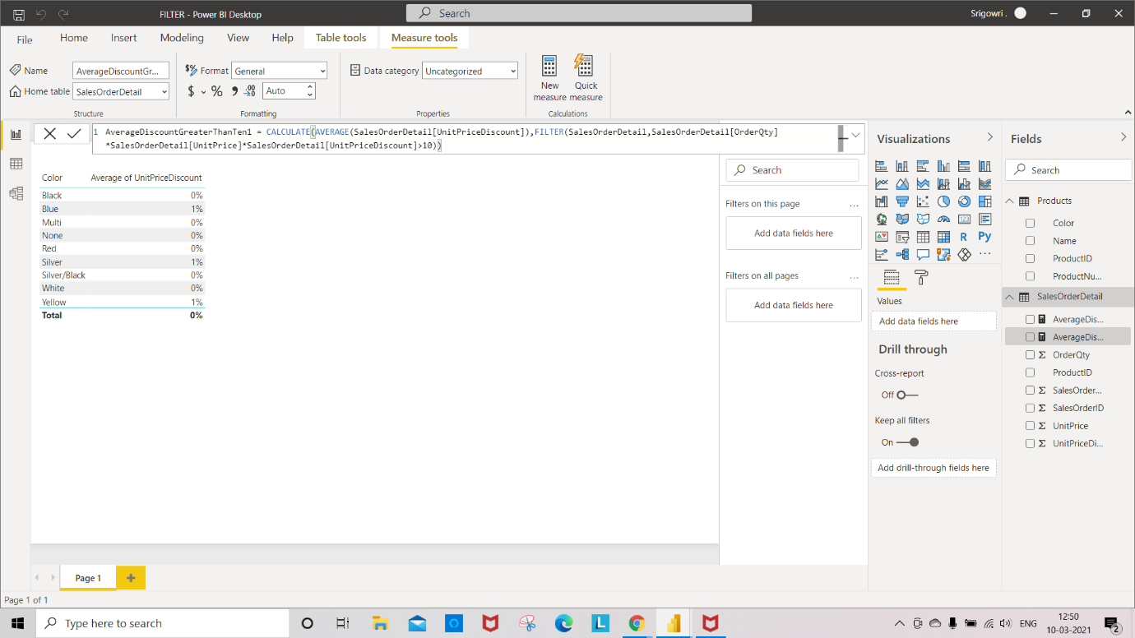

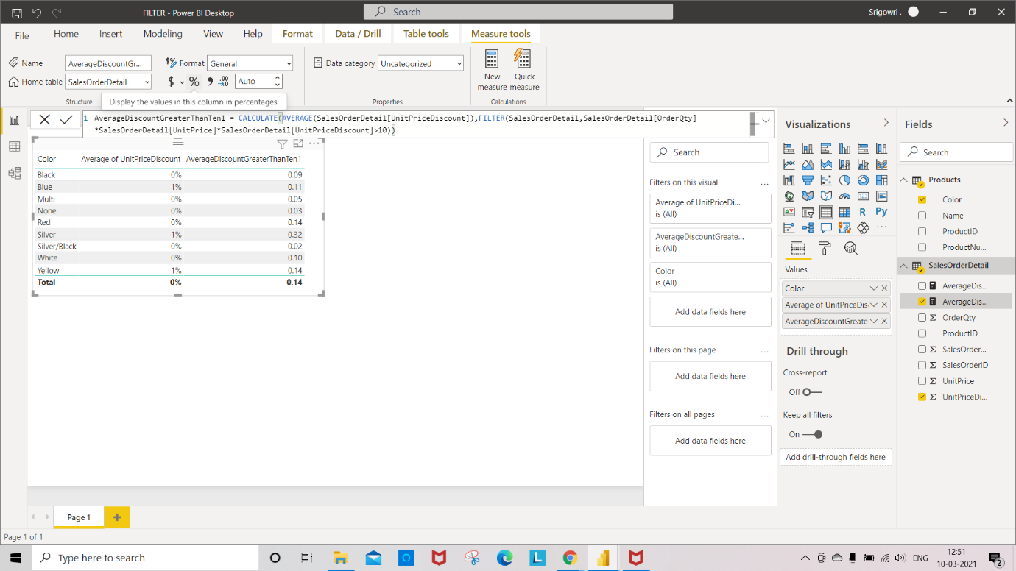

Step 5: Go to **Modeling** **->** Select **AvarageDiscountGreaterThanTen ->**Select **%**

**T**o view the result in % format.

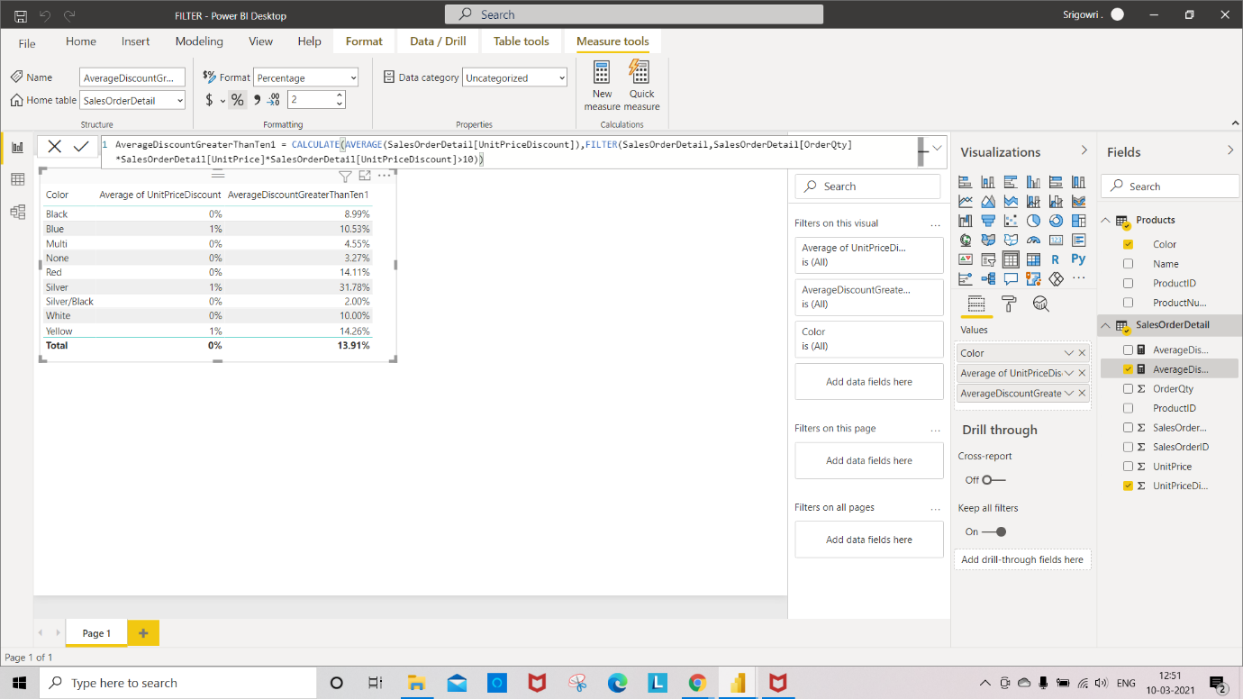

Step 6: Select **new Table**

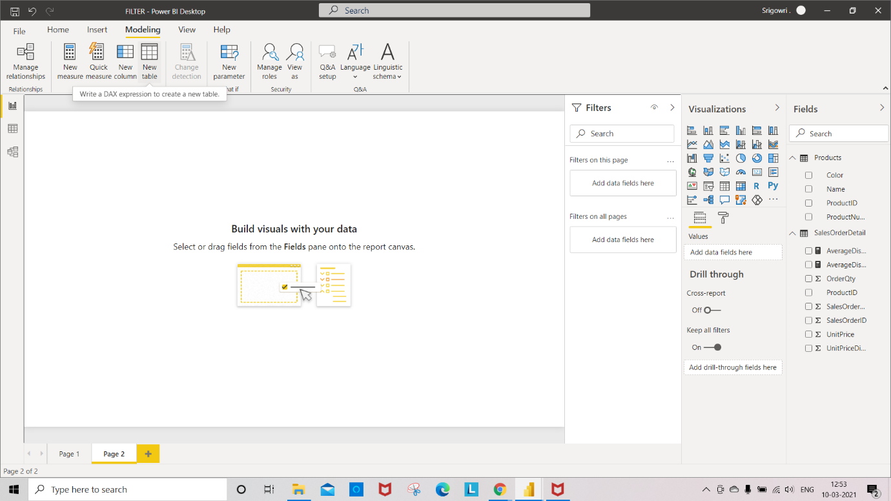

**Step** 7: write down the expression as shown in image

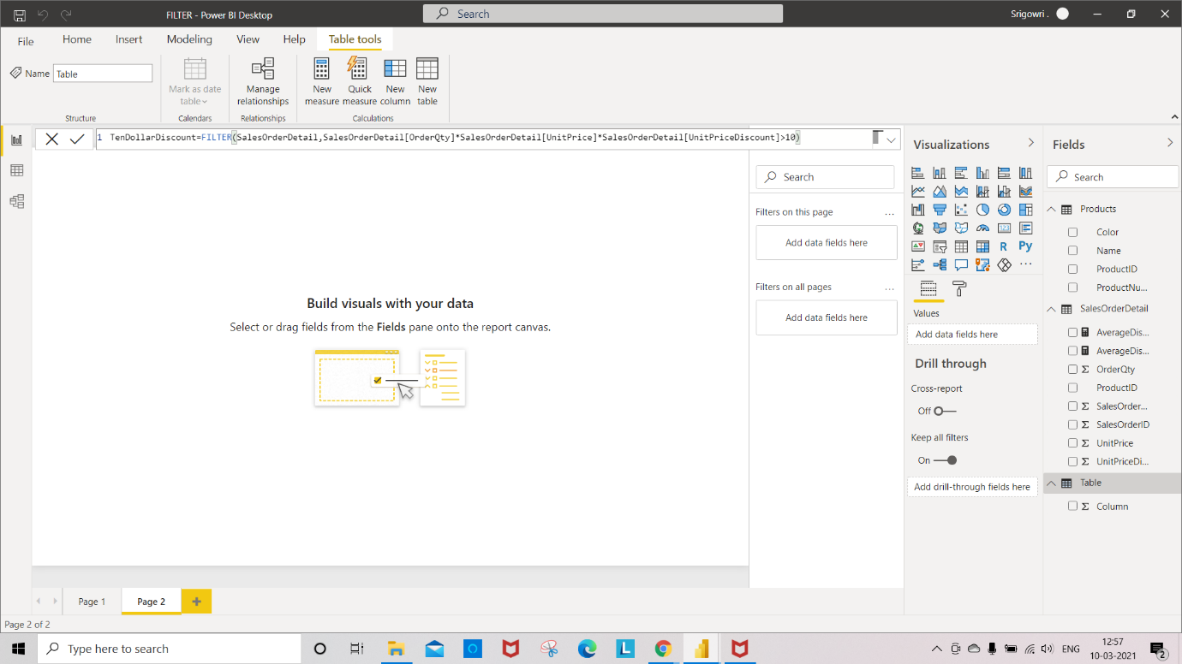

Here you can see the new table “**TenDollarDiscount**” present in Fields.

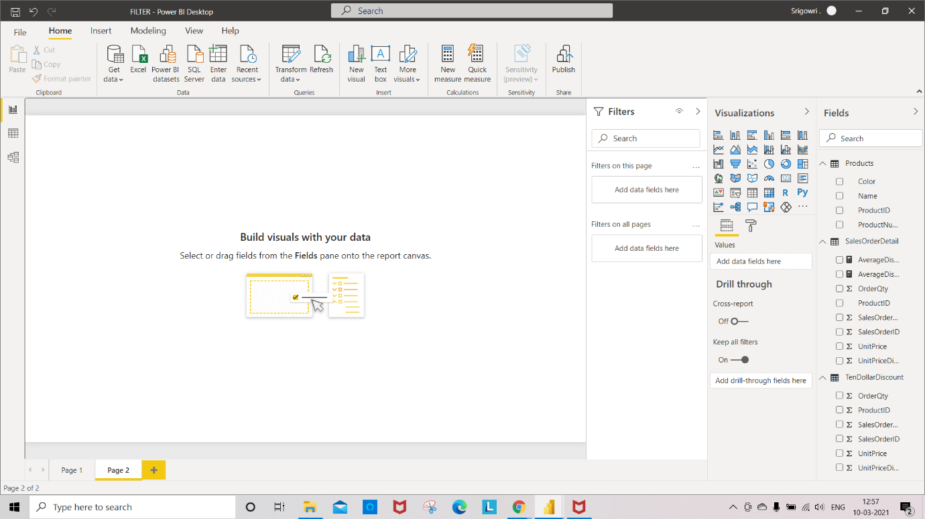

Now click on Data icon on power bi, to check all the records.

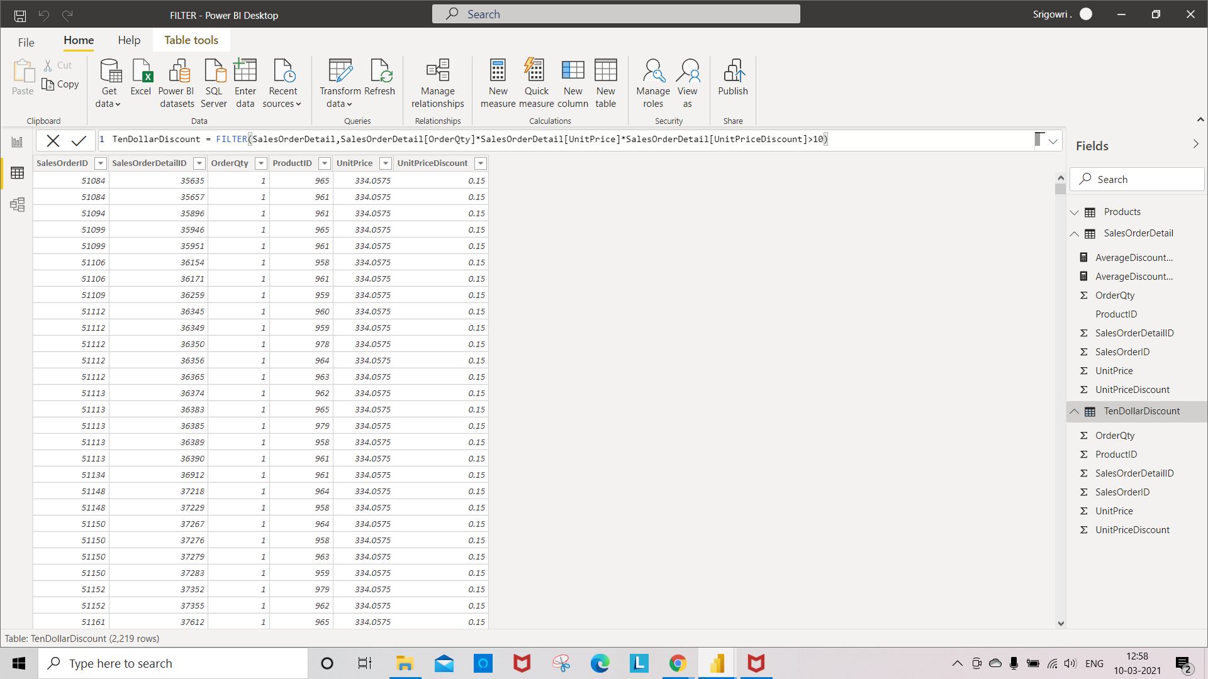

3.Using All:

Let us see how to unapplying a column filter and clear unapplying an entire table filter using ALL function.

Step 1: Select Table visualization

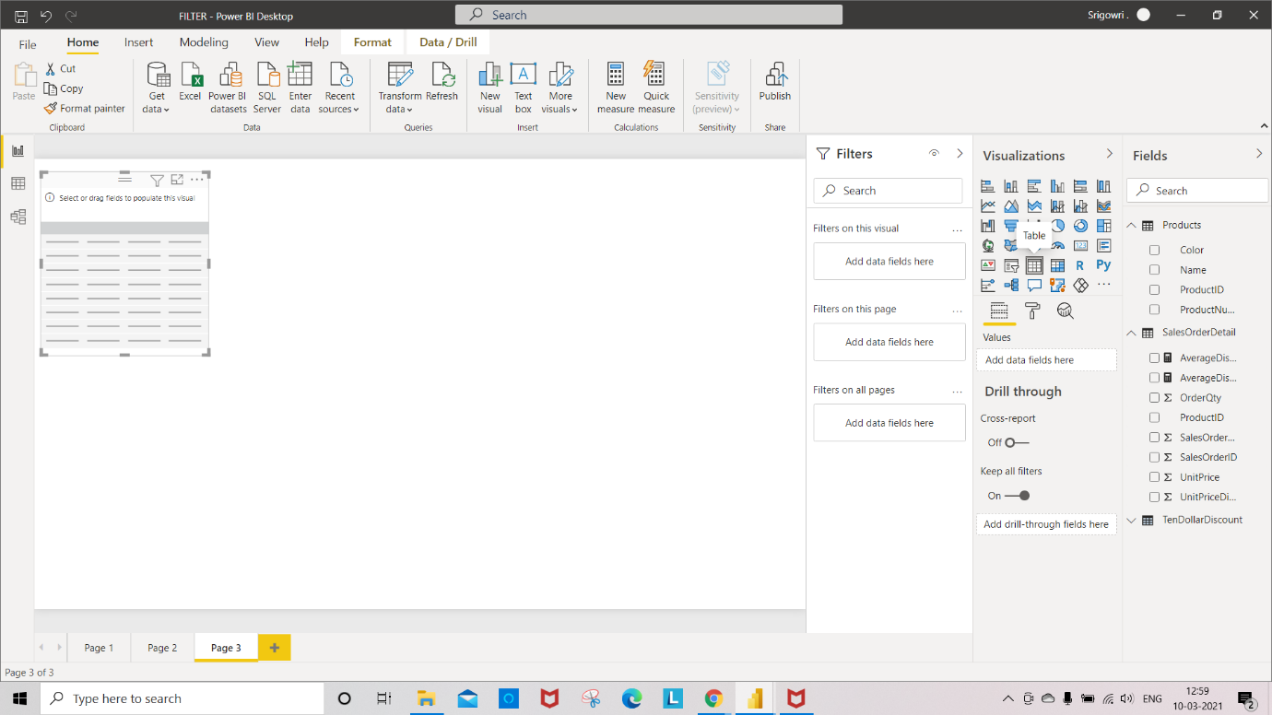

Step 2: Select **color** and **OrderQty** columns for table visualization

Step 3: Select a **Slicer** visualization

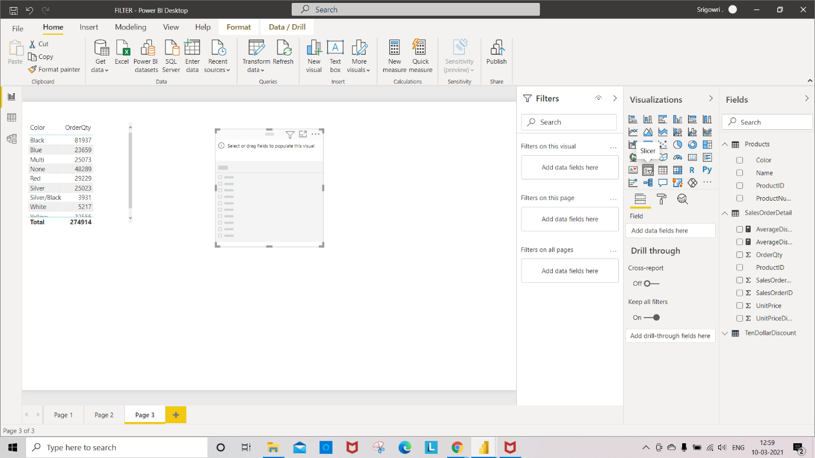

Step 4: Select **ProductNumber** column for **slicer**.

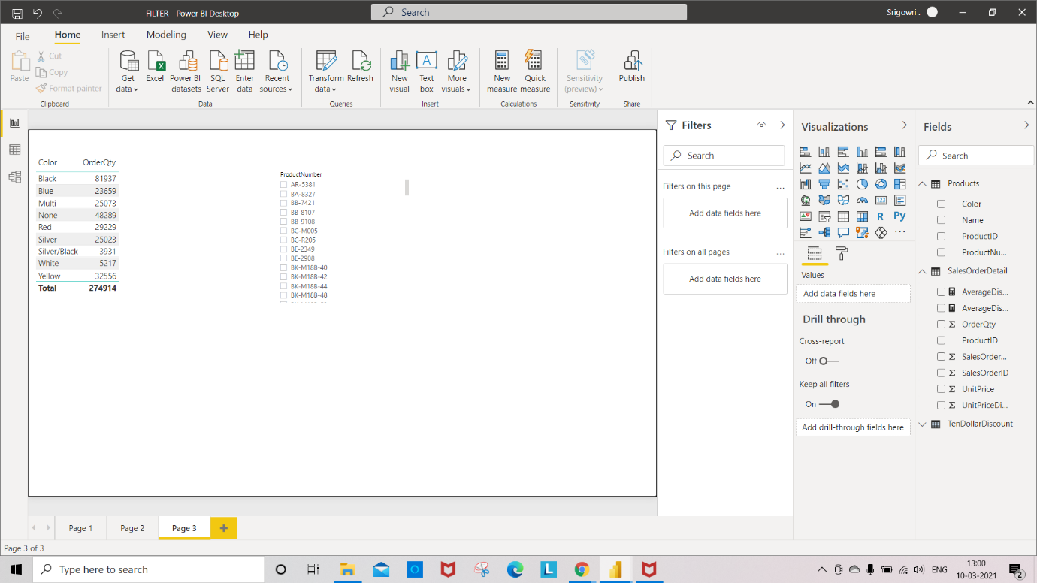

Step 5: Select “**New Measure**” in **Product** Table.

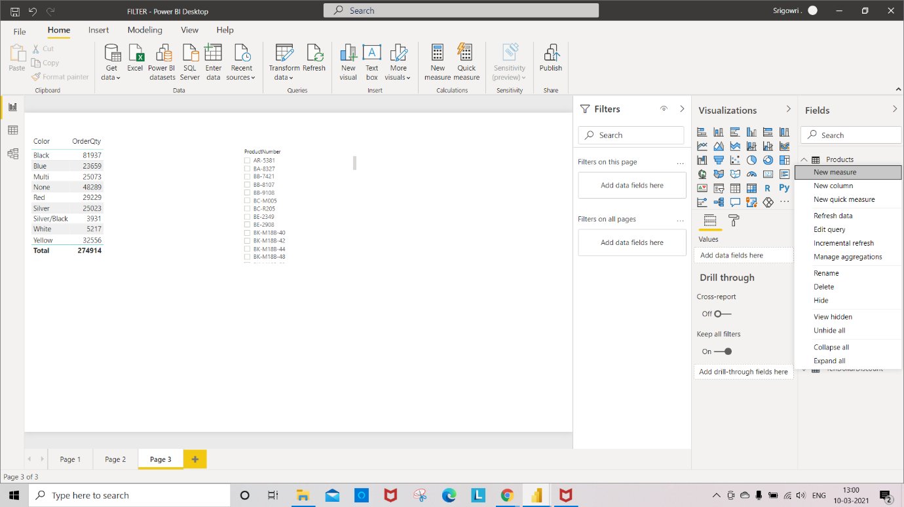

Step 6: Write an Expression for “PersentageOfTotalSales” as shown in fig.

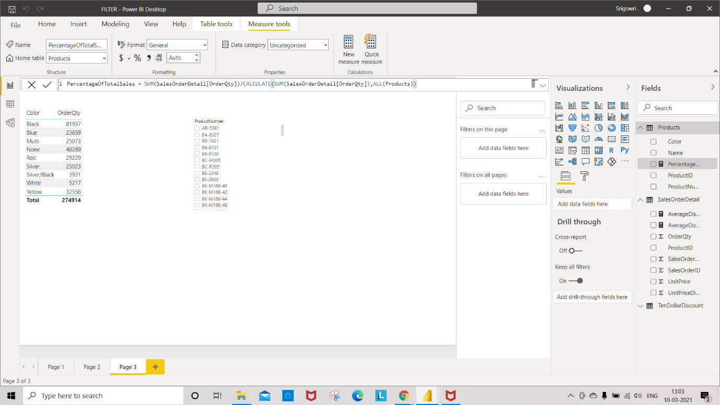

Step 7: Select color, OrderQty, and PercentageOfTotalSales columns to display in table visualization.

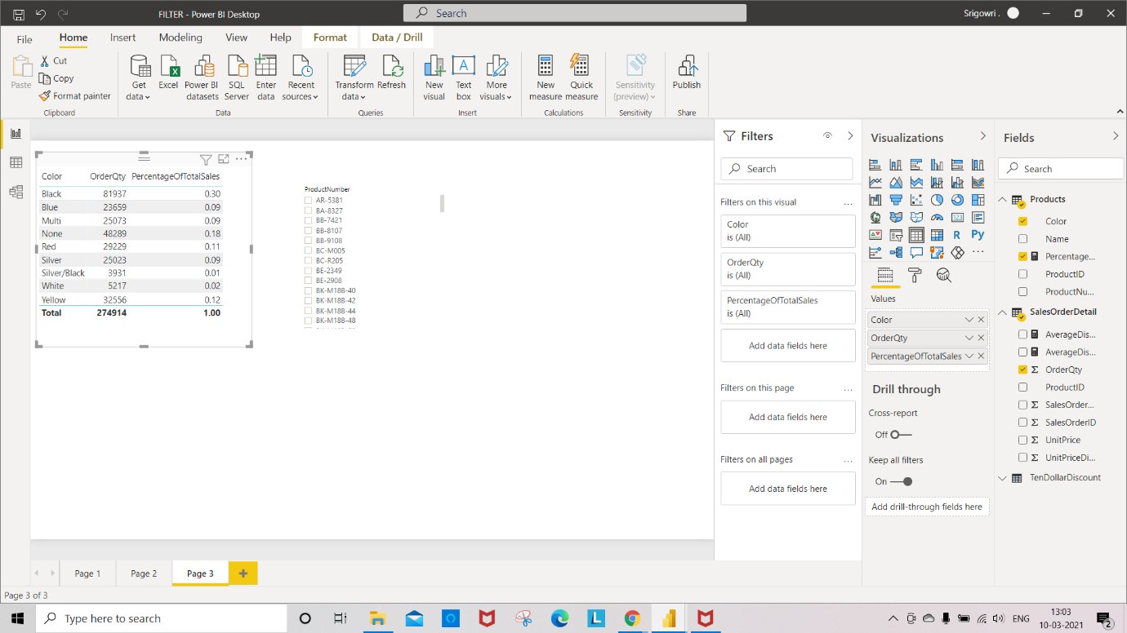

Step 8: Unfilter and change the expression s shown in fig.

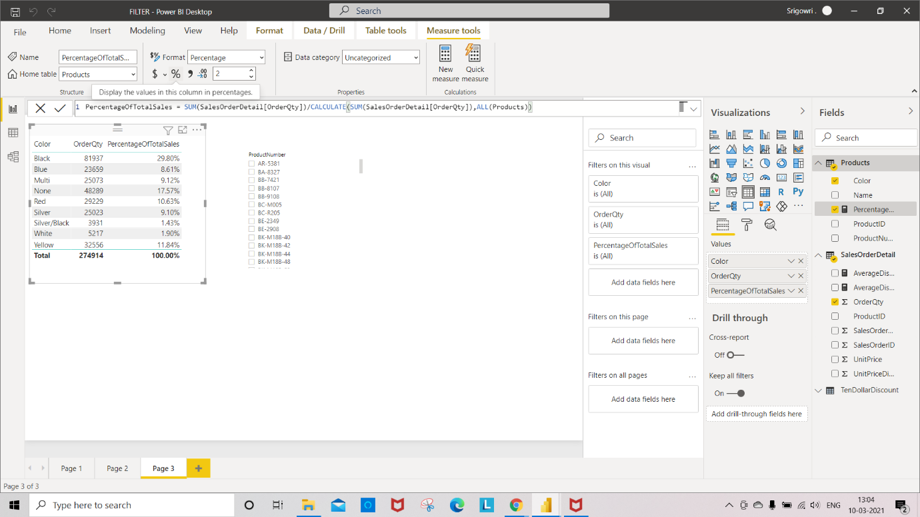

Step 9: Select BB-7421 ProductNumber in Slicer

Now you can see the changes in table visualization.

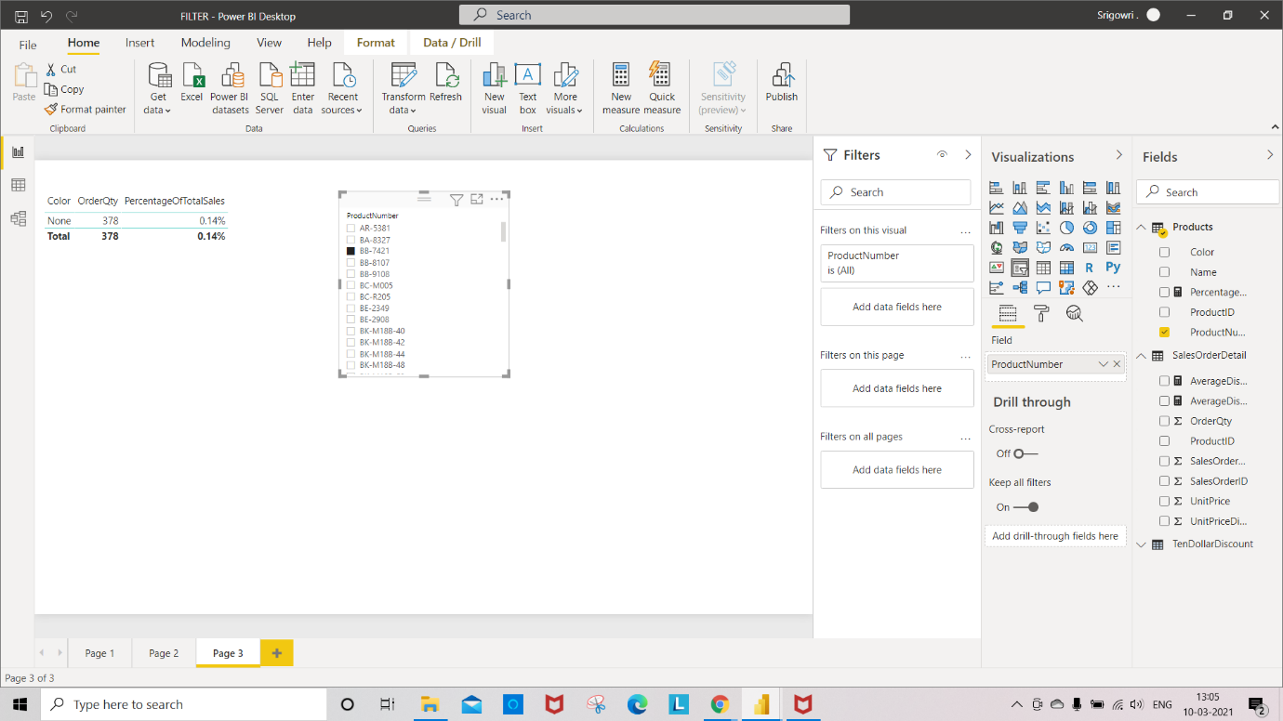

**Loop over Data with Iterators**

**Iterators:**

Step 1: select **Table** in visualization.

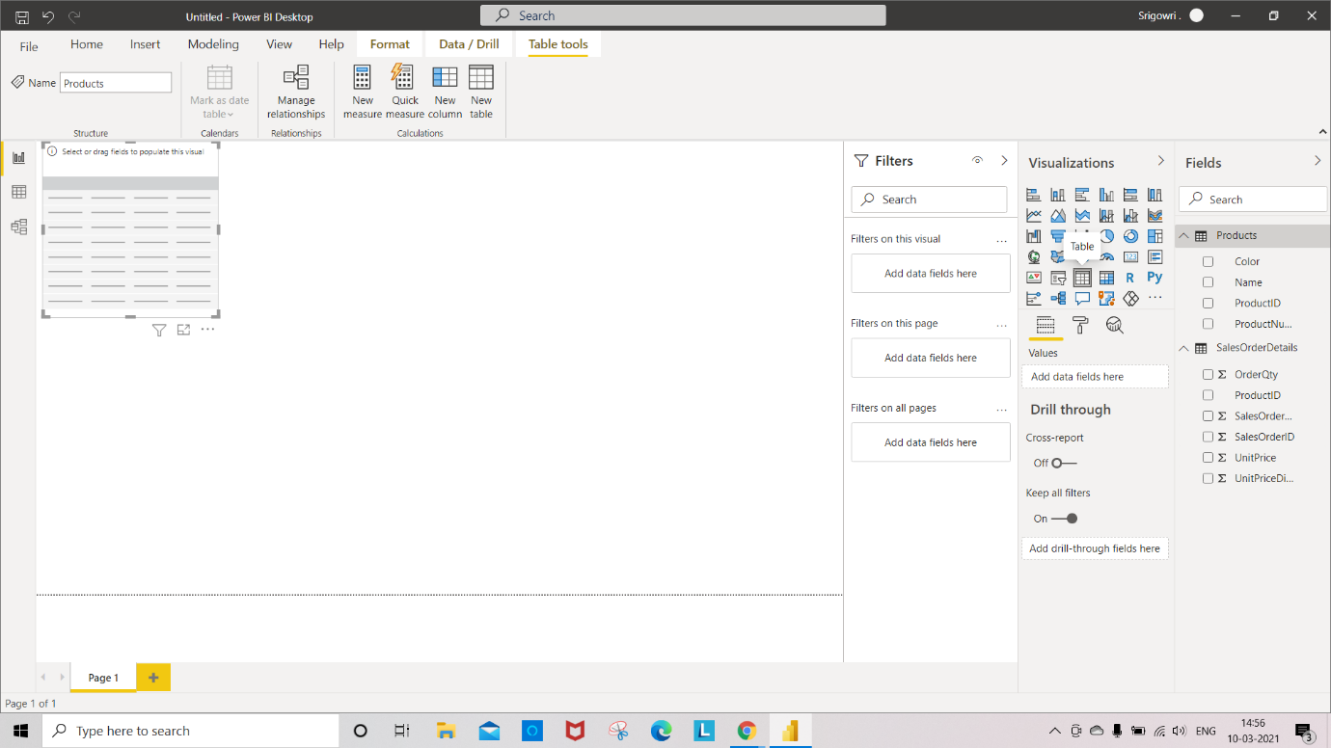

Step 2: Select “**Color**” attribute to Table visualization.

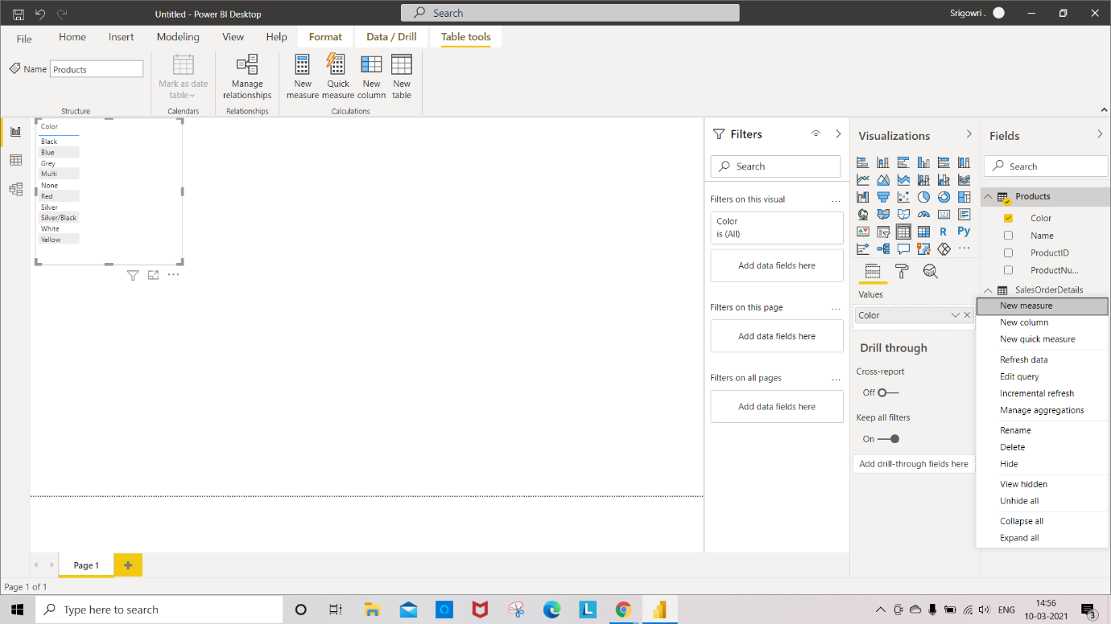

Step 3: Create “**New measure**” in SalesOrderDetail for calculating AvarageGrossSales as shown in below fig.

**AVERAGEX** function enables you to evaluate expressions for each row of a table, and then take the resulting set of values and calculate its arithmetic mean.

Syntax: **AVERAGEX(<Tablename>,<expression>)**

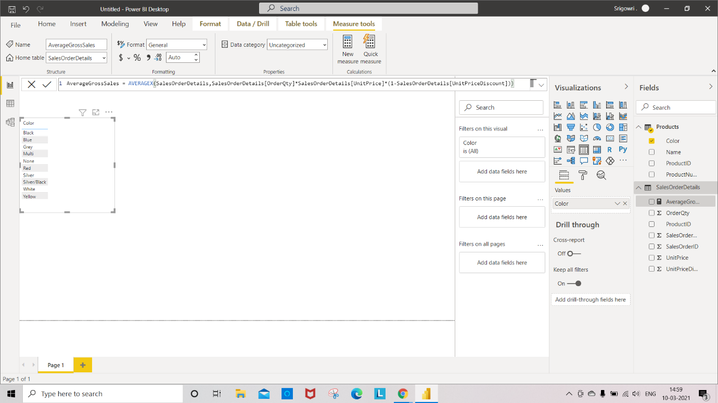

Step 4: add the column “**AvarageGrossSales**” to the Table.

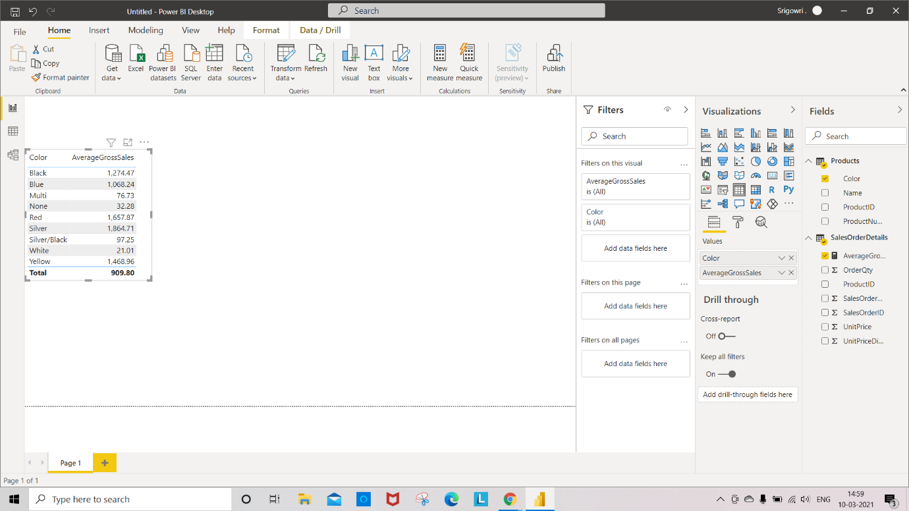

Step 5: Create “**New measure**” in **SalesOrderDetail** for finding distinct product **colors** shown in below fig.

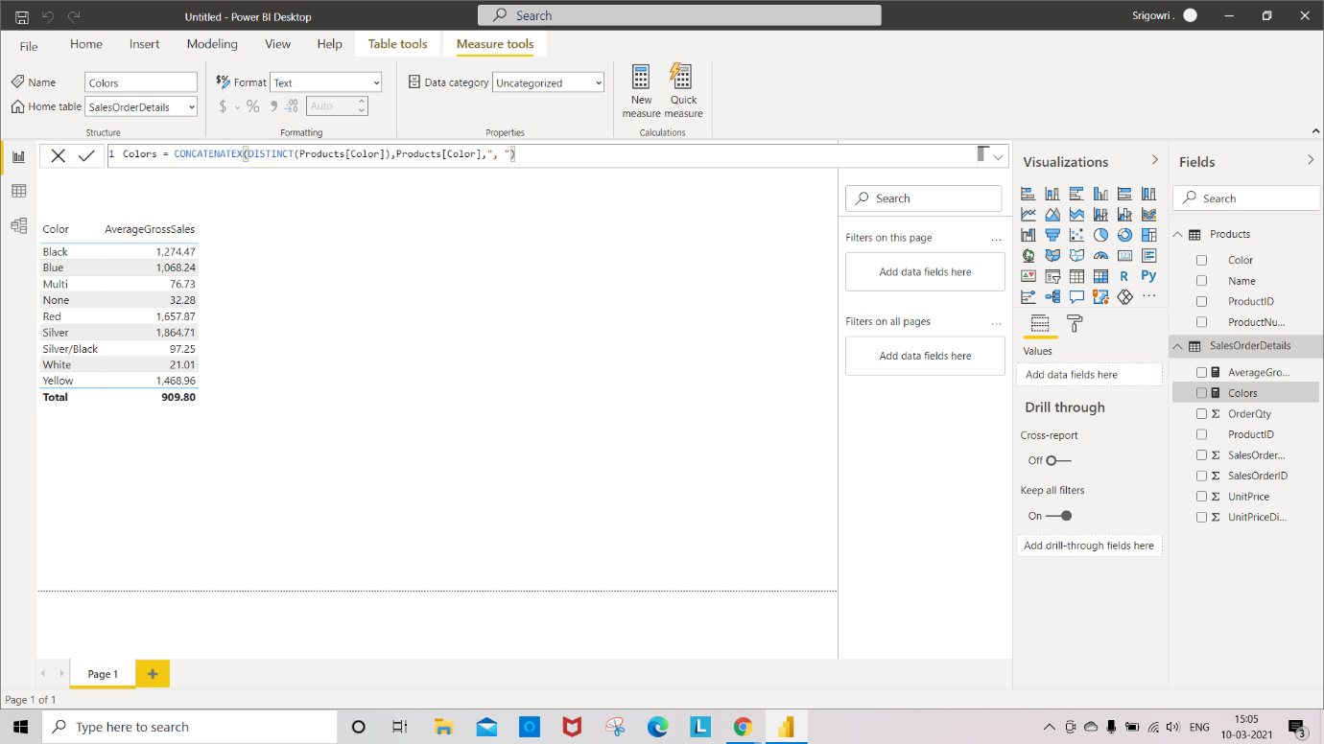

Step 6: Select **Card** Visualization from visualization tab to display the distinct product colors.

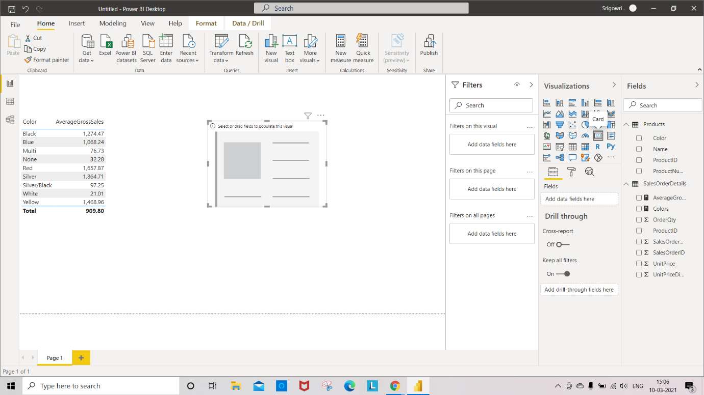

Step 7: add **colors** Measures to the card visualization for displaying distinct colors.

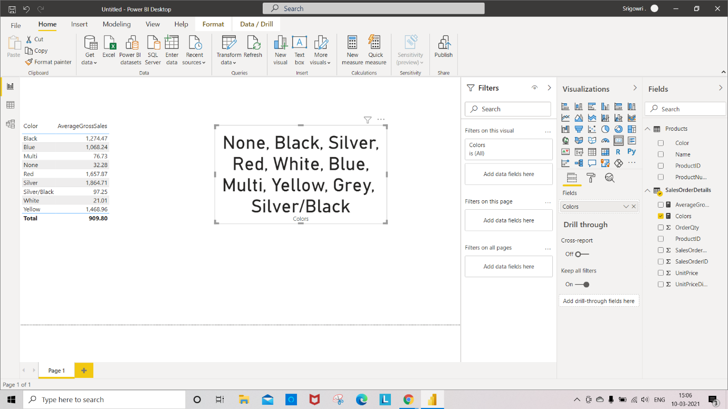

Step 8: To add particular value to **card** visualization, Select the required colors from the page filter.

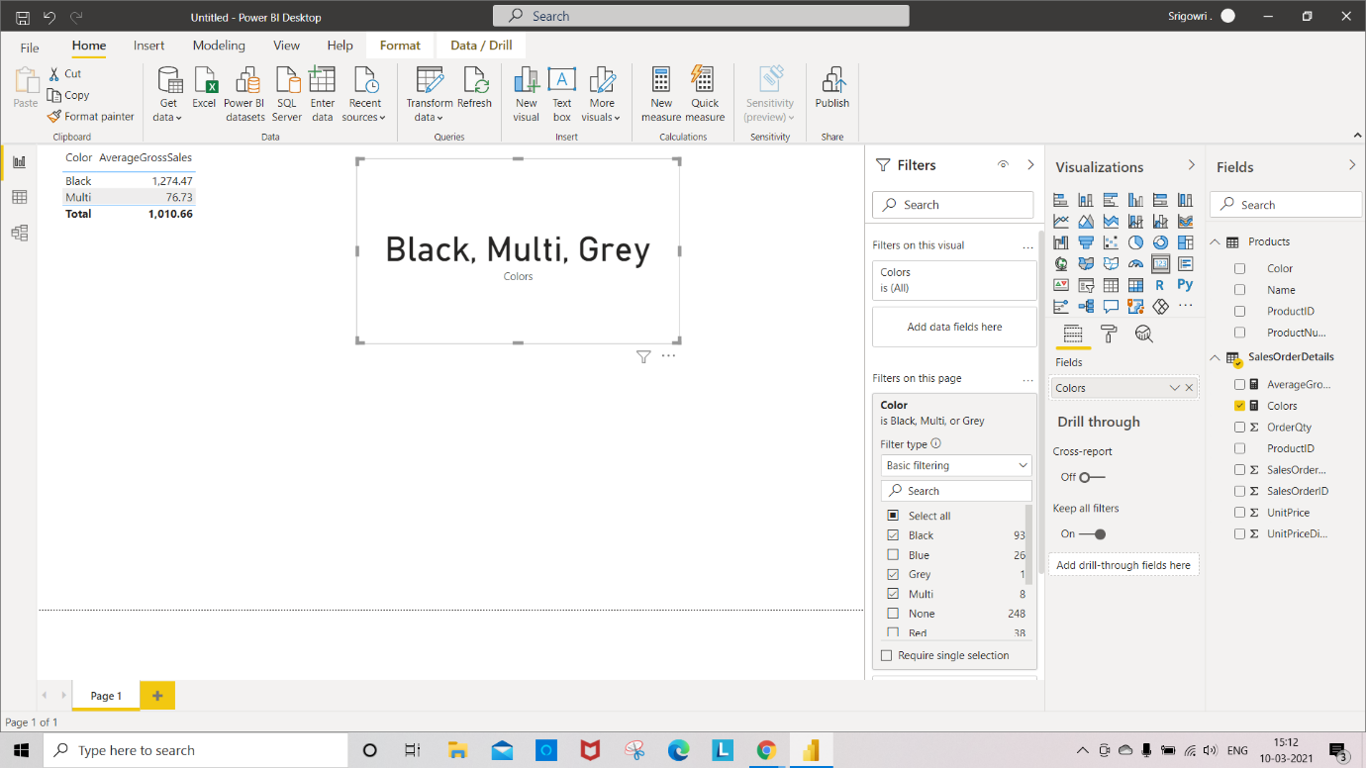

**Nested:** Using Expression inside another Expression.

Step 1: Select the **Table** visualization as shown in fig.

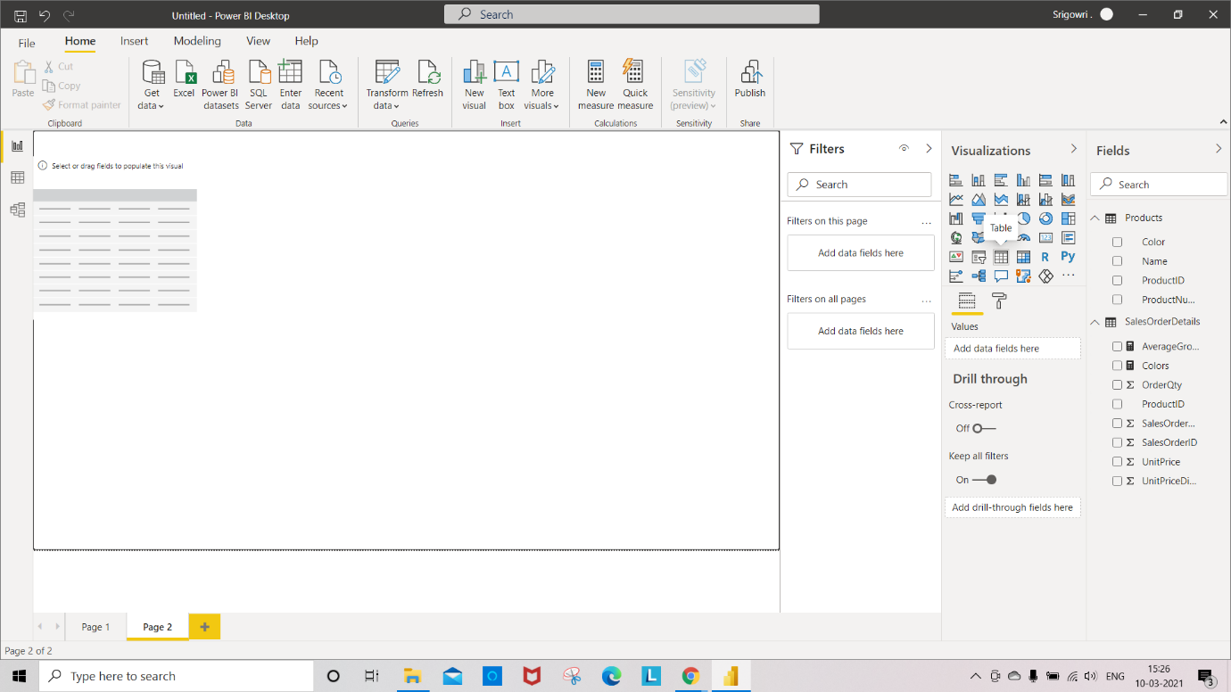

Step 2: Create a “New Column” in salesOrderDetails

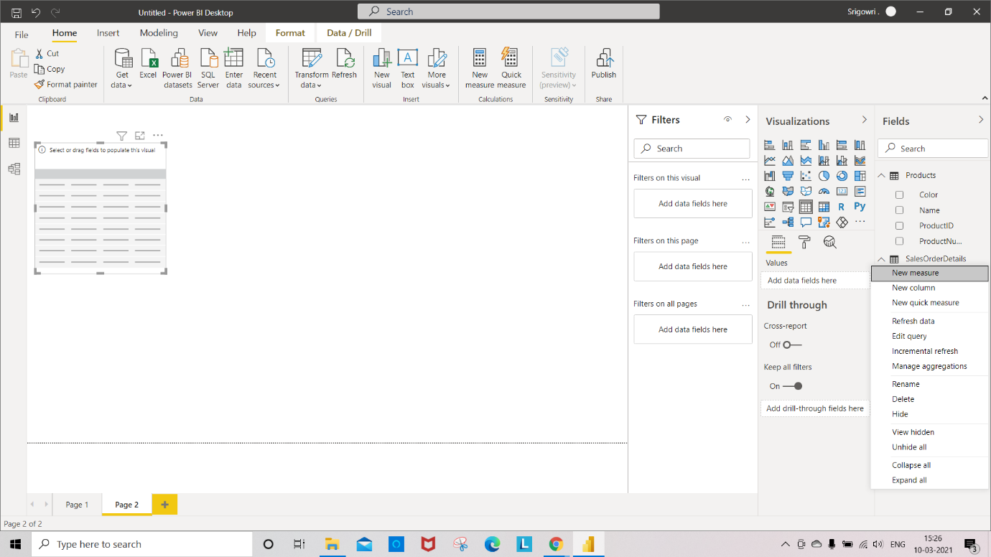

Step 3: Create a **GrossSales** column as shown in fig.

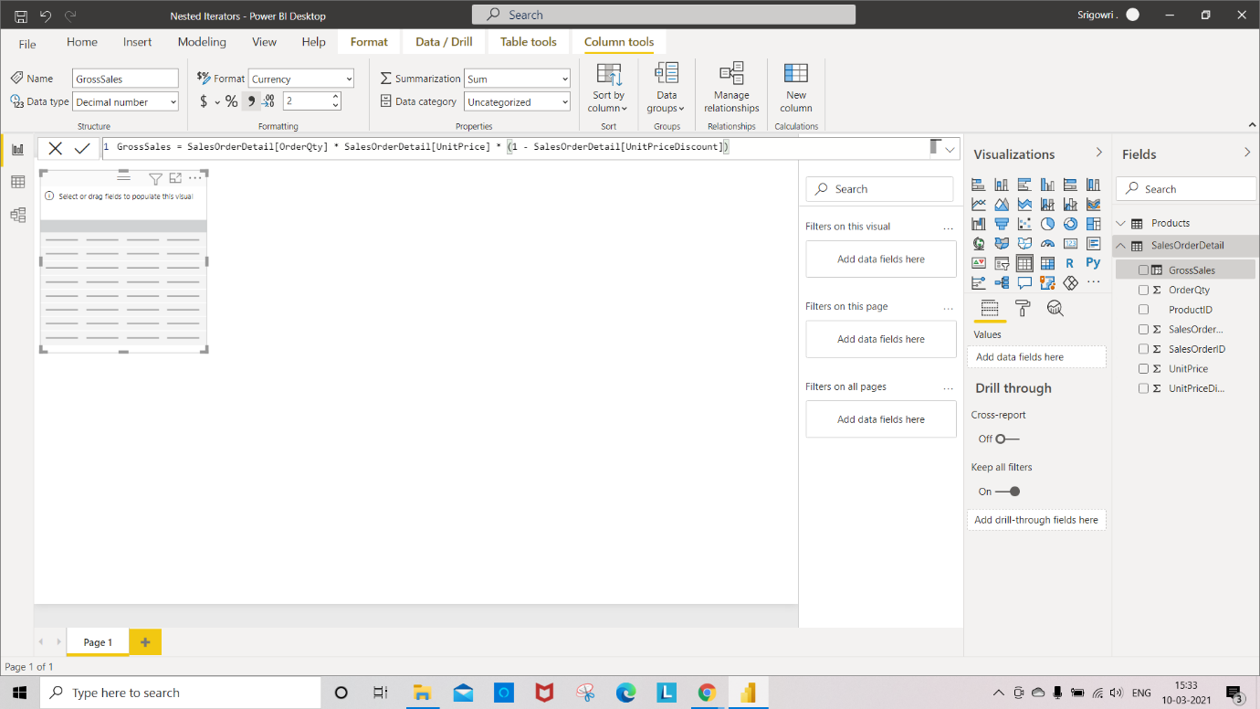

Step 4: select a “**New Column**” in **Product** table -> Create a **Ranking** column by using the Expression as shown fig.

**RANKX**: -DAX expression that returns a single scalar value. The expression is evaluated for each row of table, to generate all possible values for ranking.

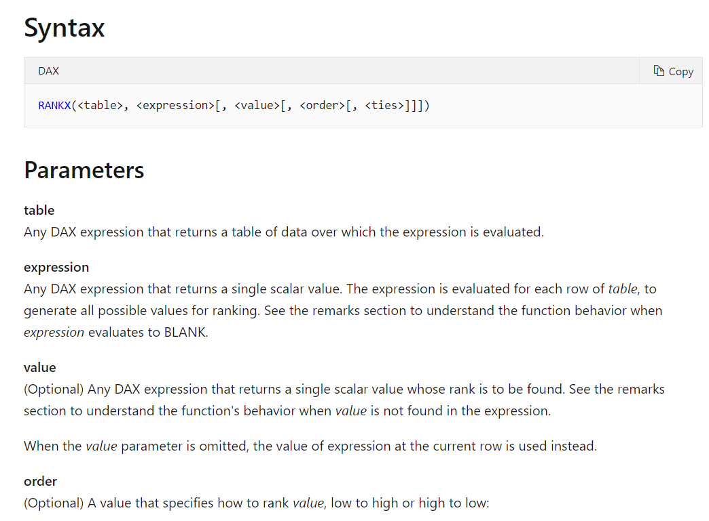

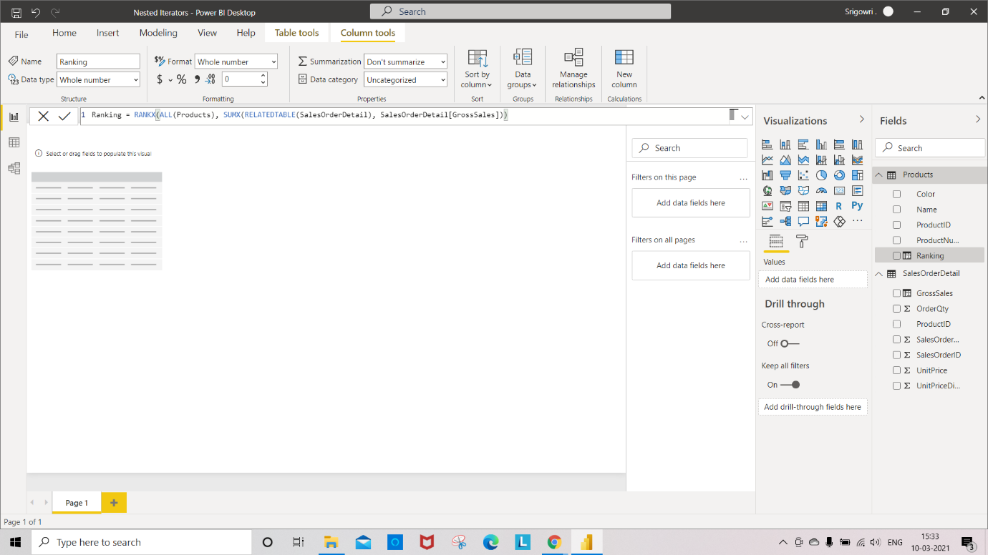

Step 5: add Product ID, Ranking from **Product** Table and GrossSales from **SalesOrderDetail** Table.

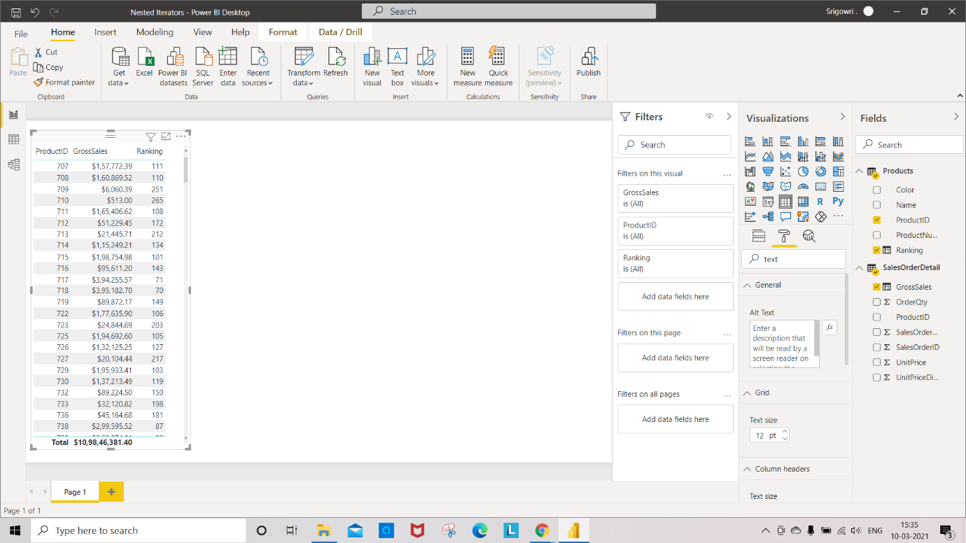

Step 6: **Sort** the **Ranking** column from Table visualization.

Output: The Table shows the ranking of products based on their GrossSales.

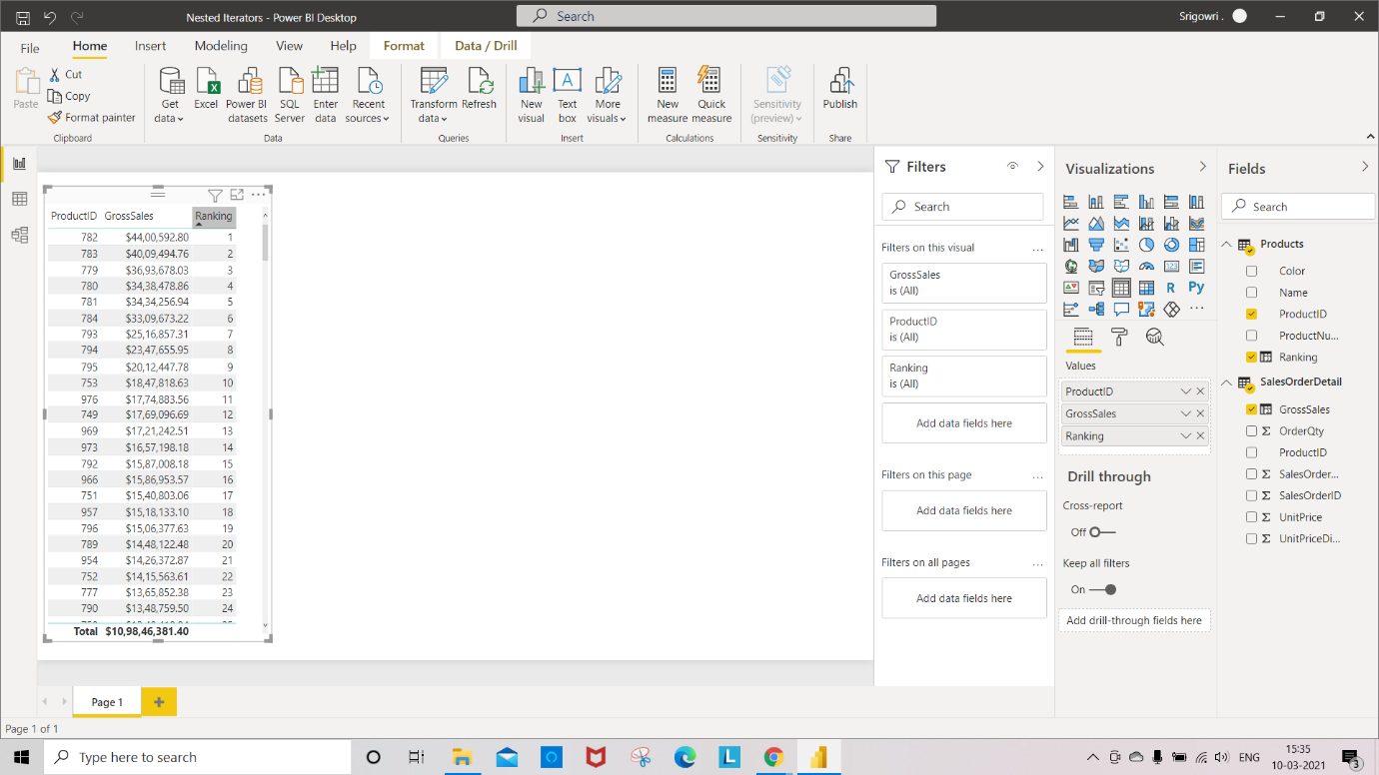

Step 7: Select the **Data** icon on PowerBi -> Select “**SalesOderDetail**” Table to see the records

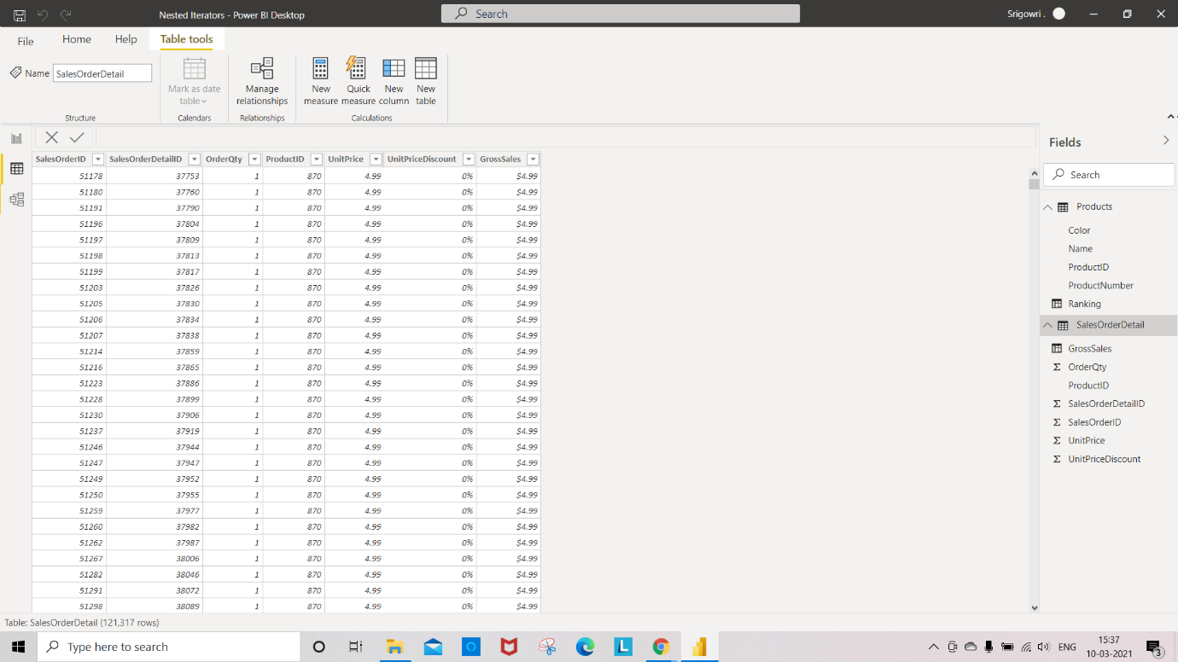

**KO 5: Able to create New Text Attributes Product and Channel Dimensions, New Date Attributes Calendar and Customer Dimensions and Metrics from Aggregate Functions.**

* Handling blanks and creating Product dimension table

Step 1:-The below fig shows creating a table using the “SUMMARIZECOLUMNS” function.

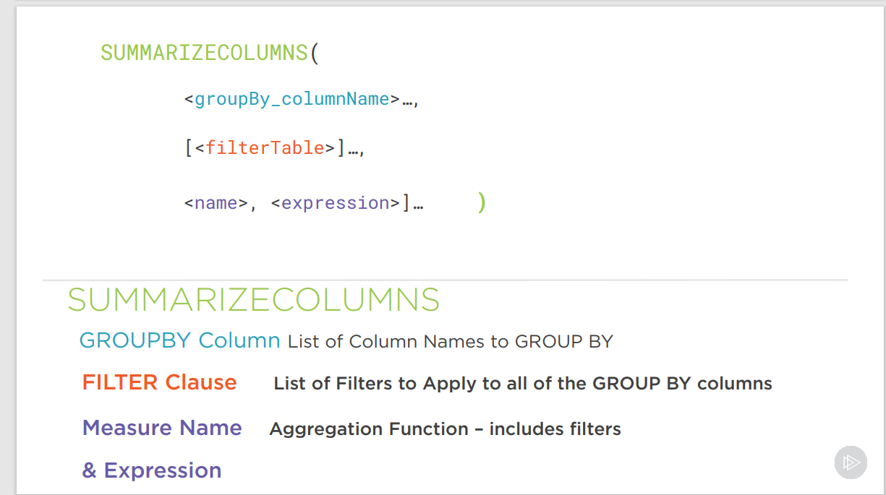

The below image shows the creation of the “metrics” table using the “SUMMARIZECOLUMNS” method.

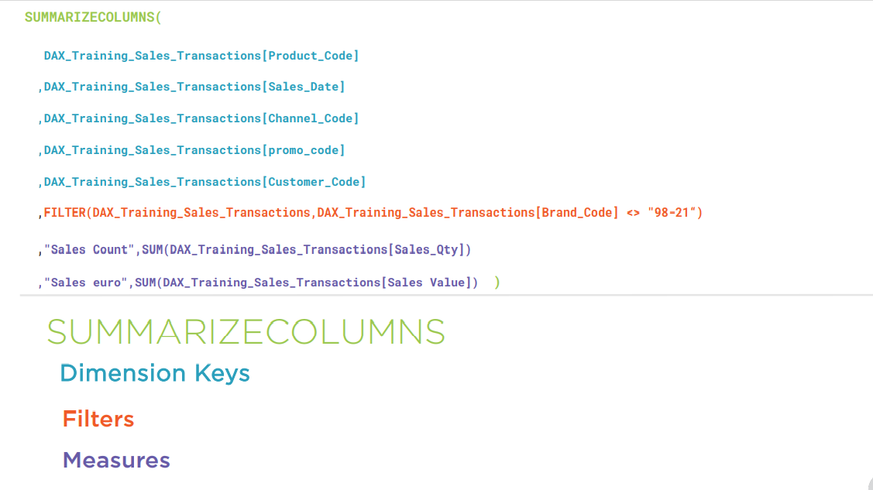

Step 1:- creating metrics table by using the Dax_Training_sales_transactions

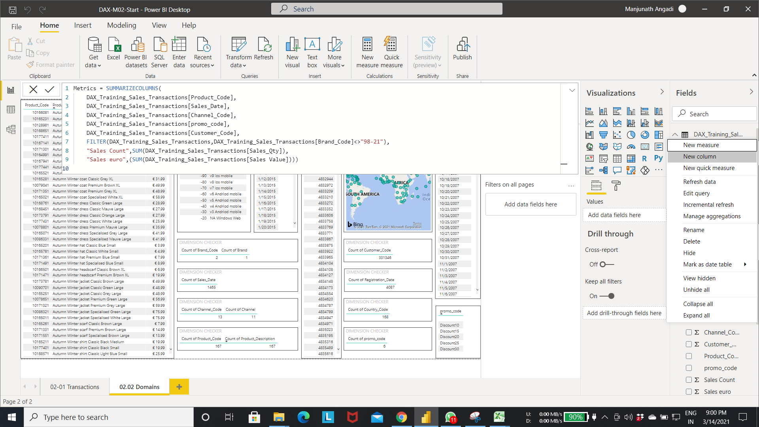

Step 2: Handling blank data using **“isblank()”** function.

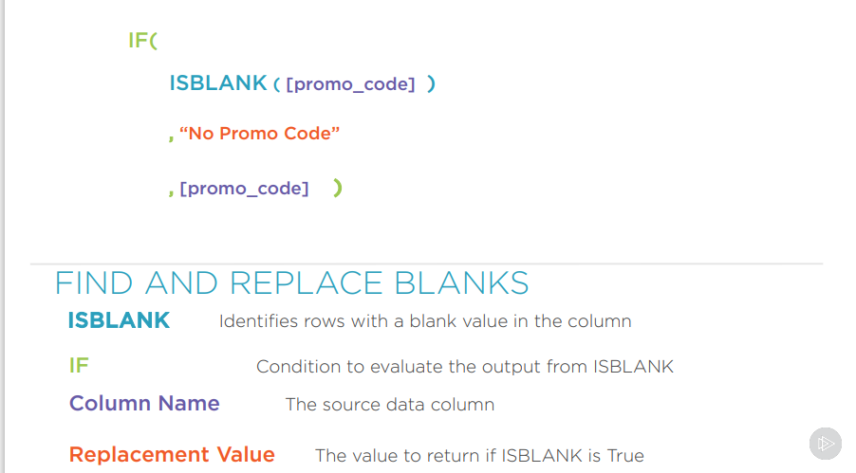

Step 3:- In the below fig we are checking the whether “promo code” is blank or not .if it is blank we are adding NO PROMO CODE to new **Promo code** column else the promocode value is added to the **Promo code** column.

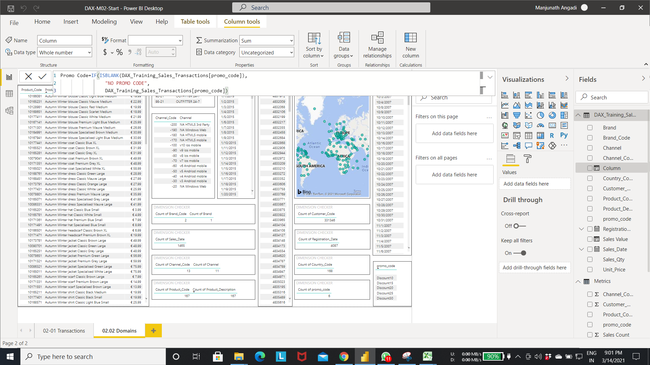

Output of step 3:-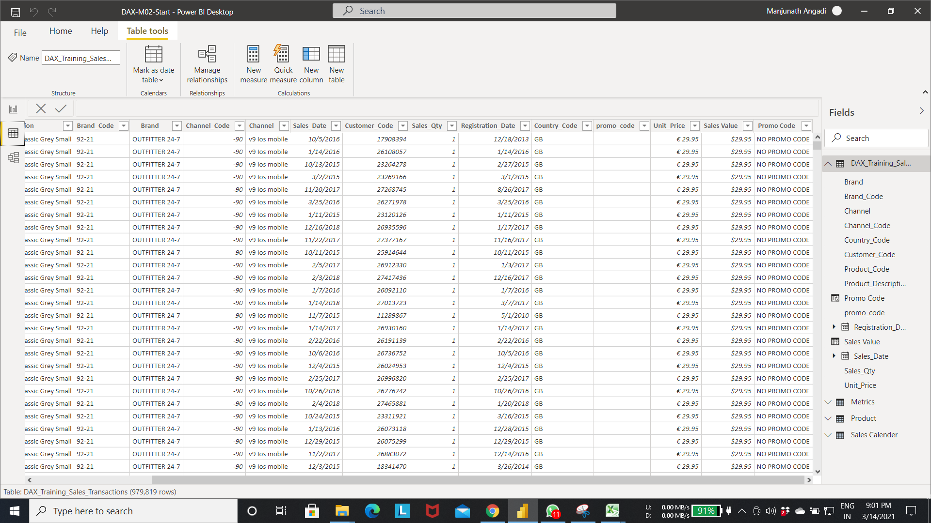

Step 4:- updating the Metrics table with new **Promo_Code** Column creating in the previous images.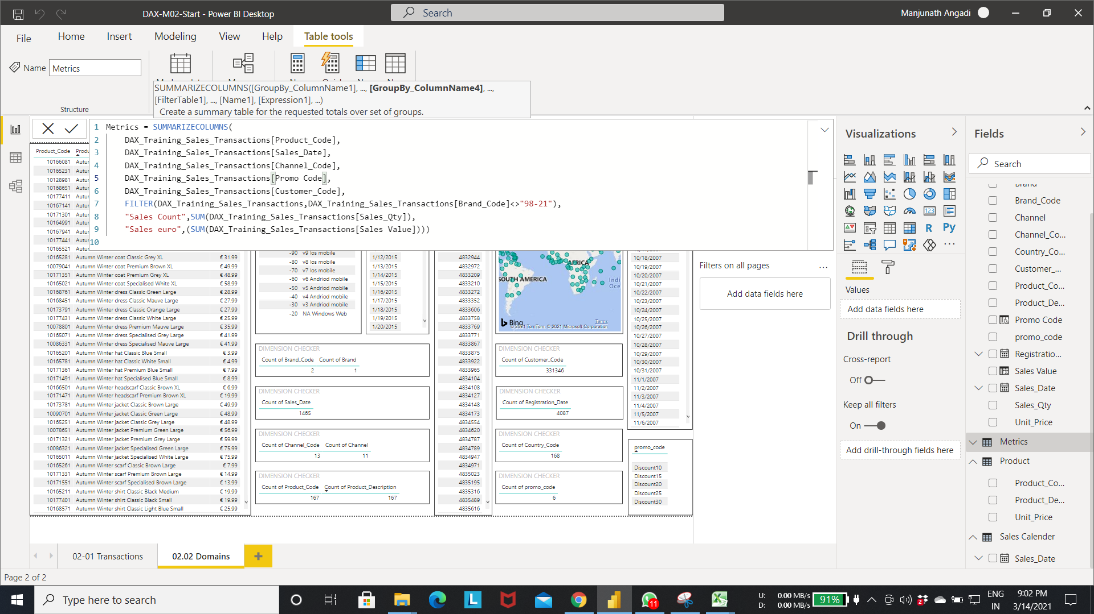

Step 5:- The below fig shows creating a table using the “GROUPBY” function.

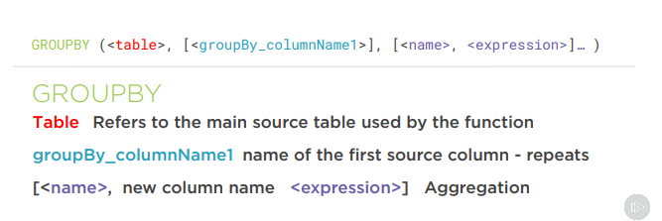

Step 6:- the below fig shows creating promotion table using group by function.

* Select the new table option from the table tools. This will prompt the expression editor
* Add the expression as shown in the fig to create promotion table.
* In the below fig table is created with one column promocode from the DAX_training_Sales_Trancaction table.

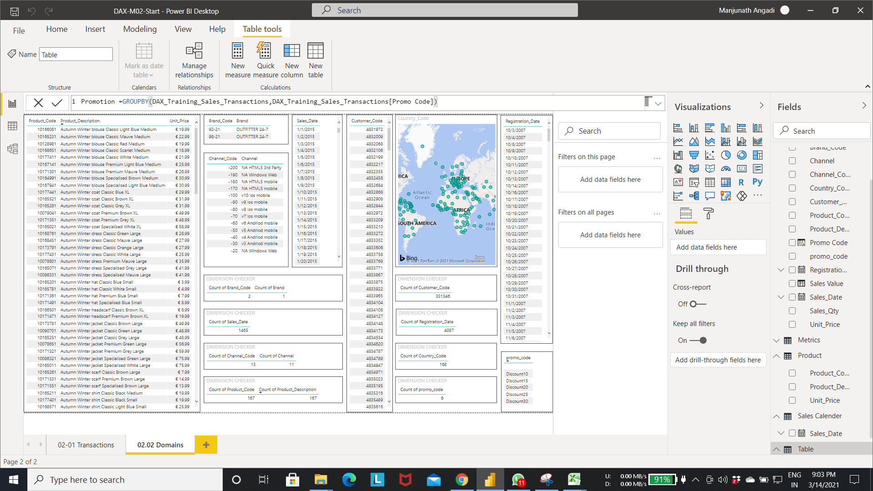

Output of step 6:- below fig shows the promotion table with promocode attribute.

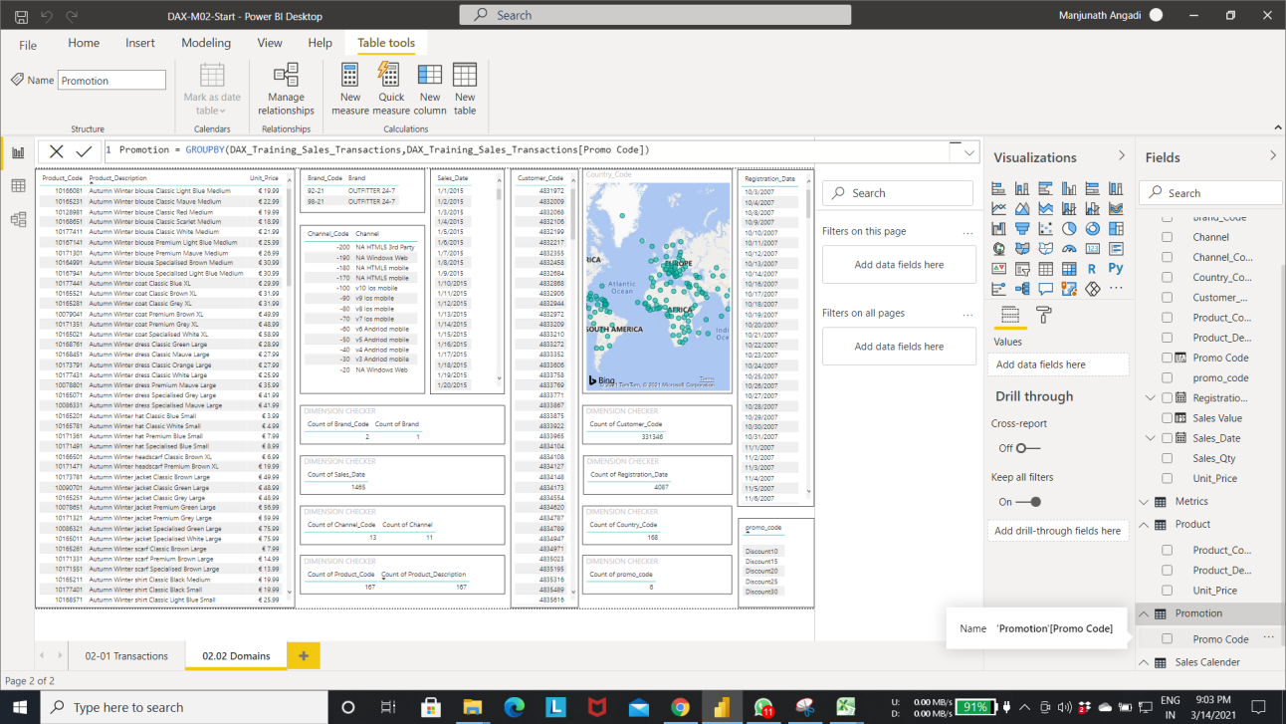

Step 7:- select the relationship icon to see the relationship betwee the tables.

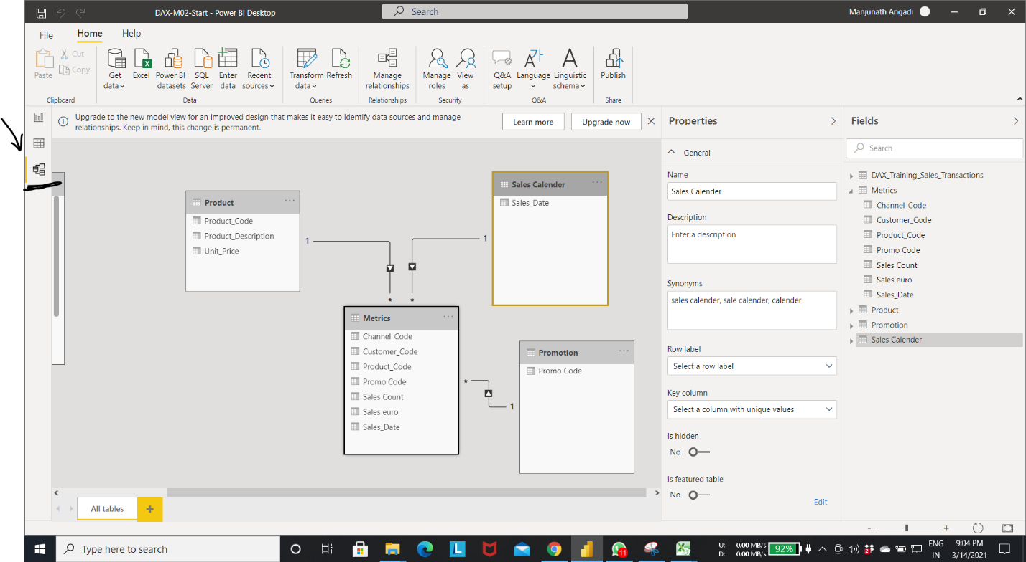

* Processing text in the columns using the string manipulation DAX function.

Step1:- Substitute function to edit the column row values.

Substitute function:- Replaces the oldtext value to new text value

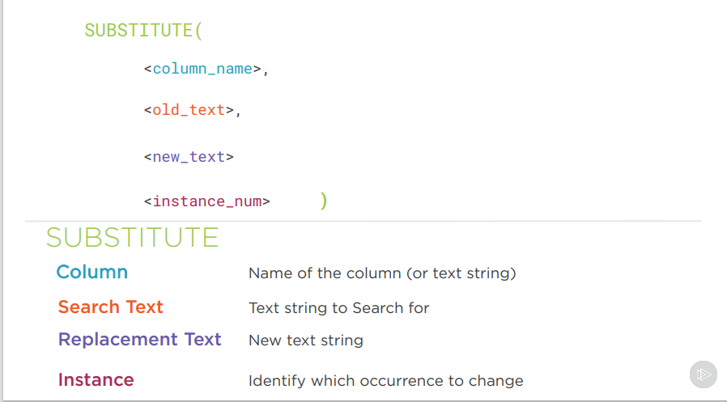

Step 2:- The below fig inner substitute replaces the first occurrence of “ ” present in the product description column with “&” . and outer substitute replaces the “ ” present in inner substitute output column with “,”.

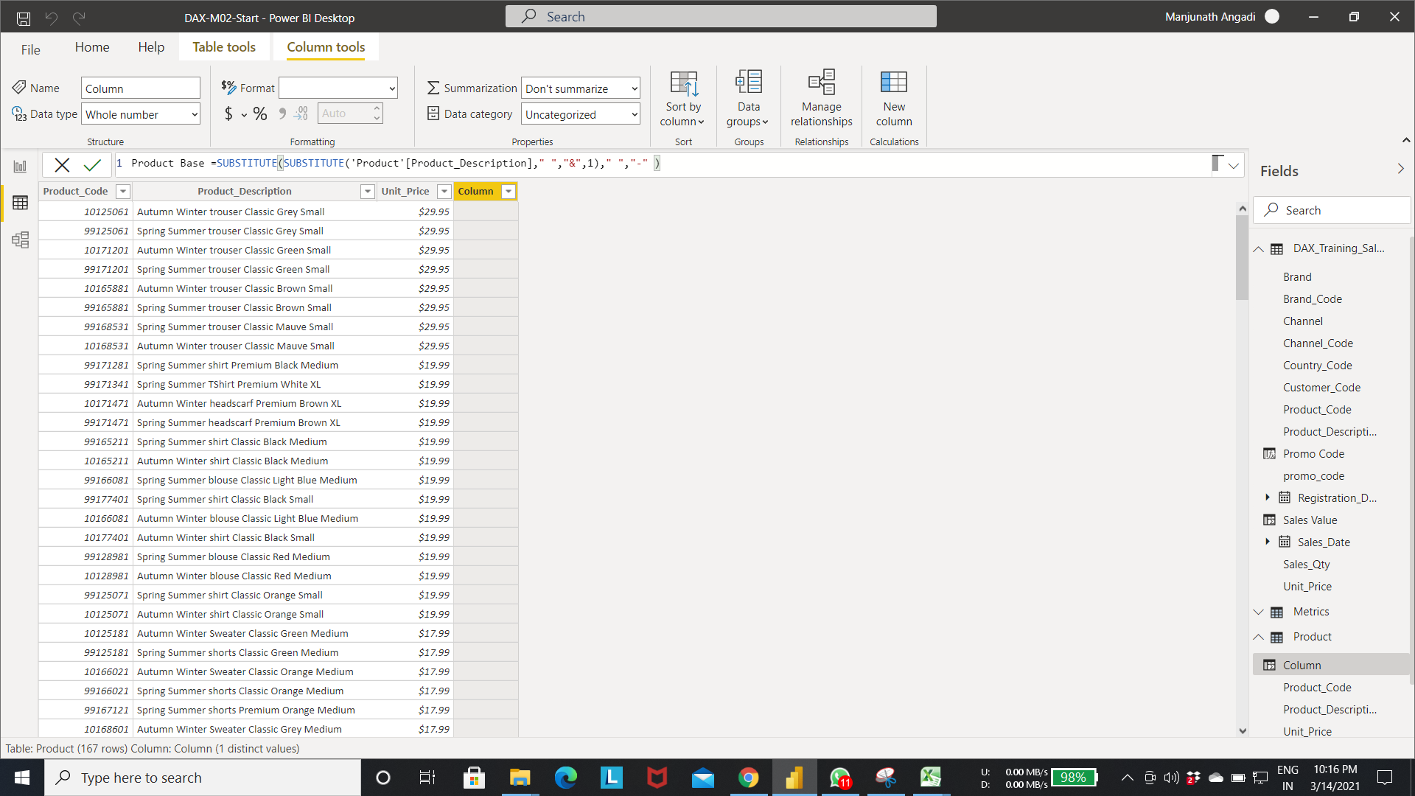

Output of step2:-

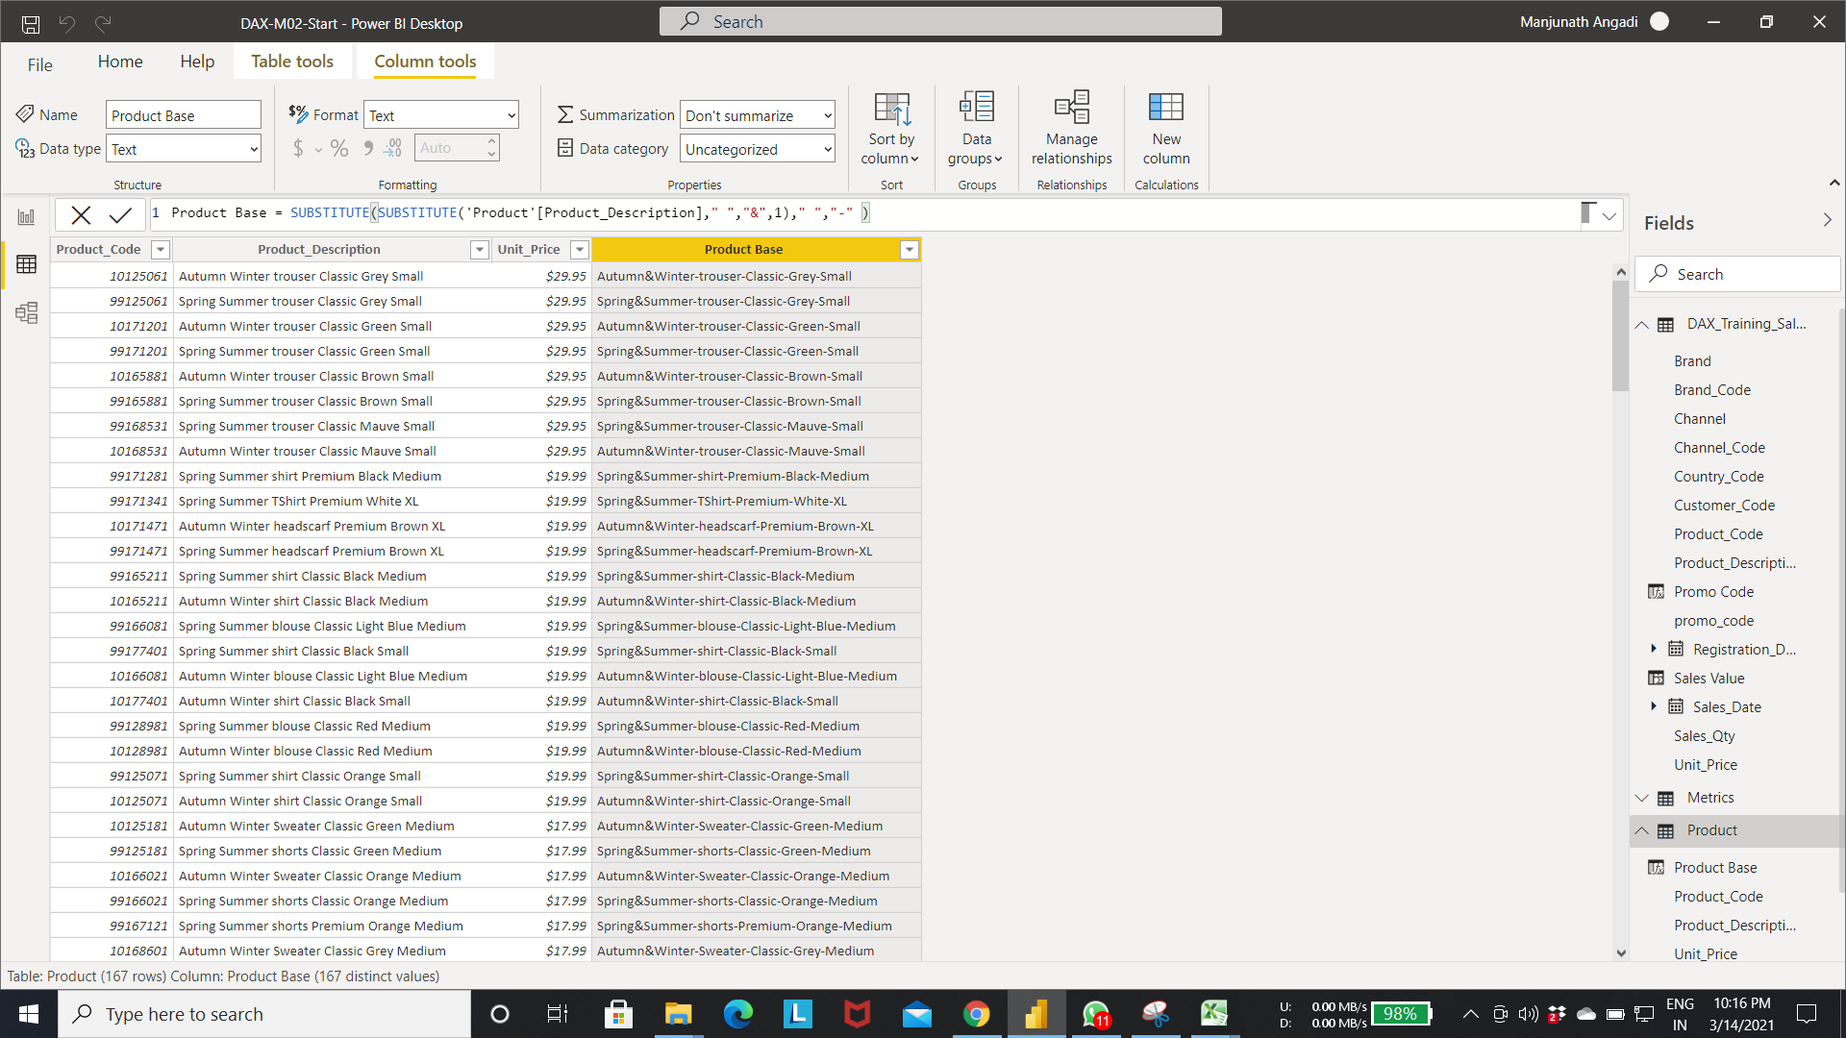

Step 3:- Using search to get the position of the of a letter or word.

Search function:- searches for the String in the column with the the starting position as shown in the below image.

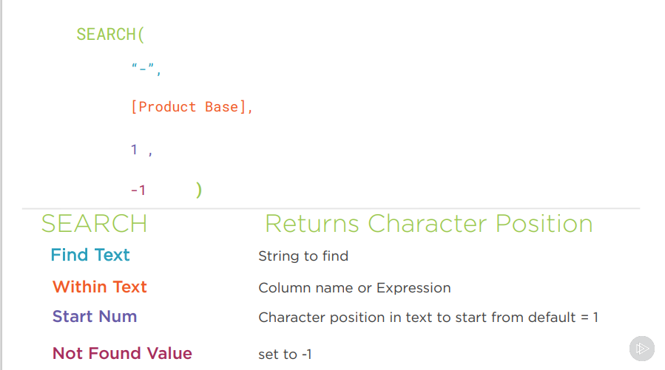

Step 4:- In below fig search function search for the “-” string from 1st index if string found it will return the pos of the string else returns the -1. 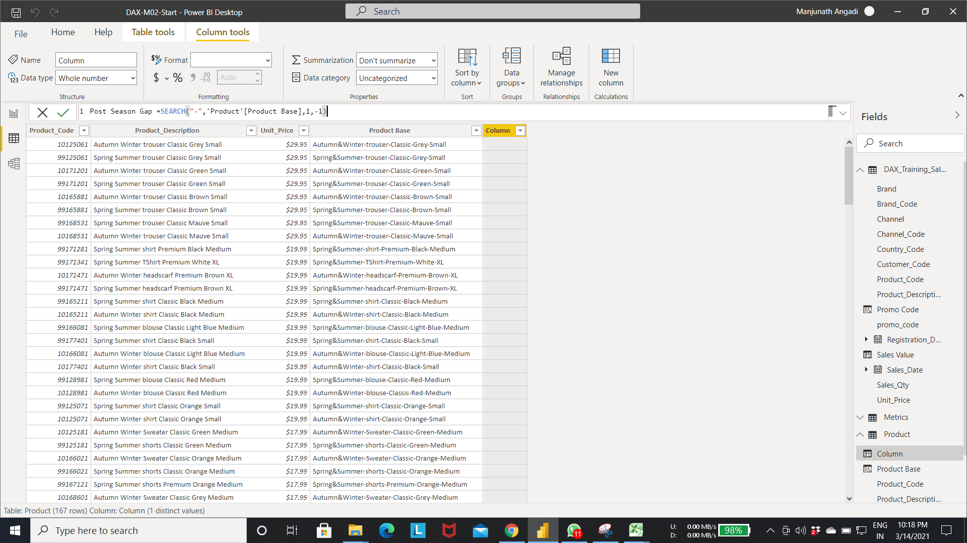

Output of step 4:-

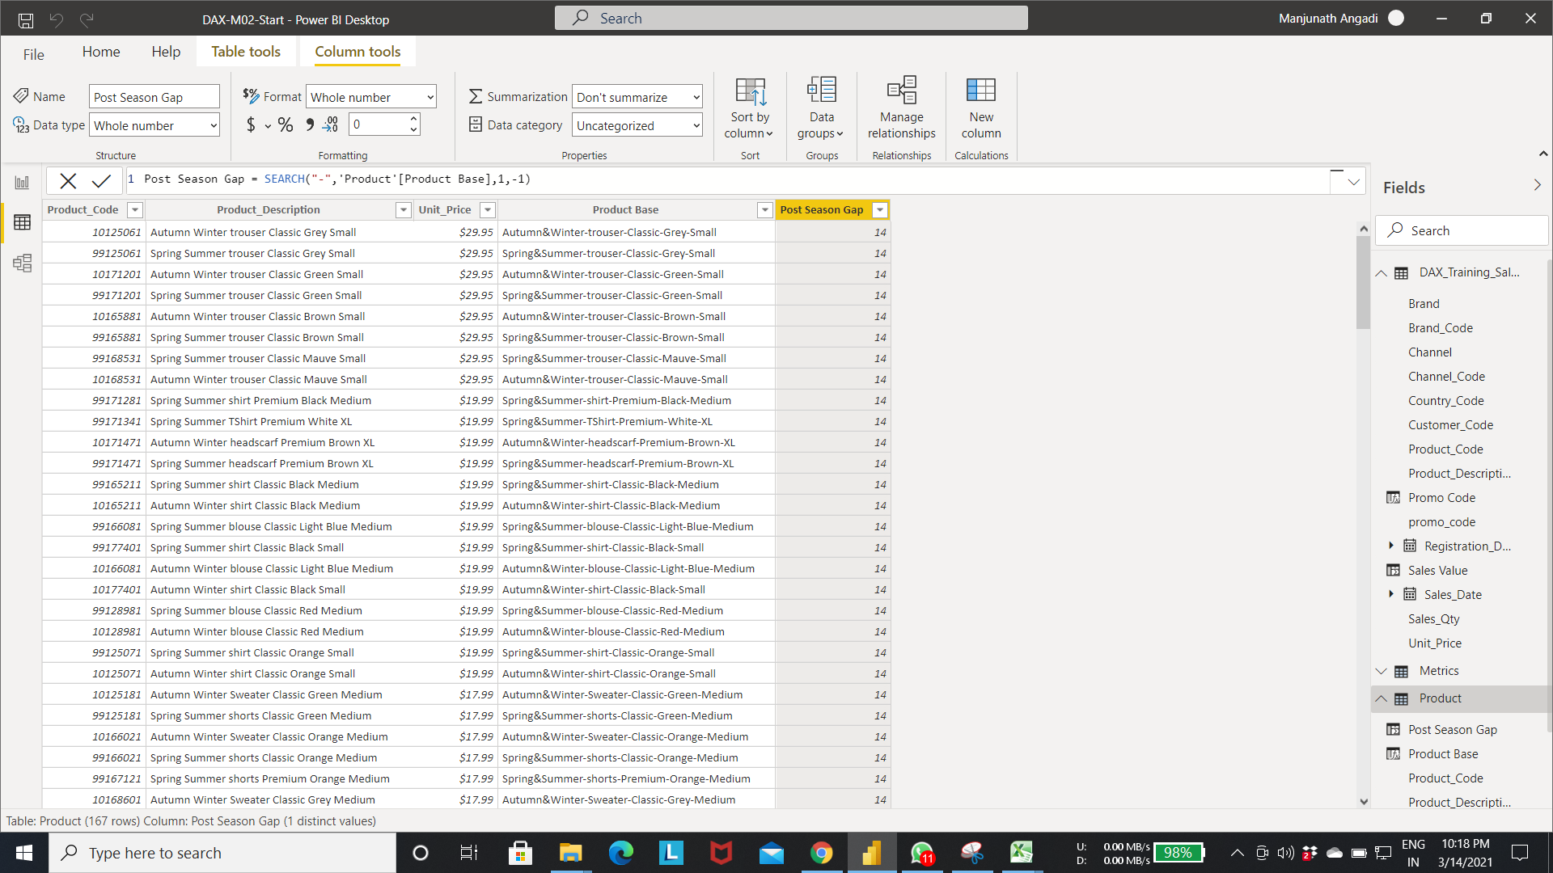

Step 5:- The below fig creates the new column Post Product Gap in the product table .

* Select the new column in the Product table-> write the expression as shown in the fig.
* search function search for the “-” string from “Post season Gap” column index if string found it will return the pos of the string else returns the -1.

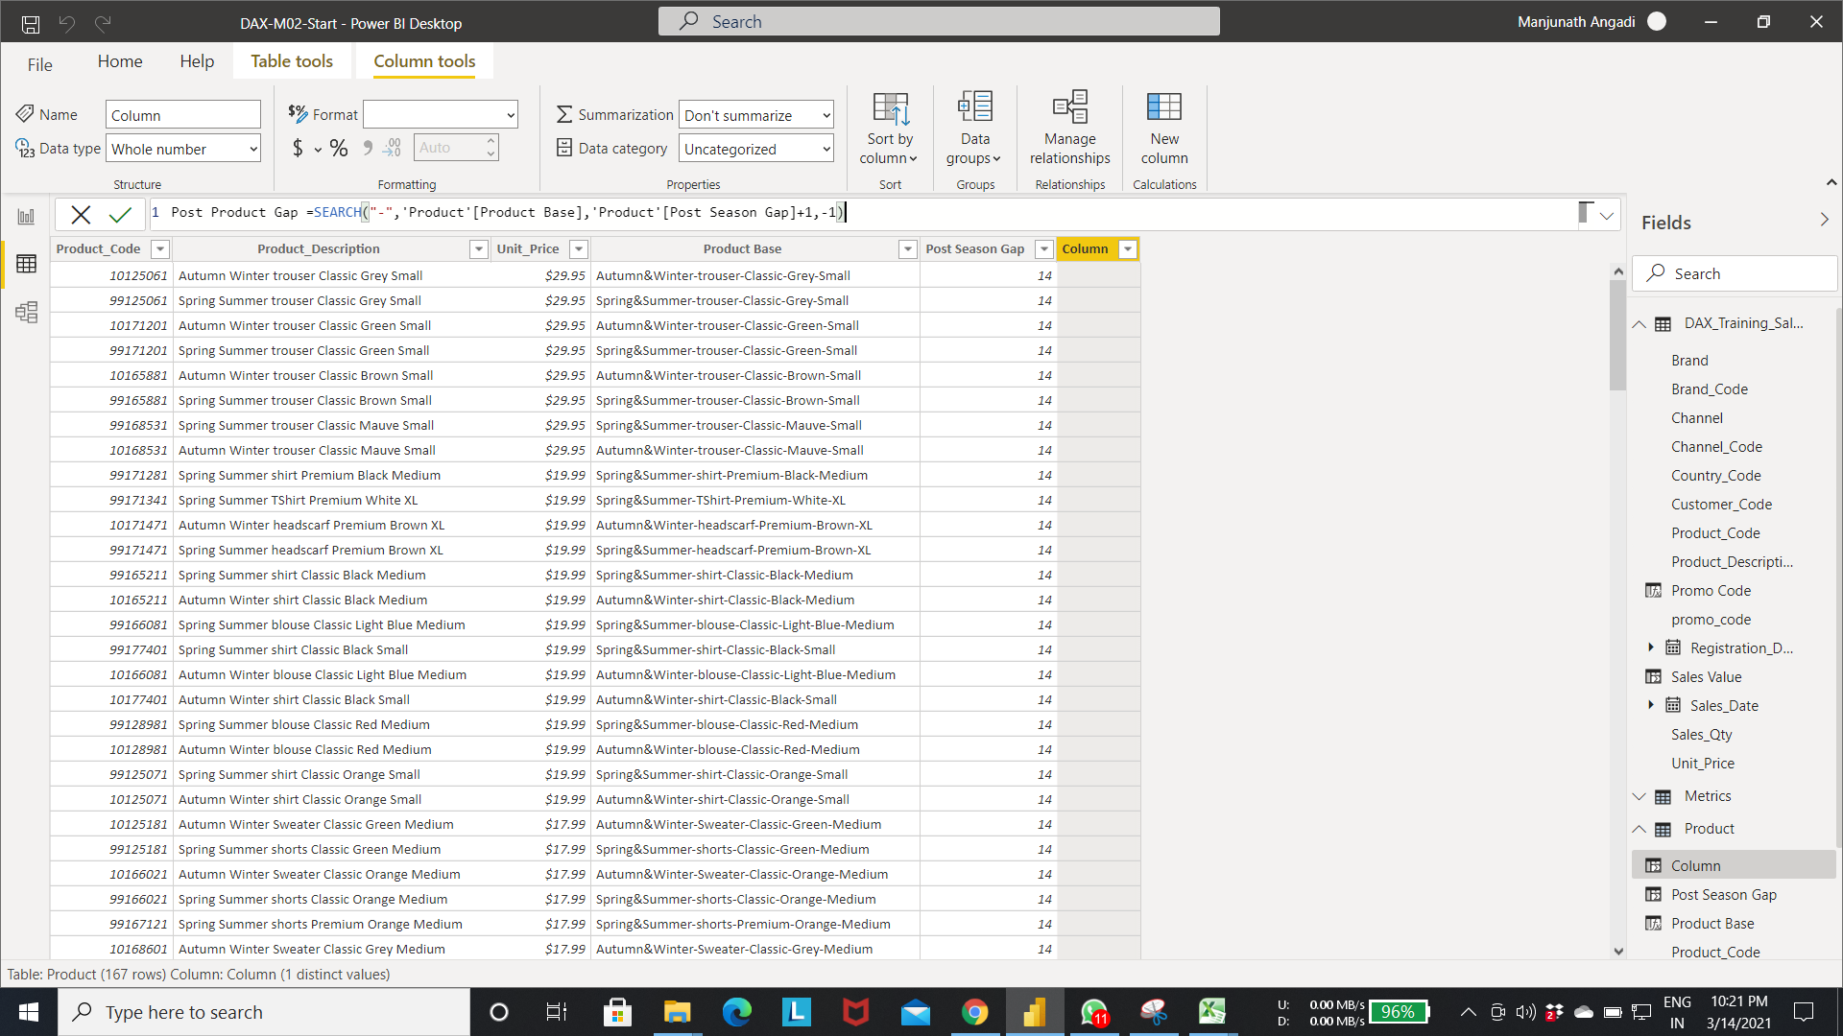

Output of step 5:-

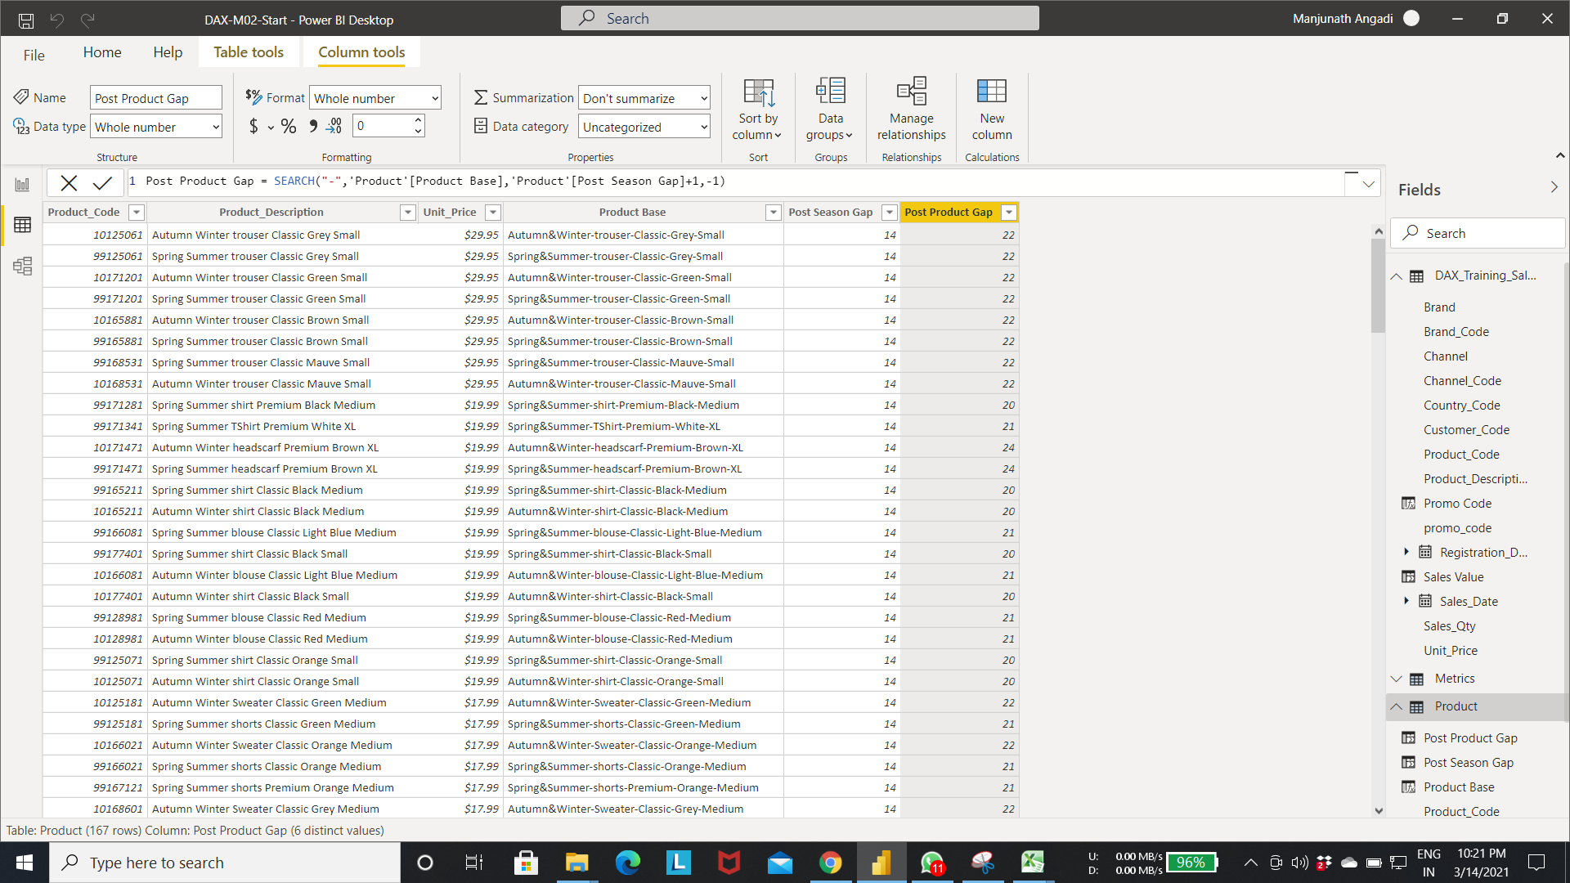

Step 6:- The below fig creates the new column Post Prod Type Gap in the product table .

* Select the new column in the Product table-> write the expression as shown in the fig.
* search function search for the “-” string from “Post Product Gap” column index if string found it will return the pos of the string else returns the -1.

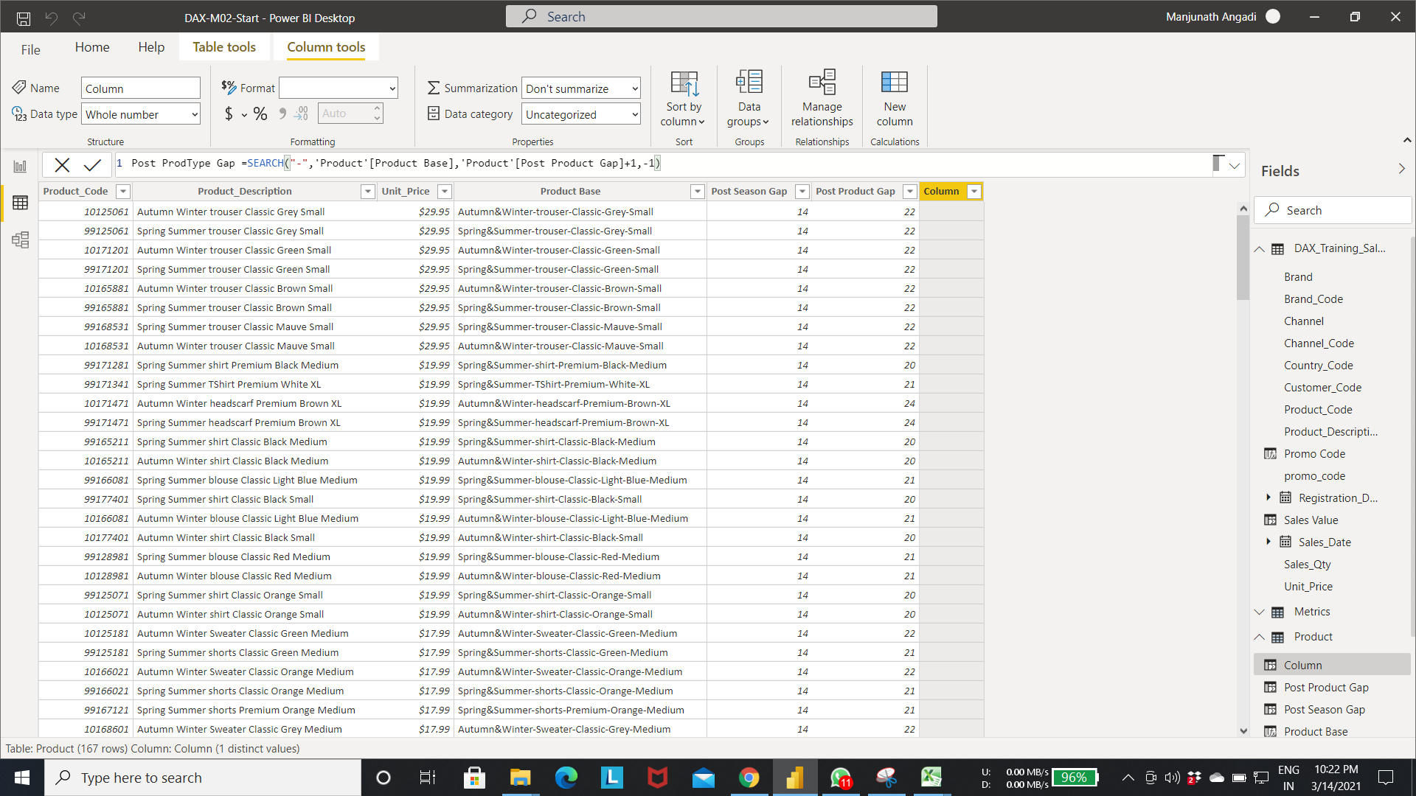

Output of Step 6:- 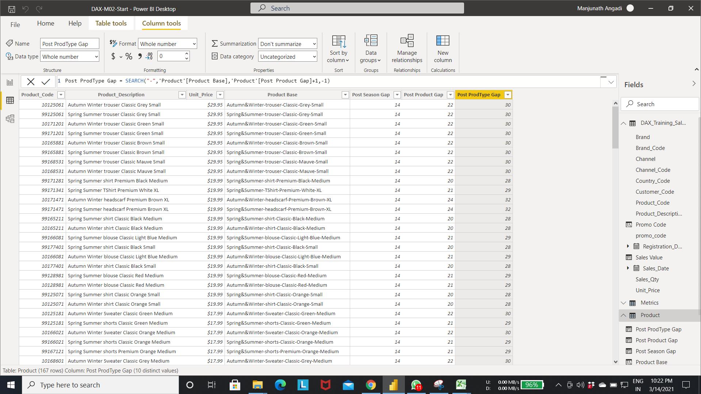

Step 7:- The below fig creates the new column Post Prod Type Gap in the product table .

* Select the new column in the Product table-> write the expression as shown in the fig.
* search function search for the “-” string from “Post Prod Type Gap” column index if string found it will return the pos of the string else returns the -1.

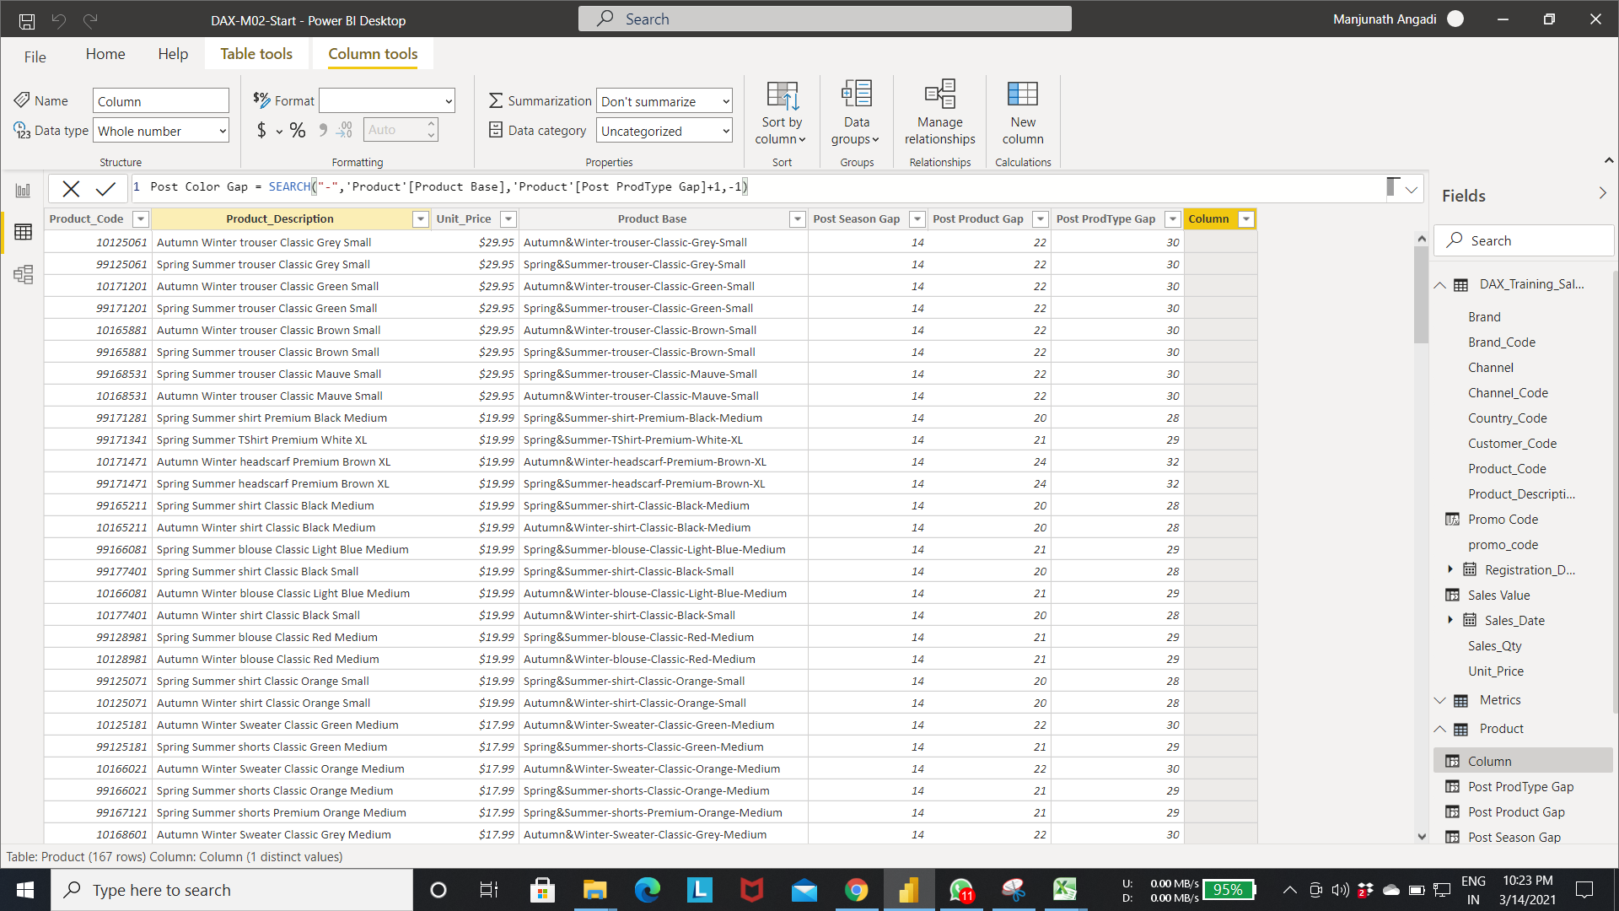

Output of step 7:-

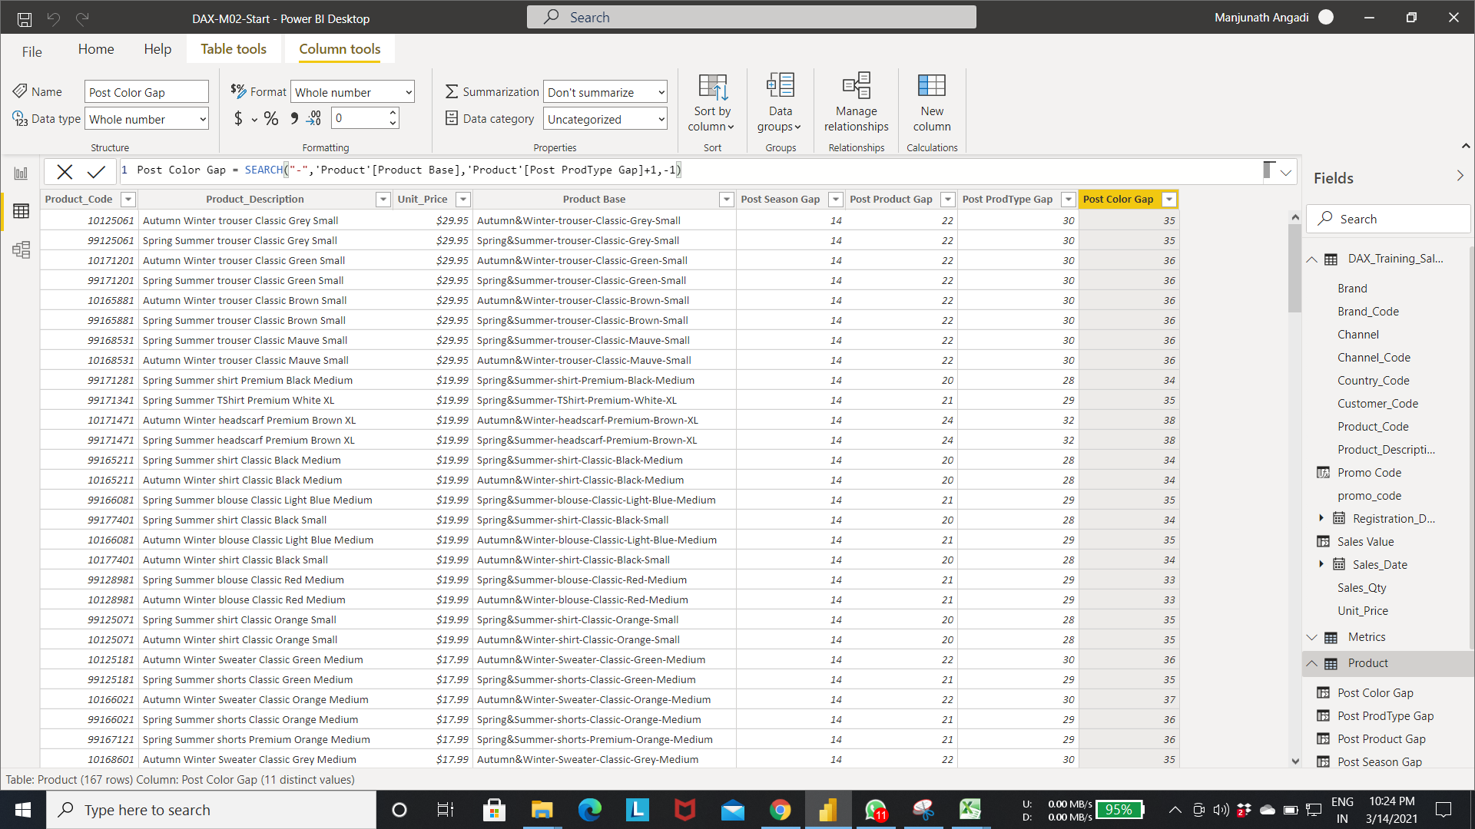

* Cutting functions in DAX. (extracting the particular text from the column).

Step 1:- Extracting the particular length of String with start index to end index from the column values.

LEFT function:- extract the string from start index 0 to endindex value.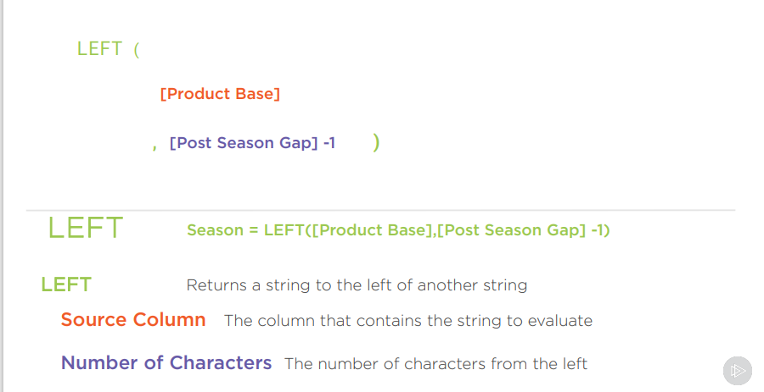

Step 2:- The below fig creates the new column in Product table. ->extract the string from Product base column with index 0 to Post season Gap column value +1 index.

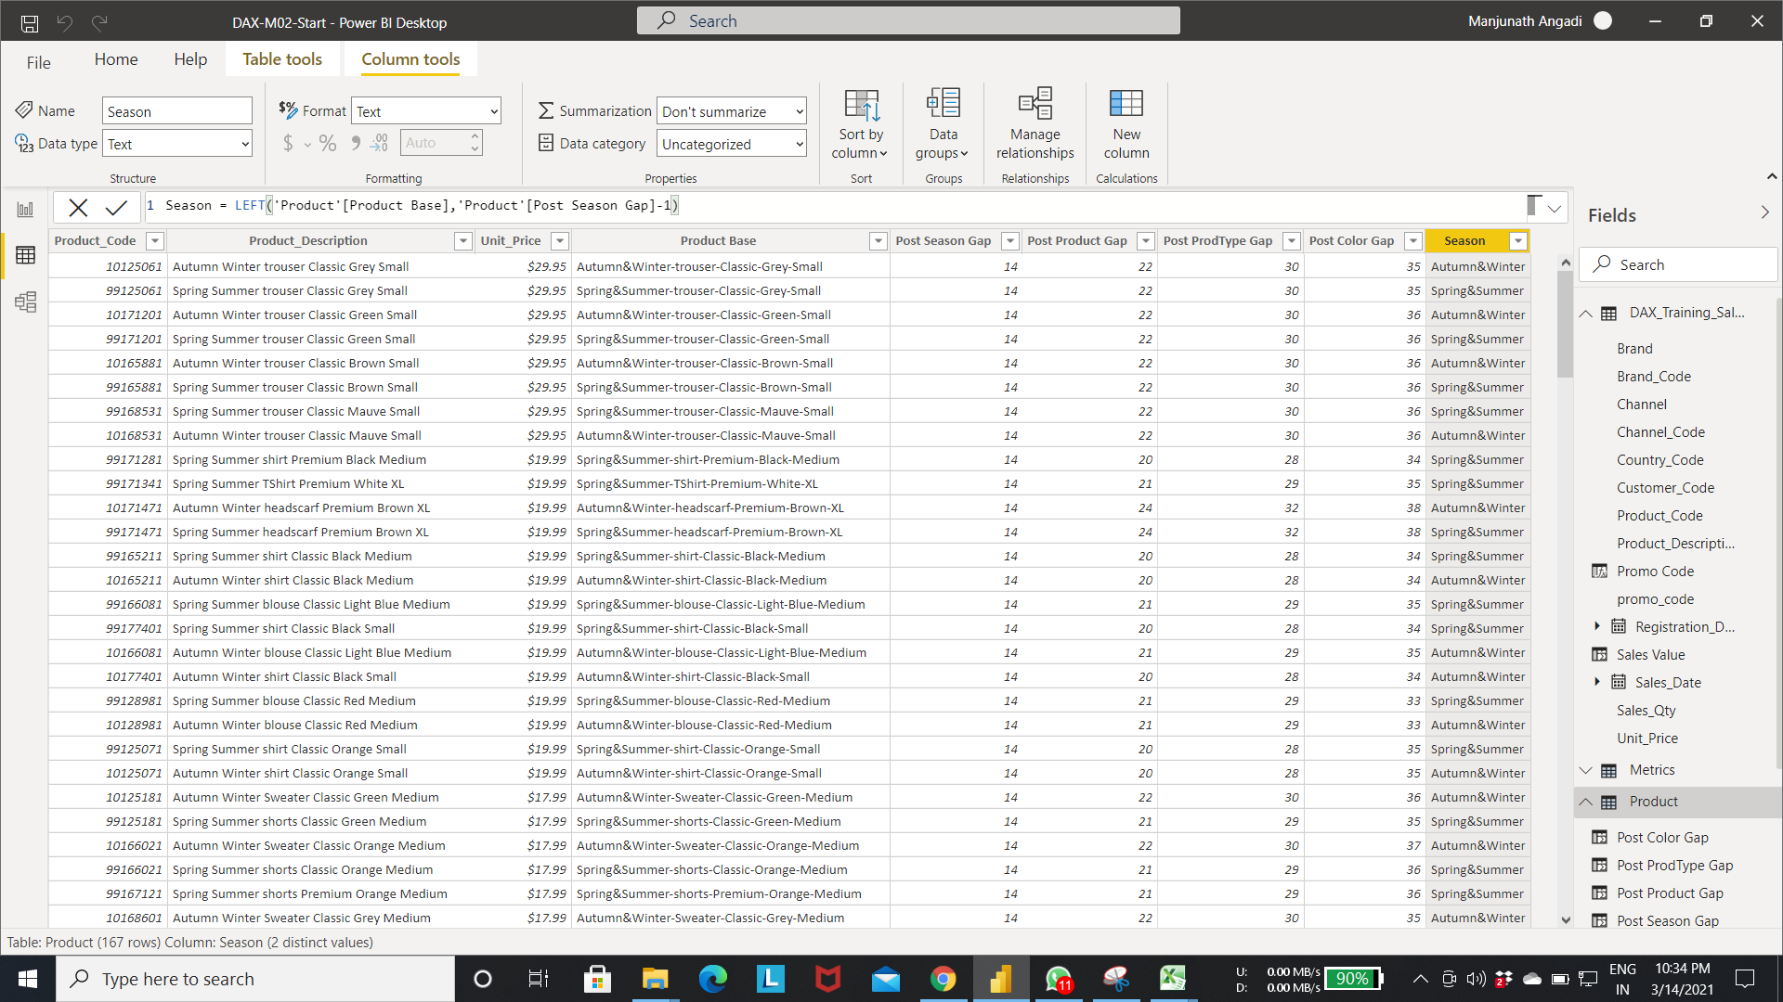

Step 3: MID function is used to extract middle string from the column.

MID function:-

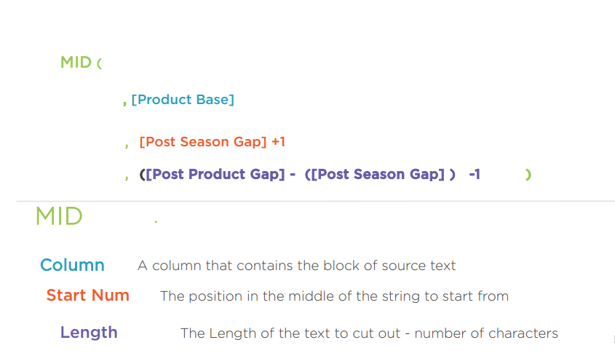

Step 4:- The below fig creates the new column “**Product”** in the product table.

* The mid function extract letters from the Product Base column from “Post Season Gap”+1 index to “[Post Product Gap]-[Post season Gap]”-1 index.

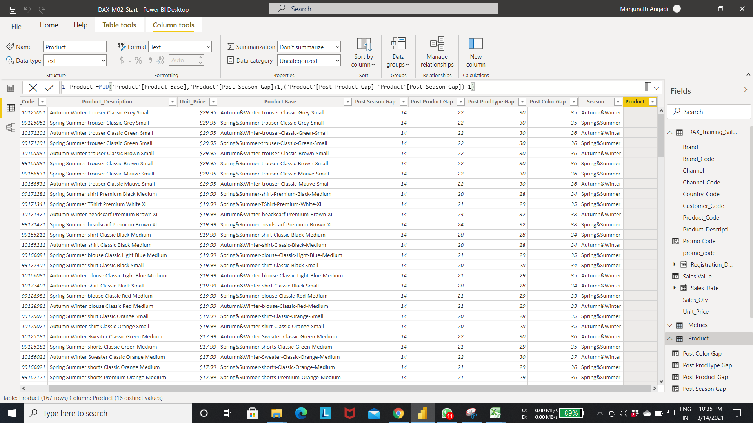

Output of step 4:-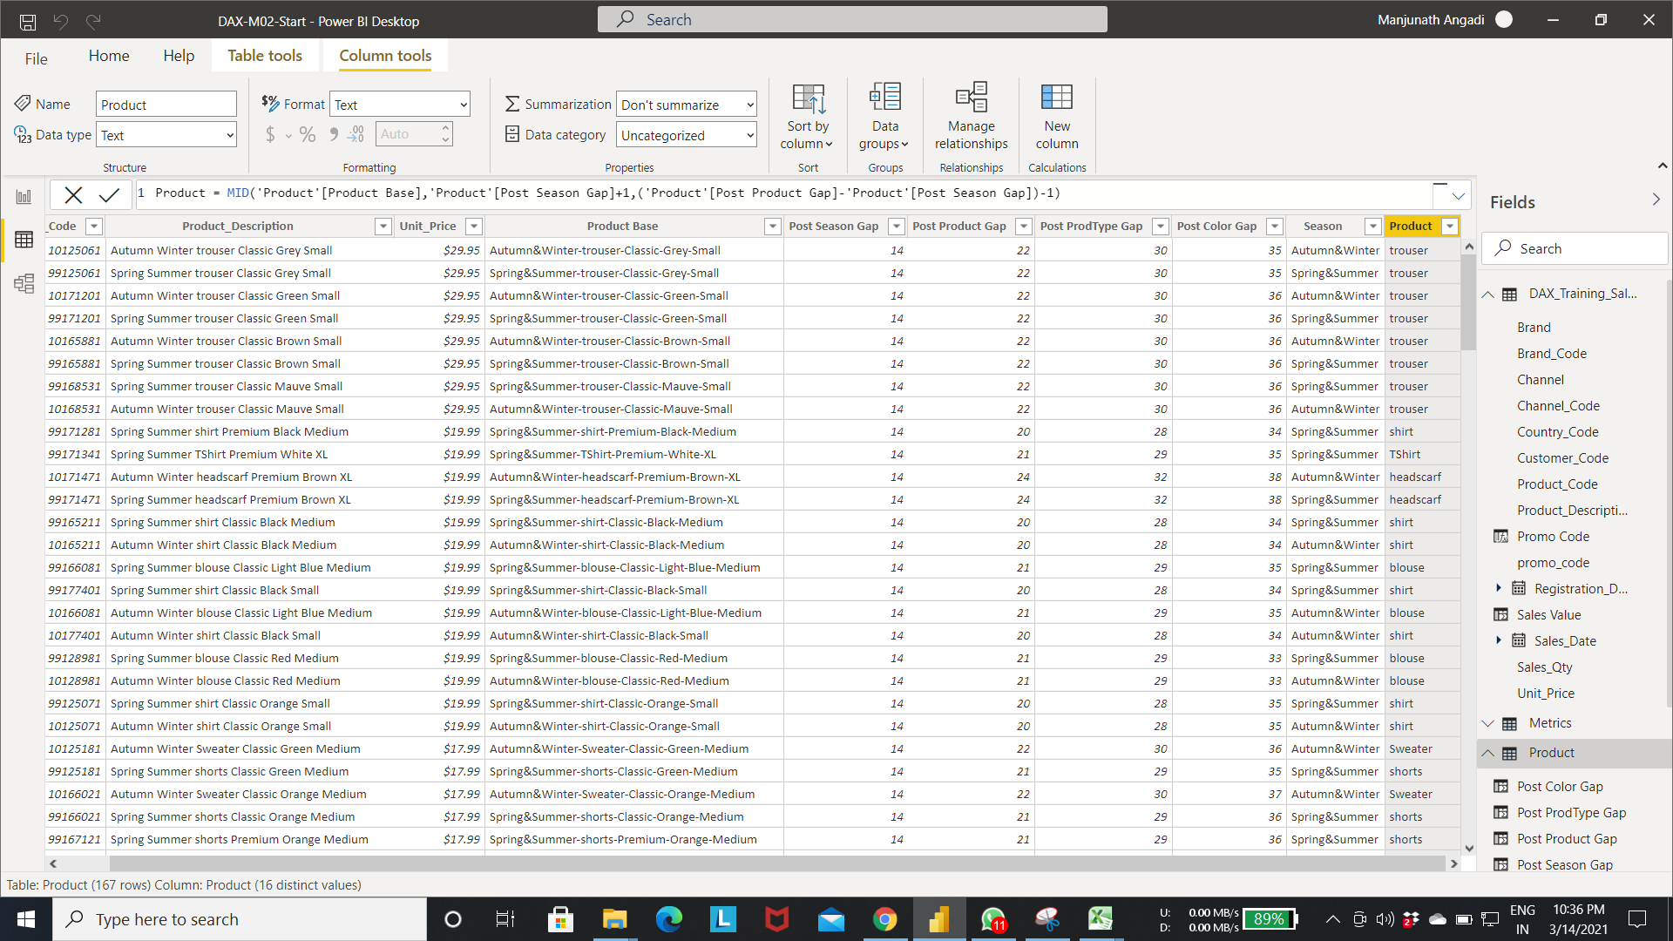

Step 5:- The below fig creates the new column “**Product Type”** in the product table.

* The mid function extract letters from the Product Base column from “Post Product Gap”+1 index to “[Post ProdType Gap]-[Post Product Gap]”-1 index.

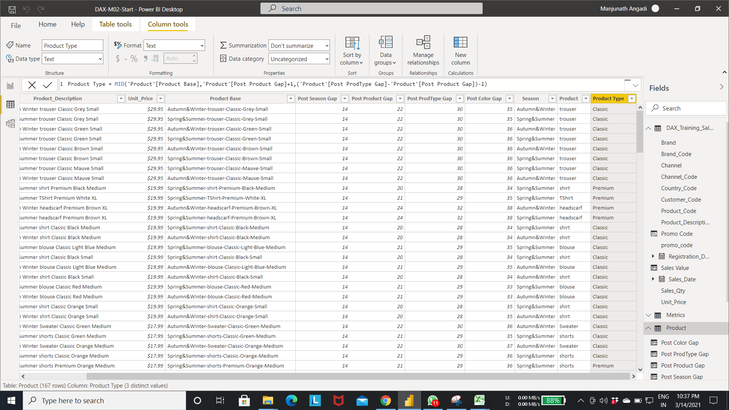

Step 6:- The below fig creates the new column “**Product Color”** in the product table.

* The mid function extract letters from the Product Base column from “Post ProdType Gap”+1 index to “[Post Color Gap]-[Post ProdType Gap]”-1 index.

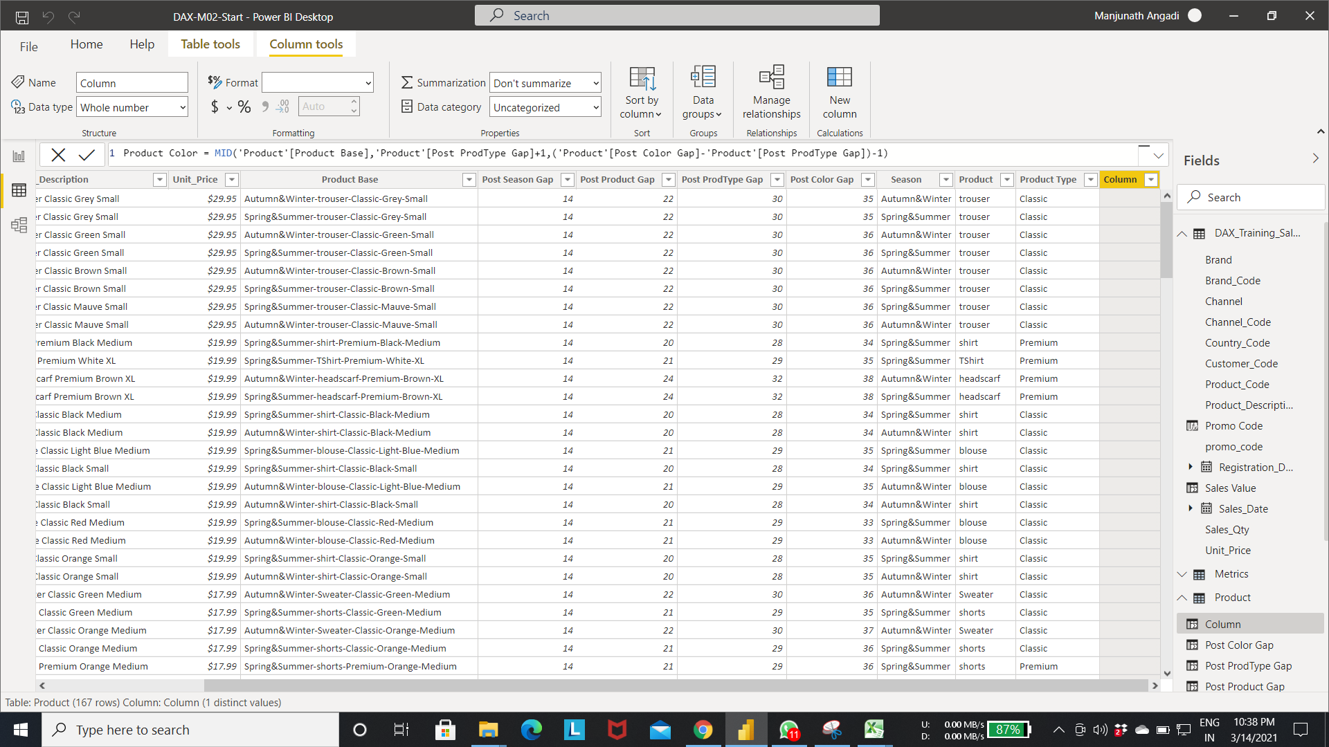

Step 6:- RIGHT function to extract the letters from start index to end of the String.

RIGHT function:- In the below fig select the new column option in product table.->Enter the expression as shown in fig.

* right function extract the string From “total length of [Product Base] column –[Post color Gap]” to end of the string.

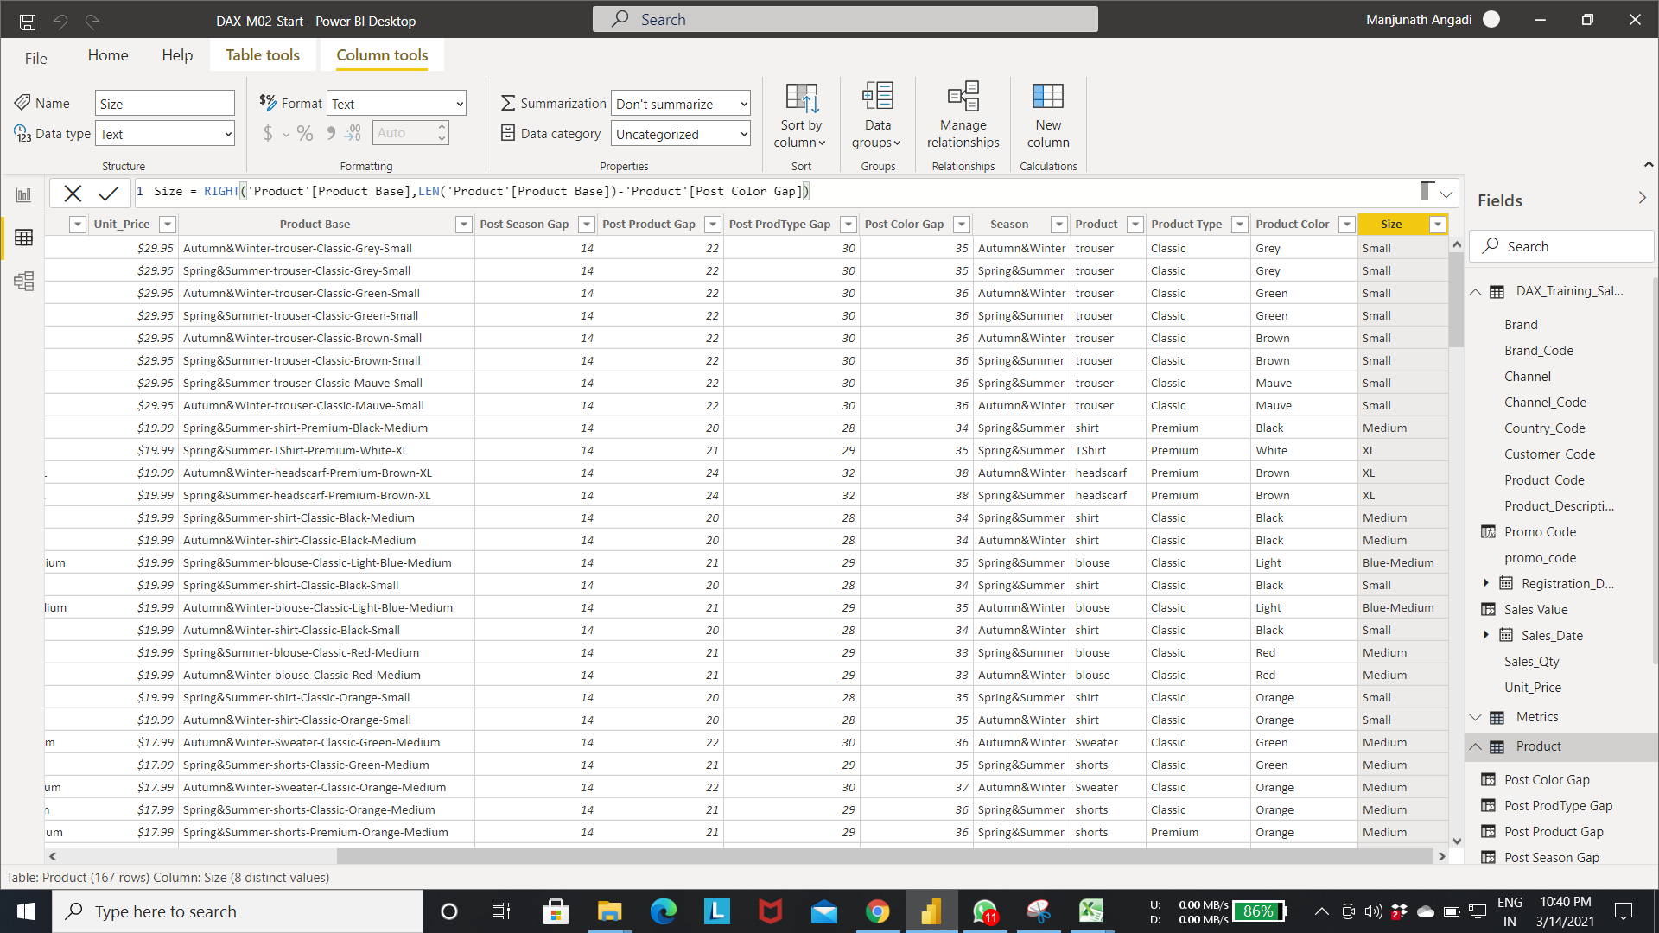

* Fixing messy text

Step 1:-In the below fig product column first letter is lower. To replace it with the capital follow the below steps.

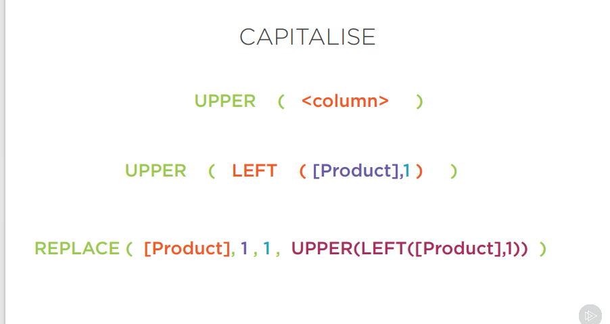

* Extract the first letter from the Product Lower column using left function as shown in the fig
* Convert the extracted letter to upper using upper function
* Replace the first letter from the product(lower) table with the capital word from the previus step.

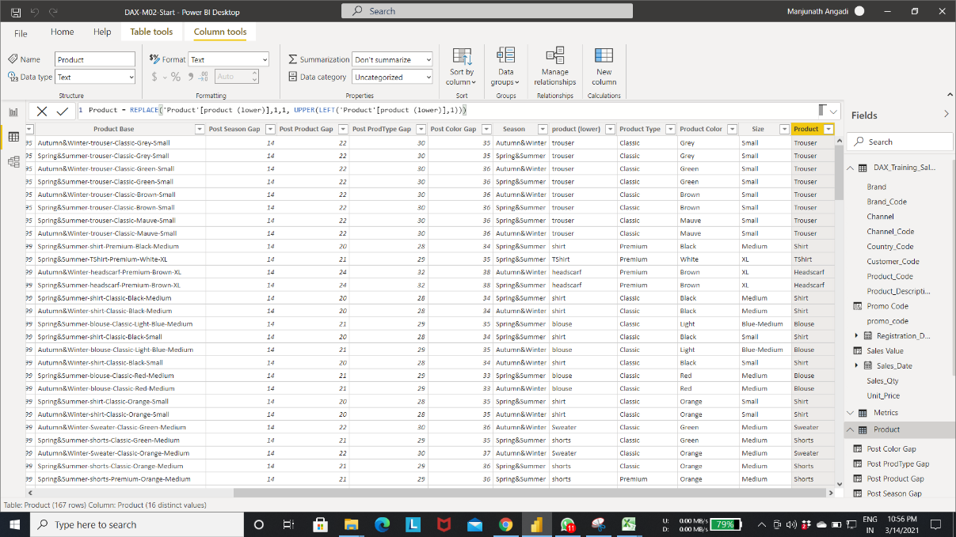

Step 2:- creating a new table using group by function. Below fig creates the customer table with the customer_code, Registration date column.

* Select the new table option-> Enter the expression as shown in the fig to create new table.
* For group by function refer the above pages.

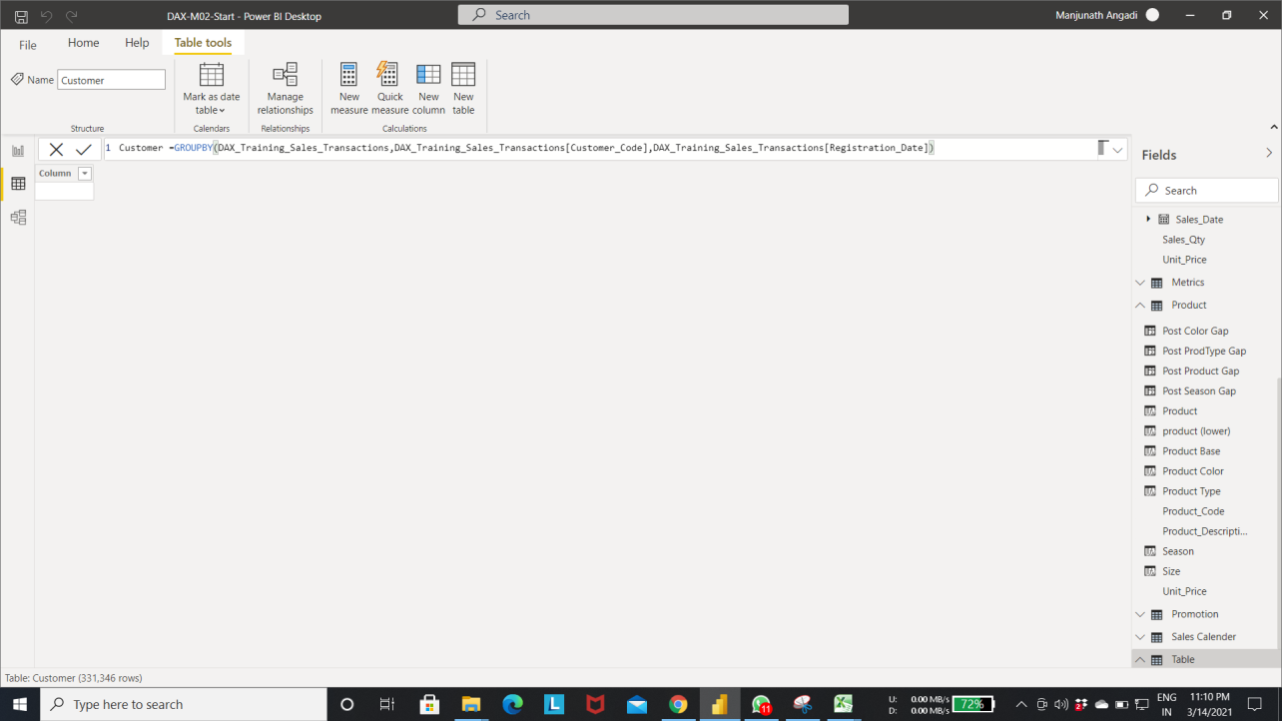

Output of step 2:-

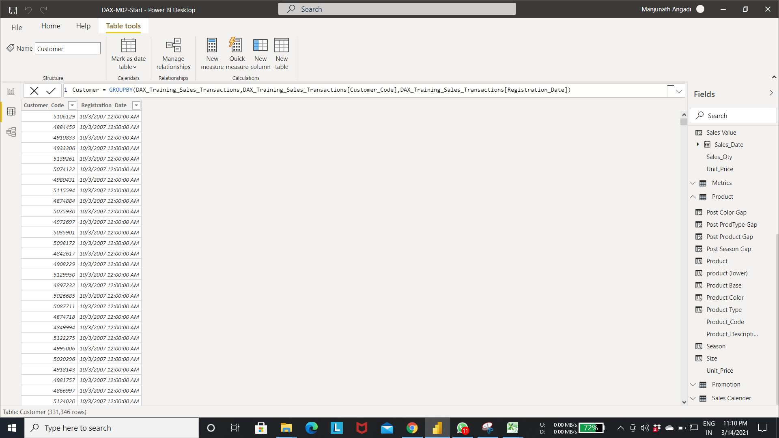

Step 3:- From below relationship diagram we can see the customer table got created with entioned attributes.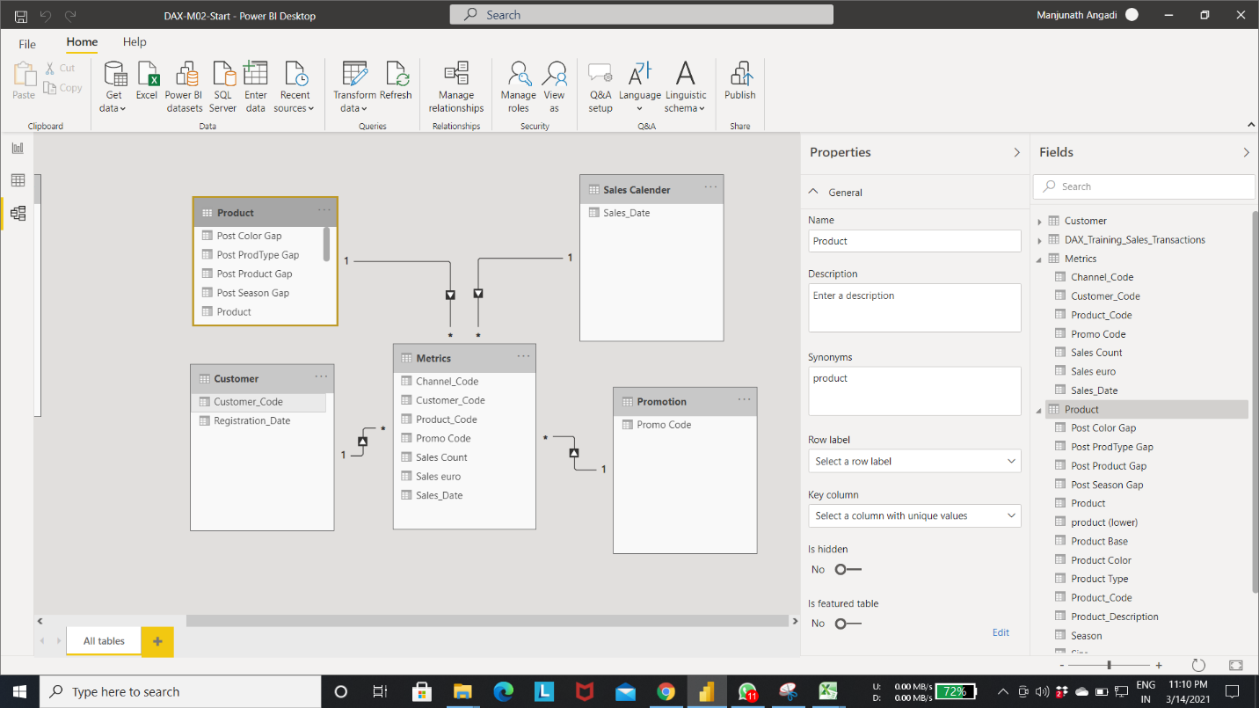

Step 4:- creating first day column in the DAX_traning_sales_transaction table using conditional statement.

* In below fig if statement compares if registration date and sales date are equal, if equal it add the “First Day” String to the First day column else other day to the column. This column tell us whether the customer purchased the product on the Registration date or not.

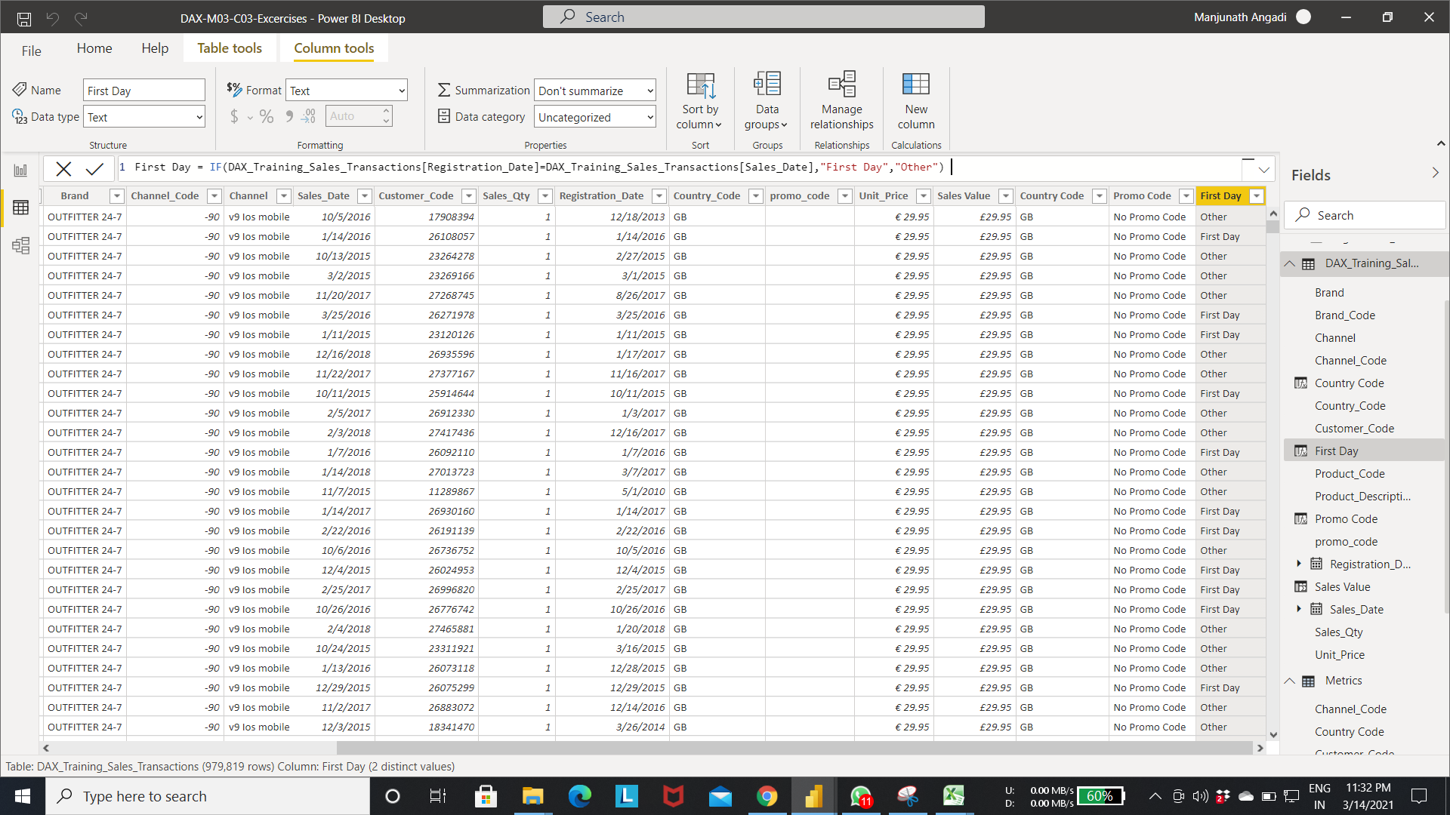

Step 5:- Adding the new column from the other table.

RELATEDTABLE function:- helps us to fetch the column from the other table using the relationship between the table. For this function to work relation must be there between the tables.

* Select the new column in the customer table-> Enter the expression as shown on fig.
* In the below fig fetch the sales count column from the metrics table .calculate the sum of the sales count values for the customer code. And add the value to the sale count column of customer table.

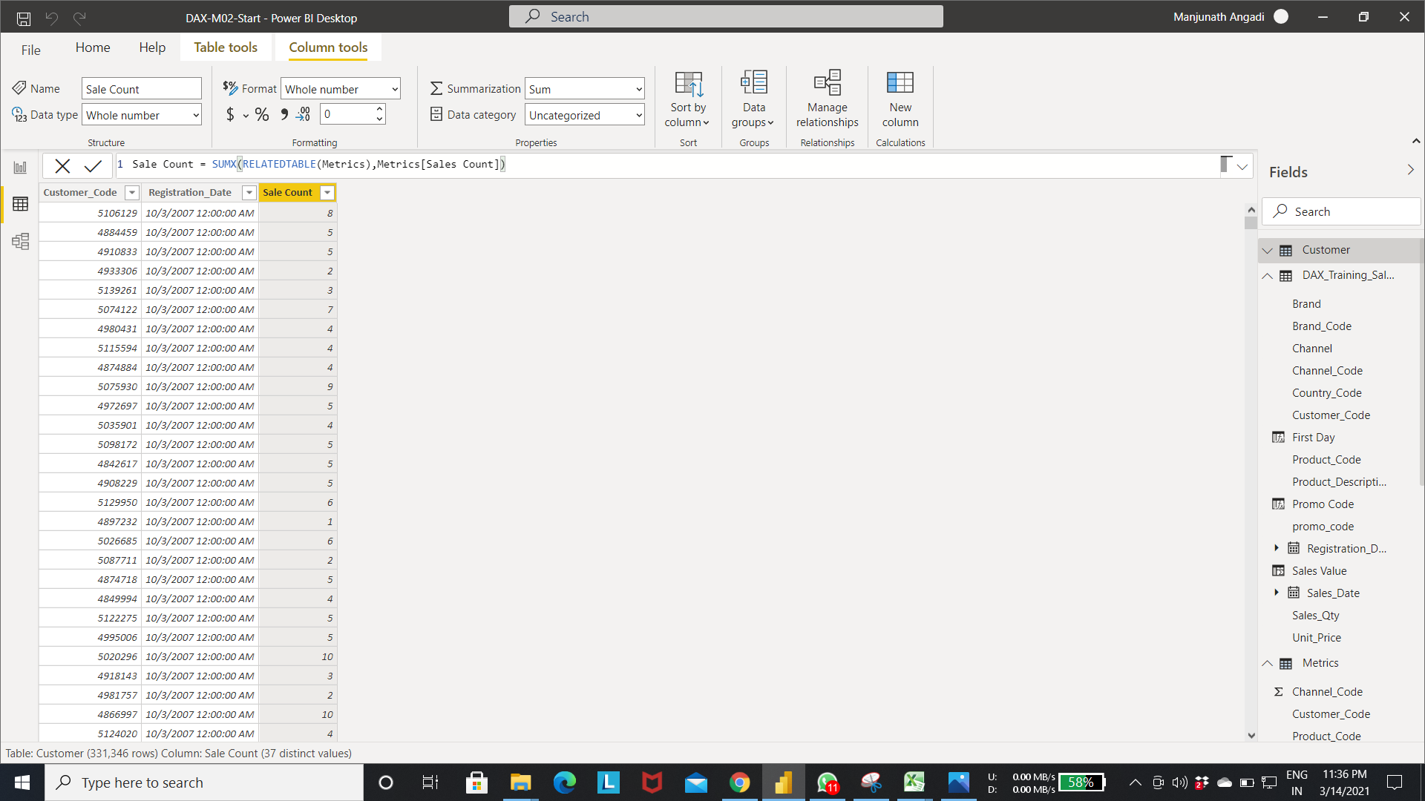Output of step 5:-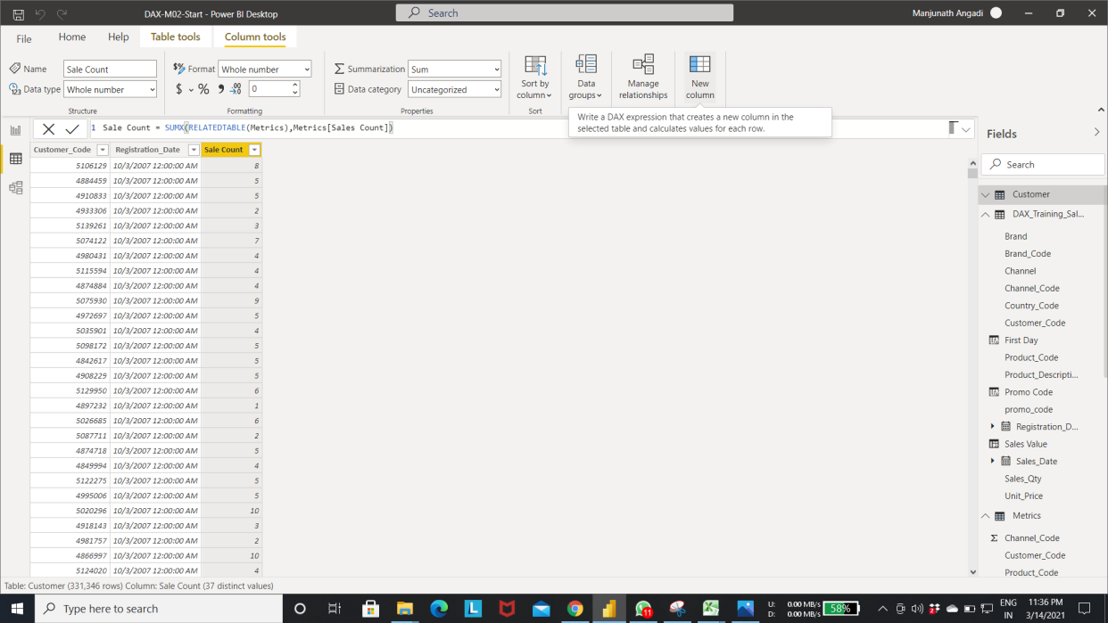

Step 6:-select the new column in the customer table->enter the expression as shown in the fig.

* The below fig add the multi Sale column to the customer table and for value if the customer purchased one time it will add single else Multiple to the column.

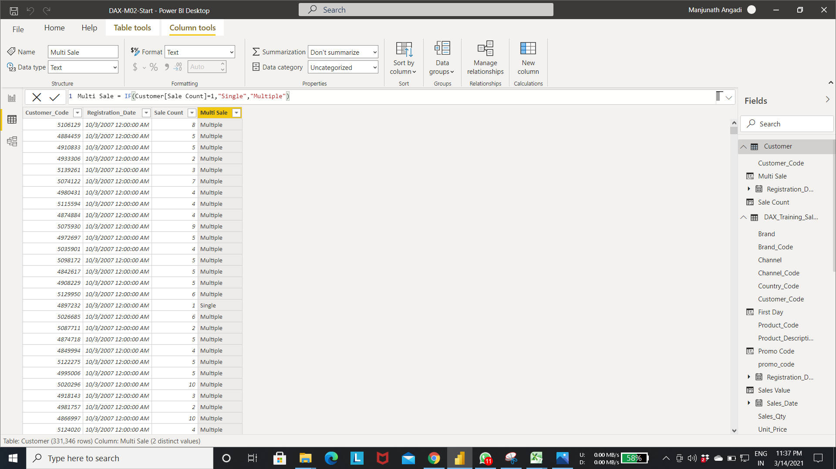

* Creating new date attributes calendar

Step 1:- Creating Sales Calender table by using the Group by Function. In below fig Sales calendar table is created with Sales Date column from the DAX_Training_Sales_Transactions column.

* Select the new table option in table Tools ->Enter the expression as shown in the fig.

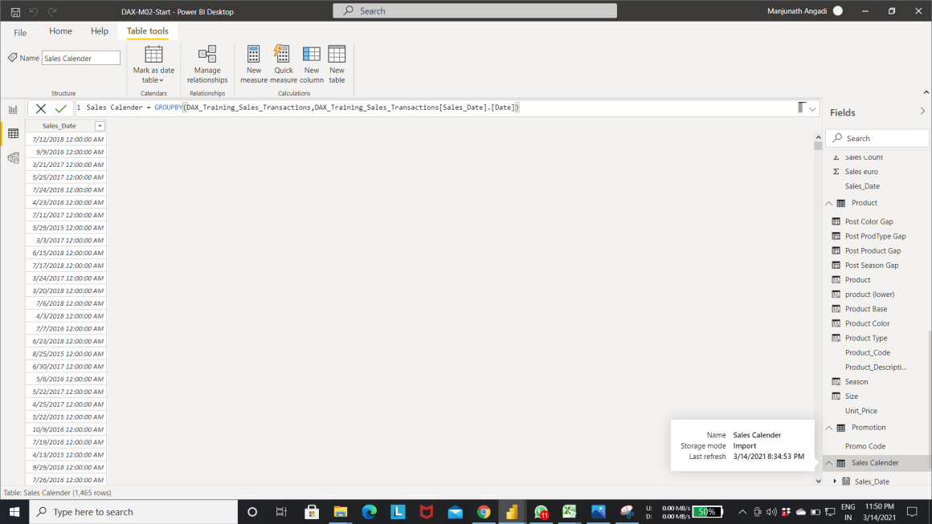

Step 2:- extracting year from Sales Date column using Format function as shown in fig.

* Select the new column the Sales Calender table-> Enter the below expression.
* “yyyy” indicates the year.

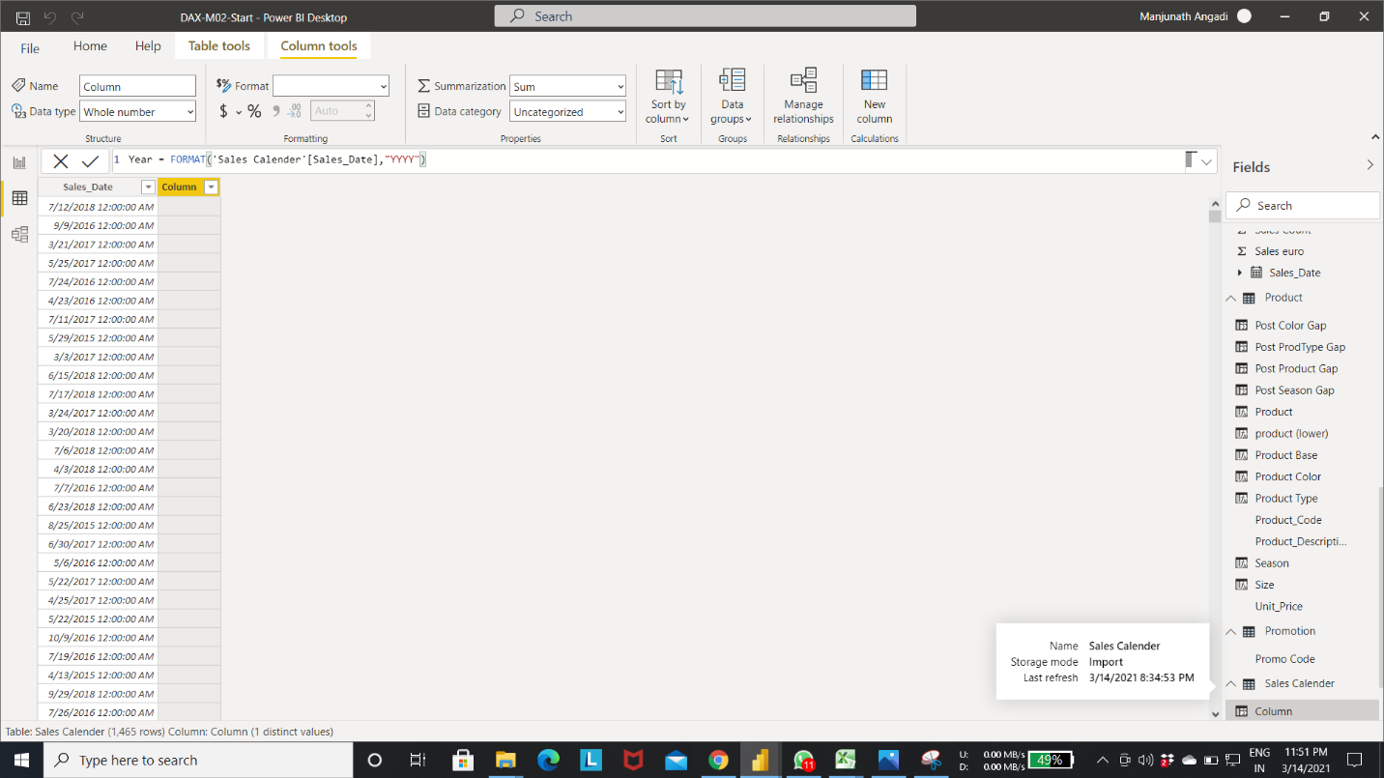

Ourput Step 2:-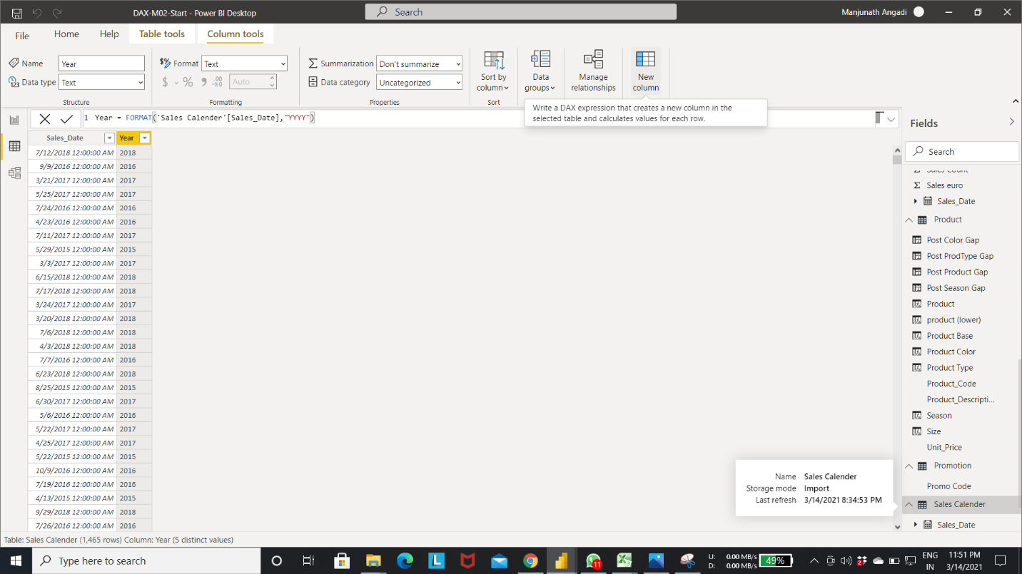

Step 3:- extracting “year-month” from Sales Date column using Format function as shown in fig.

* Select the new column the Sales Calender table-> Enter the below expression.
* “yyyy-mm” indicates the year-month.

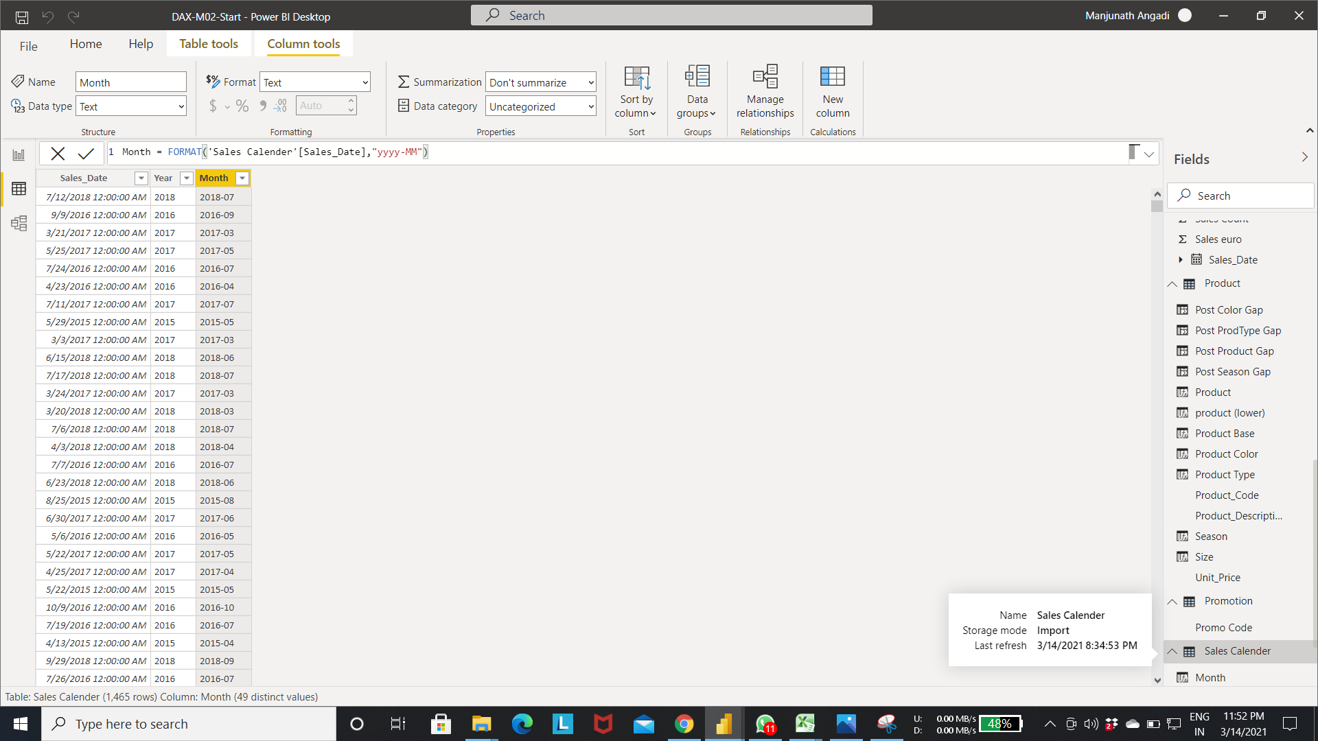

Output of step 3:-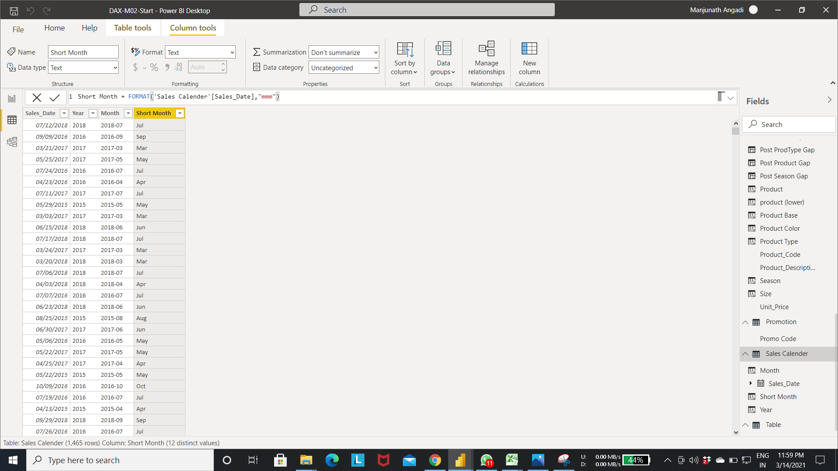

Step 4:- extracting month from Sales Date column using Format function as shown in fig.

* Select the new column the Sales Calender table-> Enter the below expression.
* “mm” indicates the month.

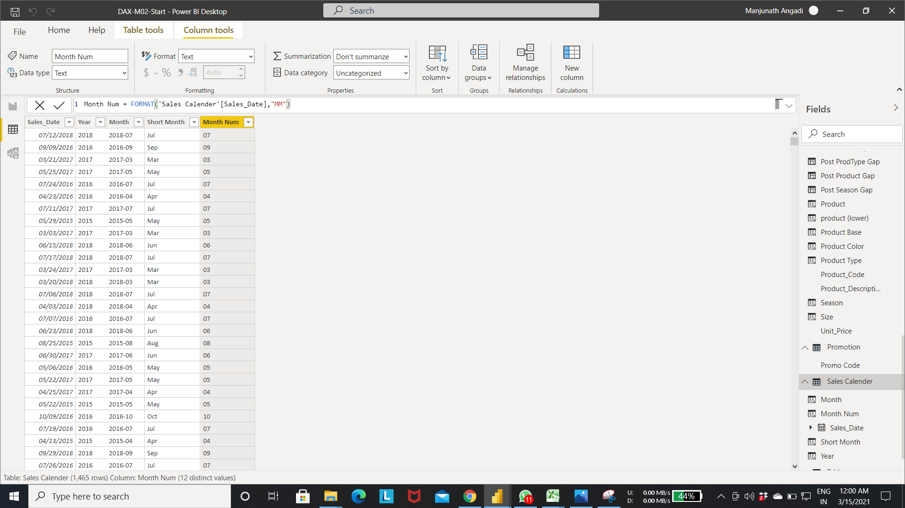

Output of step 4:-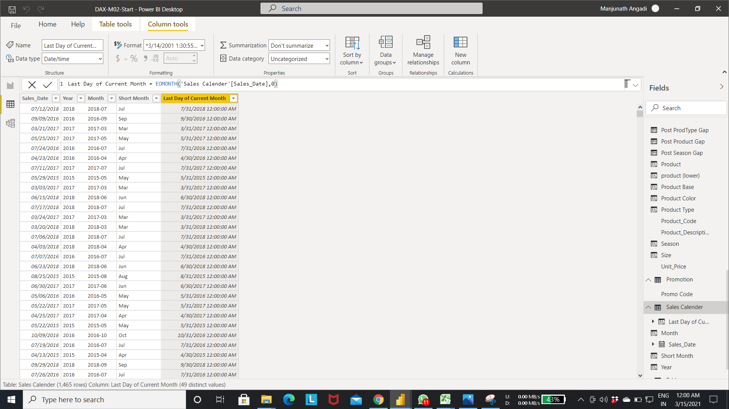

Step 5:- calculating the last date using the EOMONTH function.

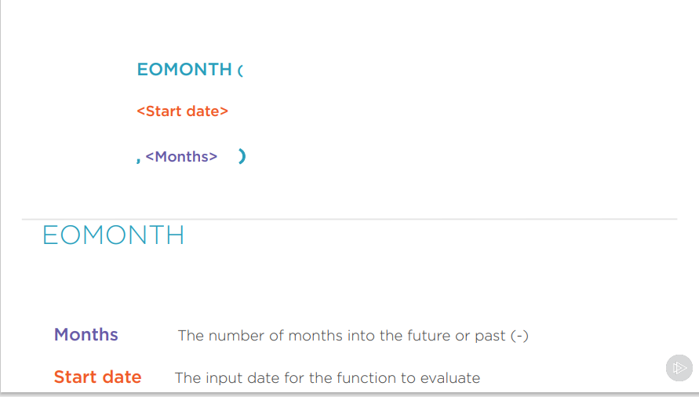

* Select the new column in Sales calendar table.-> Enter the expression as shown in fig
* Below expression calculate the last date of next month from current day.

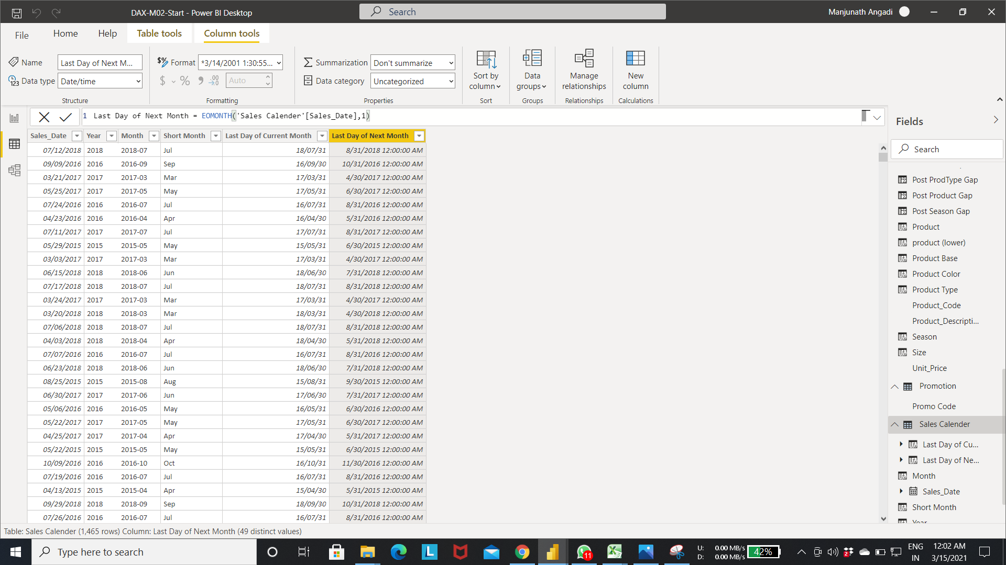

Step 6:- Select the new column in Sales calendar table.-> Enter the expression as shown in fig

* Below expression calculate the last date of premious month from current day.

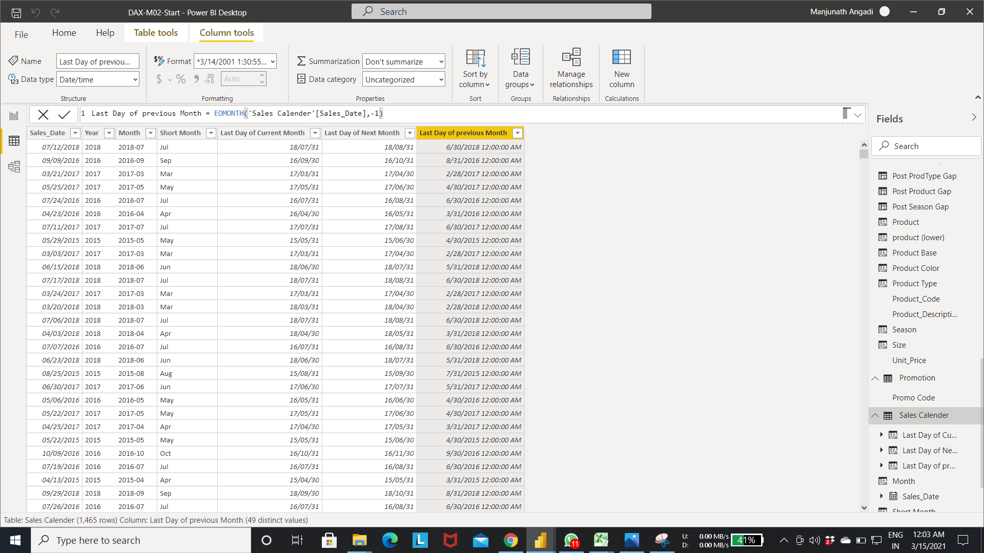

Step 7:- we can change the format of date column.

* Select the date column-> select the format option as shown in below fig to change to required format.-> select the date format.

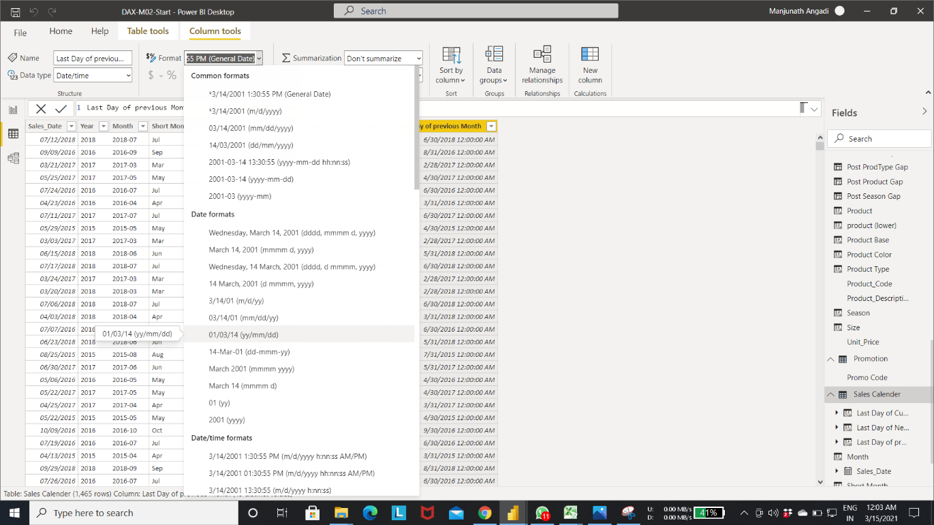

Output of step 7:-

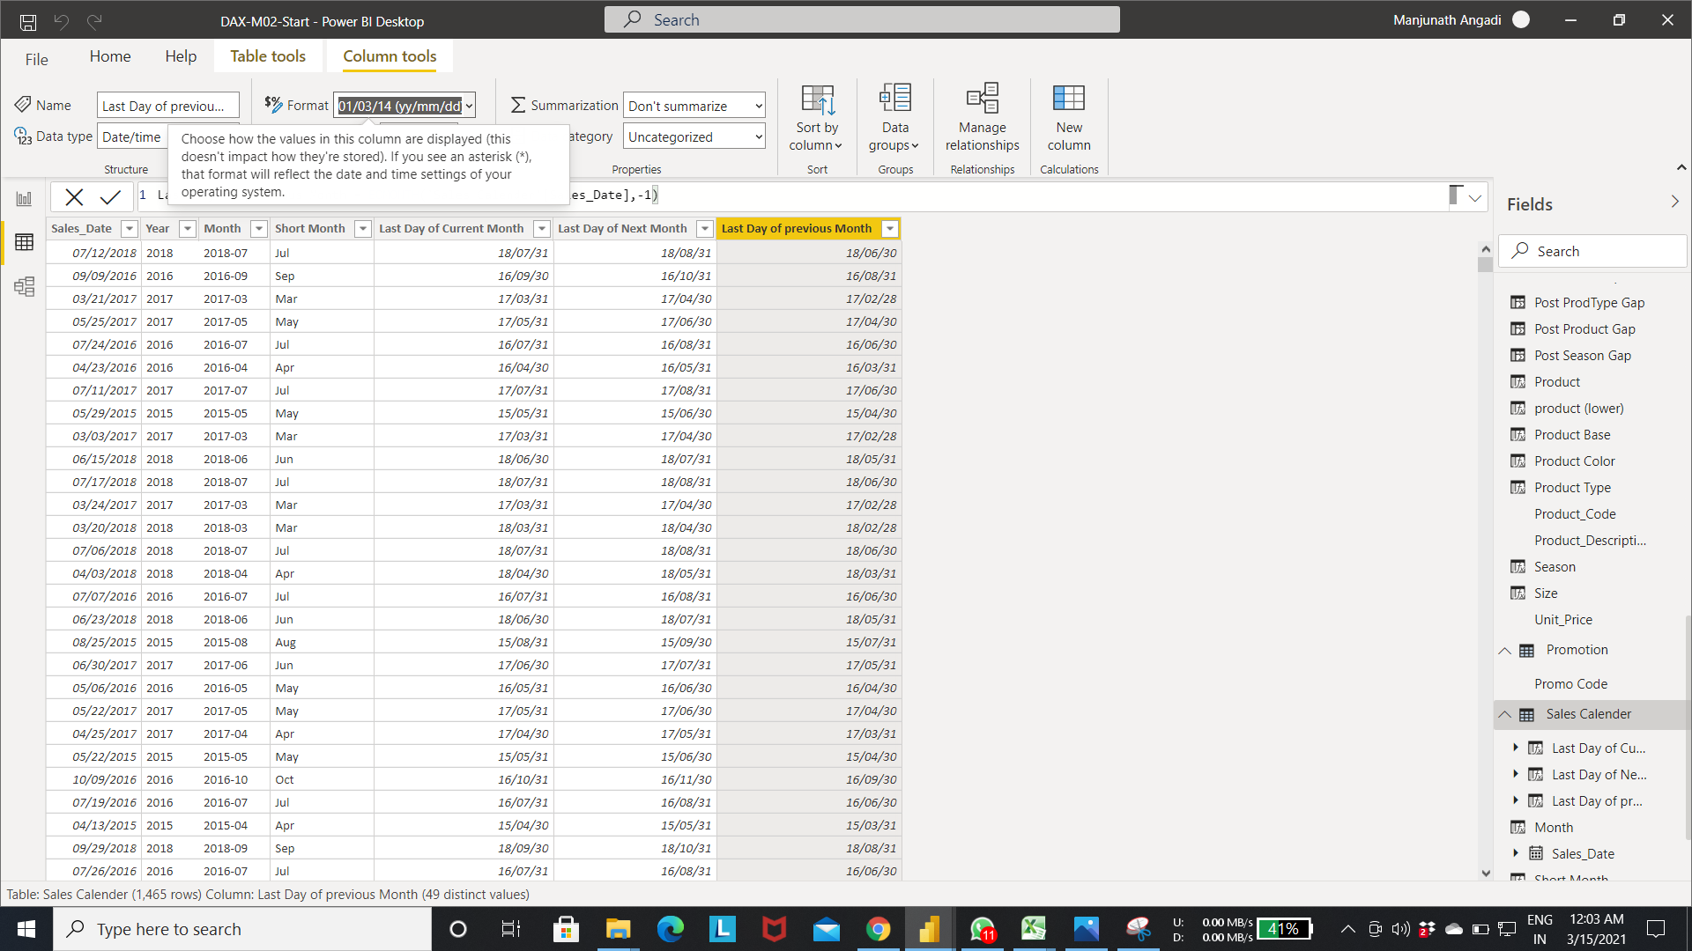

* Creating new date using DATE function.

Date Function:-

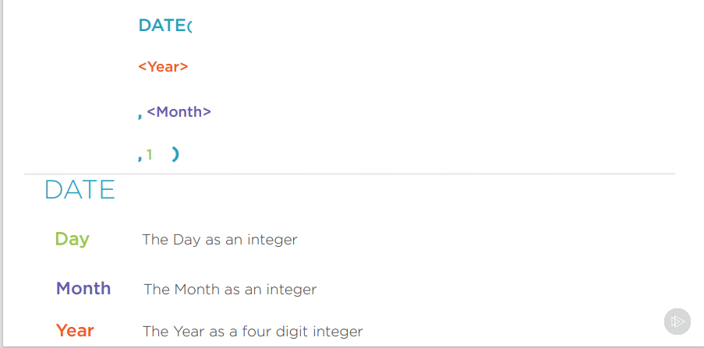

Step 8:- below fig creates the new date “First day of Month” with year, month from the sales date column and day as 1.

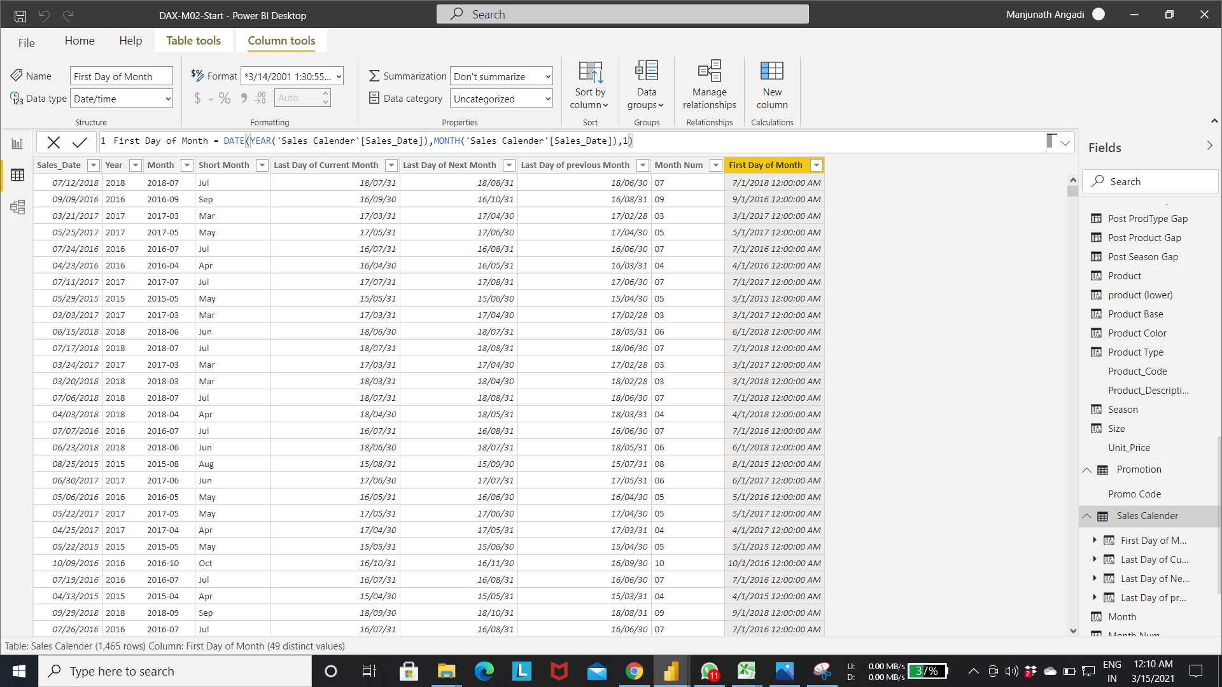

Step 9:- change the “First day of Month” to “dd/mm/yy” using format option.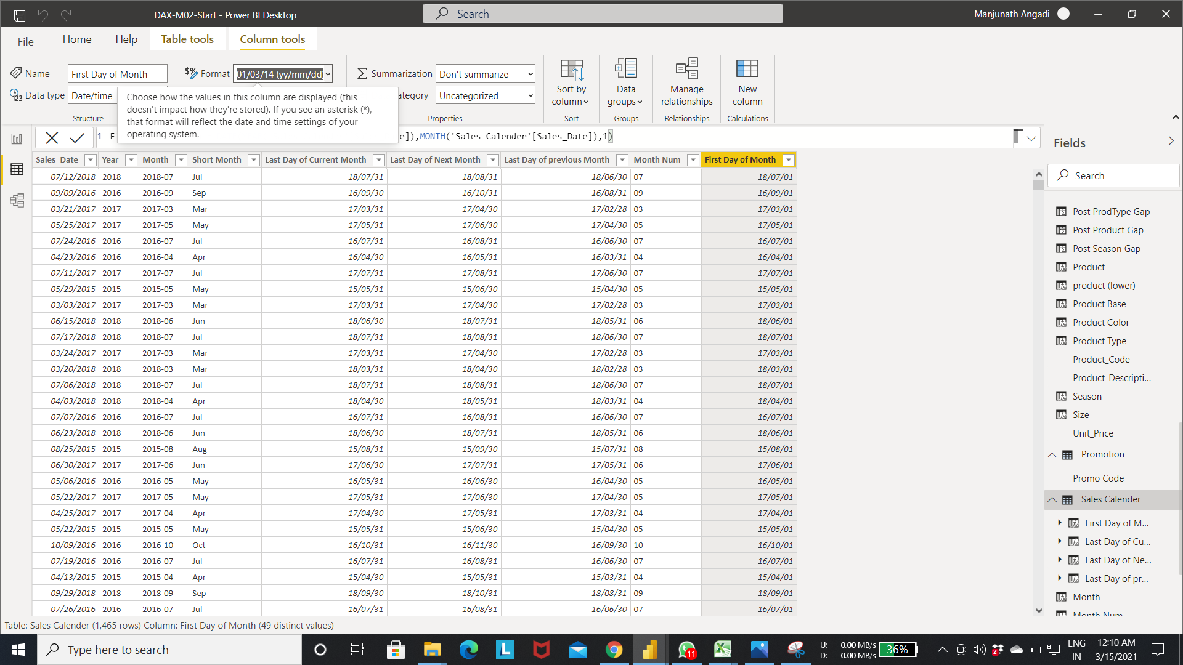

Step 10: using DATEADD function add month/year/ day to the current date.

DATEADD function:-

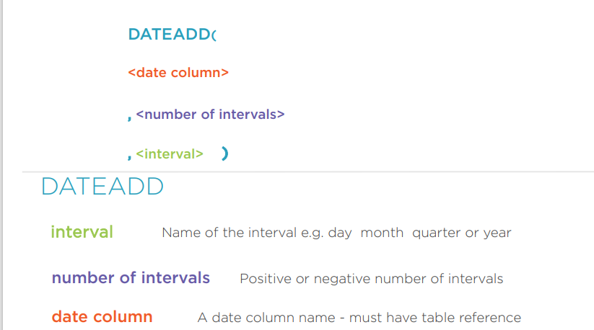

* Select new column in the Sales calendar table->Enter the expression as shown in below fig.
* The below expression substract the 1 month from the current date(calculate the previous month date with current year and month).

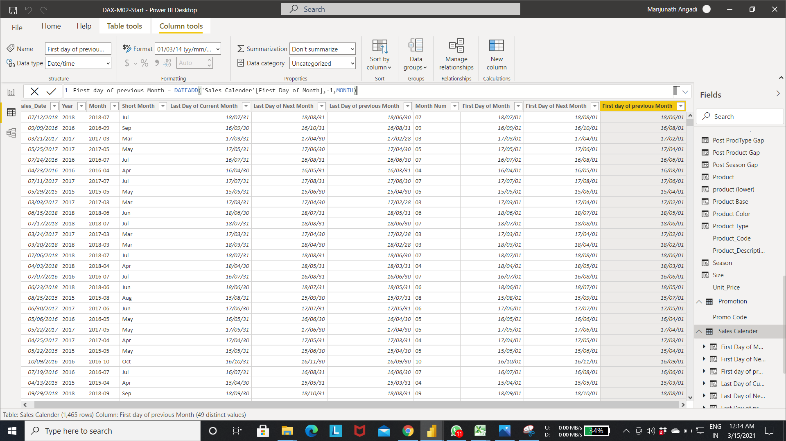

Step 7:- Calculating Sales week from the Sales date using the weeknum function.

WEEKNUM function:- Takes the date as input and return the weeknum of the date.

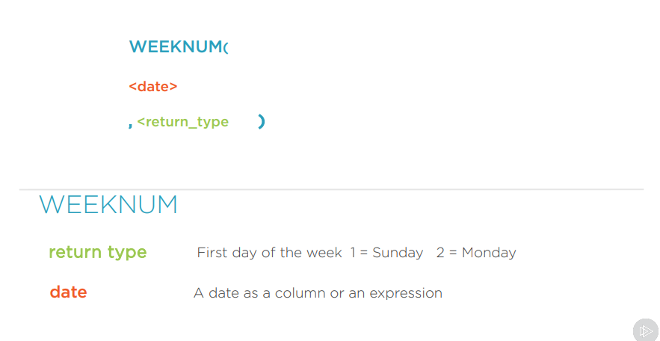

* Select the new column in the Sales Calender table->enter the expression as shown in fig.
* The below expression calculate the weeknum using current date.
* Extract the year using year function.
* Combine the year and weeknum using the combinevalues function.

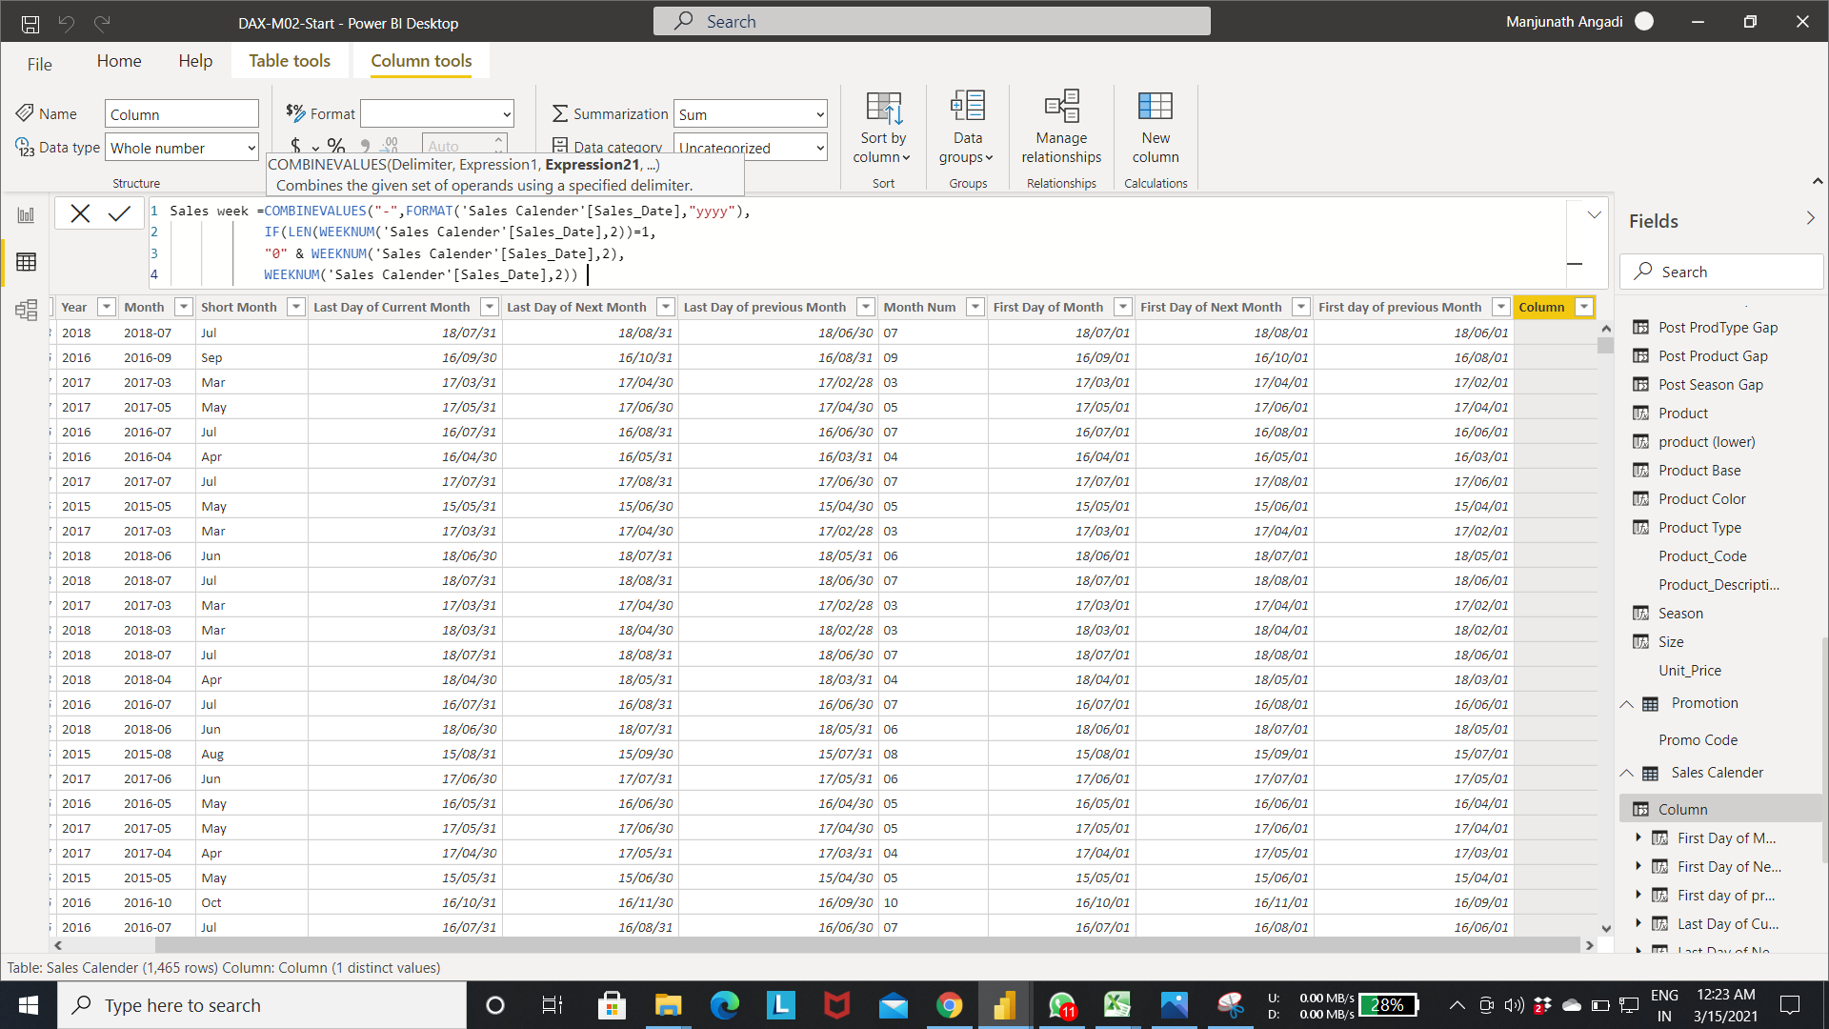

Output of step 7:-

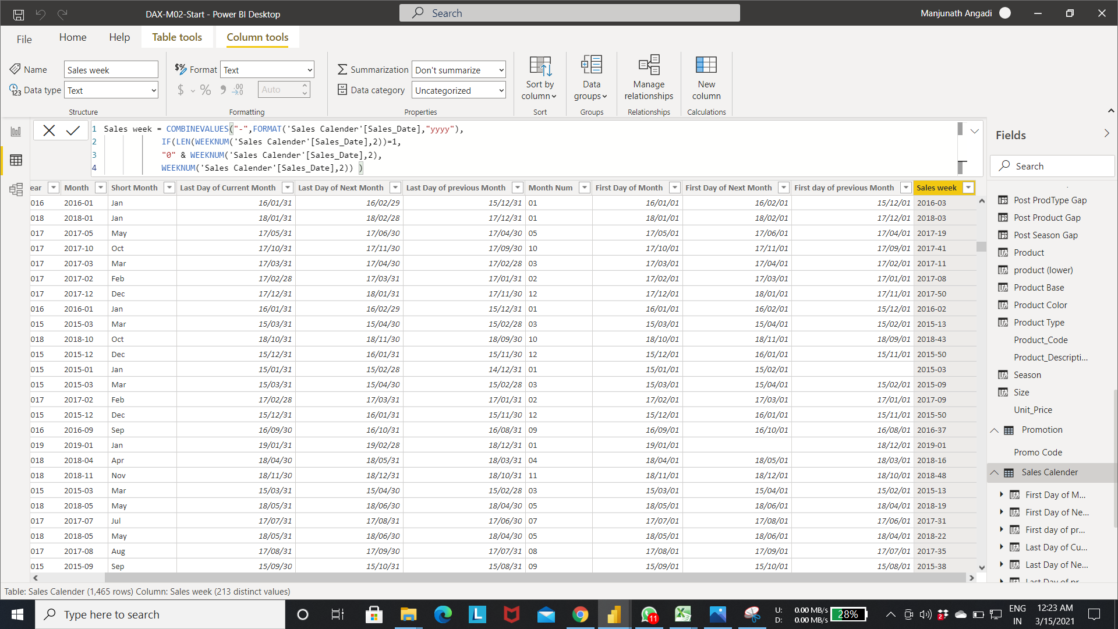

Step 10:- fetching day of week using the format function.-> select the new column-> enter the expression as shown in fig.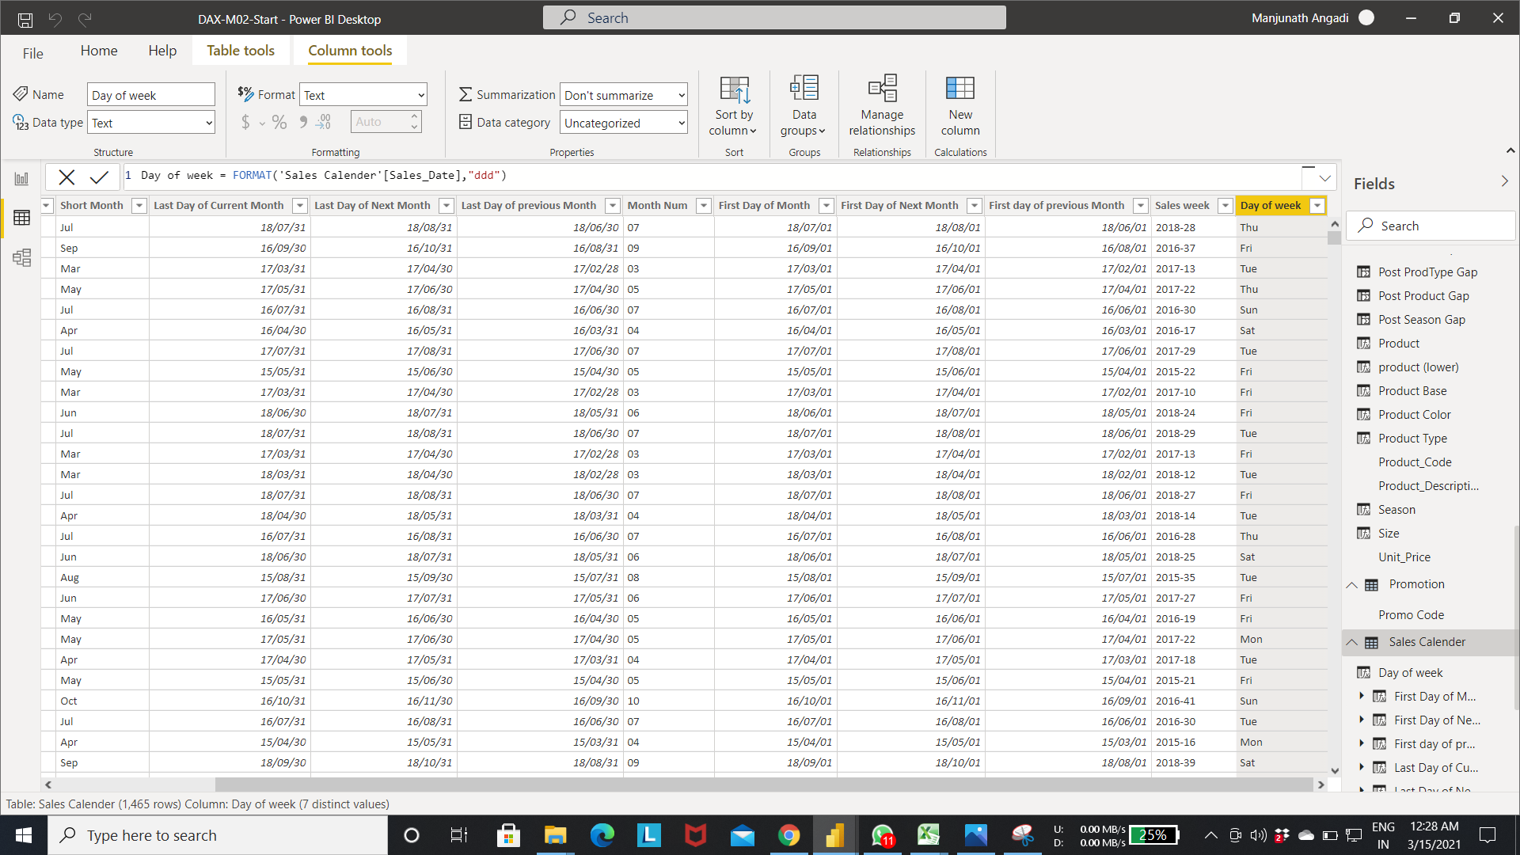

Step 11:- Below fig shows the calculating the last day of the previous week using the sales date column values.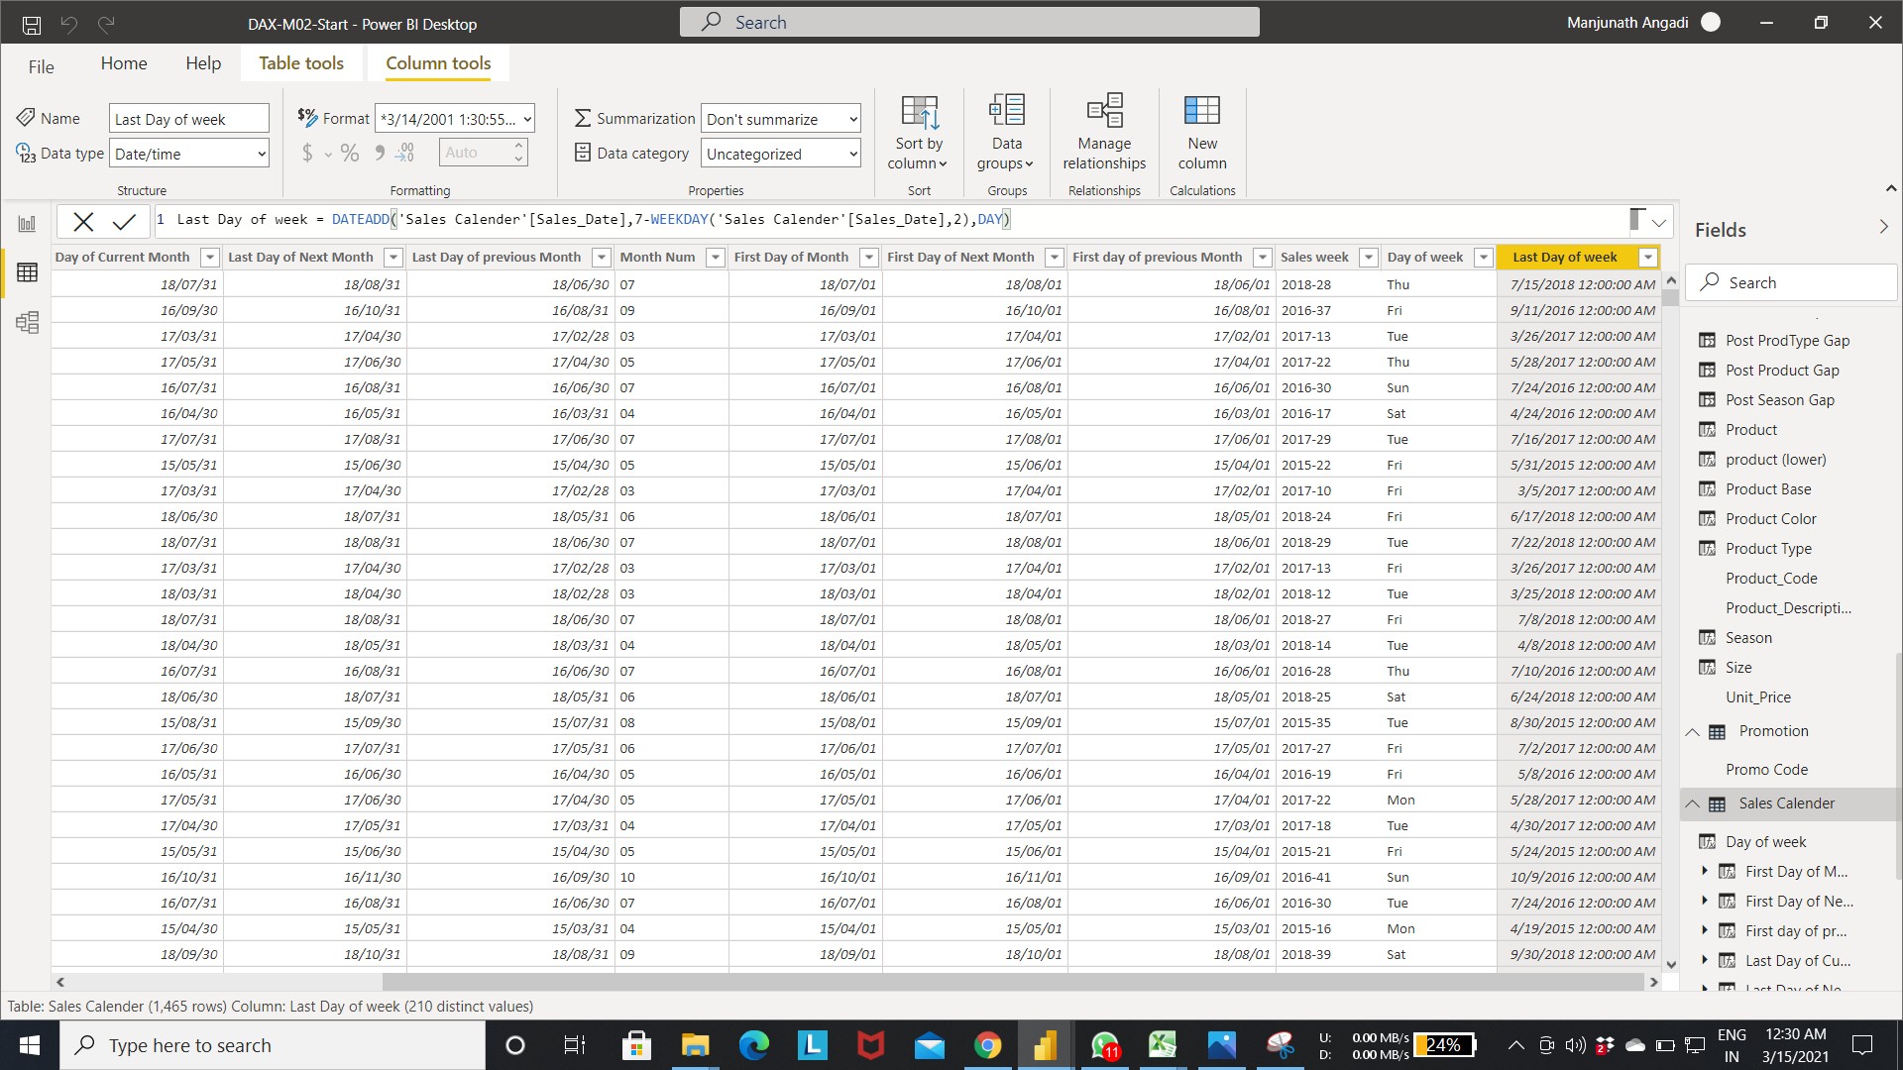

Step 12:- formatting the Last Day of week to dd/mm/yy.

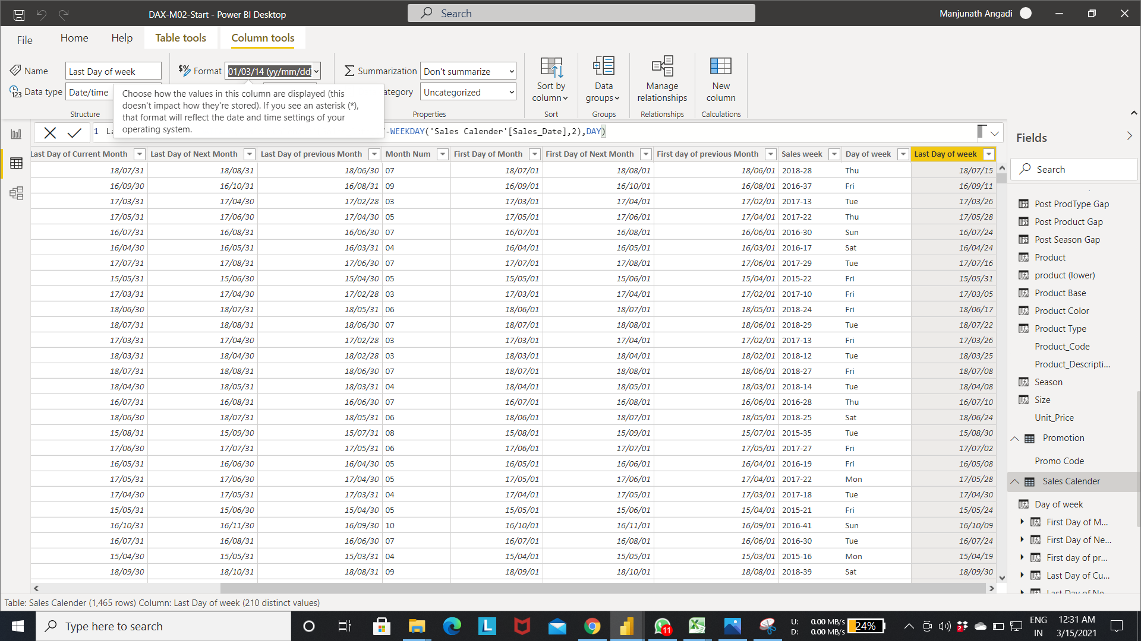

Step 13:- calculating the first day of week using the Sales_date column value

* In Below fig weekday function calculate the first day of week
* Date add function subtract “output from previous step” with the Salesdate.

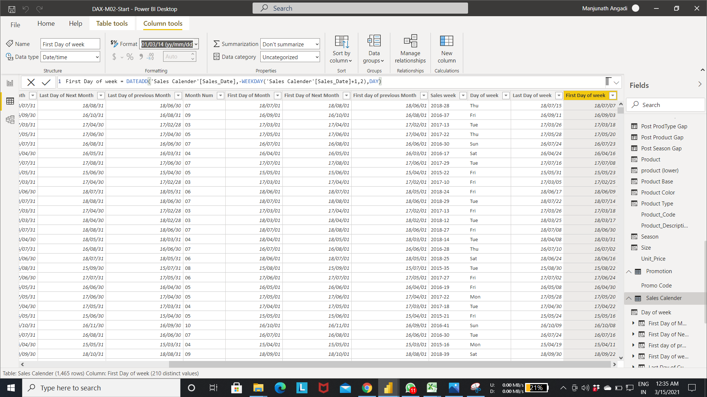

Step 14:-Change the “First Day of week” to yy/mm/dd format.

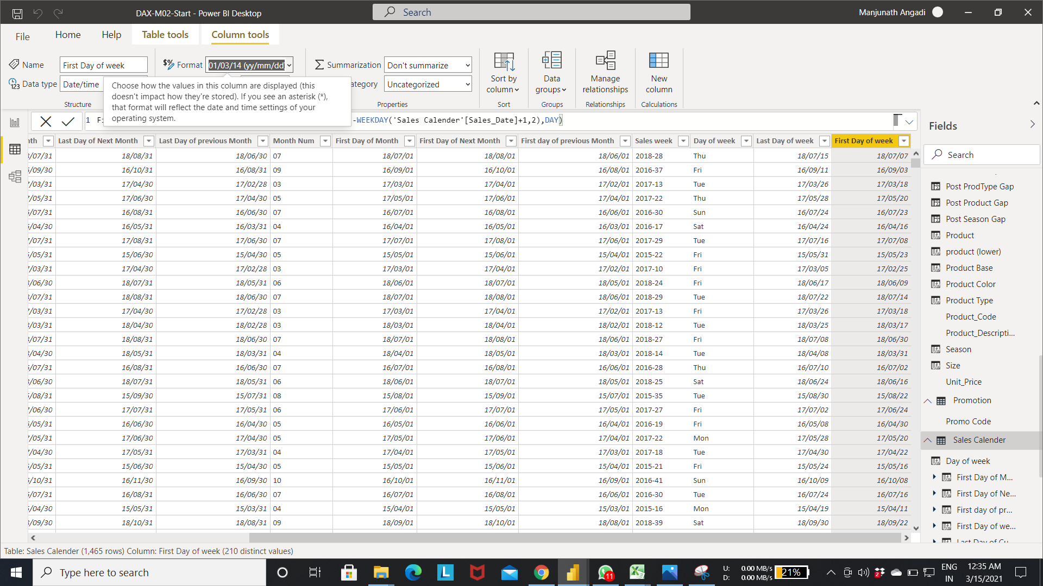

Step 15:- calculating the last purchase date of customer

* Create a new column in the customer table.->Enter the expression as shown in fig.
* The below expression fetch the Sales date for customer from the metrics table and calculate the latest date.

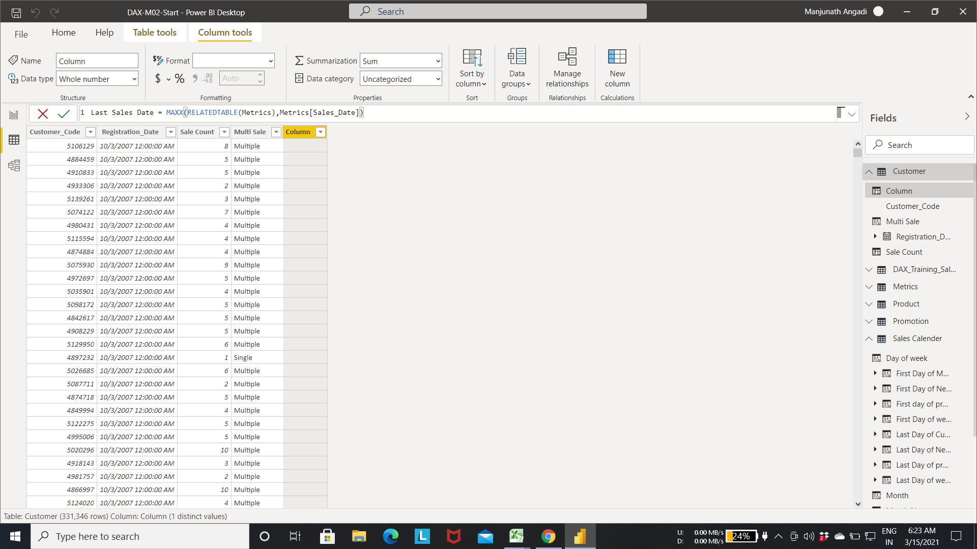

Step 16: Changing the last Sales Date to “yyyy-mm-dd” format from the format menu.

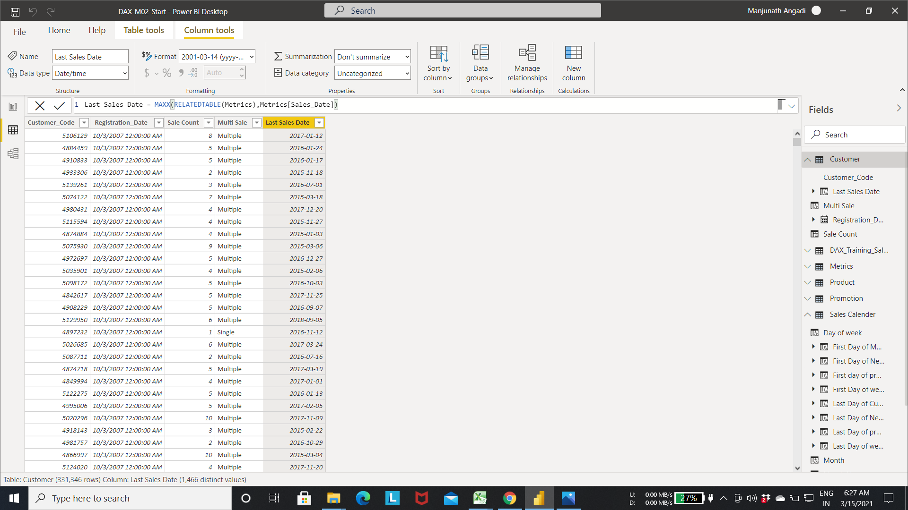

* Creating a metrics From Aggregate functions.

Step 1:- Select a new measure in the Metrics table as shown in fig.

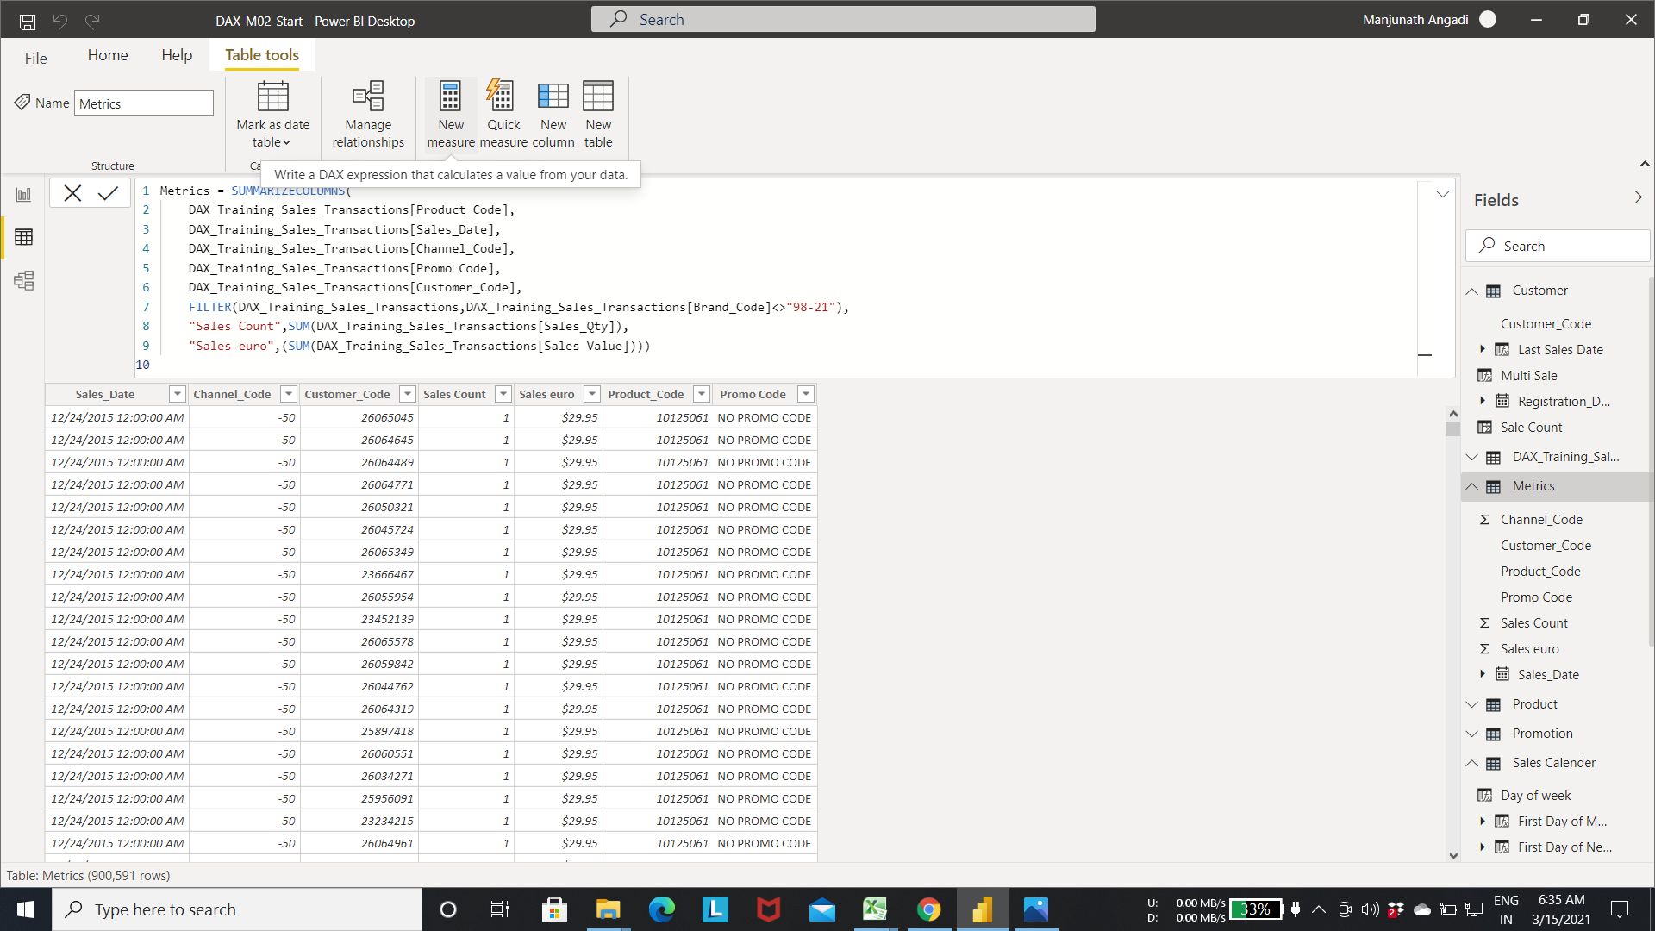

Step 2:- calculating the sum of sales each customer using the sum function.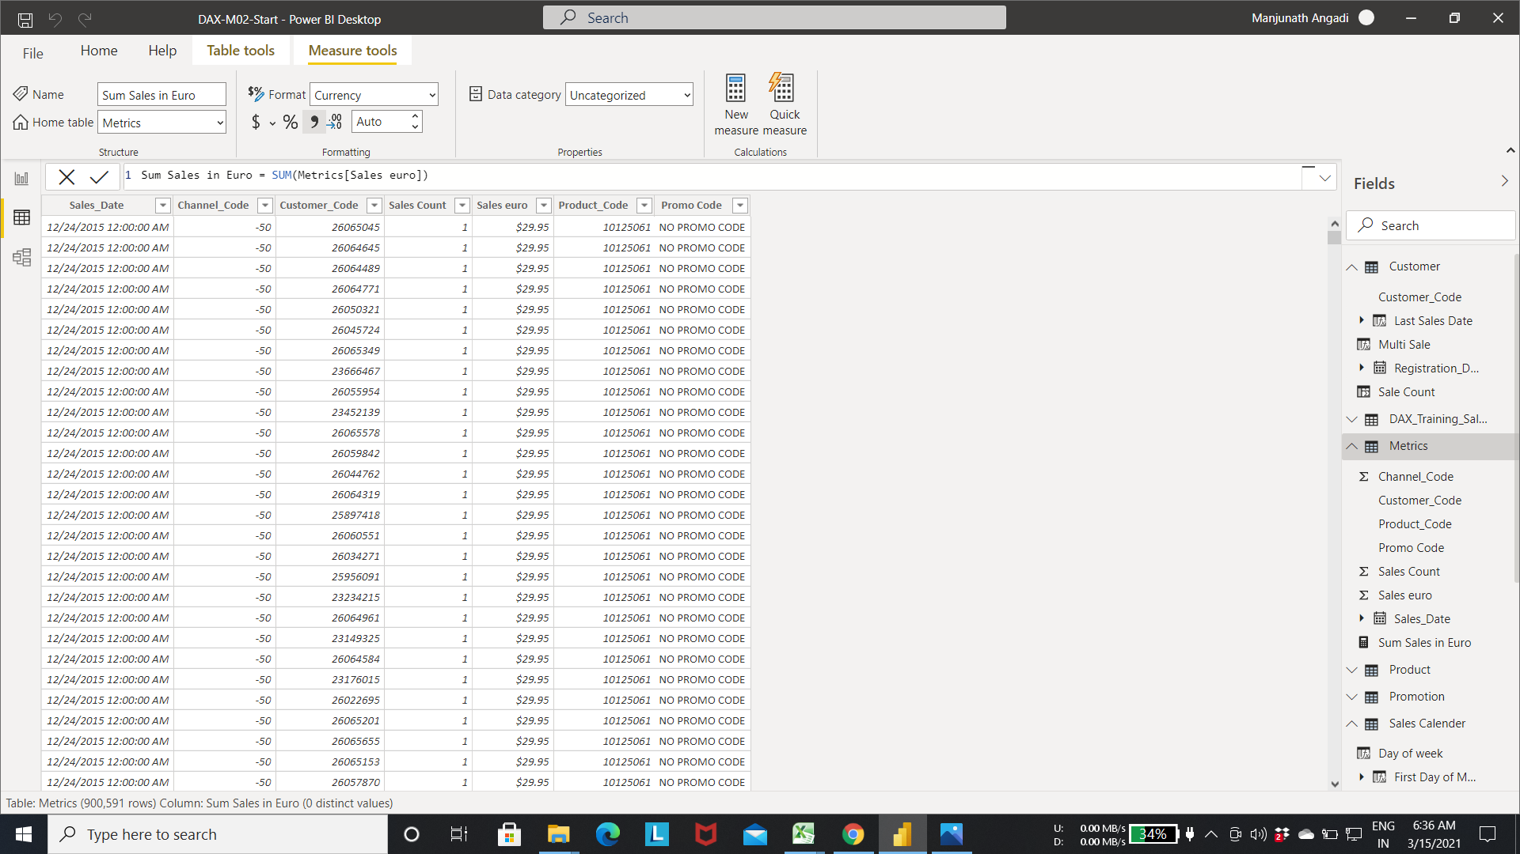

Step 3:- calculating the average sales of each customer by creating the Average Sales measure.

* select the new measure in the metrics table->Enter the below expression

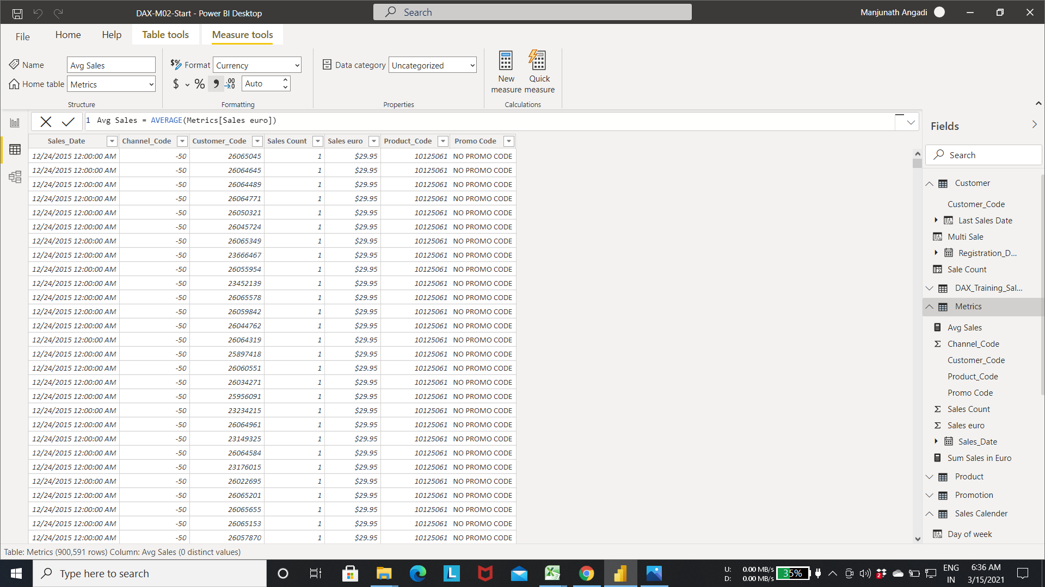

Step 4:- calculating the median by creating the Median in euro measure in metrics table.

* select the new measure in the metrics table->Enter the below expression.

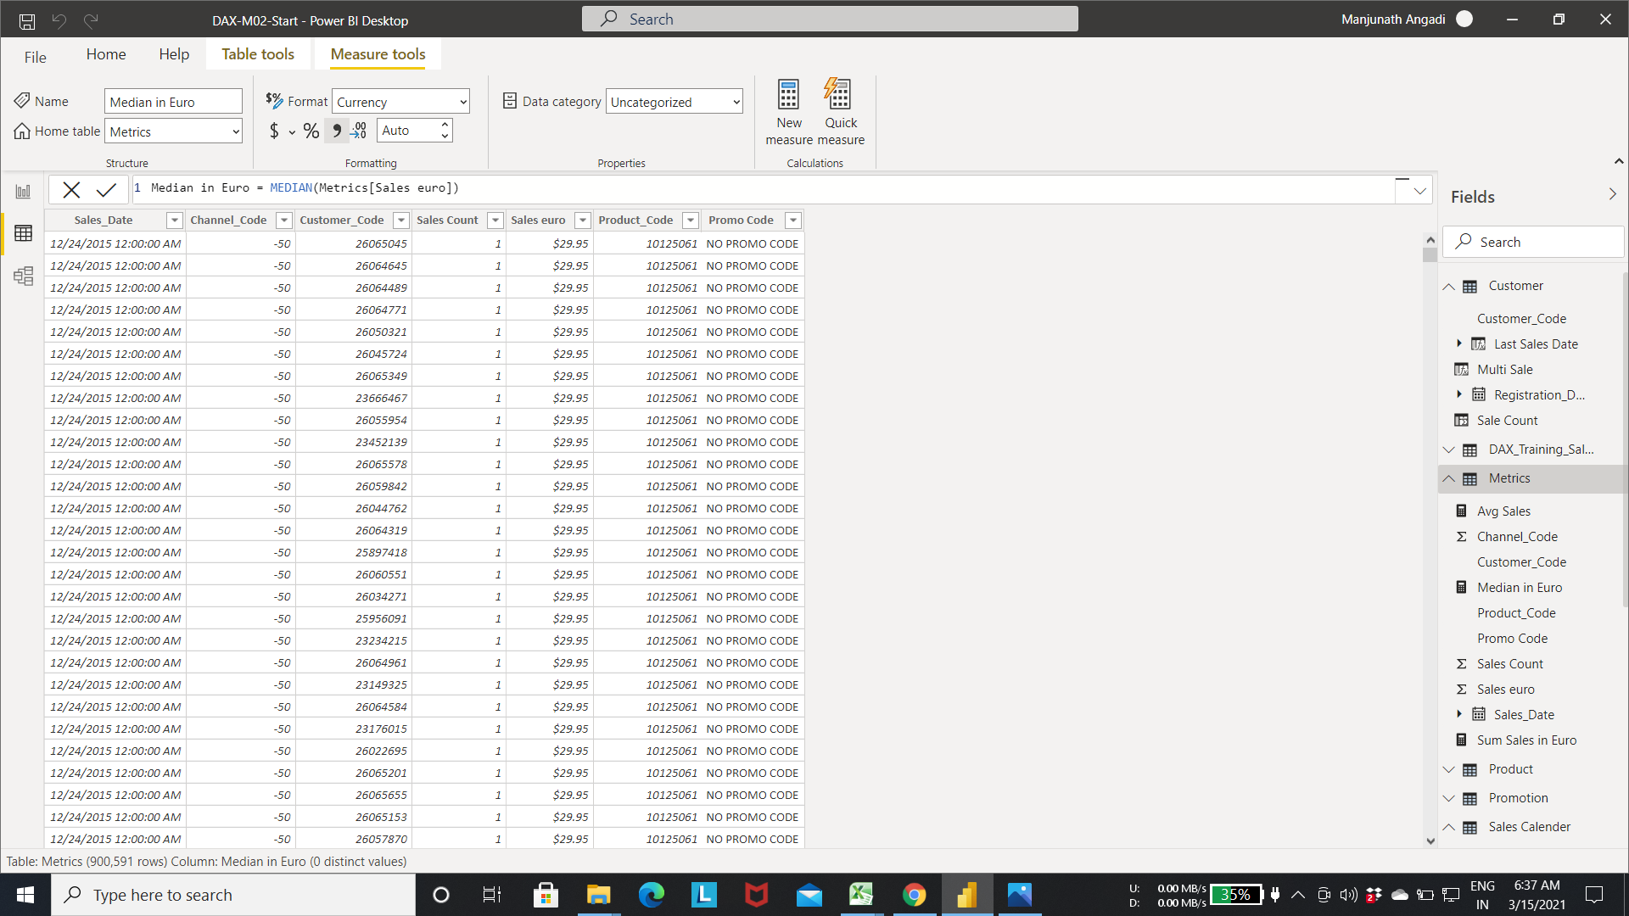

Step 5:- calculating the Maximum sales amount by creating the Max Sale measure.

* select the new measure in the metrics table->Enter the below expression.

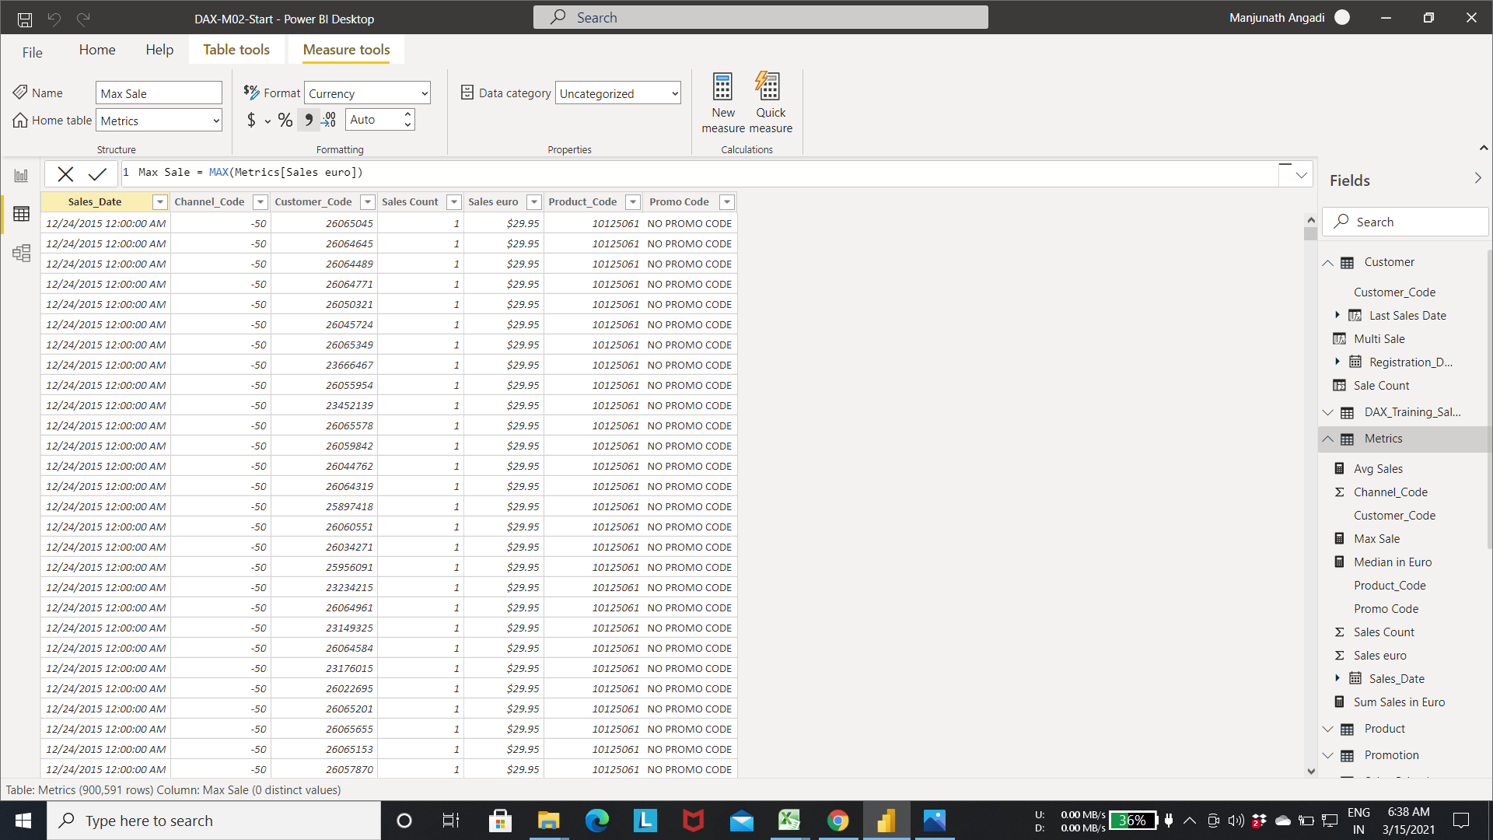

Step 6:- calculating the Minimum sales amount by creating the Min Sale measure.

* select the new measure in the metrics table->Enter the expression as shown in fig.

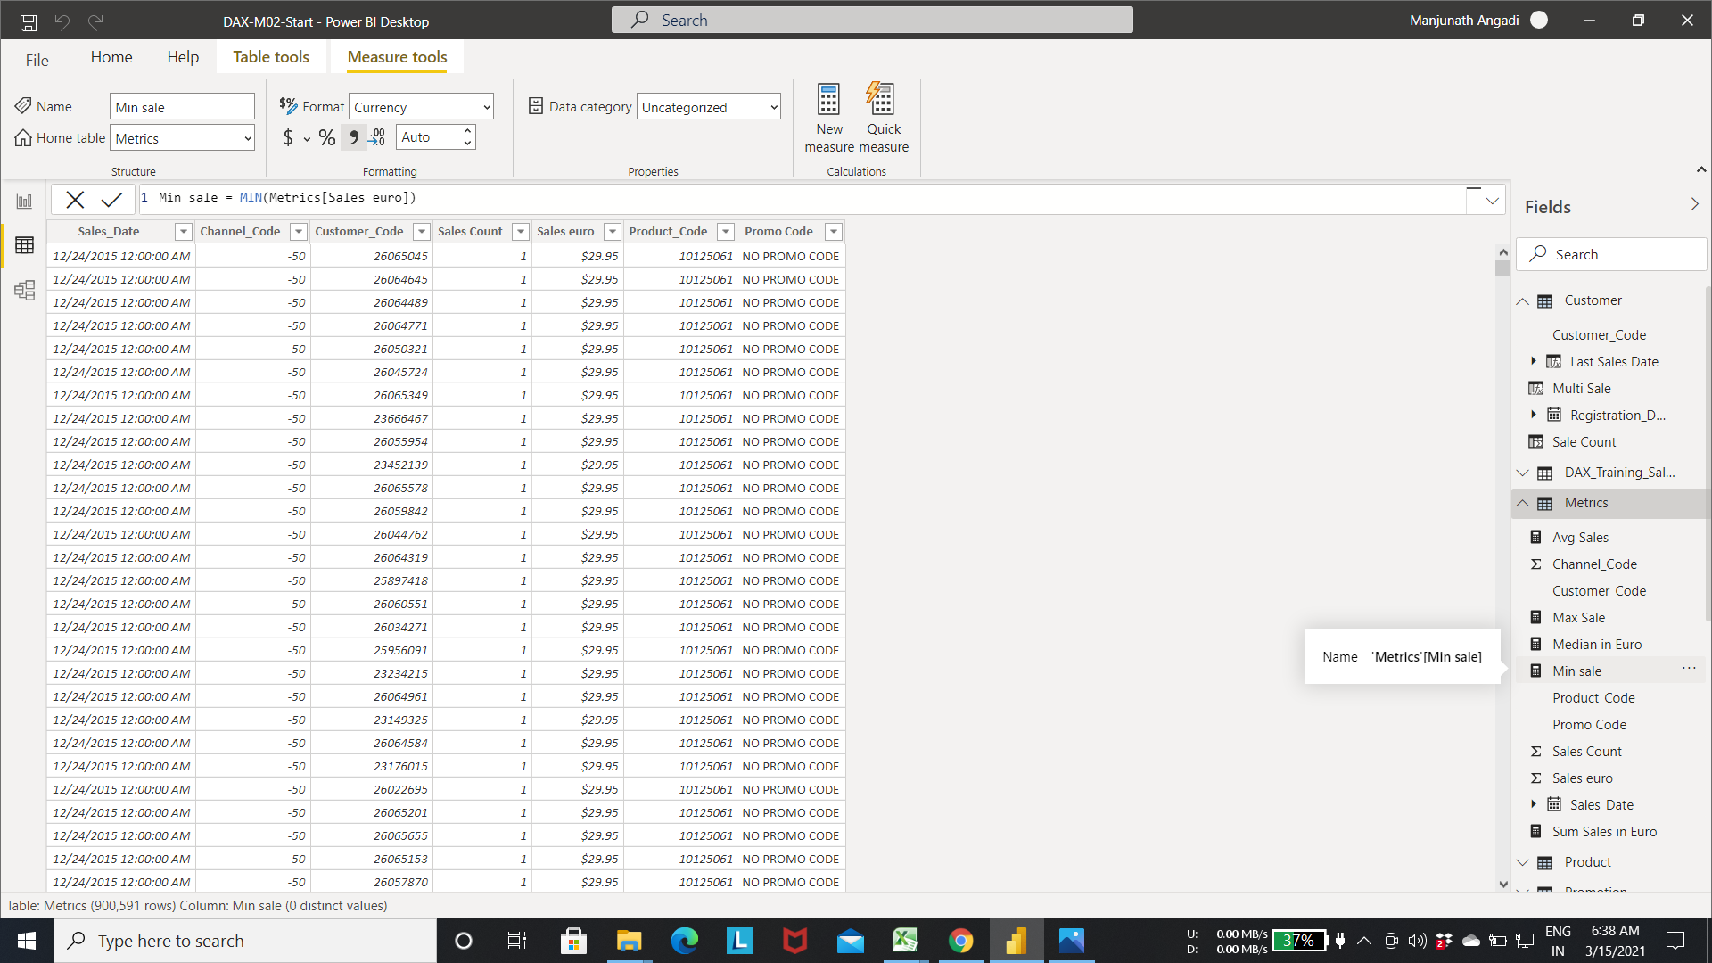

Step 7:-Calculating the count of all distinct customer using the distinct count measure.

* select the new measure in the metrics table->Enter the expression as shown in fig.

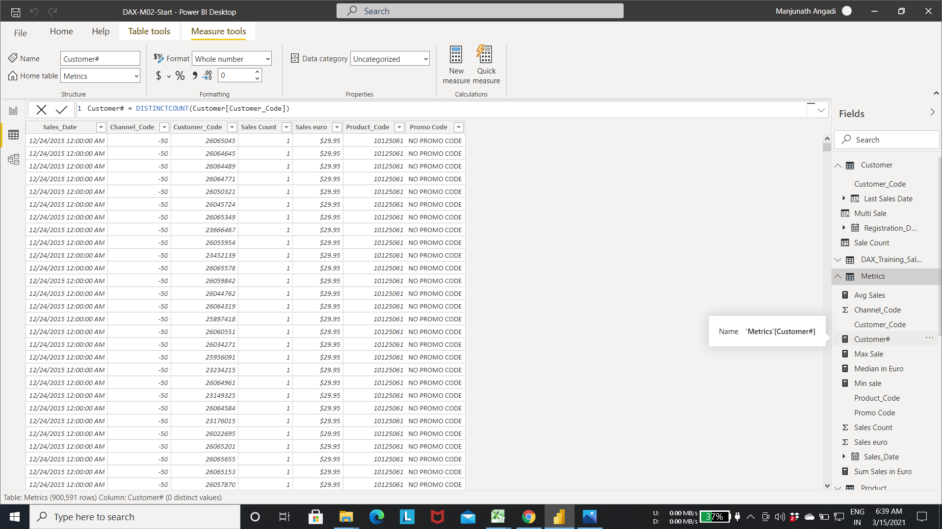

Step 8:- We can change the currency symbol using the format option.

* Select the measure/ column you want to change->Go to format option as shown in fig-> change the symbol based on requirement.

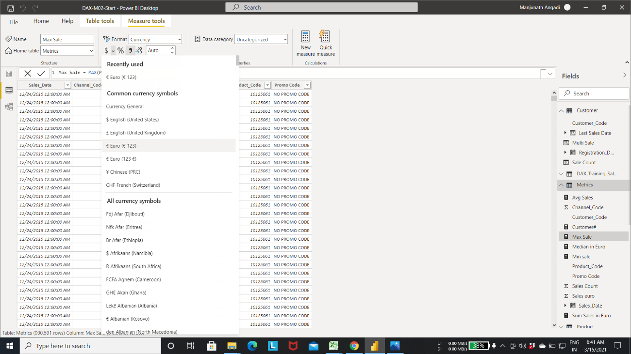

Step 9:- Adding recently created measures to the visualization using the card layout.

* Select the card visualization from the visualizations tab-> add the measures to see the measure values in action.

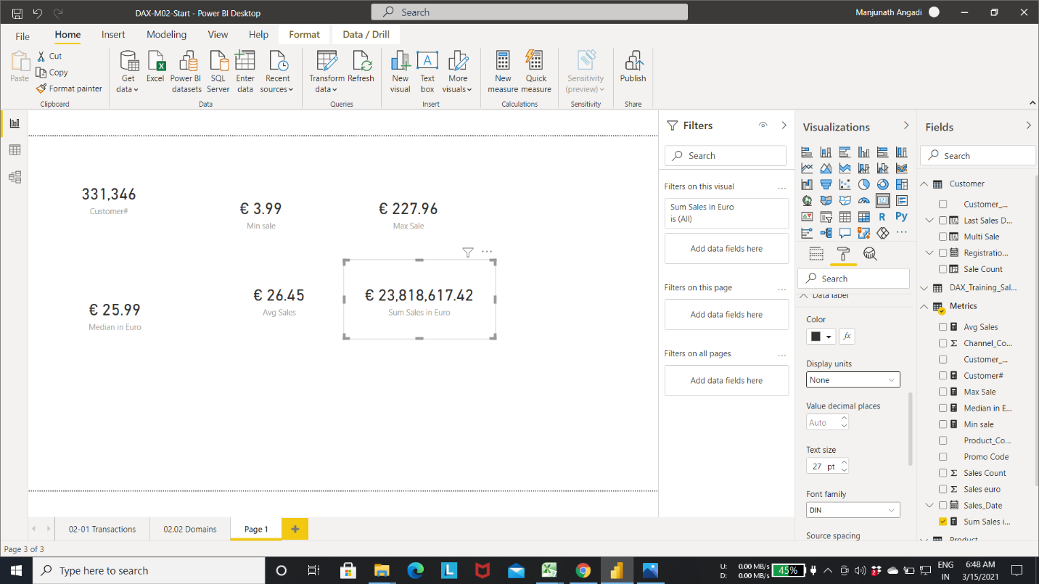

Step 10:- Calculating the total Sales quantity using the sum function.

* Select the new measure in the metrics table-> enter the expression as shown in the fig.

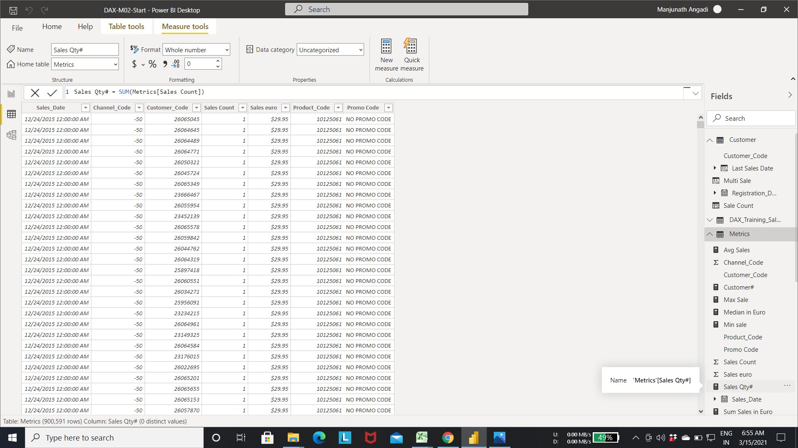

Step 11:Calculate the total rows in metrics table using the COUNTROWS() function.

* Select the new measure in the metrics table-> enter the expression as shown in the fig.
* Below fig calculate total rows in the metrics table.

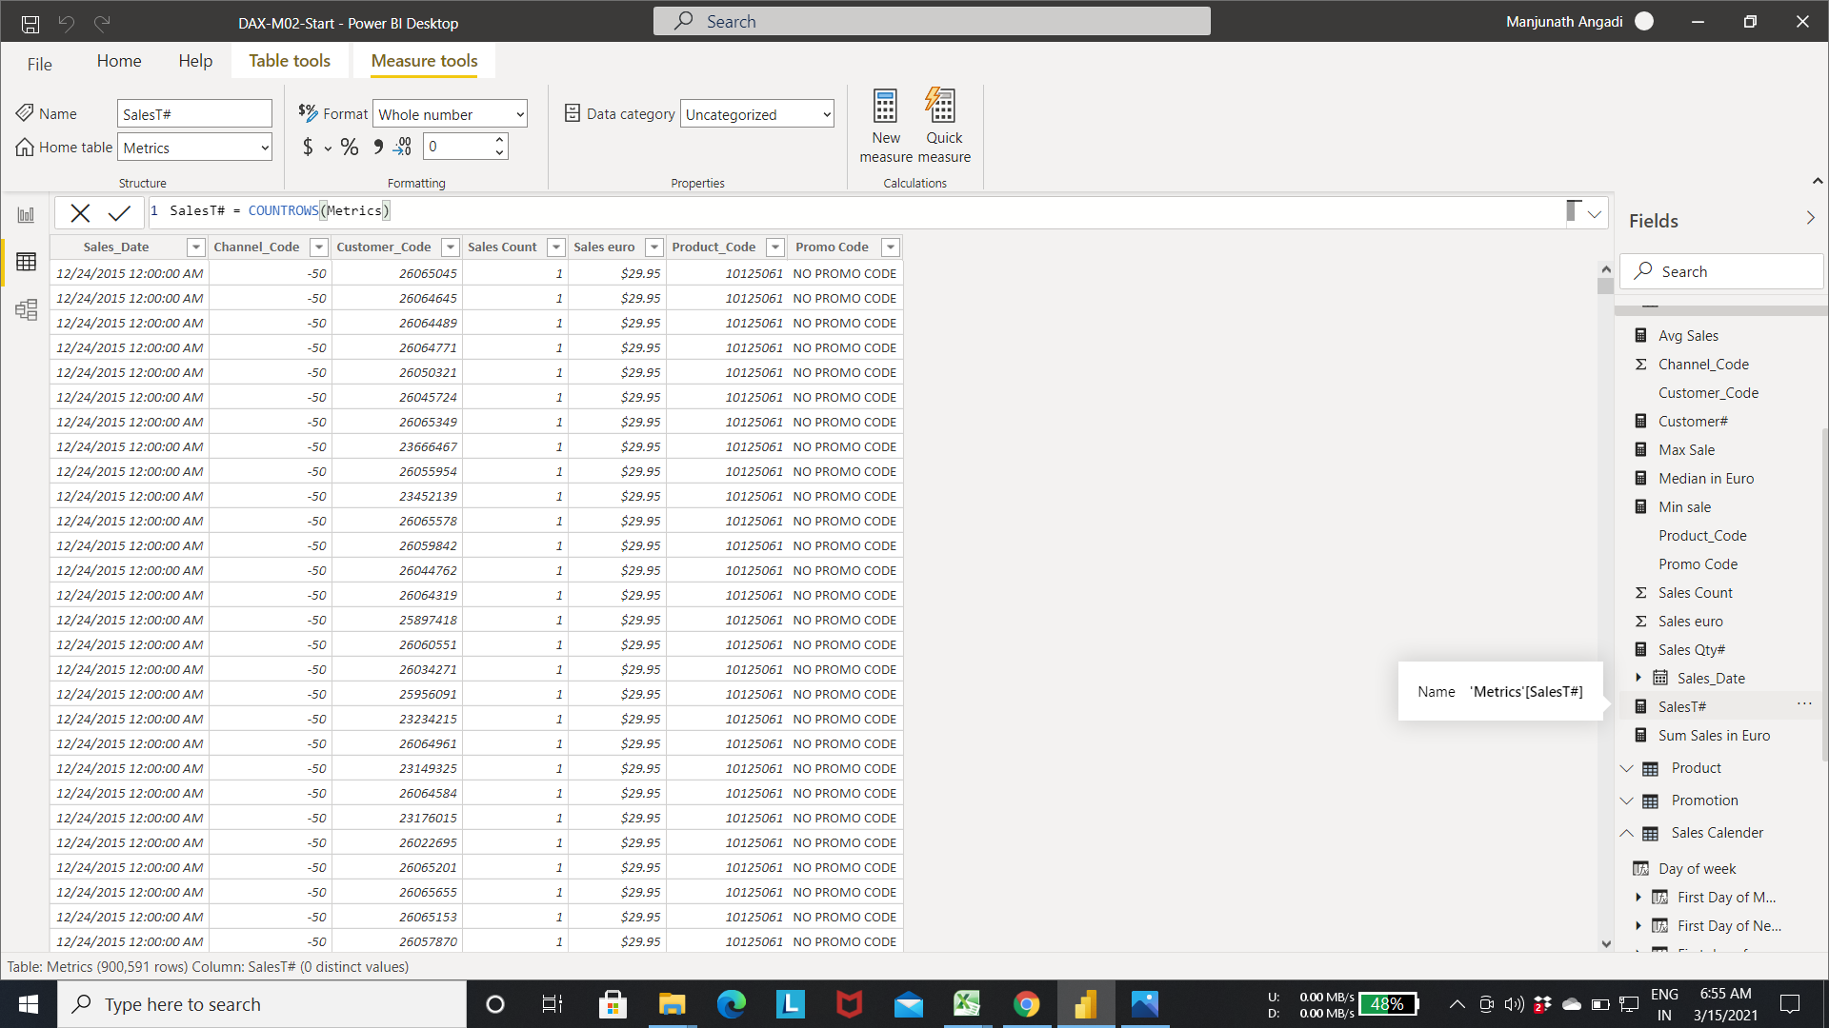

Step 12:- creating table visualization with attributes from the metrics and Product table.

* Select Customer_code,Sales euro,Sales QTY,Sales T, sum sales in euro from the Metrics table.
* Select Product and Unit Price from the Product table.

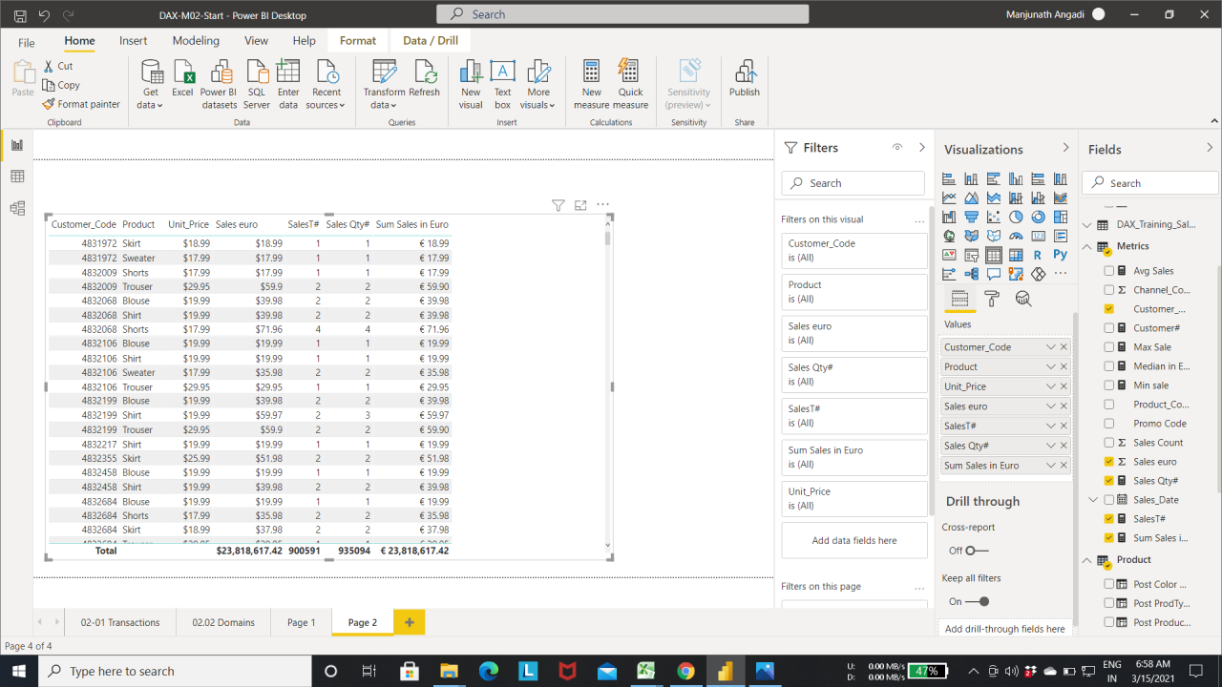

Step 13:- Select a new column Customer Table.

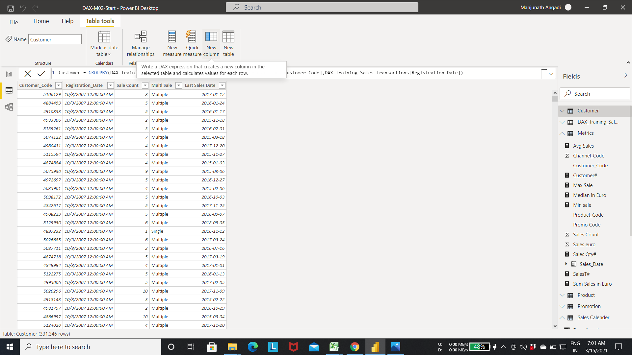

Step 14:- calculating the total number of transaction made by the customer.

* Fetch the total number of transaction(Count of rows for each customer) metrics table.

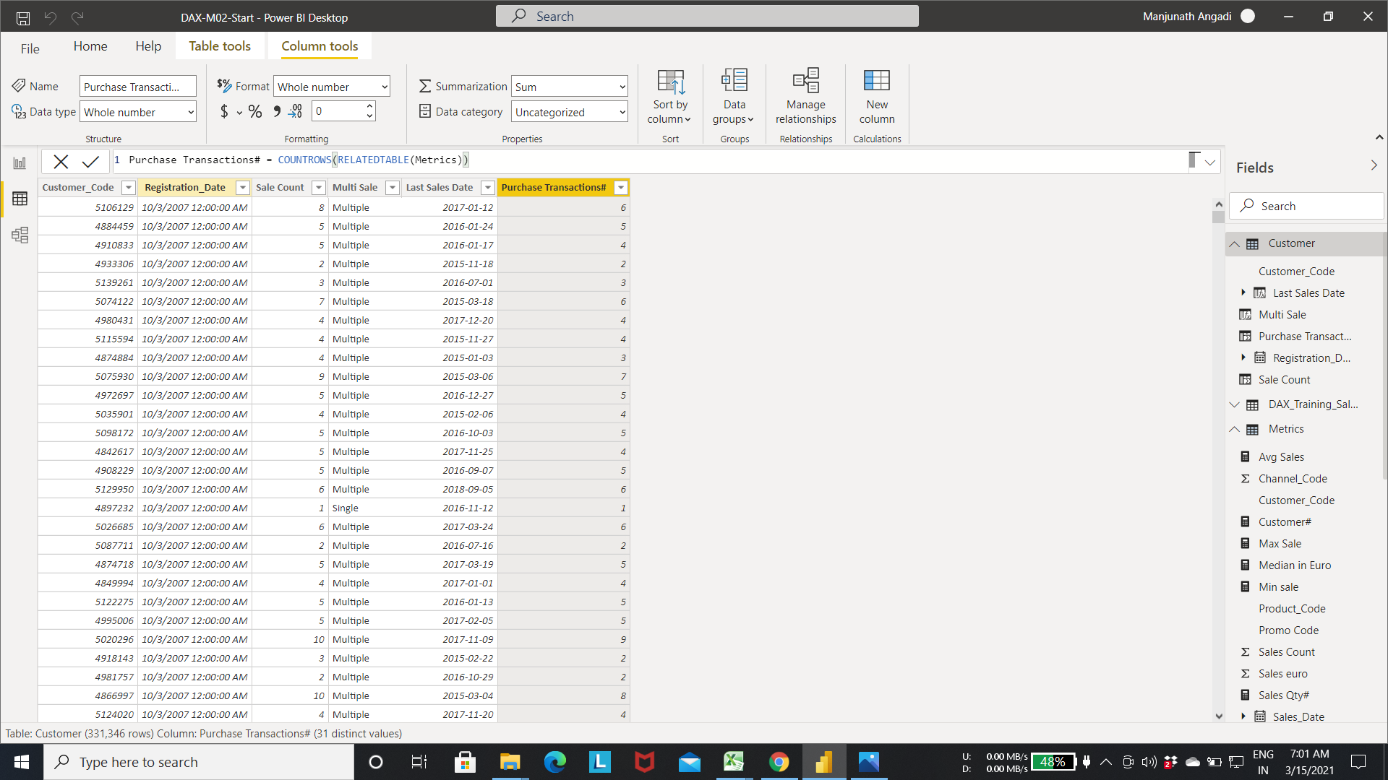

Step 15:-Calculating the total Units purchased by the customer using the below Expression.

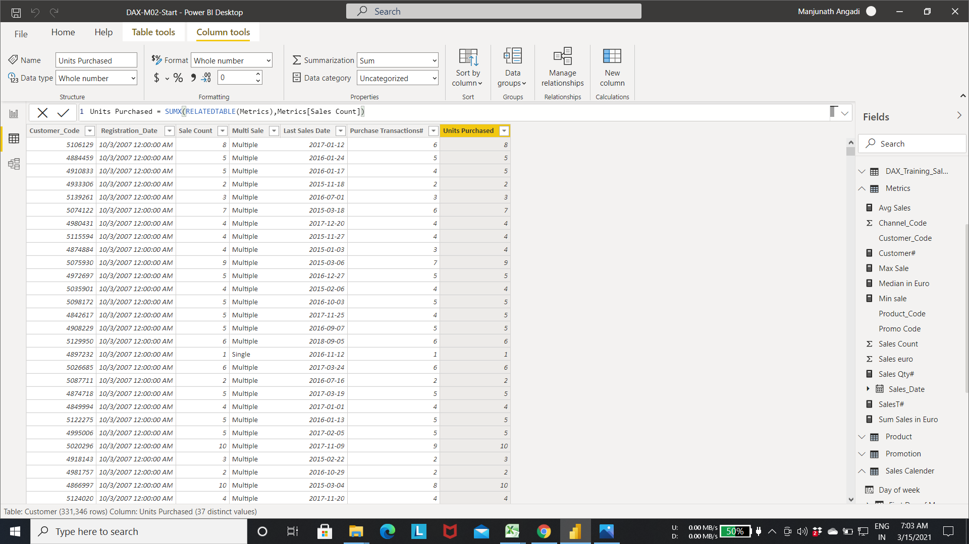

**K06:Able to include Calculated Metrics in a Chart or Table, Filter Metrics with Time Intelligent Functions.**

**Calculated Metrics in a Chart or Table**

Step 1:- Addding Product_code, Sales_Count, Sales_euro, Avg Sales attribute to table visualization.

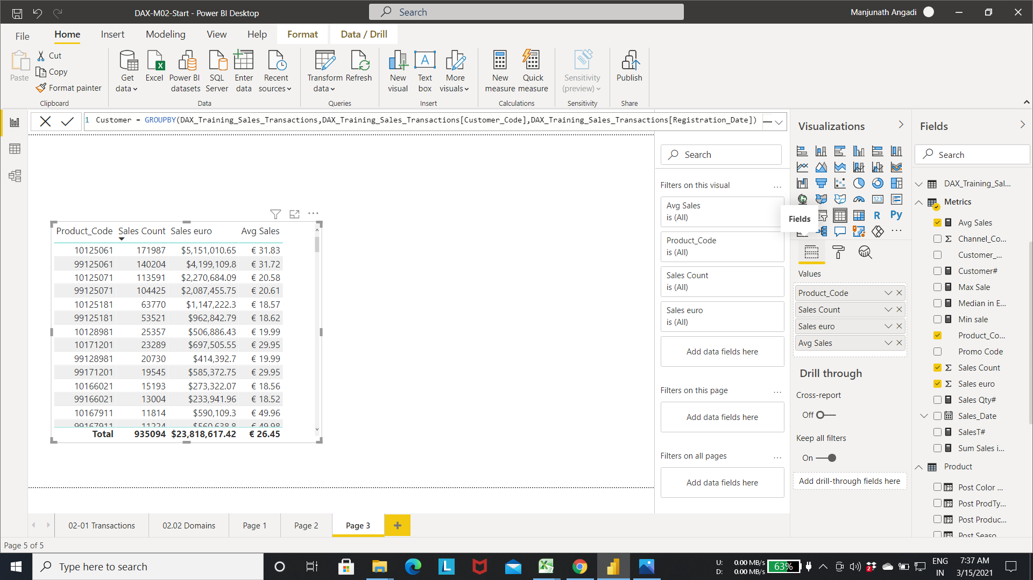

Step 2:-Select the slicer visualization from the visualization Tab.

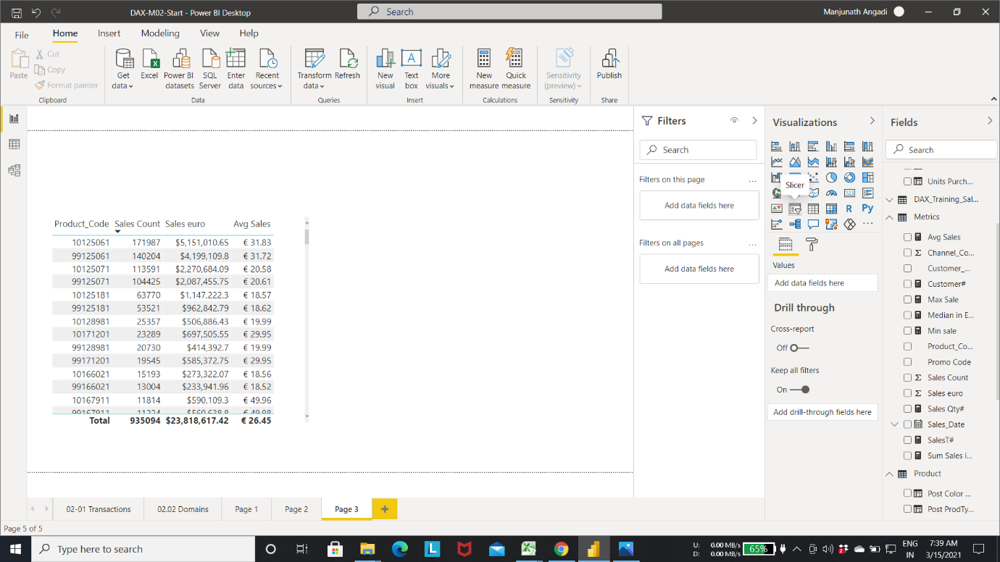

Step 3:- Add the Product code for one slicer and Sales count measure for another slicer

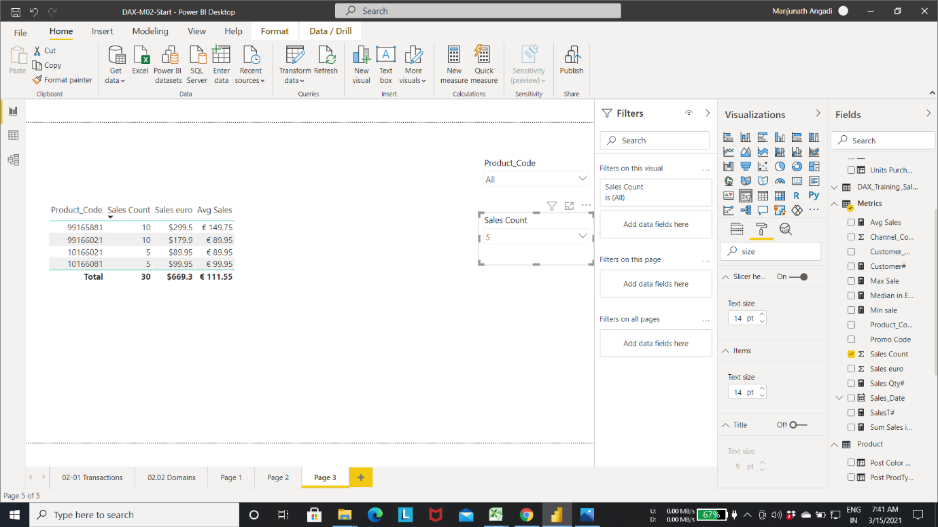

Step 4:-Select a new measure in the metrics table.

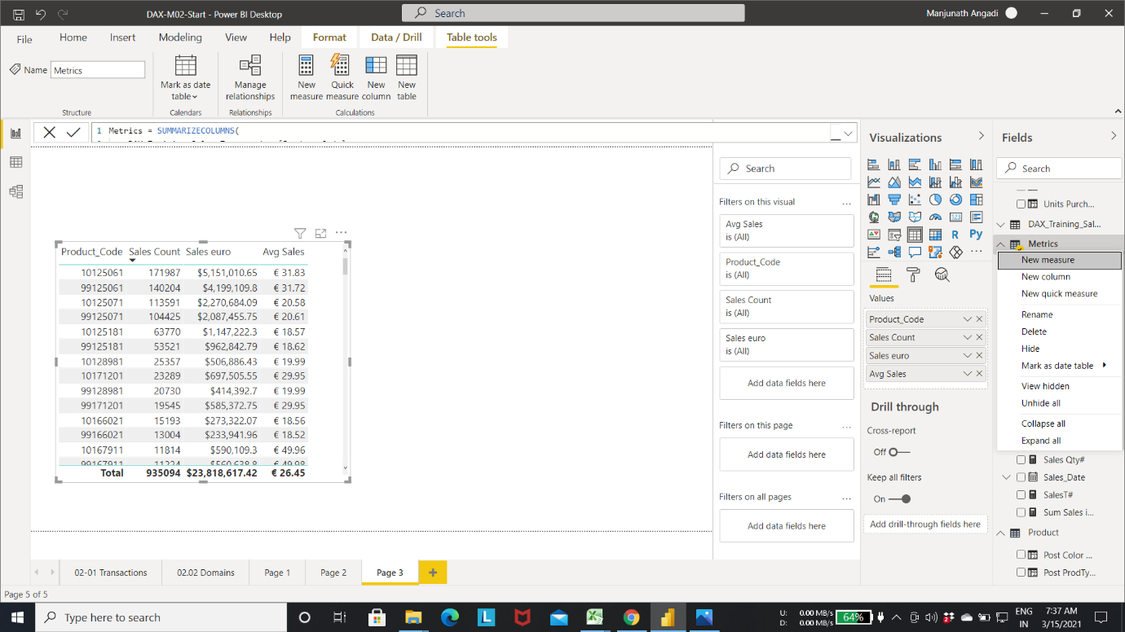

Step 5:- Enter the expression as shown in fig for creating average price .

* Below expression calculate the average price by dividing Sales euro with Sales count.

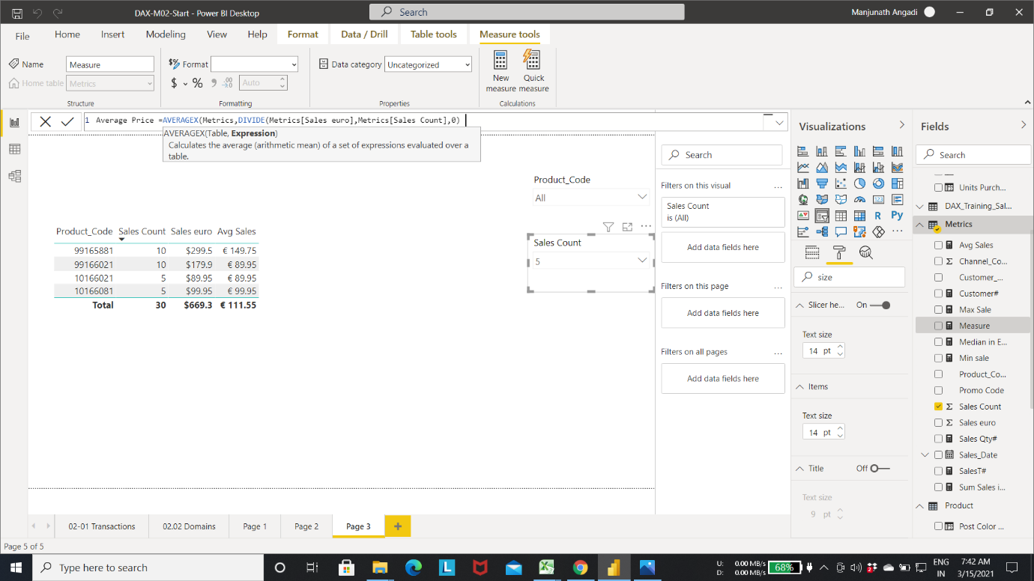

Step 6:- Adding filter to the visualization by selecting the option from the slicer

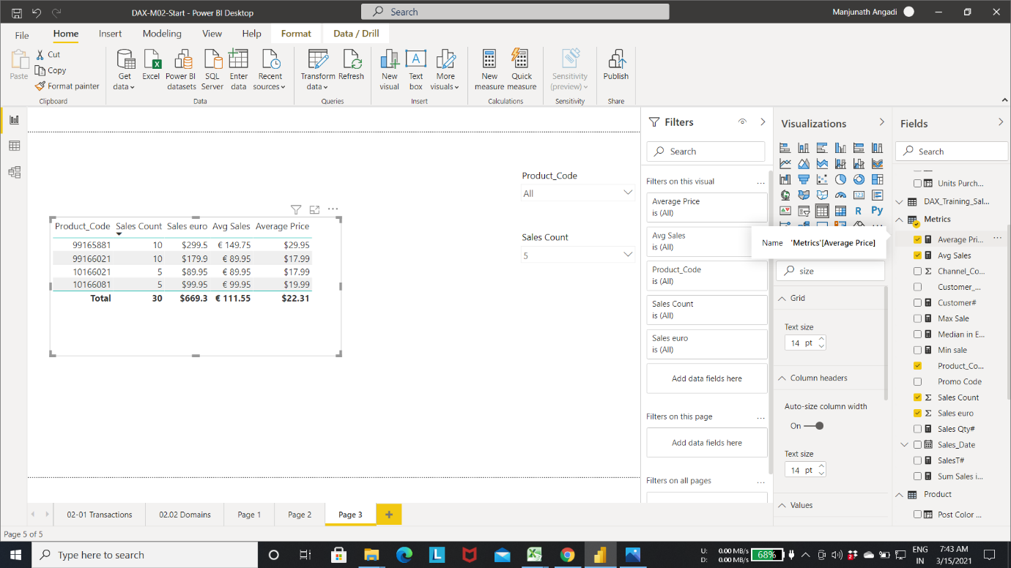

Step 7:- Adding Product, Sum Sales in euro , SalesT# to the table visualization

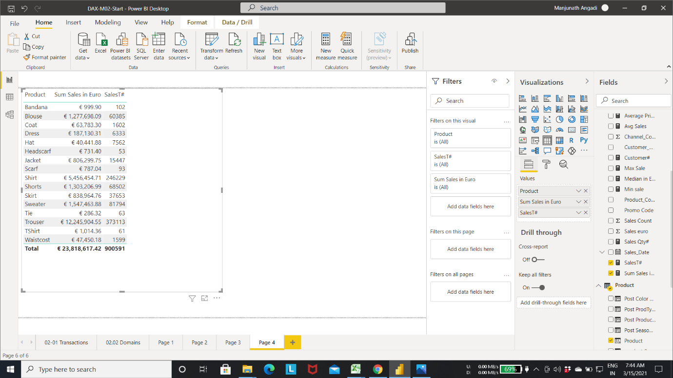

Step 8:-Select a new measure

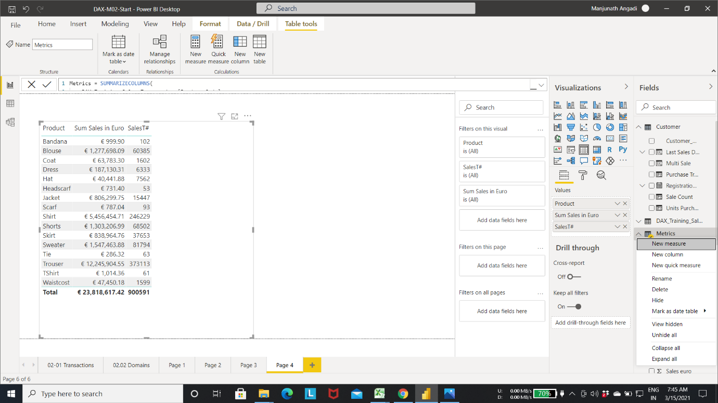

Step 9:- calculate the total Sales by ignoring the filter.

* All()- function will ignore the filters applied to the visualization.

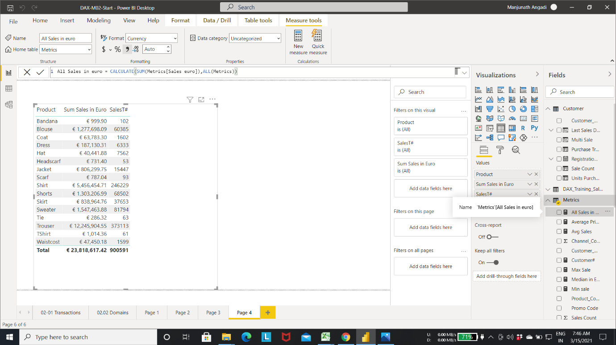

Step 10:- Select new measure in Metrics table.

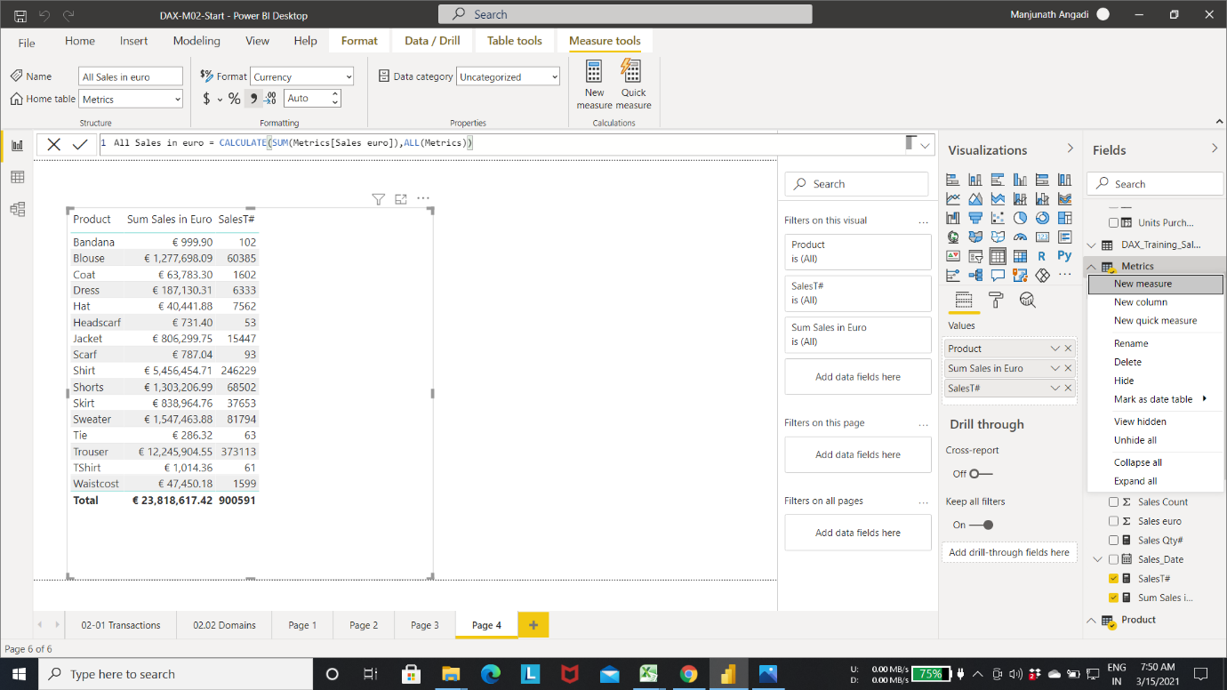

Step 11:- calculating the % change in Sales by using the below expression.

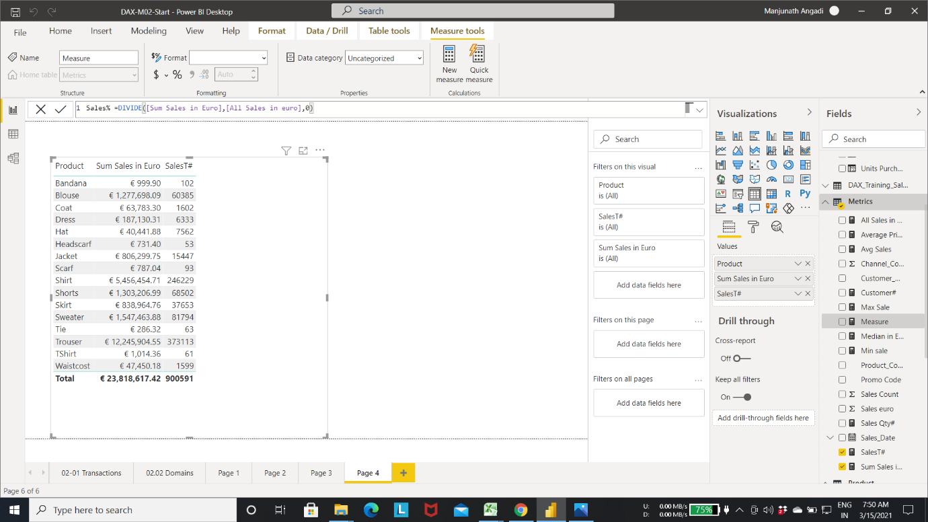

Step 12:- Adding Sales% to the table visualization.

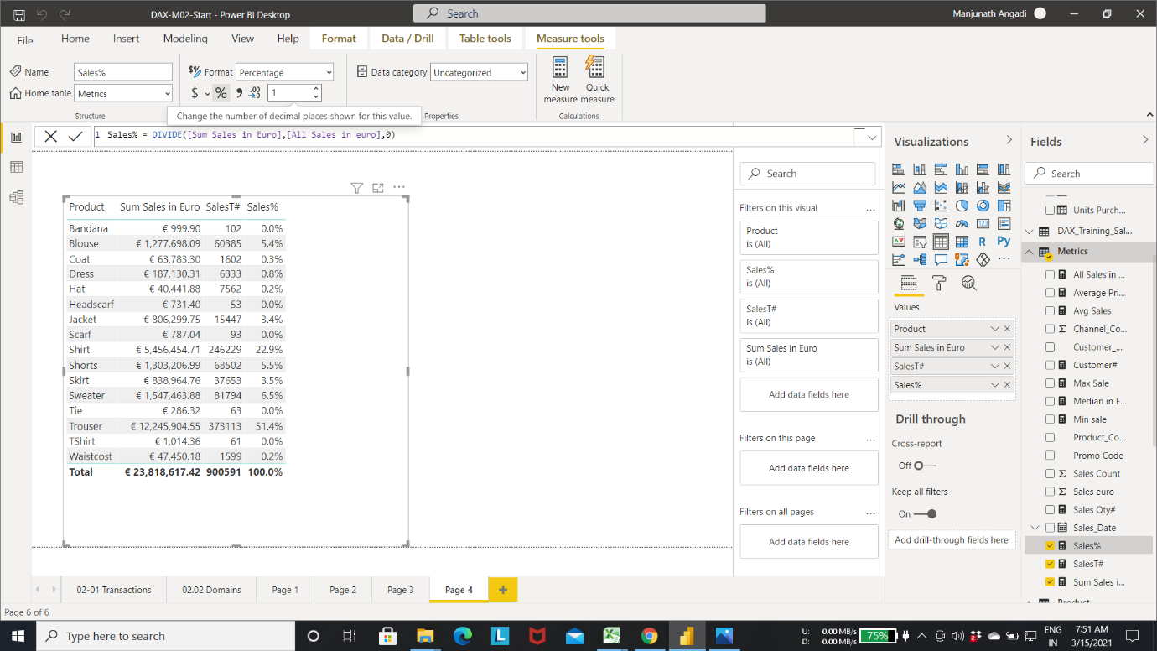

Step 13:- Applying filter to the visualization by selecting the visual filter as shown in fig.

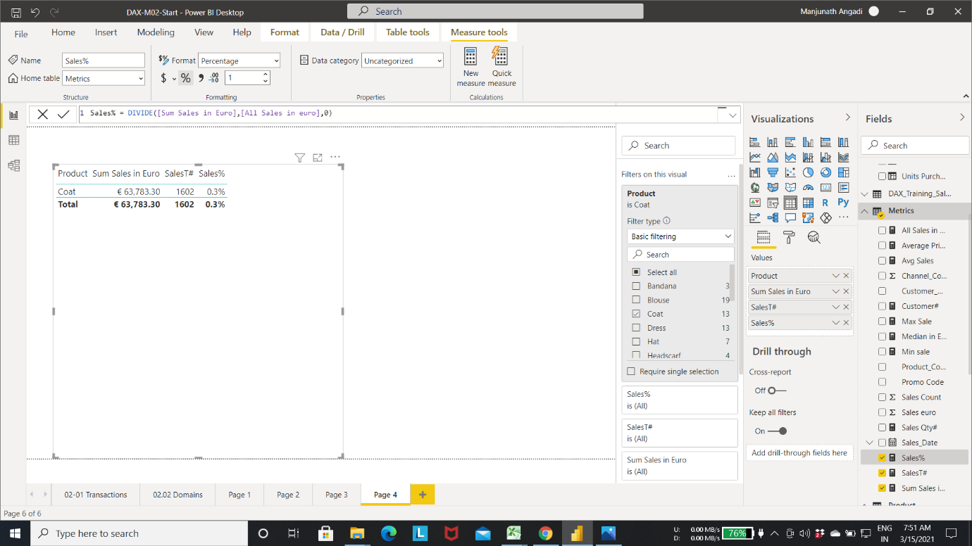

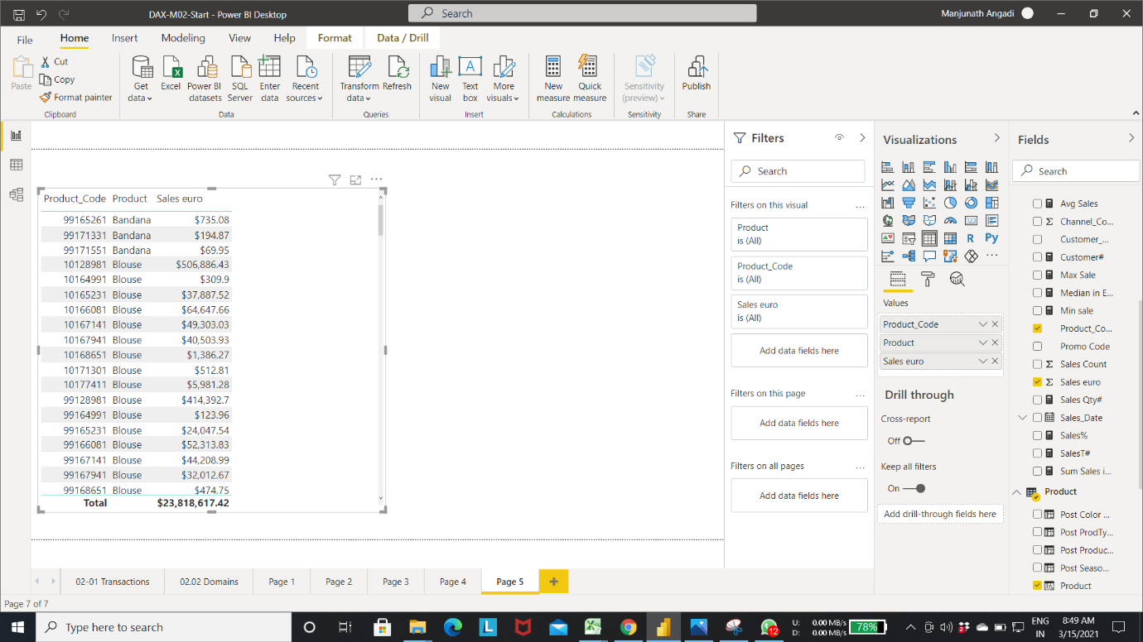

**Rankx**

Let us see how to create an attribute that will calculate Rank number

Step 1: Create a new column in the product table

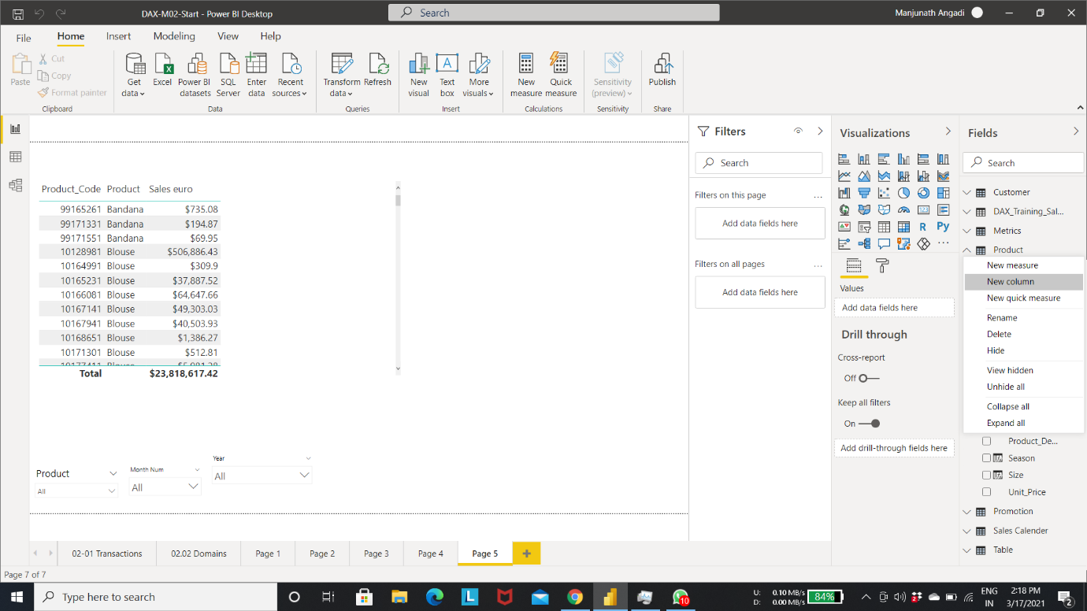

Step 2: Rename the column “Top Products”

This attribute will rank the products by sales value.

Let us create a Ranking number for each product using RANKX Function.

**RANKX**: RANKX is an aggregate expression function that will return a serial number that indicates the rank for each product.

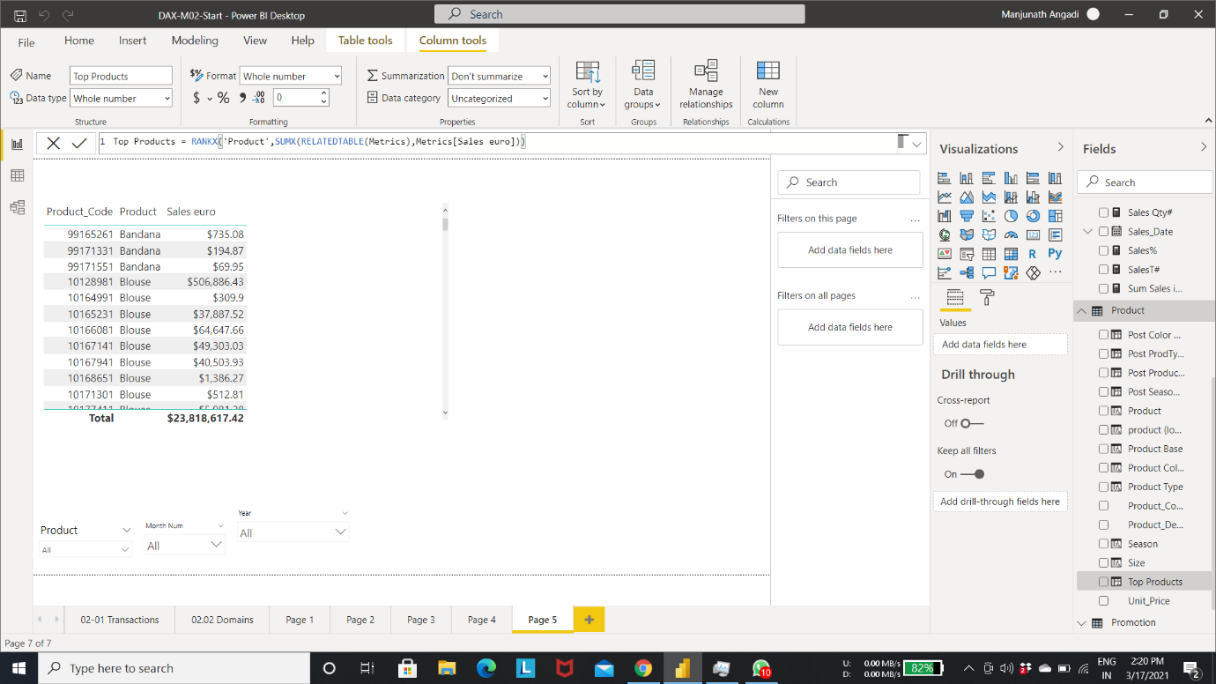

Step 3: add the column “Top product” to the table visualization

Here you can see the products are now ranked by sales value.

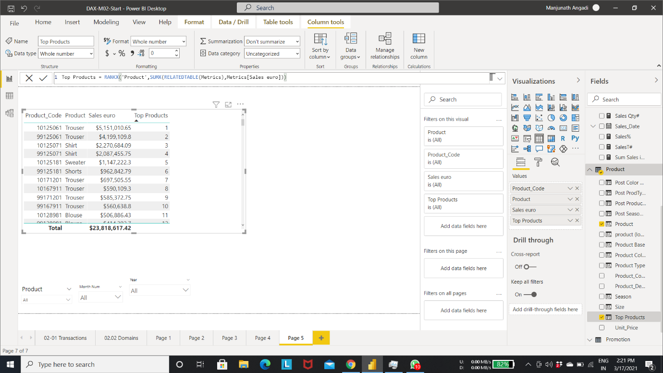

Step 4: add “Top products” attributes to the slicer

Now we can see that this allows filter the data to see top results.

Here the other slicers continue to filter the rows displayed in visualization.

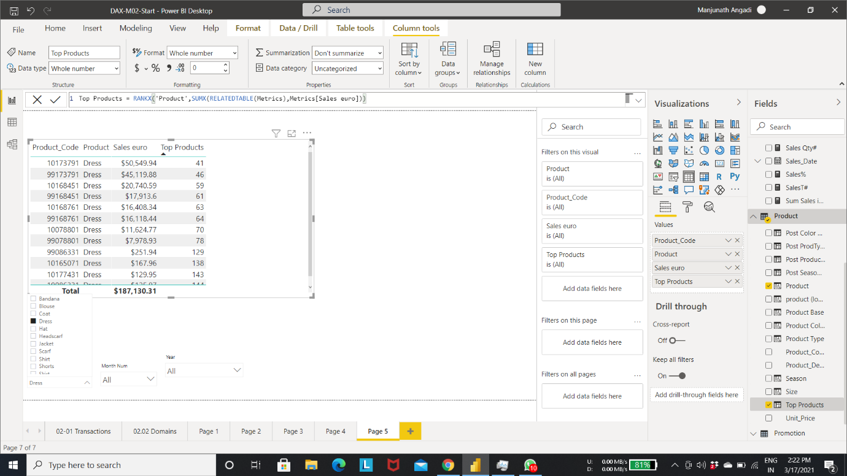

**Filtering matrices with Time Intelligent Functions**

Step 1: Create a New measure “Sales YTD auro” as shown in fig.

Here DAX provide the function called “TOTALYTD”

We can see that new measure accumulates the value through the year, when we go first day of next year the value reset and start again.

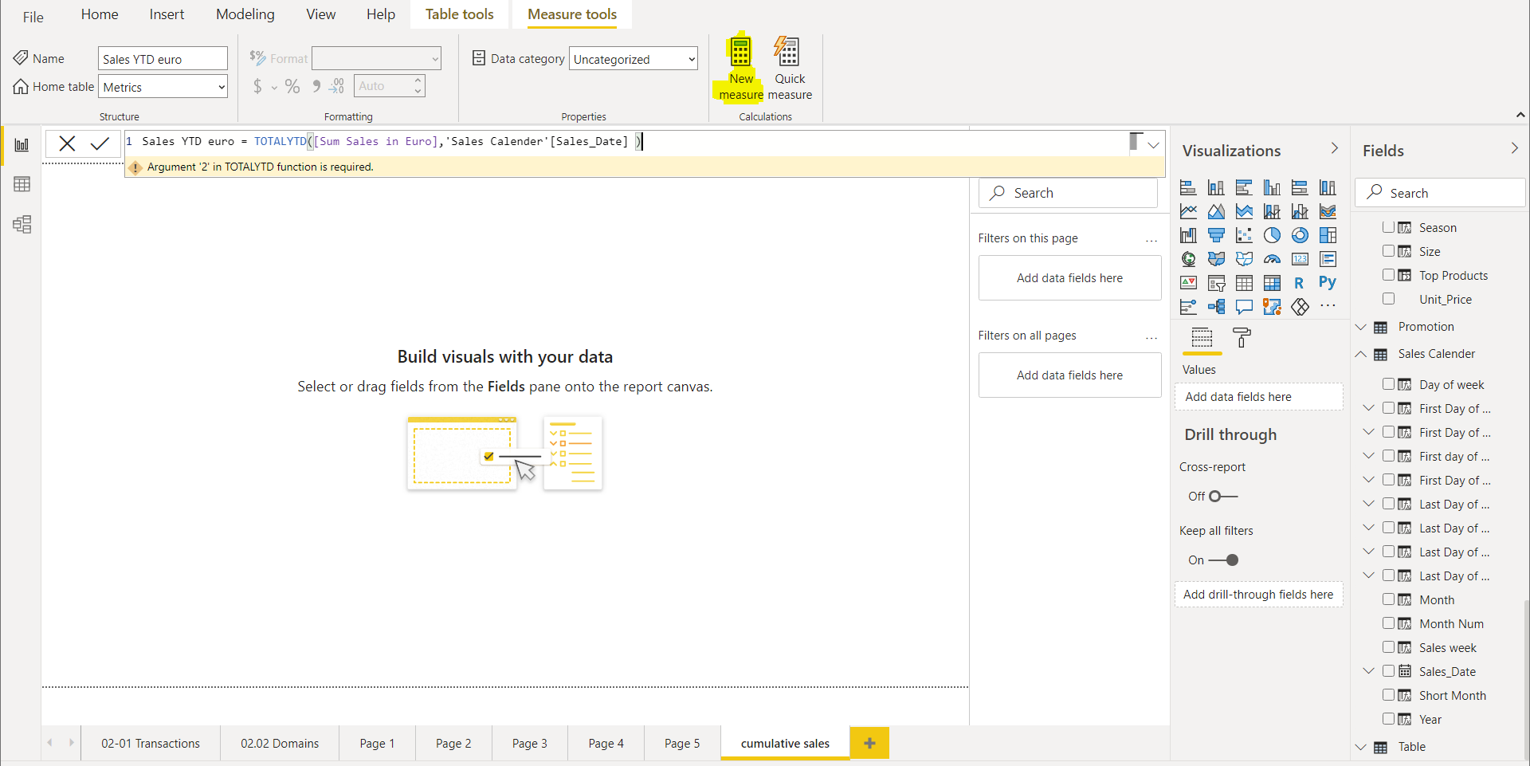

output of cumulative sales till end of the year

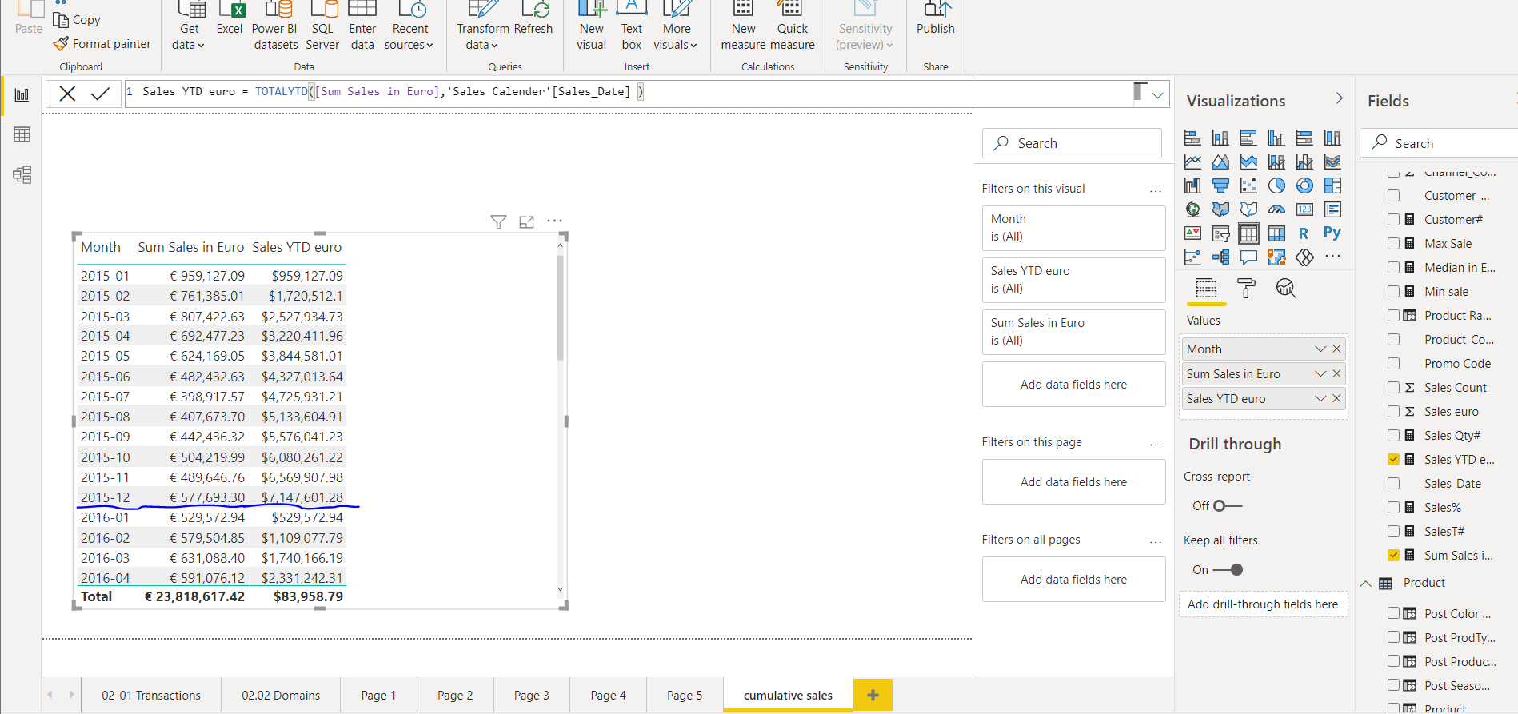

Step 2: creating new measure “Sales YTD euro LY” for calculating cumulative sales for last year.

Add Sales YTD euro LY column to the table visualization.

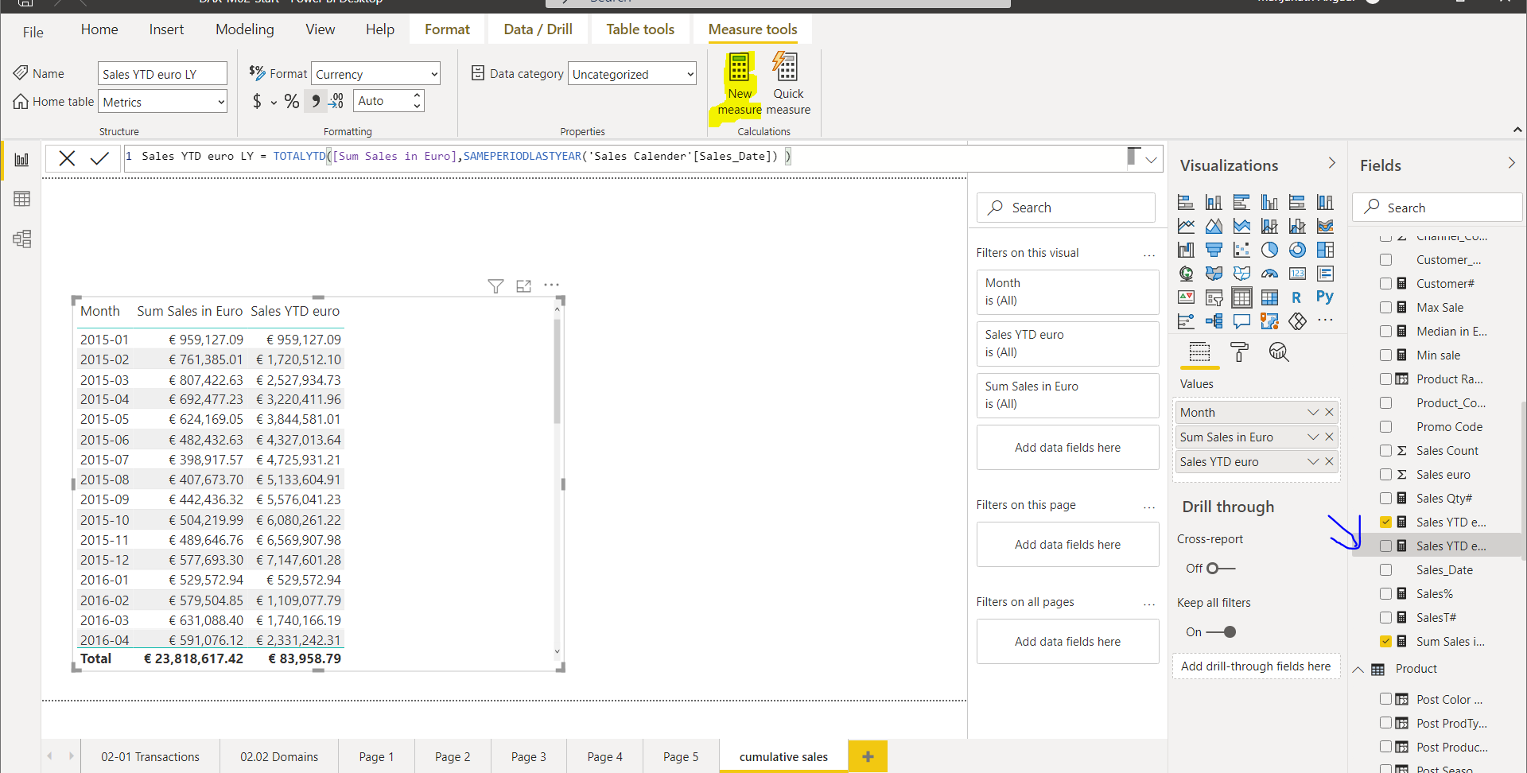

Here, You can see the calculated cumulative sales for last year.

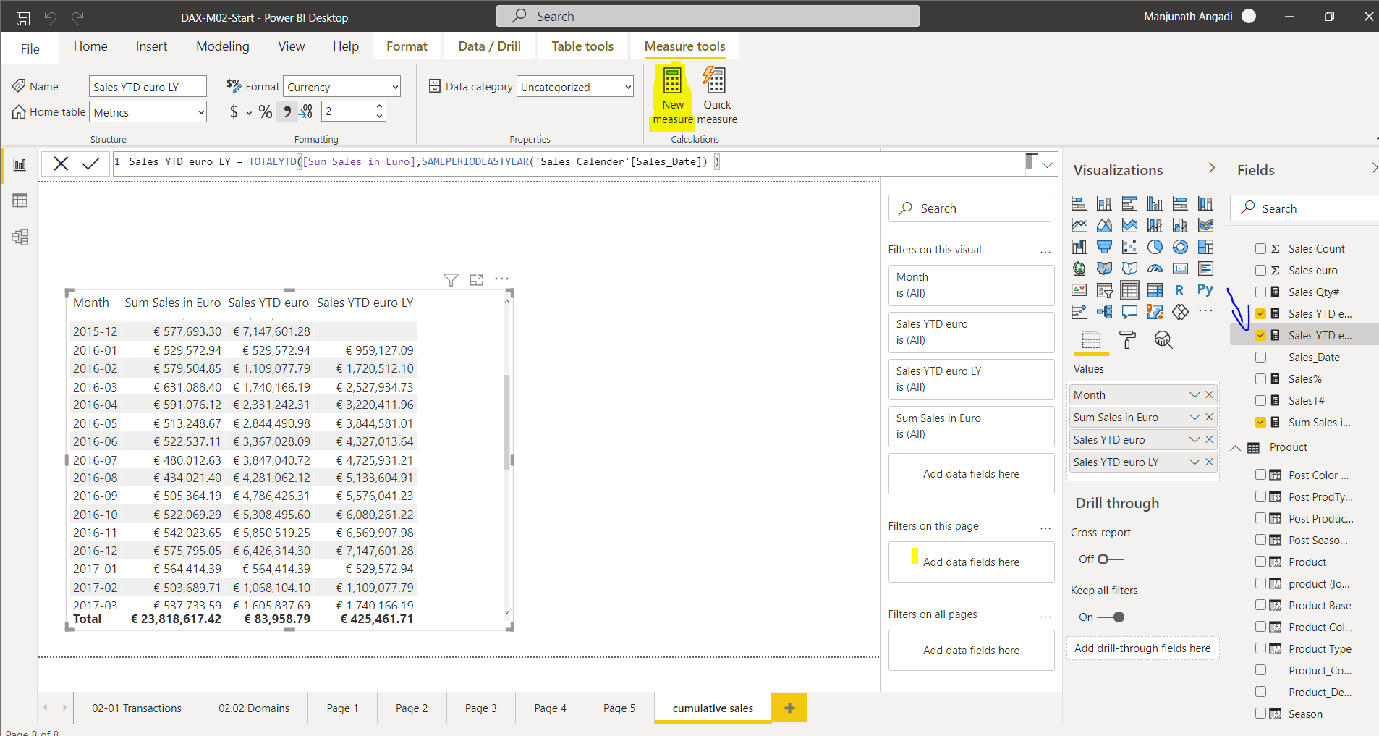

Step 3: create a new measure “sales YTD euro”. 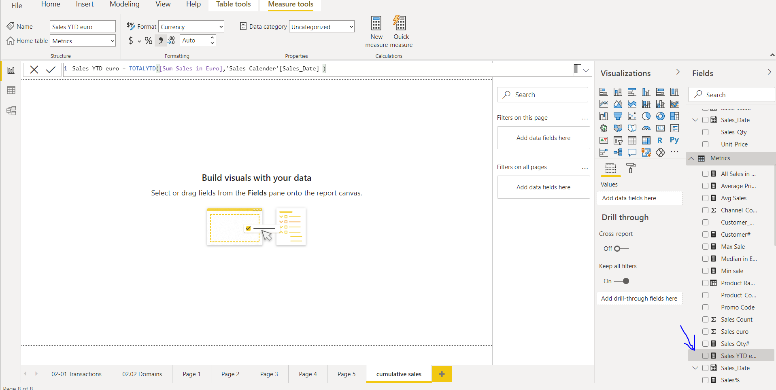

creating measure to calculate last year sales from selected date 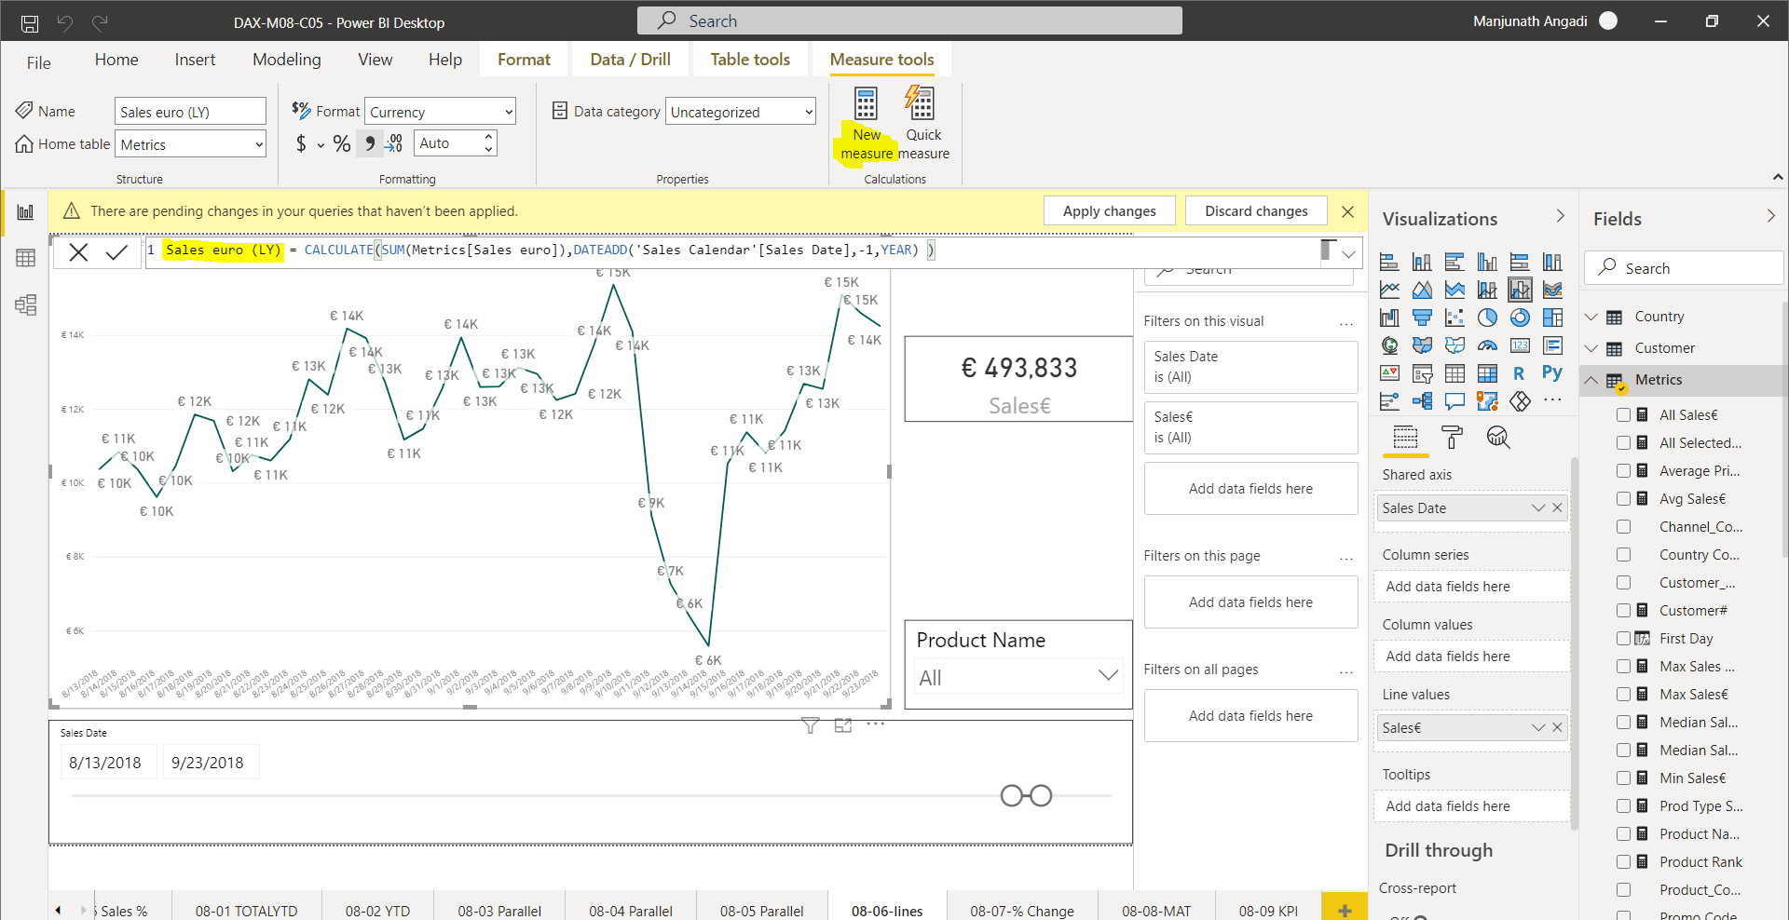

comparing last year sales with current year sales

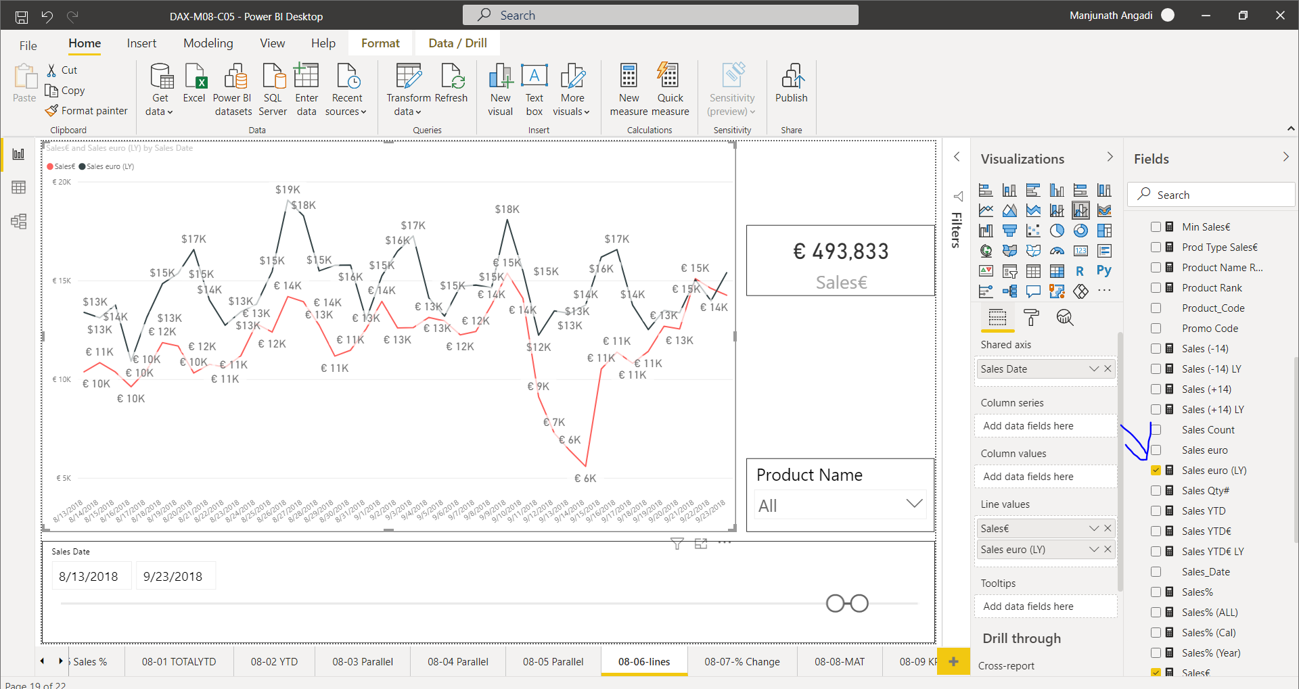

calculating Sales % change from previous month(with waterfall chart)

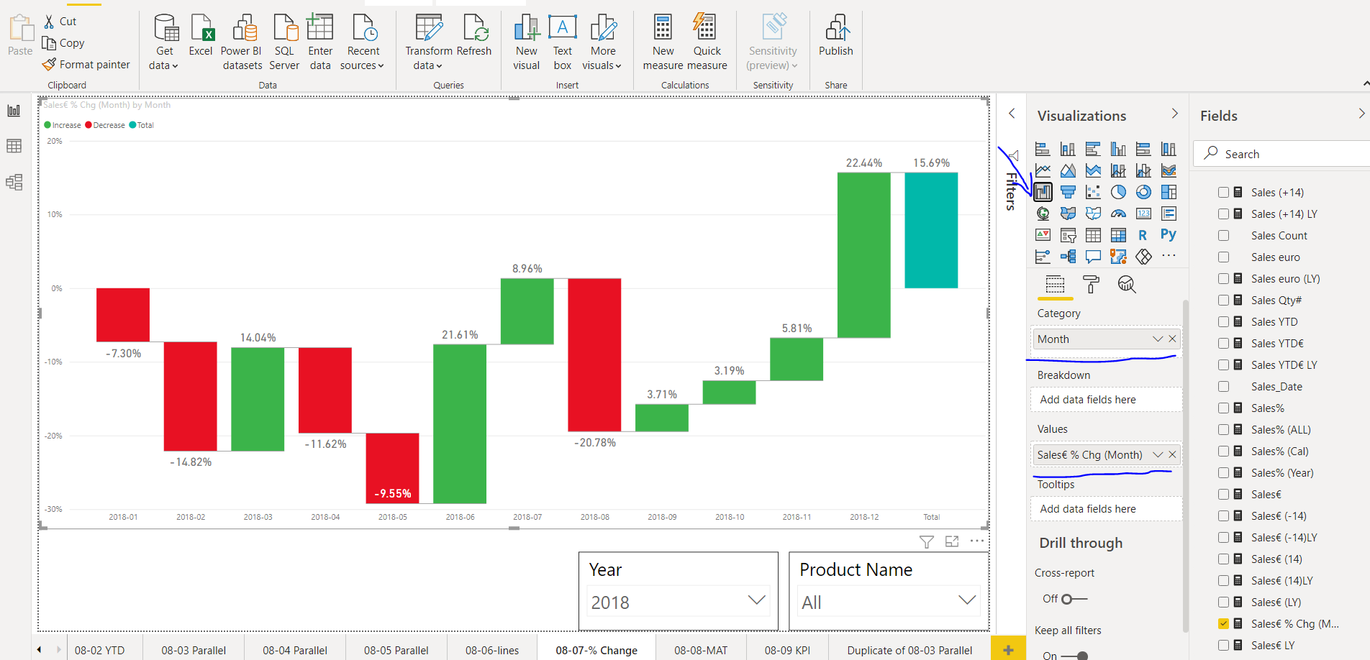

calculating Sales % change from previous month

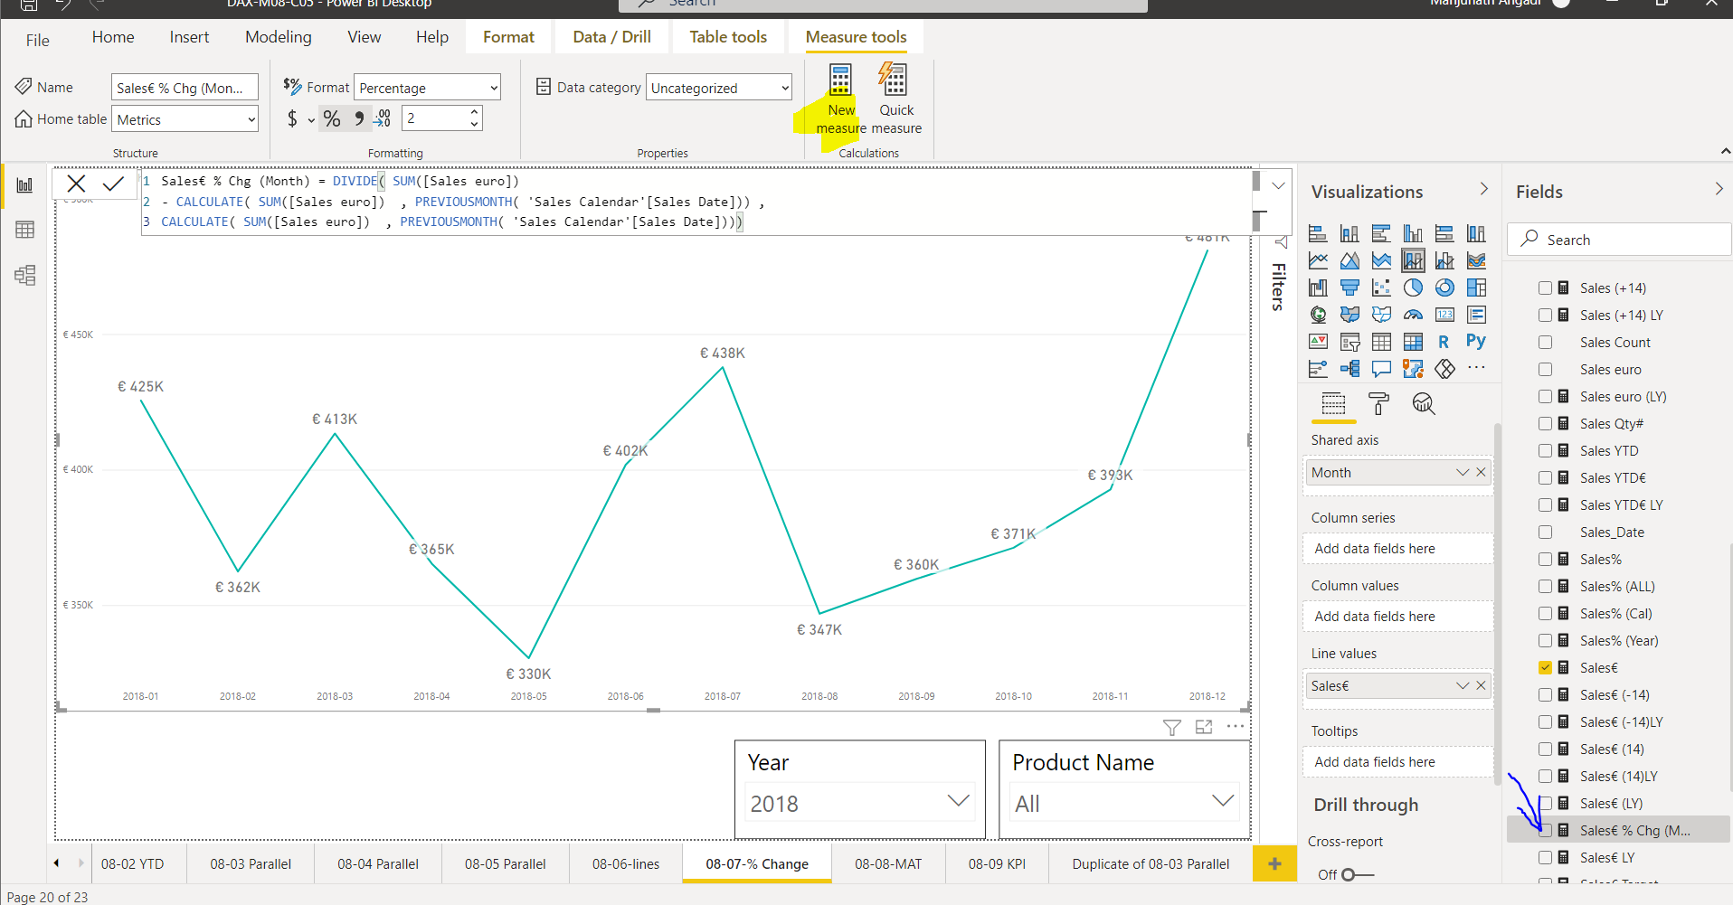

**moving annual total**

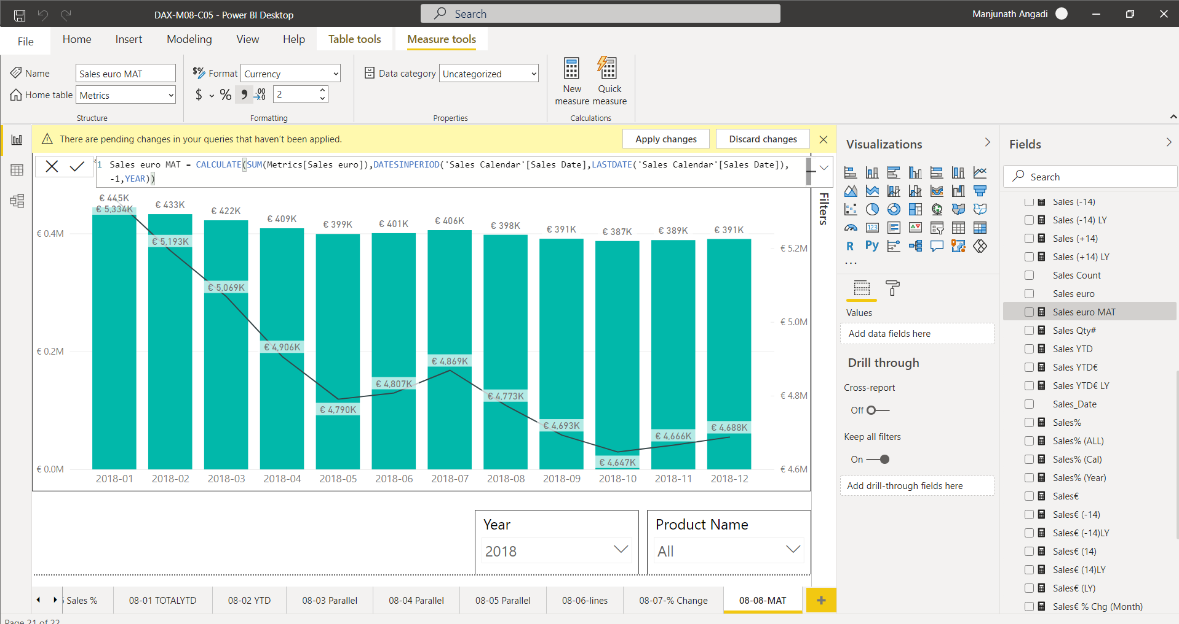

**date in period**

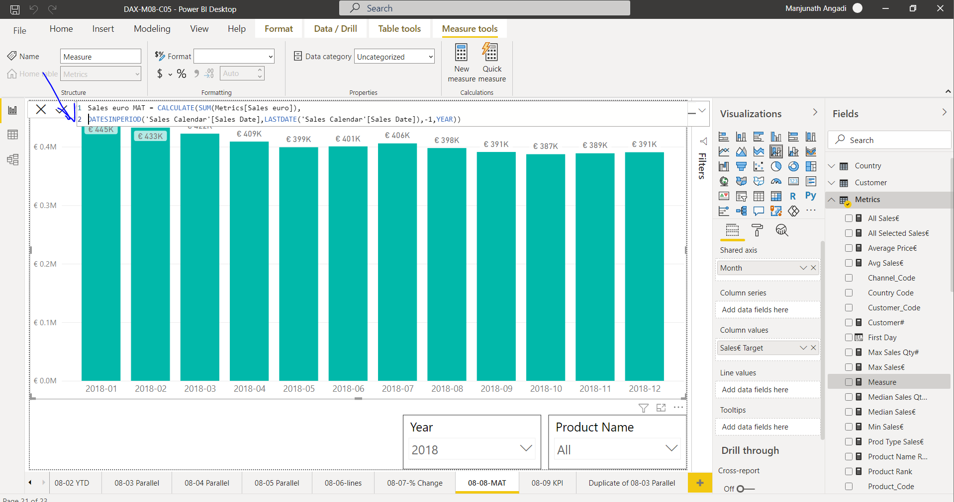

**KPI(setting target value as average total sales of previous year)**

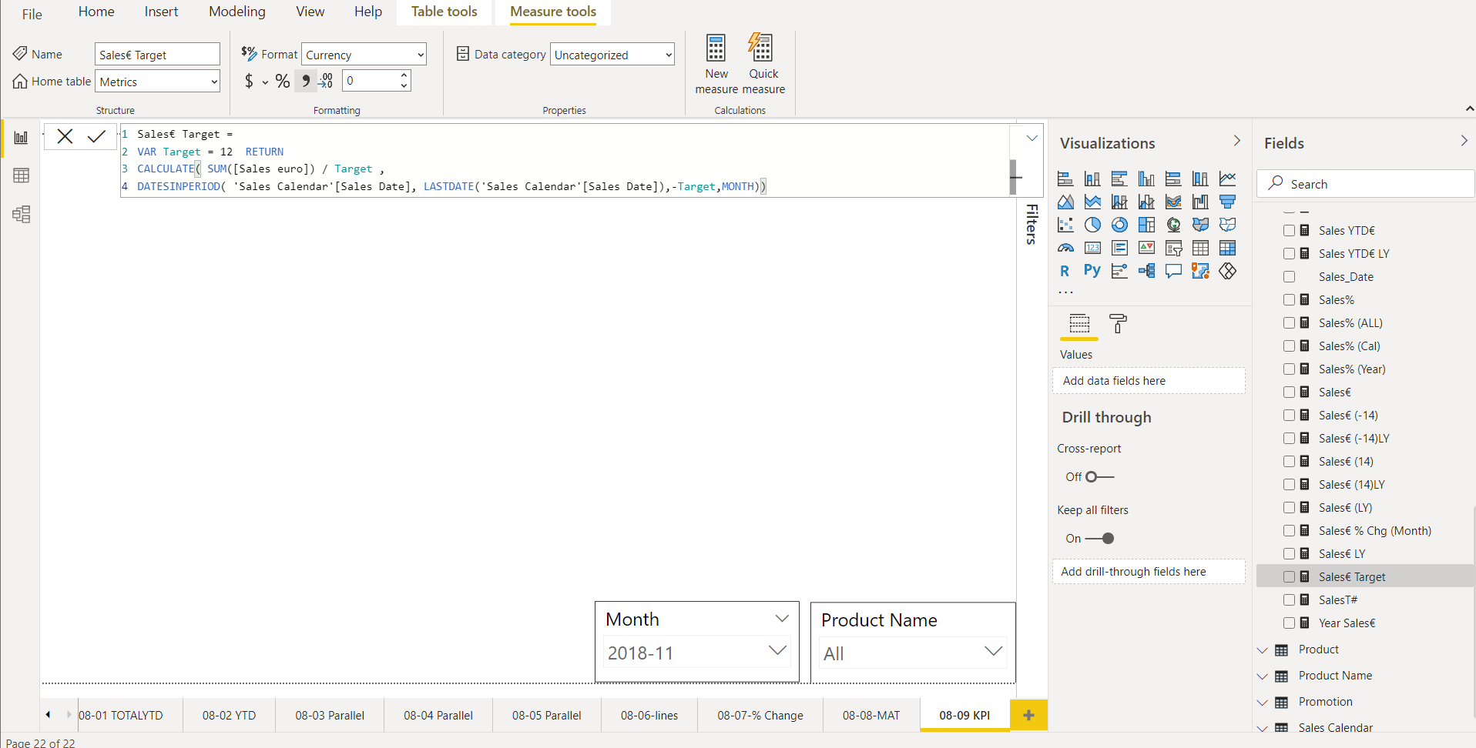

**select kpi visualization**

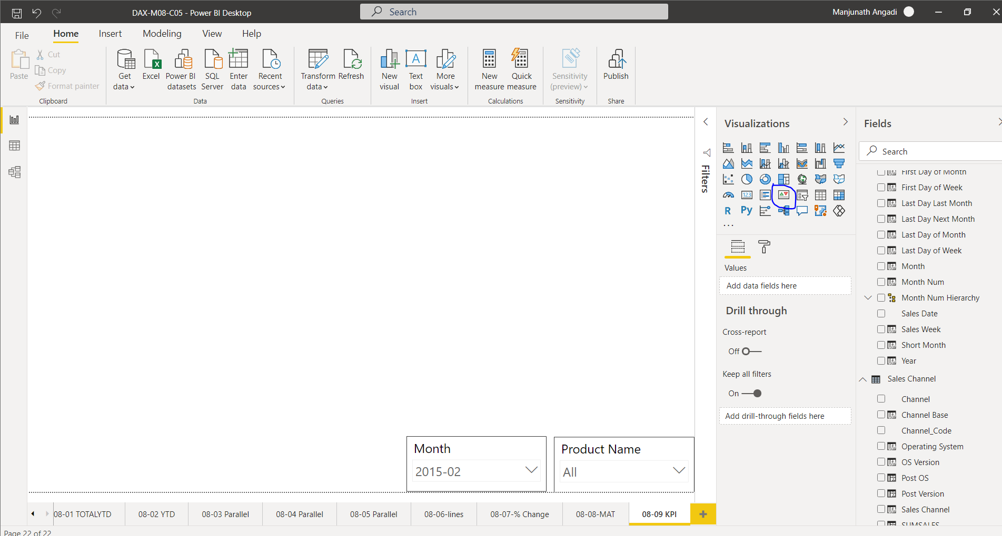

**kpi**

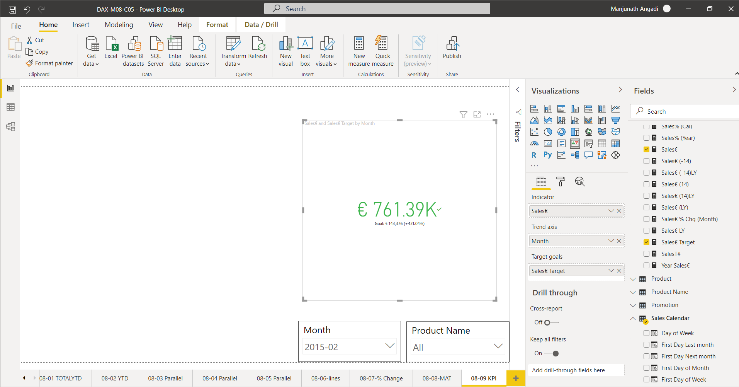

**KO7:** **Able to Create Attributes with Conditional Values**

**Power BI groups:**

Create a Group in Power BI

Step 1: click on **product nam**e and select **new group** option.

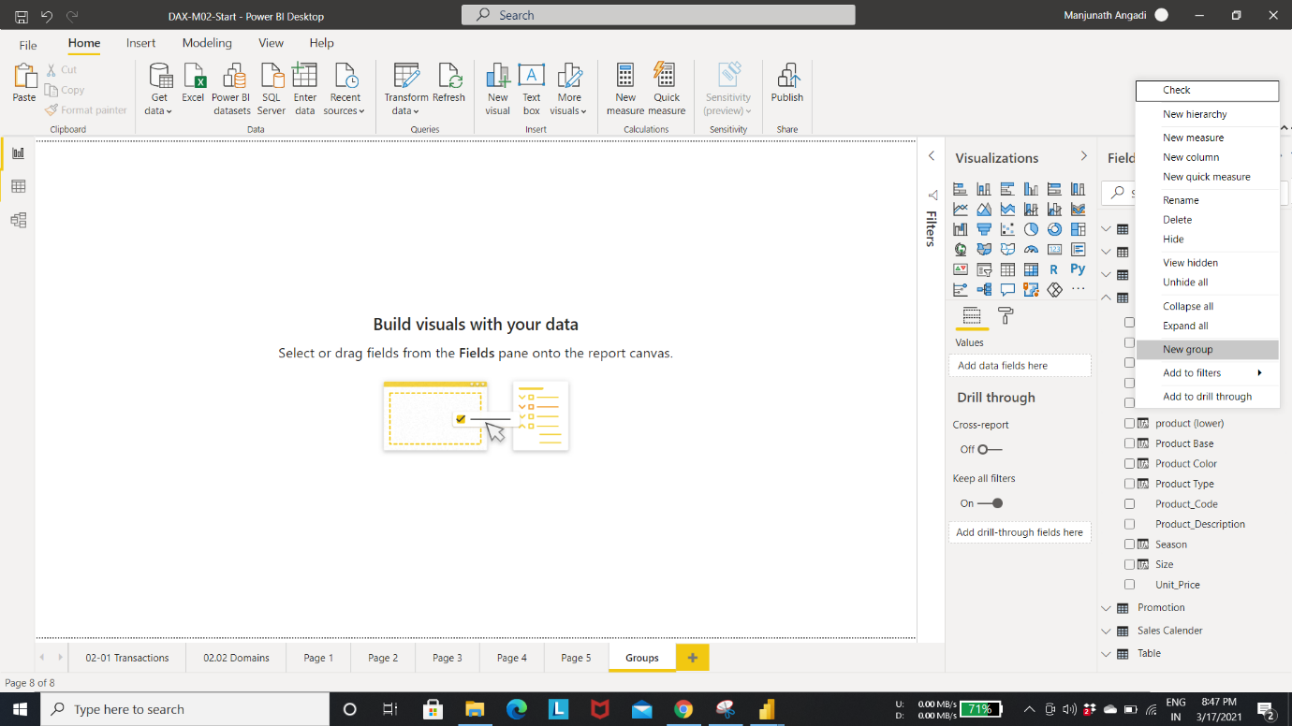

Give the credentials as shown in fig.

Step 2: Create a row in the group called **Accessories** by selecting scarf, jacket and Headscarf

Step 3: Create a group for **Tops**.

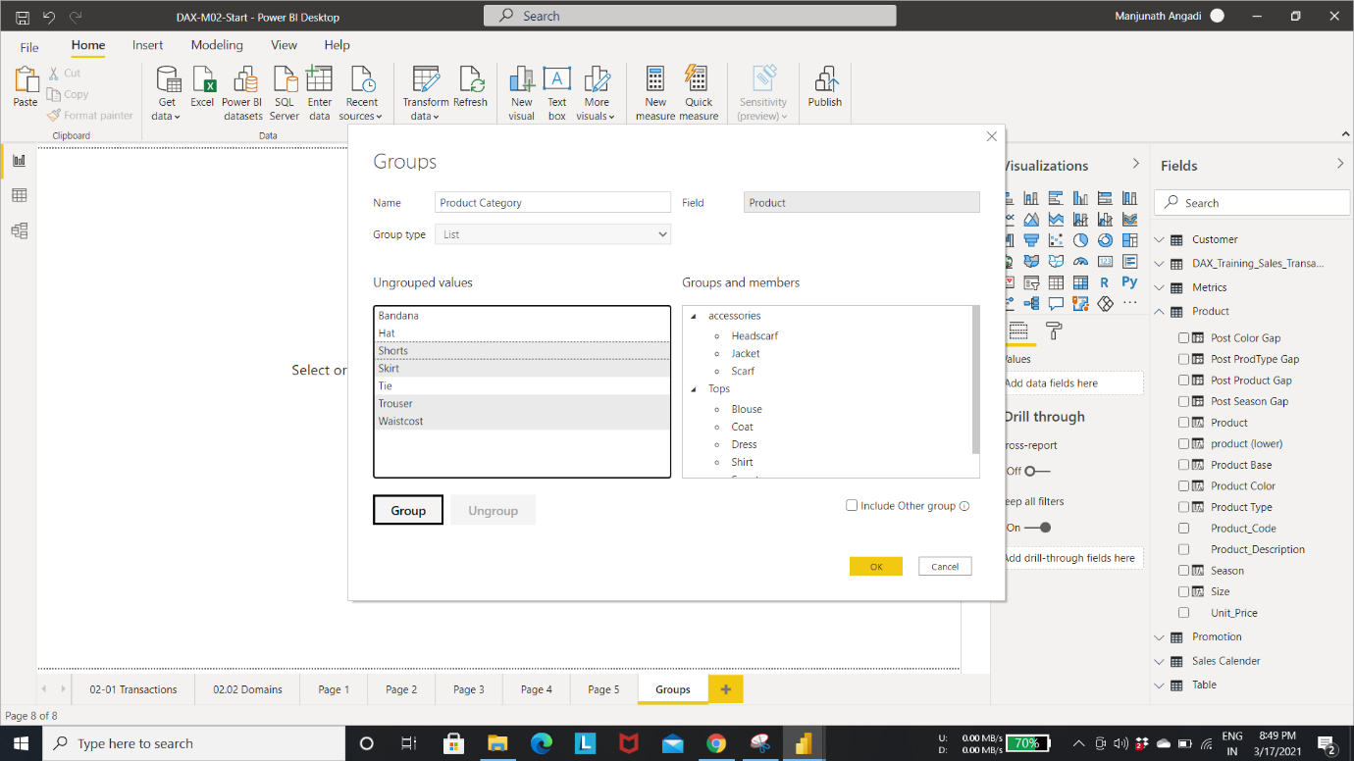

Step 4: Create a group for **bottoms**.

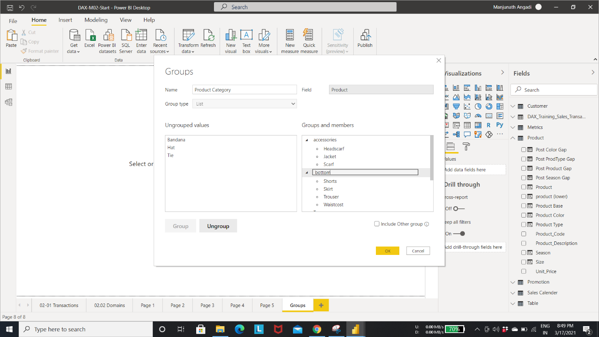

Step 5: Create a group for **overwears** as shown in below fig.

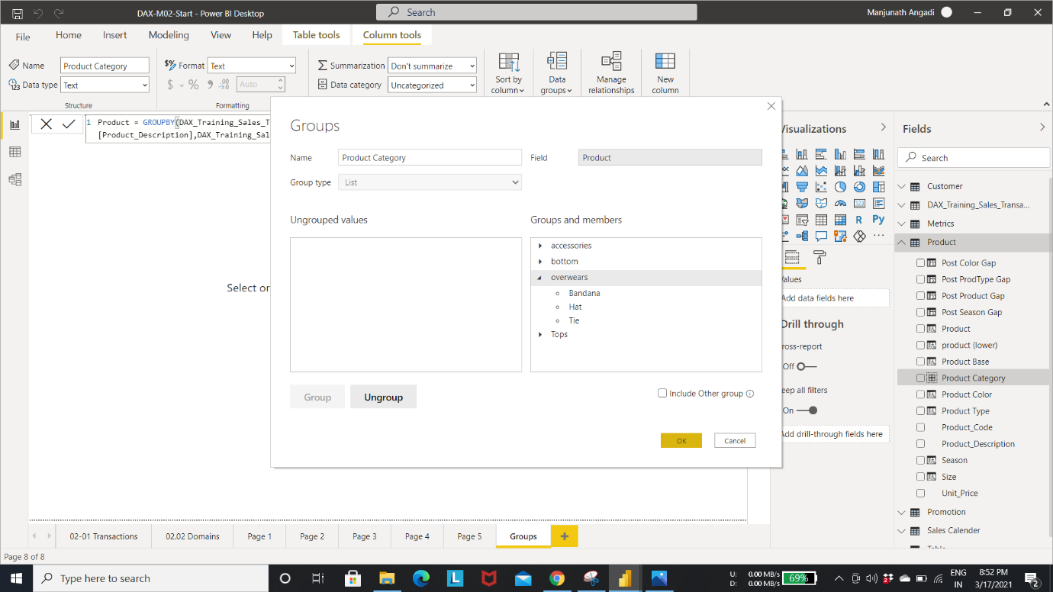

Step 6: Create a **hierarchy** based on product group

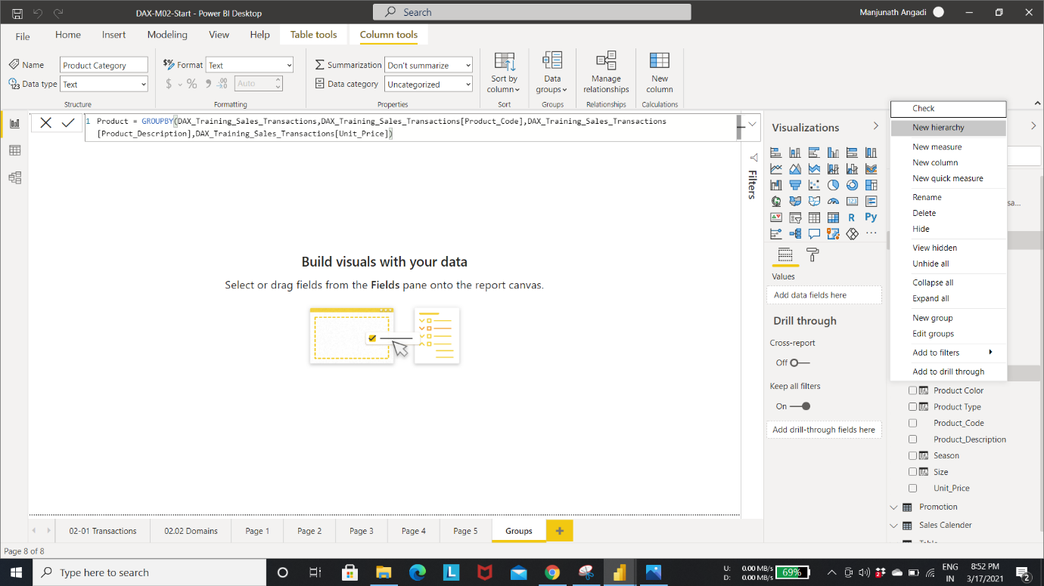

Step 7: drag drop to add the product**.**

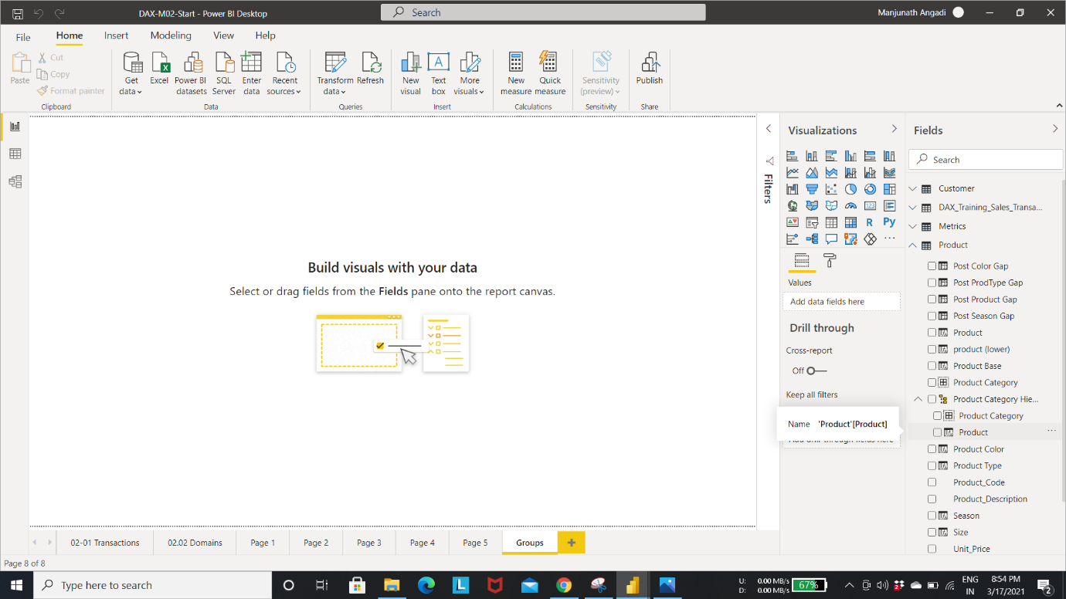

Step 8: Click on product table in **data modal**

You can see the new column has been added.

You can also achieve same thing by creating column with DAX code.

**COMBINEVALUES**: used to join multiple data columns together at row level to create concatenated columns.

Step 9: Create a concatenated column and rename it as **seasonal product**.

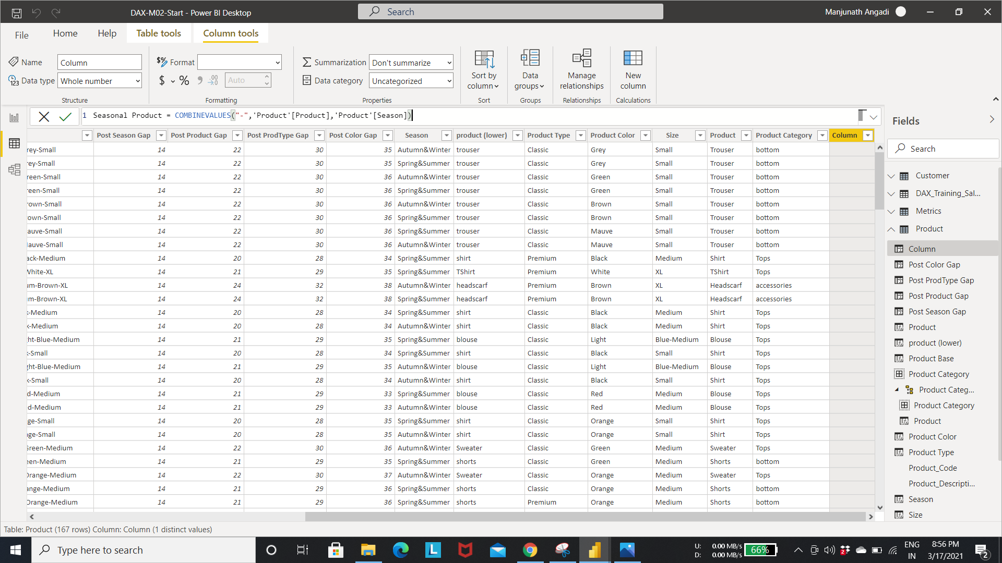

Step 10: Use hierarchy in bar chart to display product name and include drill capability.

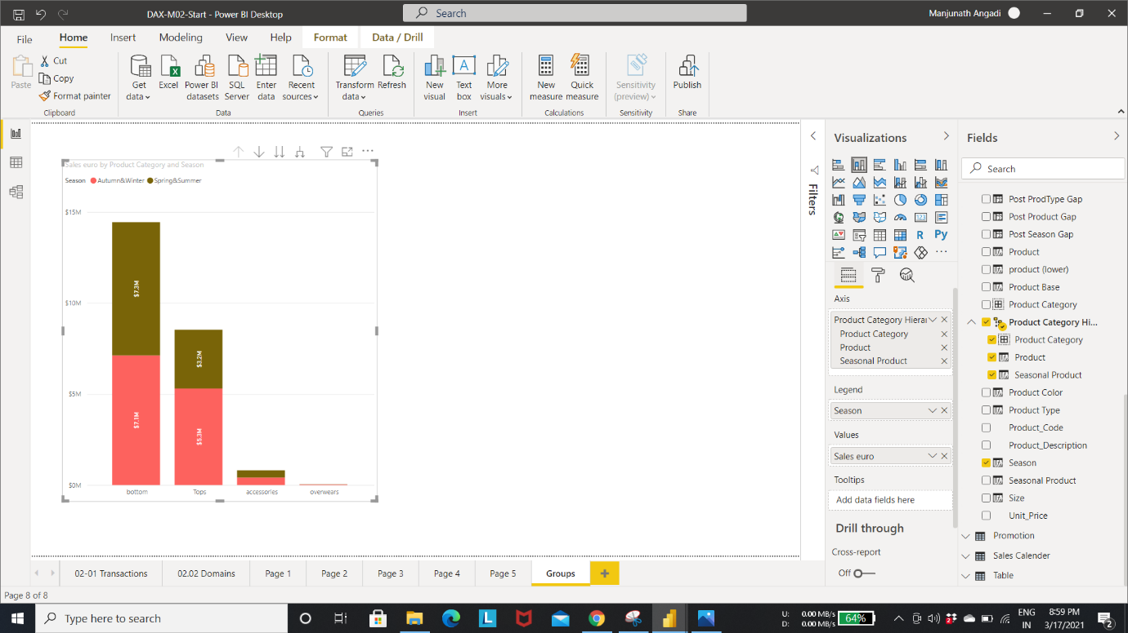

Groups are displayed on x- axis

Drill down to see the product name and later drill back up.

Step 11: Click on Tops bar to drill down, you can see the scales values for shirts and blouses.

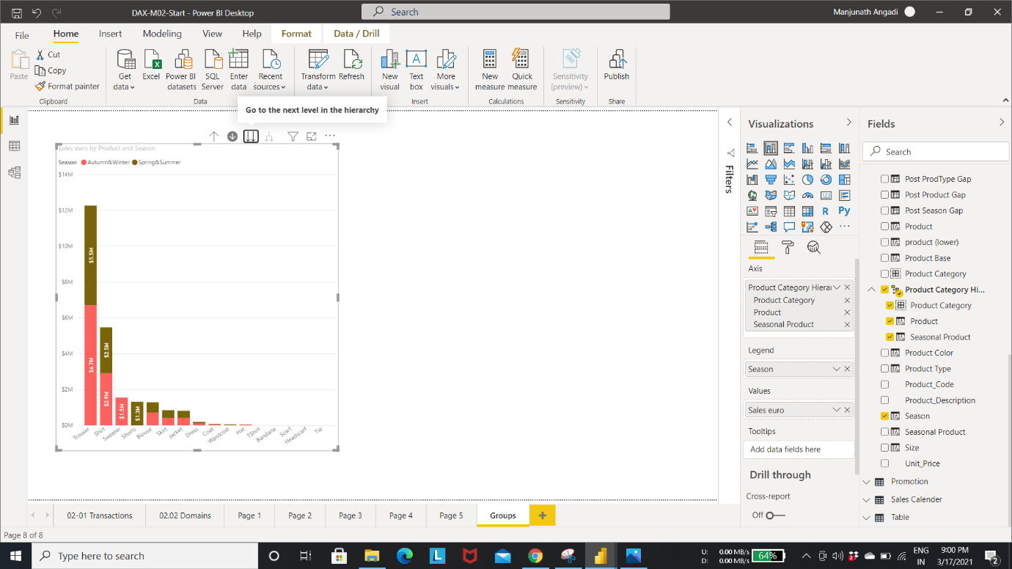

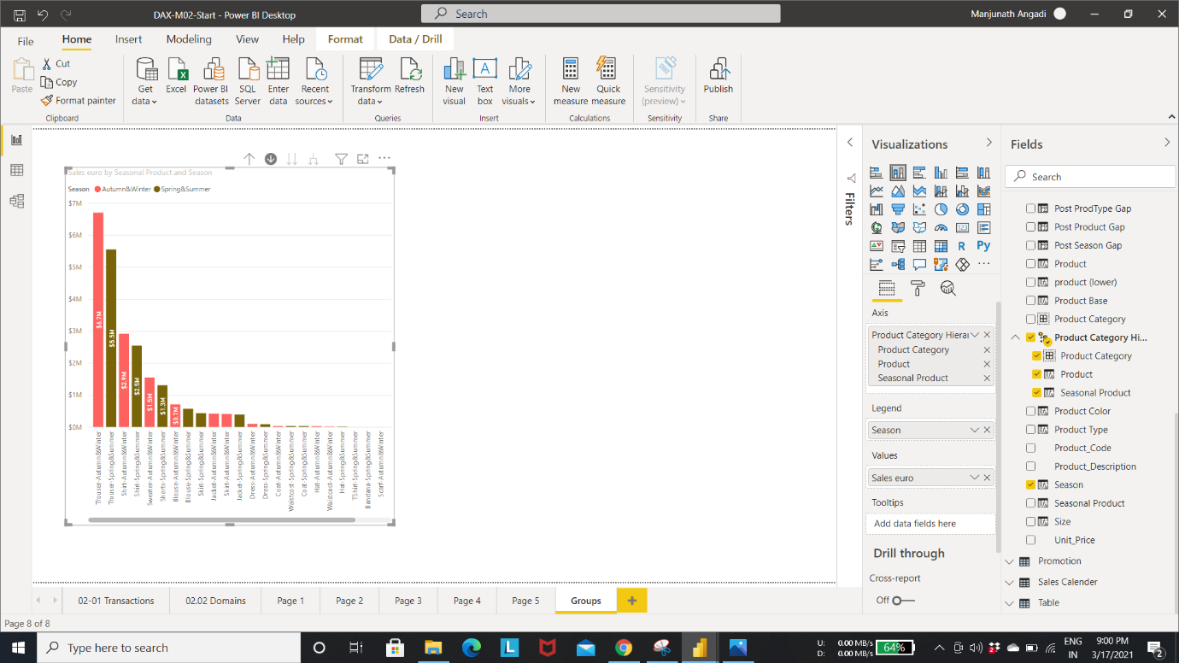

**Create Product category with conditional value:**

Function Trios:

* Switch
* True
* IN

Step 1: Create a new column in Product table as “**Product Category**”

Write the expression using **Switch**(used to swap one value for another).

For the first parameter in SWITCH, provide TRUE function.

Enter the third function IN

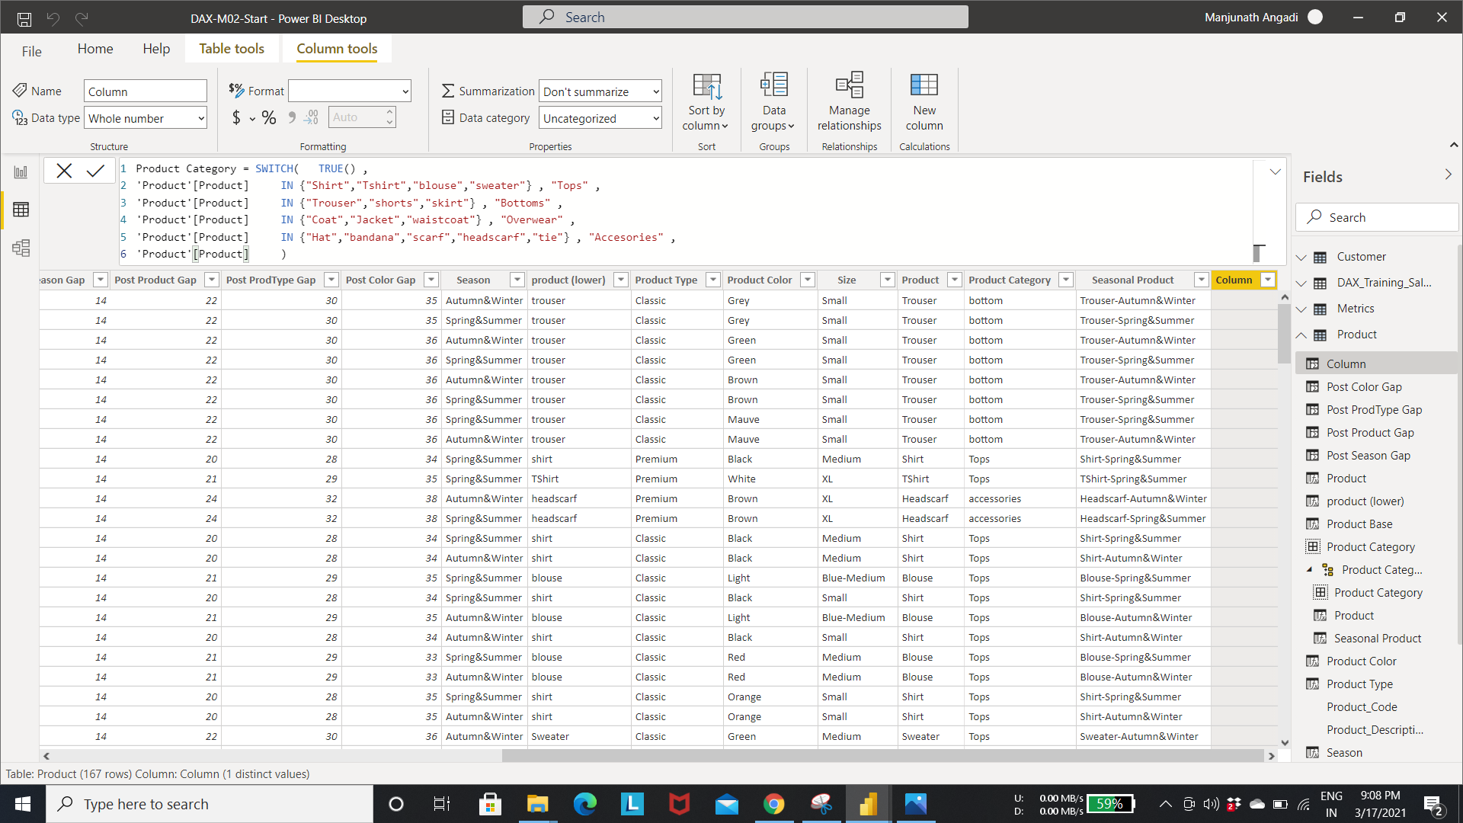

Here, result will be returned only if the Expression is true.

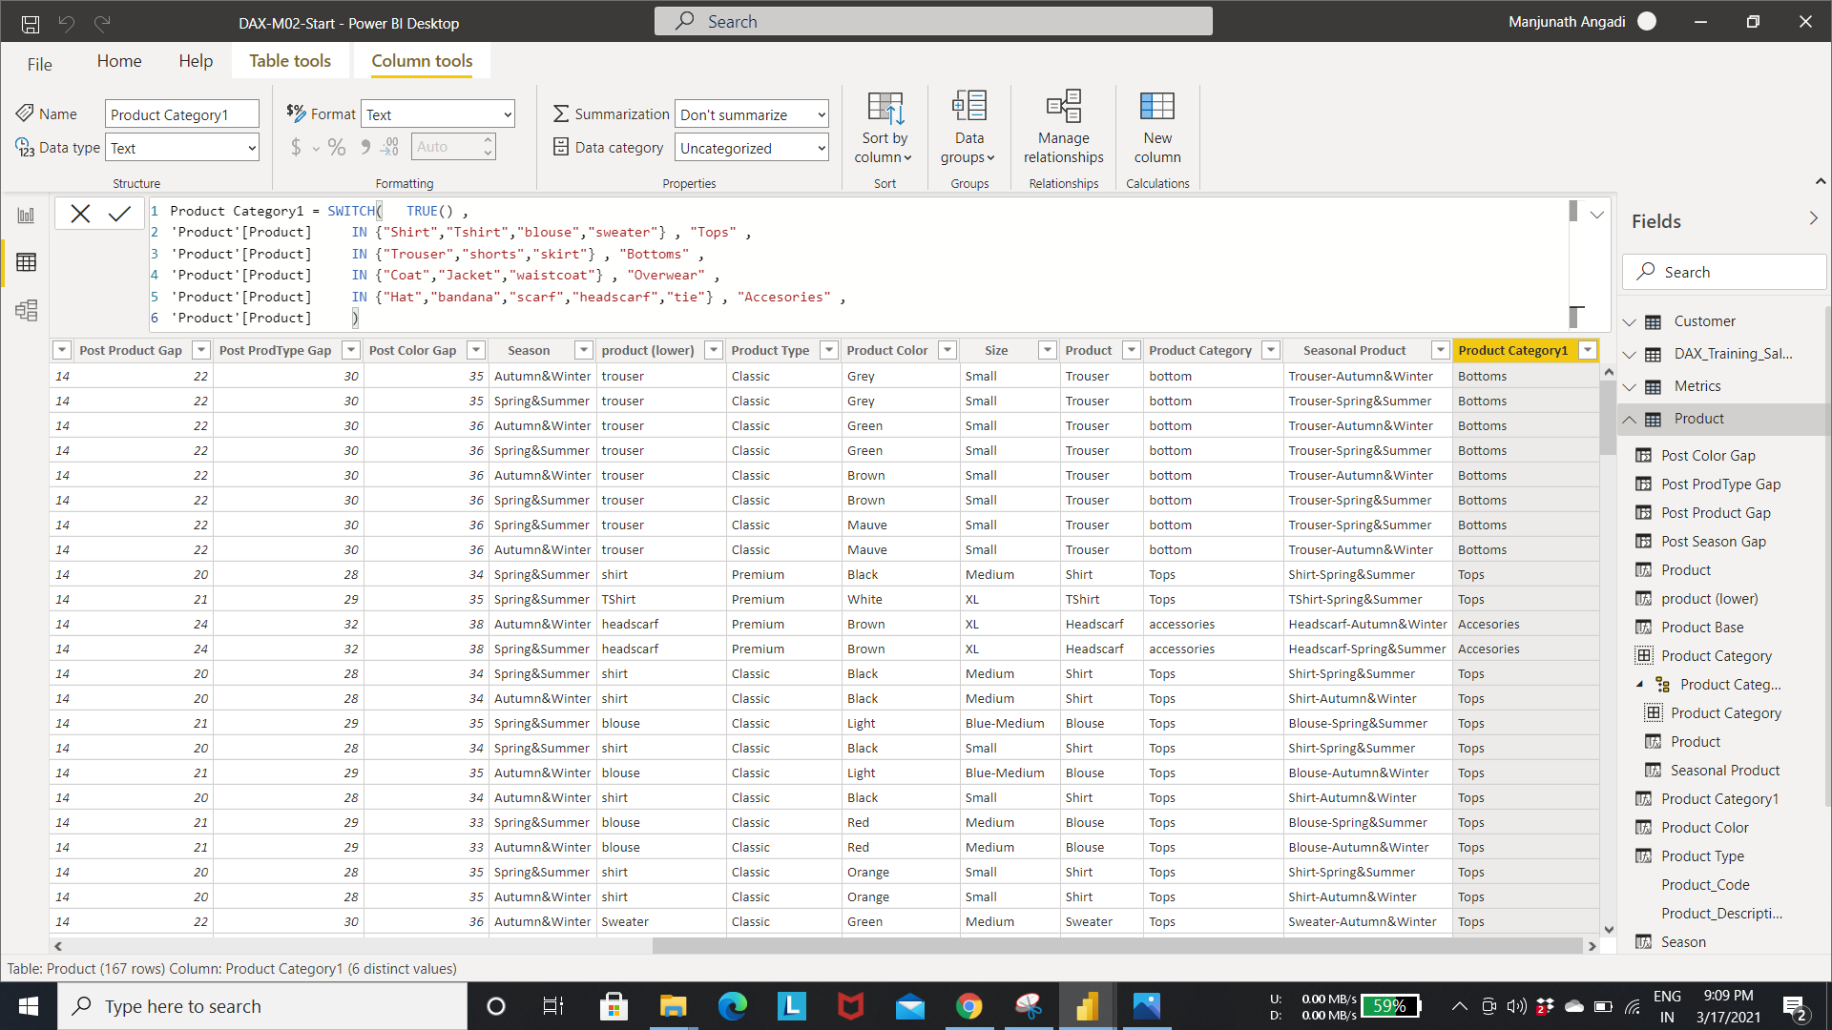

Step 2: Create a table visualization containing list of product names and then add new column “**Product category**” to the table.

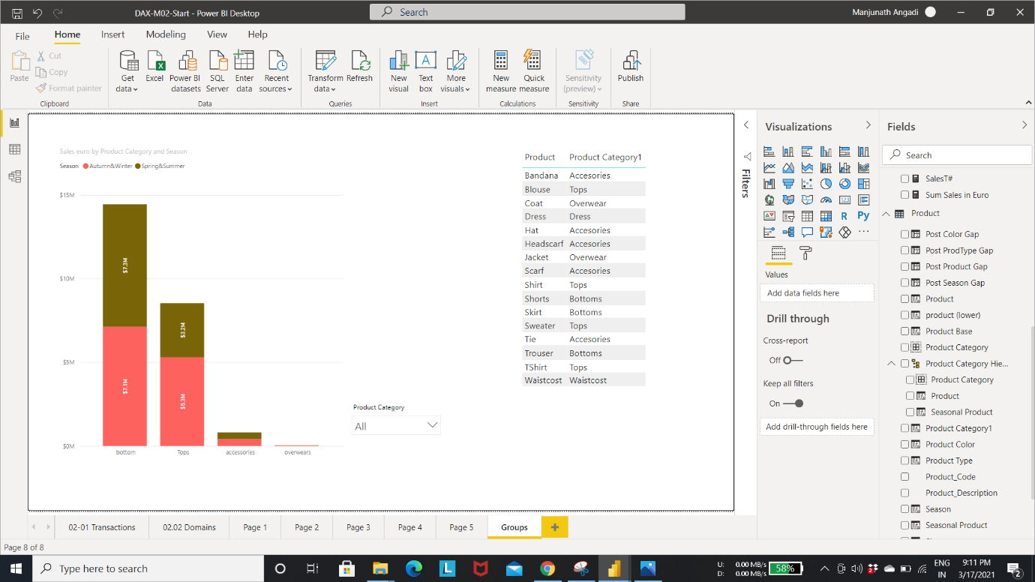

Step 3: create a slicer and use “**product group**” as slicer to see that the values correspond in all cases with product group.

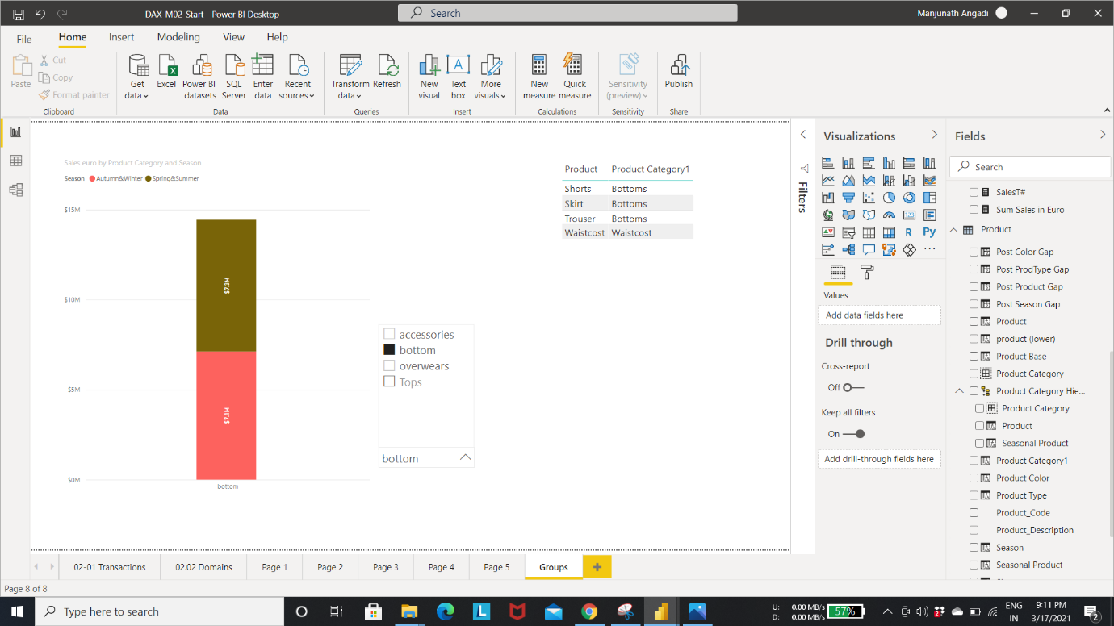

**Conditional logic with switch:**

Step 1: Create a new column in **product dimensions** table called **product Gender.**

Here, if the product category is dress then return Female.

if the product category is Accessories, Bottoms, Overwear and Product code is 1, then return male.

if the product category is Accessories, Bottoms, Overwear and Product code is 9, then return Female.

if the product category is Top and Product code starts with 9, Product name is blouse then return Female.

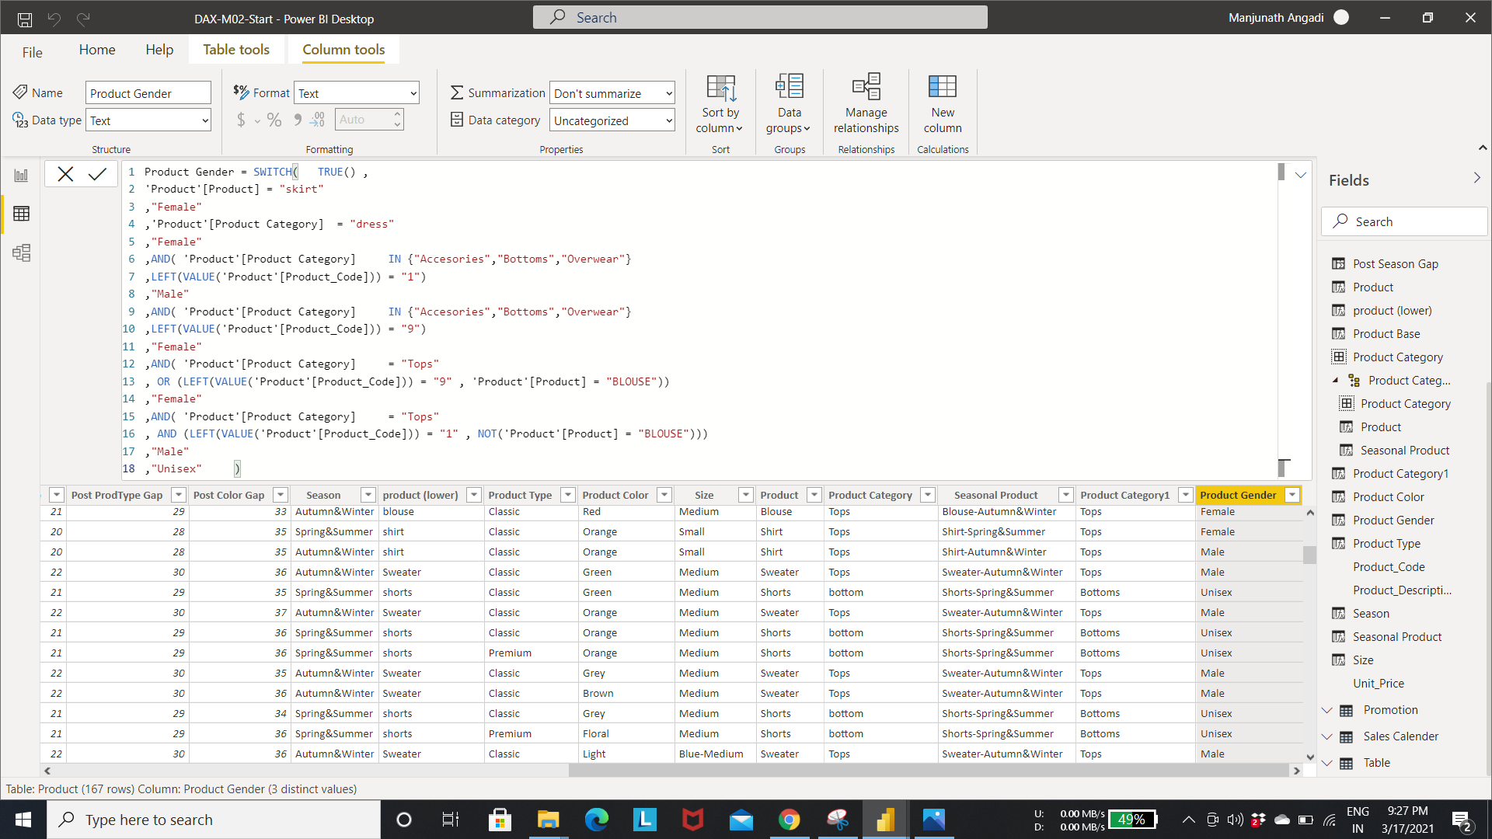

Step 1: Evaluate the value of three different columns in product table.

As shown in fig,

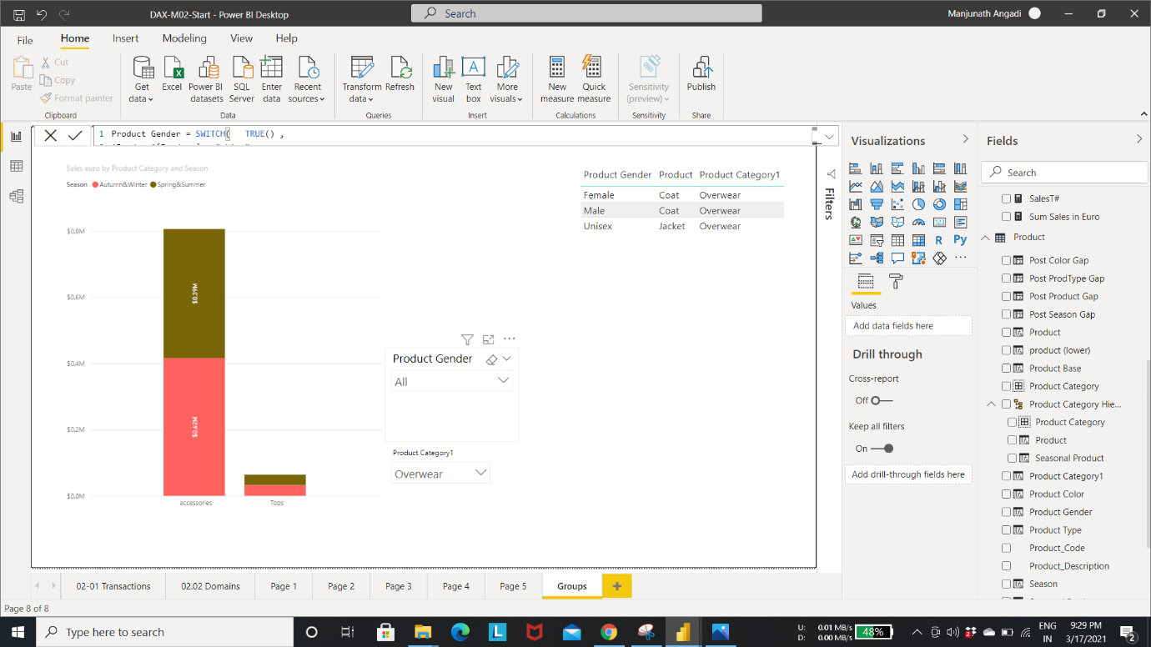

Step 3: add three columns to data visualization table

Product category, Product Name, Product code and make a copy of product category expression to use as a template.

